**Software Design Specification (SDS)**

Revision History:

|  |  |  |
| --- | --- | --- |
| Date | Author | Description |
| 2020/10/9 | Chenkai MA | Created and wrote the document |
|  |  |  |
|  |  |  |
|  |  |  |
|  |  |  |
|  |  |  |

Contents

**Software Design Specification (SDS)** 0

1. Introduction 2

1.1. Intended Audience and Purpose 2

1.2. How to use the document 2

2. System Design 2

2.1. Context 2

2.2. Design Pattern 2

2.3. Architecture 2

2.3.1. <Component Diagram> 2

2.3.2. <Deploy Diagram> 2

3. Module Interface Design 2

4. Algorithm Detailed Design 3

## Introduction

## Intended Audience and Purpose

This document will describe the design of the software of the Dog-ray Team. The people in charge of coding in this team should check this document for coding work. The people in charge of the requirements in this group should supervise the corresponding requirements in this document. PM shall track the progress of the project according to this document, so as to control the quality of the project.

## How to use the document

The logical organization of this document will be as clear as possible. Refer to the Contents section of this document for the location of relevant contents.

## System Design

## Context

This document will read into the PNG format of the picture and use Java language to write the program for processing. In view of the different ranges of the colors in the data set, the program will take some time to run in order to ensure the accuracy. The improvement of the input data quality and the unification of the formats will provide an important foundation for the improvement of software performance in the future.

## Design Pattern

This program will use different classes to process files, pictures and pixel matrixes. Generally speaking, we need to construct the class of processing file, the class of processing image to obtain pixel matrix, the class or method of generating image, the class of calculating angle, the class of giving corresponding advice according to the angle.

Although the clarity of logic makes it unnecessary to give too detailed design patterns in this document, coders still need to fully consider the rationality of coding logic in the design to facilitate others to read and facilitate future maintenance.

## Architecture

## <Component Diagram>

This team focuses on the writing of the algorithm, which does not involve complex components. For interface design, please refer to the IS document. For detailed design, please refer to the detailed design section below.

## <Deploy Diagram>

## Module Interface Design

For the interface design, please refer to the IS document, which is obtained by the negotiation of three algorithm teams.

## Algorithm Detailed Design

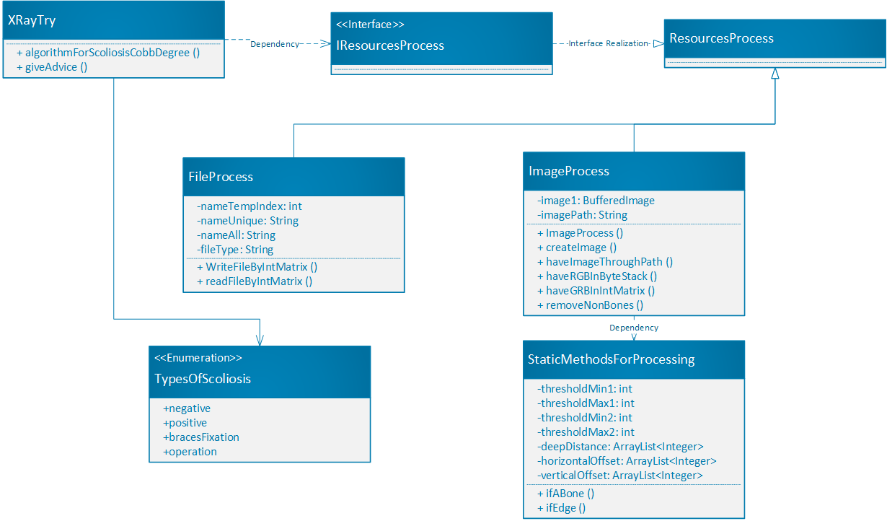The class diagram of this program is shown below,

**Figure 1 General Class Diagram of Dog-ray Team**