# Software Requirements

Version 1, last updated by Xing HUANG at 2020-09-17

# Software Requirements Specification (SRS)

Revision History:

|  |  |  |
| --- | --- | --- |
| Date | Author | Description |
|  |  |  |
|  |  |  |
|  |  |  |
|  |  |  |
|  |  |  |
|  |  |  |
|  |  |  |
|  |  |  |
|  |  |  |
|  |  |  |

Contents

Software Requirements 1

Software Requirements Specification (SRS) 1

1.  Introduction 2

2.  Concept of Operations 2

2.1    System Context 2

3.  Use Cases 2

4.System Inputs and Outputs 3

## Introduction

Web client of Scoliosis Detection via X-ray Photo Recognition.

## 2.  Concept of Operations

### 2.1    System Context

**System Requirements:**  
The client is in HTML so users must have an updated version of Browsers installed on their machine to use the application.

Browsers:

* Chrome
* Microsoft Edge
* IE
* QQ Browser

## 3.  Use Cases

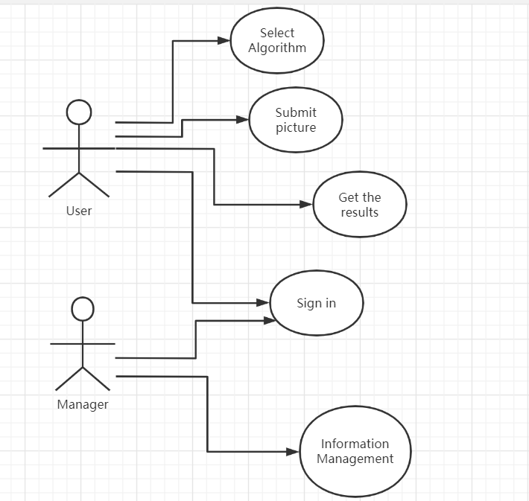

### 4. System Inputs and Outputs

#### 4.1.1 Inputs

X-ray chart .

#### 4.1.2 Outputs

Marked X-ray chart and angle of scoliosis.

## 