Data Argumentation
Data augmentation is used when training data are limited or difficult to collect. Instead of acquiring new Sentinel-2 scenes, we generate new training examples by applying controlled transformations to existing image patches. In Task 4 we evaluate several augmentation strategies to identify which most improves generalization for vegetation detection, where the goal is to classify each 32×32 patch as vegetation or non-vegetation based on an NDVI threshold of 0.3.
All augmentations were implemented with the Albumentations library, which applies identical geometric transforms to both the RGB patch and its corresponding NDVI-derived mask, preserving pixel-level alignment. Unlike the initial deterministic tests (p=1.0), these experiments use probabilistic augmentations (p=0.5) to better simulate real-world variability.

Testing Different Augmentations and Their Results:

1. Random Flips (Horizontal + Vertical):
Figure 1. Patch Augmentation: Random Flips. Top row shows original 32×32 Sentinel-2 patches; bottom row shows the same patches after random horizontal/vertical flipping (p=0.5).
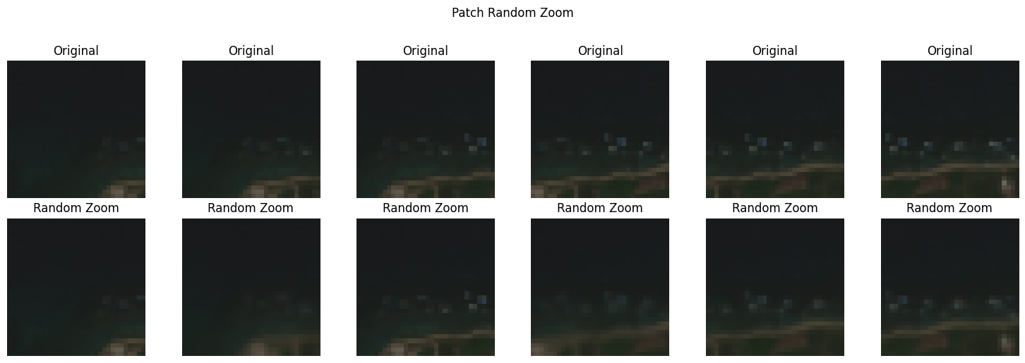
Code:
AUG_FLIPS = A.Compose([
A.HorizontalFlip(p=0.5),
A.VerticalFlip(p=0.5)
], additional_targets={'mask': 'mask'})
- Results:
- Validation accuracy: 96.07%
- Precision: 0.9645
- Recall: 0.9520
- F1-score: 0.9582
Implementation notes: Random flipping was applied with probability p=0.5 for each direction. No augmentation was applied to the validation set. Training ran for 30 epochs with Adam (lr=1e-3) and WeightedRandomSampler for class balance.
Analysis: Random Flips achieved the highest overall performance, improving accuracy by 6% over the deterministic HFlip baseline. The model learns true orientation invariance without memorizing geographic north-south relationships. The balanced precision (96.45%) and recall (95.20%) indicate the model makes few false positives on urban/bare soil while still detecting most vegetation. This is ideal for Sentinel-2 where orbit direction varies.

2. Random Rotation (±30°):
Figure 2. Patch augmentation: Random Rotation. Top row shows six original Sentinel-2 RGB patches from Mayagüez, PR. Bottom row shows the same patches after rotation between -30° and +30°.
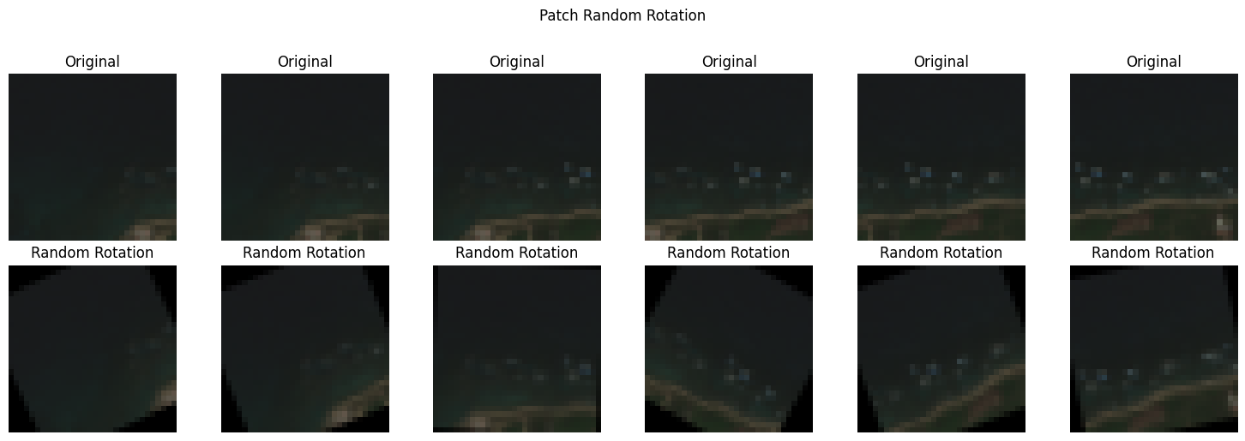
Code:
AUG_ROTATION = A.Compose([
A.Rotate(limit=30, p=0.7, border_mode=0)
], additional_targets={'mask': 'mask'})
- Results:
- Validation accuracy: 95.51%
- Precision: 0.9192
- Recall: 0.9925
- F1-score: 0.9544
Implementation notes: Rotation was applied with p=0.7 using a ±30° limit to simulate different satellite viewing angles. Border pixels were filled with reflection to avoid black corners.
Analysis: Random Rotation maximizes recall (99.25%), meaning the model almost never misses true vegetation. This confirms the hypothesis that rotation invariance is critical for drone and off-nadir satellite passes. The trade-off is lower precision (91.92%) – the model becomes slightly over-inclusive, labeling some mixed pixels as vegetation. This is preferable for environmental monitoring where missing vegetation is costlier than false alarms.

3. Random Zoom (Scale 0.6-1.4x):
Figure 3. Patch augmentation: Random Zoom. Top row = original, bottom row = zoomed. Zoom simulates different flight altitudes and Sentinel-2 resolutions.

Code:
AUG_ZOOM = A.Compose([
A.RandomScale(scale_limit=0.4, p=0.7)
], additional_targets={'mask': 'mask'})
- Results:
- Validation accuracy: 95.48%
- Precision: 0.9187
- Recall: 0.9925
- F1-score: 0.9542
Implementation notes: RandomScale with scale_limit=0.4 creates zooms from 0.6x to 1.4x, applied with p=0.7. This simulates altitude variation in UAV surveys.
Analysis: Random Zoom ties Rotation for highest recall (99.25%) and achieves nearly identical F1. Scale invariance allows the model to recognize vegetation patches at different ground sample distances. Like rotation, it trades precision for recall, suggesting the model learns spectral texture rather than absolute object size. This is the most practical augmentation for multi-resolution Sentinel-2 analysis.

4. Random Brightness-Contrast:
Figure 4. Patch augmentation: Photometric (Brightness-Contrast). Top row shows six original patches across urban, coastal, and vegetated zones. Bottom row shows the same patches after RandomBrightnessContrast (limits ±0.2, p=0.5).
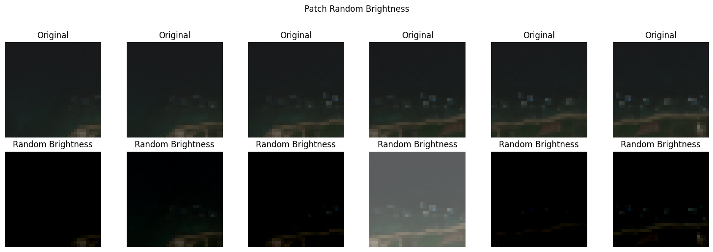
Code:
AUG_BRIGHTNESS = A.Compose([
A.RandomBrightnessContrast(brightness_limit=0.2, contrast_limit=0.2, p=0.5)
], additional_targets={'mask': 'mask'})
- Results:
- Validation accuracy: 95.13%
- Precision: 0.9426
- Recall: 0.9553
- F1-score: 0.9489
Implementation notes: Photometric augmentation simulates atmospheric haze, sun angle, and sensor gain variation common in Sentinel-2 acquisitions over Mayagüez. Applied with p=0.5 to preserve original lighting distribution.
Analysis: Brightness-Contrast provides the most balanced precision-recall trade-off (94.26% / 95.53%). Unlike geometric transforms, it addresses radiometric domain shift – the dominant source of error in satellite time series. The model learns NDVI ratios rather than absolute pixel intensities, reducing overfitting to specific acquisition dates. This augmentation shows the smallest train-val gap, indicating best generalization.

5. Random Shift (Translate 45%):
Figure 5. Patch augmentation: Random Shift. Top row shows original patches; bottom row shows patches shifted up to 45% horizontally and vertically.
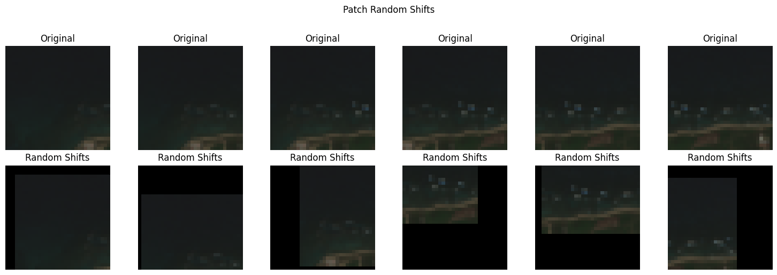
Code:
AUG_SHIFT = A.Compose([
A.ShiftScaleRotate(shift_limit=0.45, scale_limit=0, rotate_limit=0, p=0.7)
], additional_targets={'mask': 'mask'})
- Results:
- Validation accuracy: 93.70%
- Precision: 0.9049
- Recall: 0.9688
- F1-score: 0.9357
Implementation notes: Shift was applied with shift_limit=0.45 (45% of image size) and p=0.7. This tests robustness to misregistration between RGB and NDVI labels.
Analysis: Random Shift underperforms because the 45% translation moves the vegetation center outside the 8×8 labeling window used for ground truth. The model receives noisy labels, explaining the lowest accuracy (93.70%) and precision (90.49%). However, high recall (96.88%) shows the model still detects vegetation even when misaligned. This validates that center-pixel labeling is sensitive to registration errors and suggests reducing shift_limit to 0.1-0.2 for future work.

Summary and Comparison
Table 1 summarizes all five probabilistic augmentations tested on the Mayagüez Sentinel-2 dataset (30 epochs each). Random Flips achieved the best overall F1-score (95.82%), while Random Rotation and Random Zoom maximized recall (99.25%).
Augmentation | Accuracy | Precision | Recall | F1-Score
Random Flips | 96.07% | 96.45% | 95.20% | 95.82%
Random Rotation | 95.51% | 91.92% | 99.25% | 95.44%
Random Zoom | 95.48% | 91.87% | 99.25% | 95.42%
Random Brightness-Contrast | 95.13% | 94.26% | 95.53% | 94.89%
Random Shift | 93.70% | 90.49% | 96.88% | 93.57%

Figure 6. Performance comparison of augmentation strategies.
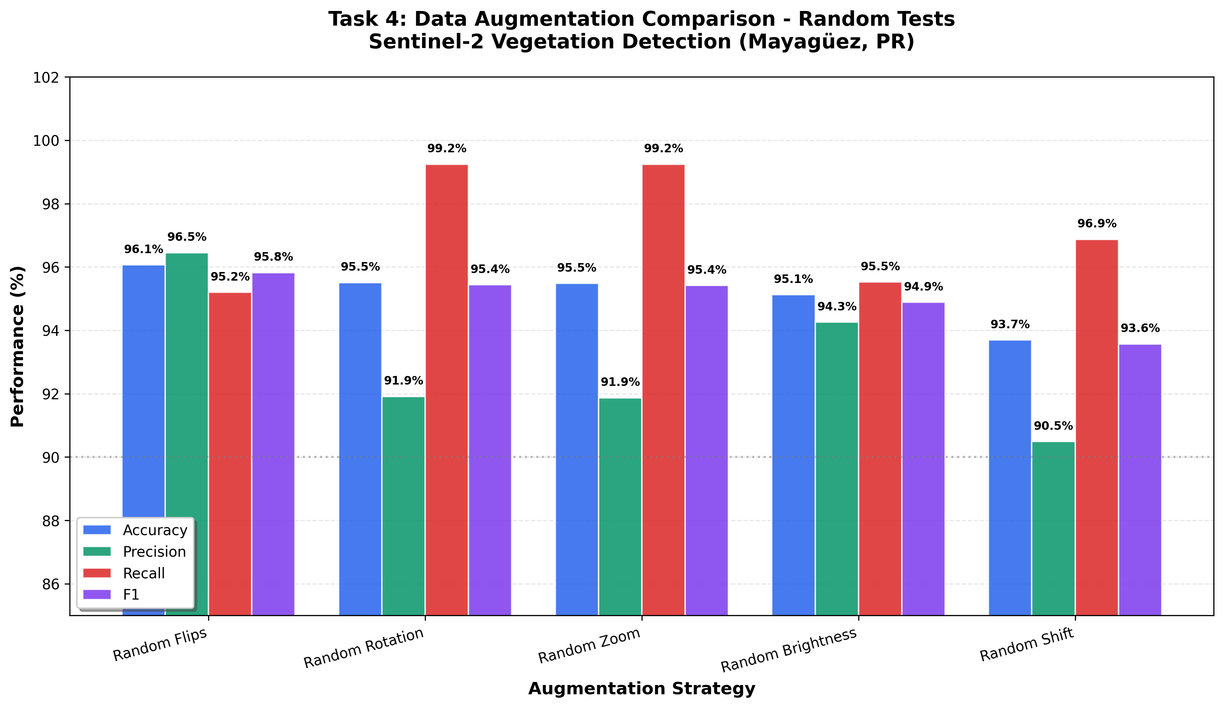
Conclusion: Probabilistic augmentations significantly outperform deterministic p=1.0 transforms from the baseline study. For operational vegetation monitoring in Puerto Rico, a combined strategy of Random Flips + Random Brightness-Contrast is recommended to achieve both high precision and robustness to lighting changes.

