Prerequisite : Data Mining
COURSE PACK FOR MACHINE LEARNING
Course Title | Machine Learning (ML) |  |  |  |  | Course Type |  | Integrated
Course Code | A4515 | Credits | 4 |  |  | Class |  | II Year I Semester
Course Structure | TLP | Credits | Contact Hours | Work Load |  | Total Number of Classes  Per Semester |  | Assessment in Weight age
Course Structure | Theory | 3 | 3 | 3
Course Structure | Practice | 1 | 2 | 1 |  | Theory | Practical | CIE | SEE
Course Structure | Tutorial | - | - | -
Course Structure | Total | 4 | 5 | 4 |  | 42 | 28 | 30% | 70%
Course Instructors | Course Lead: Dr T. Maruthi Padmaja
Course Instructors | Theory |  |  |  | Practice
Course Instructors | - Dr T. Maruthi Padmaja  - Mr. K. Anvesh |  |  |  | - Dr T. Maruthi Padmaja  - Mr. K Anvesh

COURSE OVERVIEW
This course delivers the theoretical foundation for machine learning as well as its implementation intricacies to real world data analysis. The main focus of this course is to view the machine learning as a search problem. Different hypothesis spaces, correct hypothesis searching techniques are covered under learning theory. Further, provides insight on genetic algorithm and programming for Hypothesis Space Search. This course also covers different types of learning paradigms like supervised, unsupervised. Provides sound algorithmic knowledge on supervised learning algorithms like decision tree, Naive Bayes, k nearest neighbour regression and classification. Further, this course provides the necessary skill to develop models to perform.
COURSE OBJECTIVE
The course enables the learner with the theoretical knowledge on machine learning and the skill to apply it to perceive real world data analytics.

COURSE OUTCOMES (COs)
After the completion of the course, the student will be able to:
CO# | Course Outcomes | POs | PSOs
A4515.1 | Understand the principles of Learning theory, supervised, unsupervised learning paradigms and algorithms. | - | -
A4515.2 | Applying supervised, unsupervised learning algorithms for information learning related problems. | 1 | 1,2
A4515.3 | Analyzing the real world data for procuring analytics. | 2,5 | 1,2
A4515.4 | Building machine learning models using supervised, unsupervised learning algorithms for real world data analytics . | 3,5 | 1,2
A4515.5 | Evaluating the machine learning models using evaluation metrics. | 4,5 | 1,2

BLOOM’S LEVEL OF THE COURSE OUTCOMES

CO# | Bloom’s Level
CO# | Remember  (L1) | Understand  (L2) | Apply  (L3) | Analyze  (L4) | Evaluate  (L5) | Create  (L6)
A4515.1 |  | ✔
A4515.2 |  |  | ✔
A4515.3 |  |  |  | ✔
A4515.4 |  |  | ✔
A4515.5 |  |  |  |  | ✔

COURSE ARTICULATION MATRIX

CO#/  POs | PO1 | PO2 | PO3 | PO4 | PO5 | PO6 | PO7 | PO8 | PO9 | PO10 | PO11 | PO12 | PSO1 | PSO2
A5601.2 | 3 |  |  |  |  |  |  |  |  |  |  |  | 2 | 2
A5601.3 |  | 3 |  |  | 3 |  |  |  |  |  |  |  | 2 | 2
A5601.4 |  |  | 3 |  | 3 |  |  |  |  |  |  |  | 2 | 2
A5601.5 |  |  |  | 3 | 3 |  |  |  |  |  |  |  | 3 | 3

Note: 1-Low, 2-Medium, 3-High

COURSE ASSESSMENT
S No | Component |  | Duration in Hours | Component Wise  Marks | Total Marks | Weightage | Marks
1 | Continuous Internal Evaluation (CIE) | Theory: Test-1 | 1 | 20 | 100 | 0.3 | 30
2 | Continuous Internal Evaluation (CIE) | Theory: Test-2 | 1 | 20 | 100 | 0.3 | 30
3 | Continuous Internal Evaluation (CIE) | Alternate Assessment* | - | 20 | 100 | 0.3 | 30
4 | Continuous Internal Evaluation (CIE) | Practical Exam | 2 | 40 | 100 | 0.3 | 30
5 | Semester End Exam (SEE) |  | 3 | 100 | 100 | 0.7 | 70
Total Marks |  |  |  |  |  |  | 100

* Assignment, Quiz, Class test, SWAYAM/NPTEL/MOOCs and etc..
COURSE CONTENT
THEORY
Contents
UNIT – 1
Introduction – Well-posed learning problems, Designing a learning system, Perspectives and issues in machine learning Concept learning and the general to specific ordering – Introduction, A concept le
arning task, Concept learning as search, Find-S: finding a maximally specific hypothesis

UNIT – 2
Decision Tree learning – Introduction, Decision tree representation, Appropriate problems for decision tree learning, The basic decision tree learning algorithm, Hypothesis space search in decision tree learning, Inductive bias in decision tree learning, Issues in decision tree learning

UNIT – 3
Bayesian learning – Introduction, Bayes theorem, Bayes theorem and concept learning, Maximum likelihood and least squared error hypotheses, Maximum likelihood hypotheses for predicting probabilities, Minimum description length principle, Bayes optimal classifier, Gibs algorithm, Naïve Bayes classifier, An example learning to classify text, Bayesian belief networks The EM algorithm

UNIT – 4
Computational learning theory – Introduction, Probability learning an approximately correct hypothesis, Sample complexity for Finite Hypothesis Space, Sample Complexity for infinite Hypothesis Spaces, The mistake bound model of learning.

UNIT – 5
Instance-Based Learning- Introduction, k -Nearest Neighbour Learning, Locally Weighted Regression, Radial BasisFunctions, Case-Based Reasoning, Remarks on Lazy and Eager Learning Genetic Algorithms – Motivation, Genetic Algorithms, An illustrative Example, Hypothesis Space Search, Genetic Programming, Models of Evolution and Learning, Parallelizing Genetic Algorithms

PRACTICE:
No | Title of the Experiment | Tools and Techniques | Expected Skills/Ability
1 | Implement FIND-S algorithm for finding the most specific hypothesis.  a. Read the Iris training data from a .CSV file.  b. Output best hypothesis that better separate the data. | Open source Tools: JDK 8 and above versions, Weka 3.8 above, Anaconda Python, Spider, Jupyter Notebook, pycharm  IDE:Pycharm  OS: Windows / Linux  Web browser: Internet Explorer/ Google/ Firefox | Apply Machine Learning principles to Analyze the given data
2 | Implement the Candidate-Elimination algorithm  a. Read the Iris training data from a .CSV file.  b. Output a description of the set of all hypotheses consistent with the training examples |  | Apply Machine Learning principles to Analyze the given data
3 | Write a program to demonstrate the working of the decision tree based ID3 algorithm  a. Read the Iris training data from a .CSV file.  b. Output a description of the set of all the decision rules.  c. Output the accuracy of the Iris data |  | Apply Machine Learning principles to Analyze the given data
4 | Write a program to implement the naïve Bayesian classifier  a. Read the Iris training data from a .CSV file.  b. Output the accuracy of the Iris data |  | Apply Machine Learning principles to Analyze the given data
5 | Evaluate the naïve Bayesian Classifier model to perform this task  a. Read the text data from a .CSV file.  b. Output the accuracy of the Iris data  c. Calculate precision, and recall for individual class of text. |  | Apply Machine Learning principles to Analyze the given data
6 | Write a program to implement the Bayesian Network  a. Read the Medical data from a .CSV file.  b. Output the accuracy of the Iris data  c. Calculate precision, and recall for individual class. |  | Apply Machine Learning principles to Analyze the given data
7 | Apply EM and K Means algorithm to cluster the given data  a. Read the IRIS data from a .CSV file.  b. Compare the results of these two algorithms and comment on the quality of clustering. |  | Apply Machine Learning principles to Analyze the given data
8 | Write a program to implement k-Nearest Neighbour algorithm to classify  a. Read the IRIS data from a .CSV file.  b. Print both correct and wrong predictions. |  | Apply Machine Learning principles to Analyze the given data
9 | Implement the non-parametric Locally Weighted Regression algorithm  a. Read the Bike sharing data from a .CSV file.  b. Output Root Mean Square Error.  C. Output Appropriate Graphs |  | Apply Machine Learning principles to Analyze the given data
10 | Let y= w1.x1+w2.x2+w3.x3+w4.x4+w5.x5+w6.x6,  where (x1, x2, x3, x4, x5, x6) = (4, -2, 3.5, 5, -11, -4.7).  a. maximize this equation by using the genetic algorithm for the best possible values after a number of generations |  | Apply Machine Learning principles to Analyze the given data

Text Books:
1. Machine Learning – Tom M. Mitchell, – MGH
2. Machine Learning: An Algorithmic Perspective, Stephen Marsland, Taylor & Francis (CRC)

Reference Books:
- Machine Learning Methods in the Environmental Sciences, Neural Networks, William W Hsieh, Cambridge Univ. Press.
- Richard o. Duda, Peter E. Hart and David G. Stork, pattern classification, John Wiley & Sons Inc., 2001
- Chris Bishop, Neural Networks for Pattern Recognition, Oxford University Press, 1995.
- Machine Learning by Peter Flach , Cambridge.

Journals/Magazines
- Journal of Machine Learning Research, JMLR.org
- https://ieeexplore.ieee.org/xpl/RecentIssue.jsp?punumber=34, IEEETA, PAMI,
- https://ieeexplore.ieee.org/xpl/RecentIssue.jsp?punumber=10207, IEEE computational Intelligence Magazine
- https://ieeexplore.ieee.org/xpl/RecentIssue.jsp?punumber=5962385, IEEETA, NN&LS

1) Implement FIND-S algorithm for finding the most specific hypothesis.
a. Read the Iris training data from a .CSV file.
b. Output best hypothesis that better separate the data.

Objectives
Enable the students:
- To understand how to learn specific boundaries from the given hypothesis space.
- To analyze how to learn concepts from positive targets.
- To Develop a classification model using Find-s algorithm on a training set.
- To evaluate the model using test set.

Description:

The a. csv can be any dataset that that reflects classification problem. Classification task predict the future over a learned model. The given data is divided in to training and test set folds . Here, a model is learned using FIND-S algorithm over train data. The performance of the learned model is measured on test data. For classification task the data format is like ( set of concepts, Target) i.e each instance is associated with group information (class label).

Procedure:
Step1:Load Data set
Step2: Initialize Specific Hypothesis with set of Ø.
Step3: For each training example
Step4: If example is positive example
if attribute_value == hypothesis_value:
Do nothing
else:
replace attribute value with '?' (Basically generalizing it)
Source Code
Find S lgorithm
import numpy as np
import pandas as pd
data=pd.read_csv("Book1.csv")
print(data)
train=np.array(data)[:,:-1]
print(train)
label=np.array(data)[:,-1]
print(label)
h=train[0]
print(h)
for i,val in enumerate(label):
if val=="Yes":
temp_h=train[i]
for j in range(len(h)):
if (h[j]!=temp_h[j]):
h[j]="?"
else:
pass
print(h)

Input
Data set, enjoysport.csv, which reflects a classification task of whether a student enjoyed the sport (yes) or not (no). Here the concepts are (sky, air_temp, humidity, wind, water, forecast) the target is enjoy_sport.

Sky | air_temp | humidity | wind | water | forecast | enjoy_sport
Sunny | Warm | normal | strong | warm | same | yes
Sunny | Warm | high | strong | warm | same | yes
Rainy | Cold | high | strong | warm | change | no
Sunny | Warm | high | strong | cool | same | yes

Output
Specific Hypothesis
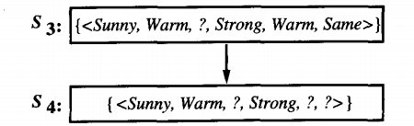

Viva questions:
1) Define classification problem.
2) Define Specific hypothesis.
3) Define satisfactory principle.
4) Define Version space?
5) Give the drawbacks of Find-S algorithm.

Web resources
1) https://www.geeksforgeeks.org/ml-find-s-algorithm/
2) https://www.edureka.co/blog/find-s-algorithm-in-machine-learning/

Datasets for the applicability to solve similar problems

1)https://medium.com/towards-artificial-intelligence/best-datasets-for-machine-learning-data-science-computer-vision-nlp-ai-c9541058cf4f
2) https://archive.ics.uci.edu/ml/index.php
3) https://www.kaggle.com/

2) Implement the Candidate-Elimination algorithm

a. Read the Iris training data from a .CSV file.
b. Output a description of the set of all hypotheses consistent with the training examples
Objectives
Enable the students:
- To understand the version space, general and specific boundaries of version space.
- To analyze how to learn from two classes.
- To Develop a classification model using Candidate elimination algorithm on a training set.
- To evaluate the model using test set.

Description:

The a.csv can be any dataset that that reflects classification problem. Classification task predict the future over a learned model. The given data is divided in to training and test set folds . Here, a model is learned using Candidate elimination algorithm over train data. The performance of the learned model is measured on test data. For classification task the data format is like ( set of concepts, Target) i.e each instance is associated with group information (class label).

Procedure:
Step1:Load Data set
Step2: Initialize General Hypothesis and Specific Hypothesis with set of .Ø and ?.
Step3: For each training example
Step4: If example is positive example
if attribute_value == hypothesis_value:
Do nothing
else:
replace attribute value with '?' (Basically generalizing it)
Step5: If example is Negative example
Make generalize hypothesis more specific.
Source Code

#Importing Important Libraries
import numpy as np
import pandas as pd
data = pd.read_csv('Book1.csv'))
print(data)

concepts = np.array(data.iloc[:,0:-1])
target = np.array(data.iloc[:,-1])
print(target)
print(concepts)

#Defining Model (Candidate Elimination algorithm concepts)
specific_h = concepts[0].copy()
print("Initialization of specific_h and general_h")
print("specific_h: ",specific_h)
general_h = [["?" for i in range(len(specific_h))] for i in range(len(specific_h))]
print("general_h: ",general_h)
print("concepts: ",concepts)
for i, h in enumerate(concepts):
if target[i] == "Yes":
for x in range(len(specific_h)):
#print("h[x]",h[x])
if h[x] != specific_h[x]:
specific_h[x] = '?'
general_h[x][x] = '?'
if target[i] == "No":
for x in range(len(specific_h)):
if h[x] != specific_h[x]:
general_h[x][x] = specific_h[x]
else:
general_h[x][x] = '?'
print("Specific_h: ",i+1)
print(specific_h,"\n")
print("general_h :", i+1)
print(general_h)
print("\nSteps of Candidate Elimination Algorithm: ",i+1)
print("Specific_h: ",i+1)
print(specific_h,"\n")
print("general_h :", i+1)
print(general_h)
indices = [i for i, val in enumerate(general_h) if val == ['?', '?', '?', '?', '?', '?']]
print("\nIndices",indices)
for i in indices:
general_h.remove(['?', '?', '?', '?', '?', '?'])
print("\nFinal Specific_h:", s_final, sep="\n")
print("Final General_h:", g_final, sep="\n")

Input
Data set, enjoysport.csv, which reflects a classification task of whether a student enjoyed the sport (yes) or not (no). Here the concepts are (sky, air_temp, humidity, wind, water, forecast) the target is enjoy_sport.
Sky | air_temp | humidity | wind | water | forecast | enjoy_sport
sunny | Warm | normal | strong | warm | same | yes
sunny | Warm | high | strong | warm | same | yes
rainy | Cold | high | strong | warm | change | no
sunny | Warm | high | strong | cool | same | yes

Output
Specific Hypothesis
General Hypothesis

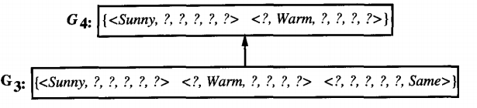

Viva questions:
1) Define general hypothesis?
2) Define Specific hypothesis?
3) Define Version space?
4) Give the significance of list then elimination algorithm?
5) Define consistent hypothesis?

Web resources
1) https://github.com/profthyagu/Python--Candidate-Elimination-Algorithm
2) https://vtucselabs.blogspot.com/2019/07/ml2.html

Datasets for the applicability to solve similar problems

1) https://medium.com/towards-artificial-intelligence/best-datasets-for-machine-learning-data-science-computer-vision-nlp-ai-c9541058cf4f
2) https://archive.ics.uci.edu/ml/index.php
3) https://www.kaggle.com/

3) Write a program to demonstrate the working of the decision tree based ID3 algorithm
a. Read the Iris training data from a .CSV file.
b. Output a description of the set of all the decision rules.
c. Output the accuracy of the Iris data
Objectives
Enable the students:
- To understand the ID3 algorithm.
- To analyze how to learn from multiple classes.
- To Develop a classification model by fitting using ID3 algorithm on a given training set.
- To evaluate the model using test set.

Description:

The a.csv can be any dataset that that reflects classification problem. Classification task predict the future over a learned model. The given data is divided in to training and test set folds . Here, a model is learned by fitting ID3 (which is a decision tree induction algorithm for categorical data) algorithm over train data. The performance of the learned model is measured on test data. For classification task the data format is like ( set of concepts, Target) i.e each instance is associated with group information (class label).
ID3 Algorithm
- Basic algorithm (a greedy algorithm)
  - Tree is constructed in a top-down recursive divide-and-conquer manner
  - At start, all the training examples are at the root
  - Attributes are categorical (if continuous-valued, they are discretized in advance)
  - Examples are partitioned recursively based on selected attributes
  - Test attributes are selected on the basis of a heuristic or statistical measure (e.g., information gain)
- Conditions for stopping partitioning
  - All samples for a given node belong to the same class
  - There are no remaining attributes for further partitioning – majority voting is employed for classifying the leaf
  - There are no samples left
Source code for fitting ID3 algorithm
#Decision Tree Fitting
from sklearn.datasets import load_iris
from sklearn.model_selection import cross_val_score
from sklearn.tree import DecisionTreeClassifier
from sklearn.model_selection import train_test_split
from sklearn.tree import plot_tree
from sklearn.tree import export_text
clf = DecisionTreeClassifier(random_state=0,max_depth=2)
iris = load_iris()
cross_val_score(clf, iris.data, iris.target, cv=10)
X_train, X_test, y_train, y_test = train_test_split(iris.data, iris.target, test_size=0.5, random_state=0)
#print("print training set\n",X_train)
#print("print testing set\n",X_test)
clf.fit(X_train,y_train)
clf.predict(X_test)
print("Avg. Accuracy",clf.score(X_train,y_train))
clf.predict_log_proba(X_test)
clf.predict_proba(X_test)
clf.cost_complexity_pruning_path(X_train,y_train)
clf.fit(X_train,y_train)
#print(clf.decision_path(X_train))
clf.get_depth()
clf.get_n_leaves()
plot_tree(clf)
r = export_text(clf, feature_names=iris['feature_names'])
print(r)

Input
Data set, iris.csv, which reflects a classification task to identify the type of Iris plant ( Setosa, Versicolour, Virginica ) based on the concepts
1. sepal length in cm
2. sepal width in cm
3. petal length in cm
4. petal width in cm
Output
Avg. Accuracy 0.9733333333333334
|--- petal width (cm) <= 0.75
| |--- class: 0
|--- petal width (cm) > 0.75
| |--- petal length (cm) <= 5.05
| | |--- class: 1
| |--- petal length (cm) > 5.05
| | |--- class: 2

Viva questions:
1) Define classification task?
2) Describe the splitting criteria for ID3.
3) Describe the attribute selection criteria for ID3.
4) Give the target function learned from ID3.
5) Give the termination criteria for ID3.
6) What the leaf nodes of the decision tree represents.
7) Define overfitting.
8) Discuss the impact of overfitting on Decision tree induction
9) Give the bias for Decision Tree.

Web resources

1) https://scikit-learn.org/stable/modules/generated/sklearn.tree.DecisionTreeClassifier.html
2) https://scikit-learn.org/stable/modules/tree.html

Datasets for the applicability to solve similar problems

1) https://medium.com/towards-artificial-intelligence/best-datasets-for-machine-learning-data-science-computer-vision-nlp-ai-c9541058cf4f
2) https://archive.ics.uci.edu/ml/index.php
3) https://www.kaggle.com/

4) Write a program to implement the naïve Bayesian classifier
a. Read the Iris training data from a .CSV file.
b. Output the accuracy of the Iris data
Objectives
Enable the students:
- To understand the Naive Bayes algorithm.
- To analyze how to learn from multiple classes.
- To Develop a classification model by fitting using Naive Bayes algorithm on a given training set.
- To evaluate the model using test set.

Description:

The a.csv can be any dataset that that reflects classification problem. Classification task predict the future over a learned model. The given data is divided in to training and test set folds . Here, a model is learned by fitting Naive Bayes algorithm over train data. The performance of the learned model is measured on test data. For classification task the data format is like ( set of concepts, Target) i.e each instance is associated with group information (class label).

Naive Bayes Algorithm

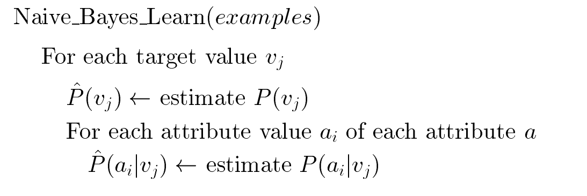
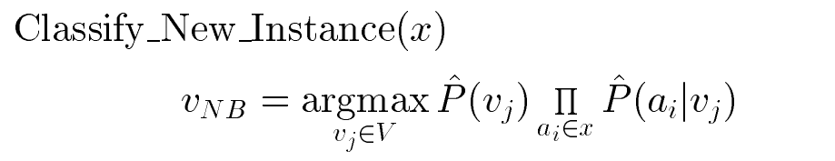
Source Code
#Naive Bayes Classifier
from sklearn.datasets import load_iris
from sklearn.model_selection import train_test_split
from sklearn.naive_bayes import GaussianNB
X, y = load_iris(return_X_y=True)
X_train, X_test, y_train, y_test = train_test_split(X, y, test_size=0.5, random_state=0)
gnb = GaussianNB()
y_pred = gnb.fit(X_train, y_train).predict(X_test)
print("Average AccurCy=",gnb.score(X_test,y_test))
print("Number of mislabeled points out of a total %d points : %d" % (X_test.shape[0], (y_test != y_pred).sum()))

Input
Data set, iris.csv, which reflects a classification task to identify the type of Iris plant ( Setosa, Versicolour, Virginica ) based on the concepts
1. sepal length in cm
2. sepal width in cm
3. petal length in cm
4. petal width in cm
Output
Average AccurCy= 0.9466666666666667
Number of mislabeled points out of a total 75 points : 4
Viva questions:
1) Define Bayes Theorem.
2) Define MAP hypothesis.
3) Define MDL principle.
4) Give the assumption for Bayes classifier.
5) Explain about accuracy measure

Web resources

1) https://scikit-learn.org/stable/modules/naive_bayes.html
2) https://scikit-learn.org/stable/modules/generated/sklearn.naive_bayes.GaussianNB.html

Datasets for the applicability to solve similar problems

1) https://medium.com/towards-artificial-intelligence/best-datasets-for-machine-learning-data-science-computer-vision-nlp-ai-c9541058cf4f
2) https://archive.ics.uci.edu/ml/index.php
3) https://www.kaggle.com/

5) Evaluate the naïve Bayesian Classifier model to perform this task
a. Read the text data from a .CSV file.
b. Output the accuracy of the Iris data
c. Calculate precision, and recall for individual class of text
Objectives
Enable the students:
- To understand the Naive Bayes algorithm for text classification.
- To analyze how to learn from multiple classes.
- To Develop a classification model by fitting using Naive Bayes algorithm on a given training set.
- To evaluate the model using test set.

Description:

The a.csv can be any dataset that that reflects classification problem. Classification task predict the future over a learned model. The given data is divided in to training and test set folds . Here, a model is learned by fitting Naive Bayes algorithm over train data. The performance of the learned model is measured on test data. For classification task the data format is like ( set of concepts, Target) i.e each instance is associated with group information (class label).

Naive Bayes Algorithm

vectorize the given text documents to convert text to vector form

Source Code
import pandas as pd

columns = ['sent', 'class']
rows = []

rows = [['This is my book', 'stmt'],
['They are novels', 'stmt'],
['have you read this book', 'question'],
['who is the author', 'question'],
['what are the characters', 'question'],
['This is how I bought the book', 'stmt'],
['I like fictions', 'stmt'],
['what is your favorite book', 'question']]

training_data = pd.DataFrame(rows, columns=columns)
training_data

from sklearn.model_selection import train_test_split
X_train, X_test, y_train, y_test = train_test_split(training_data['sent'], training_data['class'], random_state=0)
print(X_train)
print(y_train)
print(X_test)
print(y_test)

from sklearn.feature_extraction.text import CountVectorizer
cv = CountVectorizer()
X_train_cv = cv.fit_transform(X_train)
print(X_train_cv)
X_test_cv = cv.transform(X_test)

word_freq_df = pd.DataFrame(X_train_cv.toarray(), columns=cv.get_feature_names())
print(word_freq_df)
top_words_df = pd.DataFrame(word_freq_df.sum()).sort_values(0, ascending=False)
print(top_words_df)
from sklearn.naive_bayes import MultinomialNB
naive_bayes = MultinomialNB()
naive_bayes.fit(X_train_cv, y_train)
predictions = naive_bayes.predict(X_train_cv)
print(predictions)
from sklearn.metrics import accuracy_score, precision_score, recall_score
print('Accuracy score: ', accuracy_score(y_train, predictions))

Input
Any .csv file with text data in the form for example
'This is my book', 'stmt'
'They are novels', 'stmt'
'have you read this book', 'question'
'who is the author', 'question'
'what are the characters', 'question'
'This is how I bought the book', 'stmt'
'I like fictions', 'stmt'
'what is your favorite book', 'question'

Here the task to classify the given text is a statement or a question

Output

sent class
0 This is my book stmt
1 They are novels stmt
2 have you read this book question
3 who is the author question
4 what are the characters question
5 This is how I bought the book stmt
6 I like fictions stmt
7 what is your favorite book question

(0, 11) 1
(0, 0) 1
(0, 9) 1
(1, 13) 1
(1, 7) 1
(1, 15) 1
(1, 5) 1
(1, 2) 1
(2, 7) 1
(2, 14) 1
(2, 10) 1
(2, 1) 1
(3, 7) 1
(3, 2) 1
(3, 12) 1
(3, 8) 1
(4, 7) 1
(4, 2) 1
(4, 10) 1
(4, 12) 1
(4, 6) 1
(4, 3) 1
(5, 0) 1
(5, 13) 1
(5, 10) 1
(5, 4) 1

CodeText

are author book bought characters ... they this what who your
0 1 0 0 0 0 ... 1 0 0 0 0
1 0 0 1 0 0 ... 0 0 1 0 1
2 0 1 0 0 0 ... 0 0 0 1 0
3 0 0 1 0 0 ... 0 1 0 0 0
4 0 0 1 1 0 ... 0 1 0 0 0
5 1 0 0 0 1 ... 0 0 1 0 0

[6 rows x 16 columns]
0
is 4
book 3
the 3
are 2
this 2
what 2
author 1
bought 1
characters 1
favorite 1
how 1
my 1
novels 1
they 1
who 1
your 1

['stmt' 'question' 'question' 'stmt' 'stmt' 'question']
Accuracy score: 1.0

Viva questions:
1) Define Bayes Theorem.
2) Give the significance of NB classifier for text classification.
3)Define MAP hypothesis.
4) Define MDL principle.
5) Give the assumption for Bayes classifier.
6) Explain about accuracy measure

Web resources

1) https://scikit-learn.org/stable/modules/naive_bayes.html
2) https://scikit-learn.org/stable/modules/generated/sklearn.naive_bayes.GaussianNB.html
3) https://towardsdatascience.com/text-classification-using-naive-bayes-theory-a-working-example-2ef4b7eb7d5a
4) https://medium.com/analytics-vidhya/naive-bayes-classifier-for-text-classification-556fabaf252b
5) https://towardsdatascience.com/naive-bayes-document-classification-in-python-e33ff50f937e

Datasets for the applicability to solve similar problems

1) https://medium.com/towards-artificial-intelligence/best-datasets-for-machine-learning-data-science-computer-vision-nlp-ai-c9541058cf4f
2) https://archive.ics.uci.edu/ml/index.php
3) https://www.kaggle.com/

6) Write a program to implement the Bayesian Network
a. Read the Medical data from a .CSV file.
b. Output the accuracy of the Iris data
c. Calculate precision, and recall for individual class.
Objectives
Enable the students:
- To understand the Baysian Belief Network algorithm for text classification.
- To analyze how to learn from multiple classes.
- To Develop a classification model by fitting Baysian Belief Network using algorithm on a given training set.
- To evaluate the model using test set.
- Hands on Weka tool.

Description:

The a.csv can be any dataset that that reflects classification problem. Classification task predict the future over a learned model. The given data is divided in to training and test set folds . Here, a model is learned by fitting Bayesian Belief Network algorithm over train data. The performance of the learned model is measured on test data. For classification task the data format is like ( set of concepts, Target) i.e each instance is associated with group information (class label).
The procedure for fitting Belief Network in Weka
1) Opening Weka by clicking the icon on desktop, the weka GUI gets opened
2) Click on explore button on GUI as shown in below figure
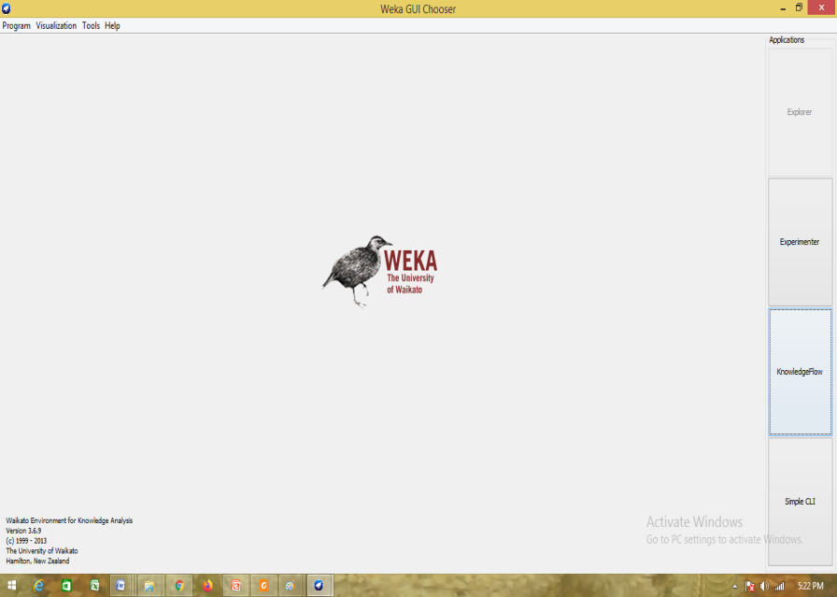

2) Load iris data by click on openfile on the top of weka, which facilities to locate desired file from directory (INPUT)
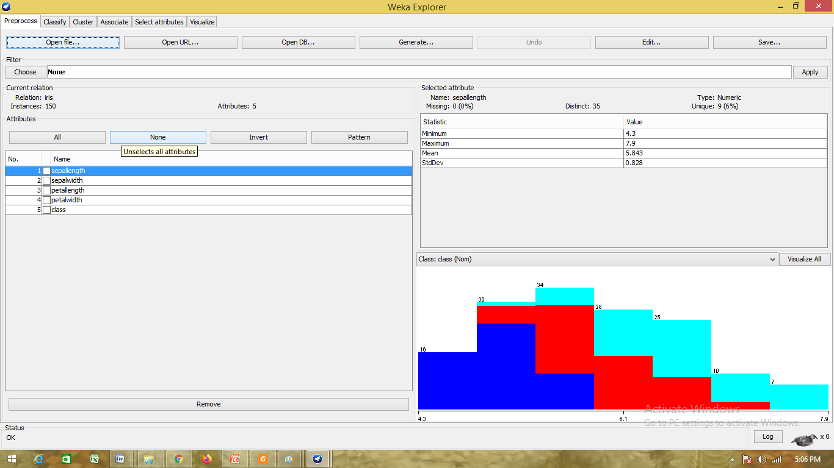
3) After loading the file click on classify button on the top of the menu, a new window gets opened
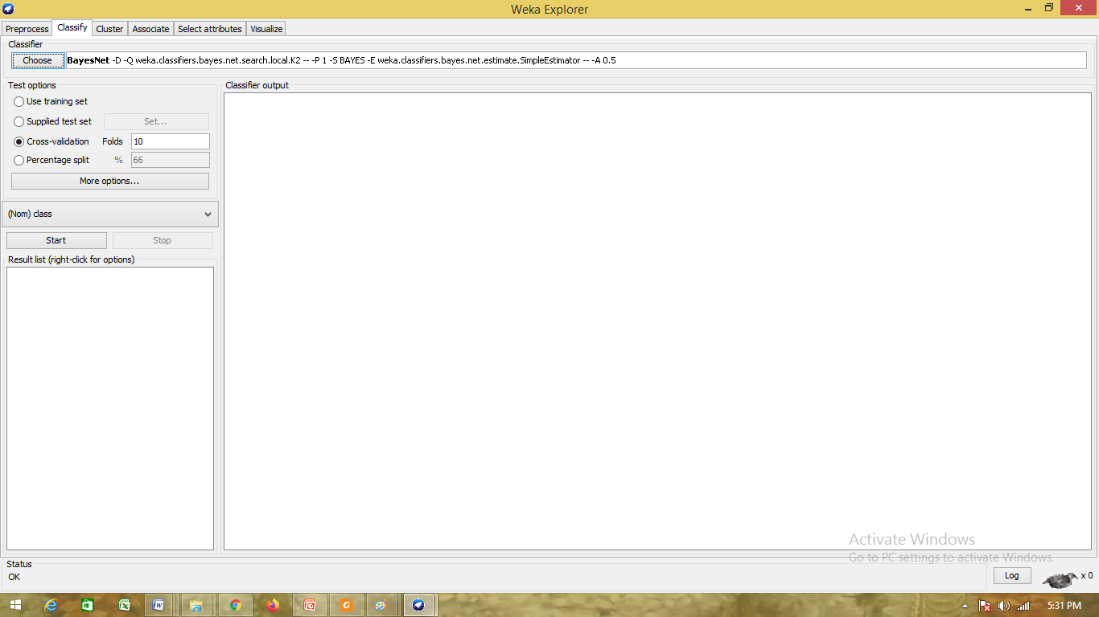

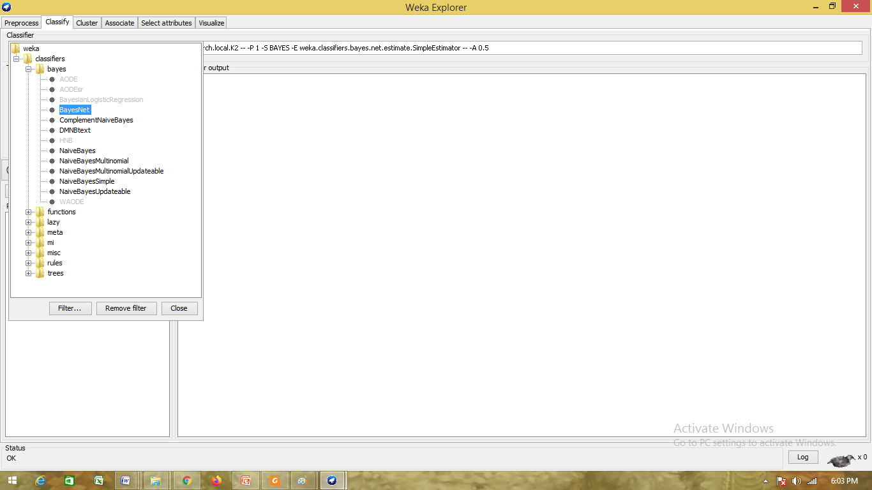
4) Click on Choose, the list of algorithms gets opened, expand Bayes folder, select BayesNet

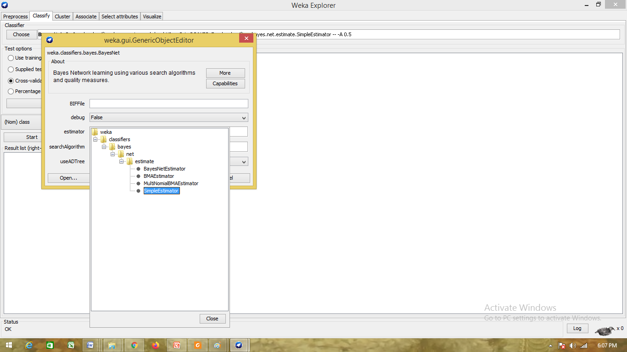
5) Can change the parameter of the model once it is selected by clicking text box on the top

There are two parameter estimator and search algorithm, estimator provides set of methods to estimate conditional probability and the search algorithm is for identifying the conditional dependencies among the attributes ( Graph/Network structure). Here the estimator is selected as simple estimator and the search algorithm selected as k2. Evaluation method is chosen as 10 fold cross validation.
The output after fitting BayesNet as
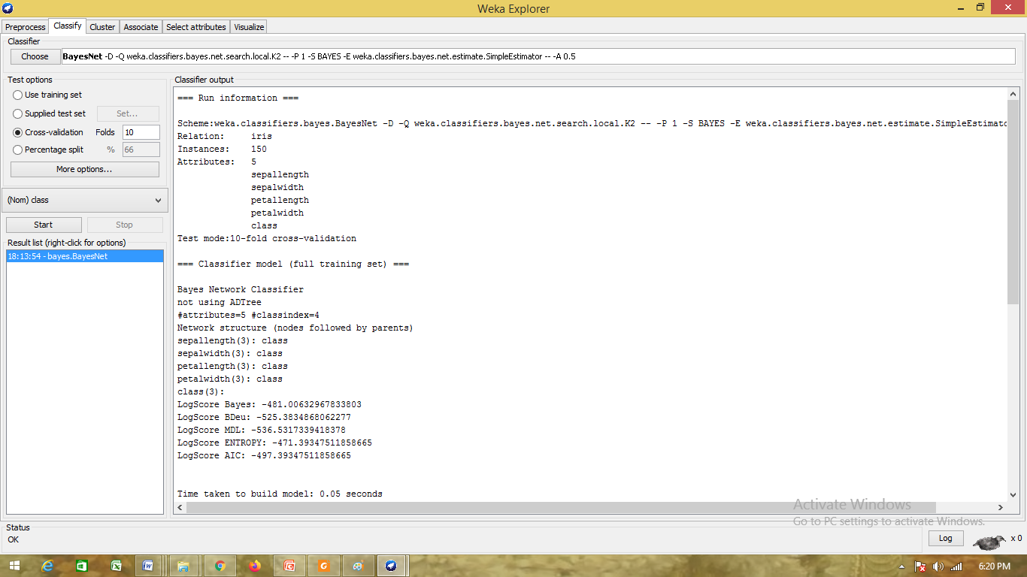
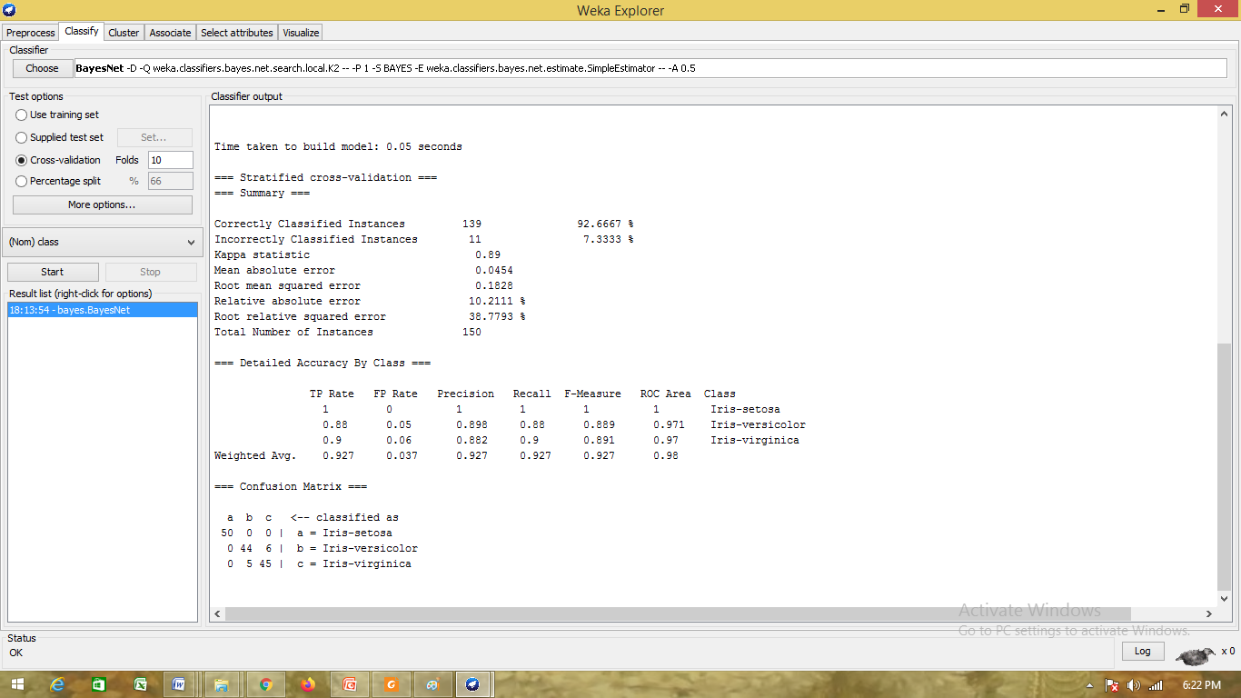
Viva questions:
1) Define Bayes Theorem.
2) Give the significant difference between NB and Bayes Classifier table.
4) Give the significance of EM in BayesNet
5) Give the significance of estimator.
6) Explain the significance of search algorithm.
7) What is the structure of input for Bayes Net

Web Resources
1) https://github.com/eBay/bayesian-belief-networks
2) https://machinelearningmastery.com/introduction-to-bayesian-belief-networks/
Datasets for the applicability to solve similar problems

1) https://medium.com/towards-artificial-intelligence/best-datasets-for-machine-learning-data-science-computer-vision-nlp-ai-c9541058cf4f
2) https://archive.ics.uci.edu/ml/index.php
3) https://www.kaggle.com/

7) Apply EM and K Means algorithm to cluster the given data
a. Read the IRIS data from a .CSV file.
b. Compare the results of these two algorithms and comment on the quality of clustering.
Objectives
Enable the students:
- To understand the EM and k-means algorithm for semi supervised learning.
- To analyze how to cluster the data based on similarity.
- To Develop a classification model by fitting using Naive Bayes algorithm on a given training set.
- To evaluate the model using test set.

Description:

The a.csv can be any dataset that that reflects clustering problem. Clustering task is to predict the group where each sample belongs. The performance of the clustering is measured over original labels. For clustering task the data format is like ( set of concepts ).
# Dataset Generation
from sklearn import datasets
import matplotlib.pyplot as plt
iris=datasets.load_iris()
#print(iris)
x=iris.data
y=iris.target
print(y)
plt.figure(2, figsize=(8, 6))
plt.clf()

# Plot the training points
color=['blue','green','pink']
for k in range(0,3):
data=iris.data[iris.target==k]
plt.scatter(data[:, 0], data[:, 1],c=color[k] )
plt.xlabel('Sepal length')
plt.ylabel('Sepal width')
plt.show()

#K-means algorithm
from sklearn.cluster import KMeans
import pandas as pd
kmeans = KMeans(n_clusters=3)
kmeans.fit(x)
#predictions from kmeans
pred = kmeans.predict(x)
print(pred)
frame=pd.DataFrame(iris.data)
frame.columns = ['sep_len','sep_wid','pet_len','pet_wid']
print(frame)
frame['cluster'] = pred
print(frame)
plt.figure(2, figsize=(8, 6))
plt.clf()
#plotting results
color=['blue','green','pink']
for k in range(0,3):
data = frame[frame["cluster"]==k]
plt.scatter(data["sep_len"],data["sep_wid"],c=color[k])
plt.xlabel('Sepal length')
plt.ylabel('Sepal width')
plt.show()

#EM algorithm

from sklearn.mixture import GaussianMixture
gmm = GaussianMixture(n_components=3)
gmm.fit(x)
#predictions from gmm
pred = gmm.predict(x)
print(pred)
frame=pd.DataFrame(iris.data)
frame.columns = ['sep_len','sep_wid','pet_len','pet_wid']
print(frame)
frame['cluster'] = pred
print(frame)
plt.figure(2, figsize=(8, 6))
plt.clf()
#plotting results
color=['blue','green','pink']
for k in range(0,3):
data = frame[frame["cluster"]==k]
plt.scatter(data["sep_len"],data["sep_wid"],c=color[k])
plt.xlabel('Sepal length')
plt.ylabel('Sepal width')
plt.show()

Input
The Input for this algorithm is iris data, where the three class labels are discritised to numeric such as1, 2,3.
Output
[0 0 0 0 0 0 0 0 0 0 0 0 0 0 0 0 0 0 0 0 0 0 0 0 0 0 0 0 0 0 0 0 0 0 0 0 0
0 0 0 0 0 0 0 0 0 0 0 0 0 1 1 1 1 1 1 1 1 1 1 1 1 1 1 1 1 1 1 1 1 1 1 1 1
1 1 1 1 1 1 1 1 1 1 1 1 1 1 1 1 1 1 1 1 1 1 1 1 1 1 2 2 2 2 2 2 2 2 2 2 2
2 2 2 2 2 2 2 2 2 2 2 2 2 2 2 2 2 2 2 2 2 2 2 2 2 2 2 2 2 2 2 2 2 2 2 2 2
2 2]

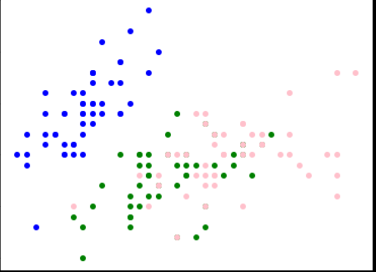
Sepal width
Sepal Length

k-means output
[1 1 1 1 1 1 1 1 1 1 1 1 1 1 1 1 1 1 1 1 1 1 1 1 1 1 1 1 1 1 1 1 1 1 1 1 1
1 1 1 1 1 1 1 1 1 1 1 1 1 2 2 0 2 2 2 2 2 2 2 2 2 2 2 2 2 2 2 2 2 2 2 2 2
2 2 2 0 2 2 2 2 2 2 2 2 2 2 2 2 2 2 2 2 2 2 2 2 2 2 0 2 0 0 0 0 2 0 0 0 0
0 0 2 2 0 0 0 0 2 0 2 0 2 0 0 2 2 0 0 0 0 0 2 0 0 0 0 2 0 0 0 2 0 0 0 2 0
0 2]
sep_len sep_wid pet_len pet_wid
0 5.1 3.5 1.4 0.2
1 4.9 3.0 1.4 0.2
2 4.7 3.2 1.3 0.2
3 4.6 3.1 1.5 0.2
4 5.0 3.6 1.4 0.2
.. ... ... ... ...
145 6.7 3.0 5.2 2.3
146 6.3 2.5 5.0 1.9
147 6.5 3.0 5.2 2.0
148 6.2 3.4 5.4 2.3
149 5.9 3.0 5.1 1.8

[150 rows x 4 columns]
sep_len sep_wid pet_len pet_wid cluster
0 5.1 3.5 1.4 0.2 1
1 4.9 3.0 1.4 0.2 1
2 4.7 3.2 1.3 0.2 1
3 4.6 3.1 1.5 0.2 1
4 5.0 3.6 1.4 0.2 1
.. ... ... ... ... ...
145 6.7 3.0 5.2 2.3 0
146 6.3 2.5 5.0 1.9 2
147 6.5 3.0 5.2 2.0 0
148 6.2 3.4 5.4 2.3 0
149 5.9 3.0 5.1 1.8 2
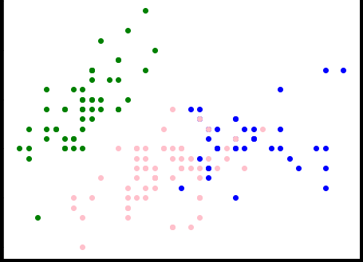
[150 rows x 5 columns]
Sepal width

Sepal Length

EM output
[1 1 1 1 1 1 1 1 1 1 1 1 1 1 1 1 1 1 1 1 1 1 1 1 1 1 1 1 1 1 1 1 1 1 1 1 1
1 1 1 1 1 1 1 1 1 1 1 1 1 0 0 0 0 0 0 0 0 0 0 0 0 0 0 0 0 0 0 2 0 2 0 2 0
0 0 0 2 0 0 0 0 0 2 0 0 0 0 0 0 0 0 0 0 0 0 0 0 0 0 2 2 2 2 2 2 2 2 2 2 2
2 2 2 2 2 2 2 2 2 2 2 2 2 2 2 2 2 2 2 2 2 2 2 2 2 2 2 2 2 2 2 2 2 2 2 2 2
2 2]
sep_len sep_wid pet_len pet_wid
0 5.1 3.5 1.4 0.2
1 4.9 3.0 1.4 0.2
2 4.7 3.2 1.3 0.2
3 4.6 3.1 1.5 0.2
4 5.0 3.6 1.4 0.2
.. ... ... ... ...
145 6.7 3.0 5.2 2.3
146 6.3 2.5 5.0 1.9
147 6.5 3.0 5.2 2.0
148 6.2 3.4 5.4 2.3
149 5.9 3.0 5.1 1.8
[150 rows x 4 columns]
sep_len sep_wid pet_len pet_wid cluster
0 5.1 3.5 1.4 0.2 1
1 4.9 3.0 1.4 0.2 1
2 4.7 3.2 1.3 0.2 1
3 4.6 3.1 1.5 0.2 1
4 5.0 3.6 1.4 0.2 1
.. ... ... ... ... ...
145 6.7 3.0 5.2 2.3 2
146 6.3 2.5 5.0 1.9 2
147 6.5 3.0 5.2 2.0 2
148 6.2 3.4 5.4 2.3 2
149 5.9 3.0 5.1 1.8 2

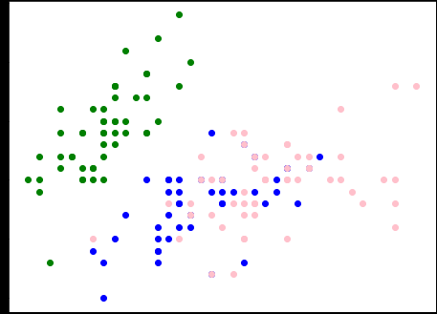
[150 rows x 5 columns]
Sepal width
Sepal Length

Viva questions
1) Difference between supervised learning and unsupervised learning
2) What k represents in k-means algorithm.
3) Give the EM principle.
4) What is the assumption for EM algorithm
5) Give the difference between k-means and EM algorithm.
Web Resources

1) https://pythonmachinelearning.pro/clustering-with-gaussian-mixture-models/
2) https://www.analyticsvidhya.com/blog/2019/10/gaussian-mixture-models-clustering/

Datasets for the applicability to solve similar problems

1) https://medium.com/towards-artificial-intelligence/best-datasets-for-machine-learning-data-science-computer-vision-nlp-ai-c9541058cf4f
2) https://archive.ics.uci.edu/ml/index.php
3) https://www.kaggle.com/

8) Write a program to implement k-Nearest Neighbour algorithm to classify
a. Read the IRIS data from a .CSV file.
b. Print both correct and wrong predictions.
Objectives
Enable the students:
- To understand the Naive Bayes algorithm for text classification.
- To analyze how to learn from multiple classes.
- To Develop a classification model by fitting using Naive Bayes algorithm on a given training set.
- To evaluate the model using test set.

Description:

The a.csv can be any dataset that that reflects classification problem. Classification task predict the future over a learned model. The given data is divided in to training and test set folds . Here, a model is learned by fitting K NN algorithm over train data. The performance of the learned model is measured on test data. For classification task the data format is like ( set of concepts, Target) i.e each instance is associated with group information (class label).
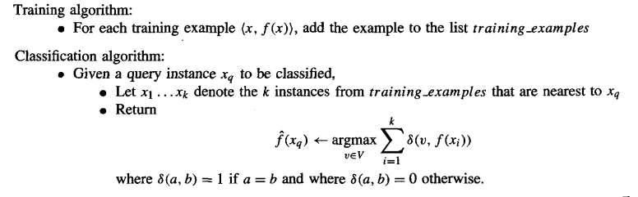
Source code
from sklearn.datasets import load_iris
from sklearn.model_selection import train_test_split
#from sklearn.naive_bayes import GaussianNB
from sklearn.neighbors import KNeighborsClassifier
X, y = load_iris(return_X_y=True)
X_train, X_test, y_train, y_test = train_test_split(X, y, test_size=0.5, random_state=0)
gnb = KNeighborsClassifier(n_neighbors=3)
y_pred = gnb.fit(X_train, y_train).predict(X_test)
print("Average AccurCy=",gnb.score(X_test,y_test))
print("Number of mislabeled points out of a total %d points : %d" % (X_test.shape[0], (y_test != y_pred).sum()))
Input
Data set, iris.csv, which reflects a classification task to identify the type of Iris plant ( Setosa, Versicolour, Virginica ) based on the concepts
1. sepal length in cm
2. sepal width in cm
3. petal length in cm
4. petal width in cm
Output
Average AccurCy= 0.9333333333333333
Number of mislabeled points out of a total 75 points : 5

Viva questions
1) Difference between lazy learning and eager learning
2) What k represents in KNN algorithm.
3) What is the impact on KNN performance when k value increases and decreases.
4) How a query point class label is predicted using KNN.
5) Which supervised learning paradigm the KNN belongs.

Web Resources
1) https://scikit-learn.org/stable/modules/neighbors.html
2) https://scikit-learn.org/stable/modules/generated/sklearn.neighbors.KNeighborsClassifier.html

Datasets for the applicability to solve similar problems

1) https://medium.com/towards-artificial-intelligence/best-datasets-for-machine-learning-data-science-computer-vision-nlp-ai-c9541058cf4f
2) https://archive.ics.uci.edu/ml/index.php
3) https://www.kaggle.com/

9) Implement the non-parametric Locally Weighted Regression algorithm
a. Read the Bike sharing data from a .CSV file.
b. Output Root Mean Square Error.
C. Output Appropriate Graphs
Objectives
Enable the students:
- To understand the Regression and Locally weighted regression algorithm.
- To analyze how to learn from continues targets.
- To Develop a classification model by fitting using Naive Bayes algorithm on a given training set.
- To evaluate the model using test set.

Description:

The a.csv can be any dataset that that reflects regression problem. Regression task predict the future over a learned model. The given data is divided in to training and test set folds . Here, a model is learned by fitting over train data. The performance of the learned model is measured on test data. For regression task the data format is like ( set of concepts, Target) i.e each instance is associated with group information (class label). Here The Target is a continues variable.
Source code
import matplotlib.pyplot as plt
import pandas as pd
import numpy as np
from math import ceil
from scipy import linalg
from IPython.display import Image
from IPython.display import display
plt.style.use('seaborn-white')
%matplotlib inline
from math import ceil
import numpy as np
from scipy import linalg

#Defining the bell shaped kernel function - used for plotting later on
def kernel_function(xi,x0,tau= .005):
return np.exp( - (xi - x0)**2/(2*tau) )

def lowess_bell_shape_kern(x, y, tau = .005):
"""lowess_bell_shape_kern(x, y, tau = .005) -> yest
Locally weighted regression: fits a nonparametric regression curve to a scatterplot.
The arrays x and y contain an equal number of elements; each pair
(x[i], y[i]) defines a data point in the scatterplot. The function returns
the estimated (smooth) values of y.
The kernel function is the bell shaped function with parameter tau. Larger tau will result in a
smoother curve.
"""
m = len(x)
yest = np.zeros(n)

#Initializing all weights from the bell shape kernel function
w = np.array([np.exp(- (x - x[i])**2/(2*tau)) for i in range(m)])

#Looping through all x-points
for i in range(n):
weights = w[:, i]
b = np.array([np.sum(weights * y), np.sum(weights * y * x)])
A = np.array([[np.sum(weights), np.sum(weights * x)],
[np.sum(weights * x), np.sum(weights * x * x)]])
theta = linalg.solve(A, b)
yest[i] = theta[0] + theta[1] * x[i]

return yest

from math import ceil
import numpy as np
from scipy import linalg

def lowess_ag(x, y, f=2. / 3., iter=3):
"""lowess(x, y, f=2./3., iter=3) -> yest
Lowess smoother: Robust locally weighted regression.
The lowess function fits a nonparametric regression curve to a scatterplot.
The arrays x and y contain an equal number of elements; each pair
(x[i], y[i]) defines a data point in the scatterplot. The function returns
the estimated (smooth) values of y.
The smoothing span is given by f. A larger value for f will result in a
smoother curve. The number of robustifying iterations is given by iter. The
function will run faster with a smaller number of iterations.
"""
n = len(x)
r = int(ceil(f * n))
h = [np.sort(np.abs(x - x[i]))[r] for i in range(n)]
w = np.clip(np.abs((x[:, None] - x[None, :]) / h), 0.0, 1.0)
w = (1 - w ** 3) ** 3
yest = np.zeros(n)
delta = np.ones(n)
for iteration in range(iter):
for i in range(n):
weights = delta * w[:, i]
b = np.array([np.sum(weights * y), np.sum(weights * y * x)])
A = np.array([[np.sum(weights), np.sum(weights * x)],
[np.sum(weights * x), np.sum(weights * x * x)]])
beta = linalg.solve(A, b)
yest[i] = beta[0] + beta[1] * x[i]

residuals = y - yest
s = np.median(np.abs(residuals))
delta = np.clip(residuals / (6.0 * s), -1, 1)
delta = (1 - delta ** 2) ** 2

return yest

#Initializing noisy non linear data
x = np.linspace(0,1,100)
noise = np.random.normal(loc = 0, scale = .25, size = 100)
y = np.sin(x * 1.5 * np.pi )
y_noise = y + noise
#pred=kernel_function(x[:40],0.2,.005)
#error=y_noise[:40]-pred
#Plotting the noisy data and the kernell at around x = 0.2
plt.figure(figsize=(10,6))
plt.plot(x,y,color = 'darkblue', label = 'f(x)')
plt.scatter(x,y_noise, facecolors = 'none', edgecolor = 'darkblue', label = 'f(x) + noise')
plt.fill(x[:40],kernel_function(x[:40],0.2,.005), color = 'lime', alpha = .5, label = 'Kernel')
plt.legend()
plt.title('Noisy sine function and bell shaped kernell at x=.2')
plt.show()
#print(sum(np.sqrt(pow(error,2))))

# Locally weighted regression for Sin data
f = 0.25
yest = lowess_ag(x, y, f=f, iter=3)
yest_bell = lowess_bell_shape_kern(x,y)
plt.figure(figsize=(10,6))
plt.plot(x,y,color = 'darkblue', label = 'f(x)')
#plt.scatter(x,y_noise, facecolors = 'none', edgecolor = 'darkblue', label = 'f(x) + noise')
plt.plot(x,yest, color = 'lime', alpha = .5, label = 'Span Bell Kernel')
plt.plot(x,yest_bell, color = 'red', alpha = .5, label = 'Bell Kernel')
plt.legend()
plt.title('sine function and bell shaped kernell at x=.2')
plt.show()
print('error from span bell kernel=',sum(np.sqrt(pow((y-yest),2)))/len(x))
print('error from bell kernel=', sum(np.sqrt(pow((y-yest_bell),2)))/len(x))

# Locally weighted regression for noisy Sin data

f = 0.25
yest = lowess_ag(x, y_noise, f=f, iter=3)
yest_bell = lowess_bell_shape_kern(x,y_noise)
plt.figure(figsize=(10,6))
plt.scatter(x,y_noise, facecolors = 'none', edgecolor = 'darkblue', label = 'f(x) + noise')
plt.scatter(x,yest, color = 'lime', alpha = .5, label = 'Span Bell Kernel')
plt.scatter(x,yest_bell, color = 'red', alpha = .5, label = 'Bell Kernel')
plt.legend()
plt.title('Noisy sine function and bell shaped kernell at x=.2')
plt.show()
print('error from span bell kernel=',sum(np.sqrt(pow((y-yest),2)))/len(x))
print('error from bell kernel=', sum(np.sqrt(pow((y-yest_bell),2)))/len(x))

Input
Synthetic data generated in the form of sine wave, any other regression data can be considered.
Output
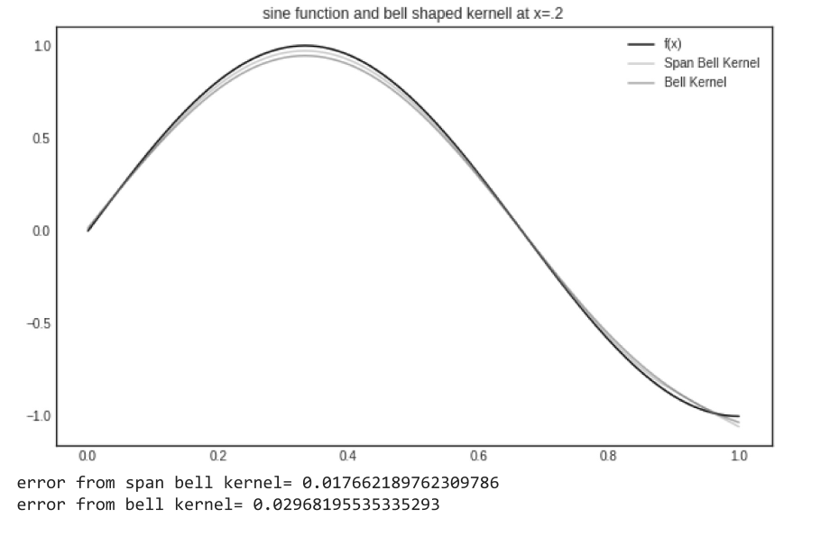
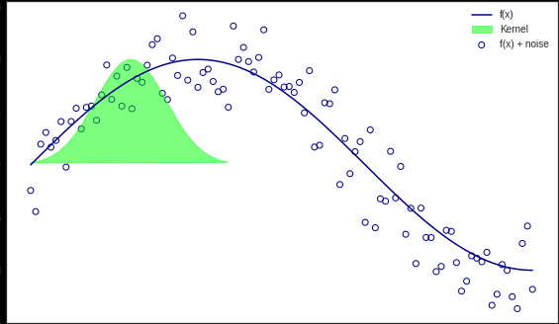

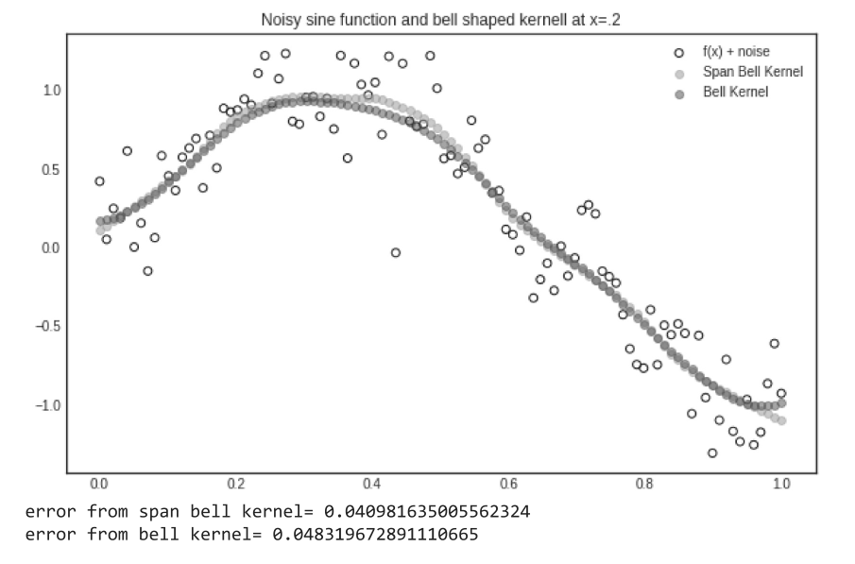
Viva questions
1) Give linear regression.
2) Give the error equation for regression.
3) Give Locally weighted linear regression.
4) Give Locally weighted regression with kernel.
5) What is the difference between linear regression and locally weighted linear regression.

Web Resource
1) https://www.geeksforgeeks.org/implementation-of-locally-weighted-linear-regression/
2) https://xavierbourretsicotte.github.io/loess.html

Datasets for the applicability to solve similar problems

1) https://medium.com/towards-artificial-intelligence/best-datasets-for-machine-learning-data-science-computer-vision-nlp-ai-c9541058cf4f
2) https://archive.ics.uci.edu/ml/index.php
3) https://www.kaggle.com/

10) Let y= w1.x1+w2.x2+w3.x3+w4.x4+w5.x5+w6.x6, where (x1, x2, x3, x4, x5, x6) = (4, -2, 3.5, 5, -11, -4.7).
a. maximize this equation by using the genetic algorithm for the best possible values after a number of generations
Objectives
Enable the students:
- To understand optimization problems and genetic algorithm.
- To analyze how to maximize an equation given inputs.
- To Develop a python code for optimizing optimize an equation using genetic algorithm.
- To evaluate the output for maximum values.

Description:

The genetic algorithm is for finding the best solution in the solution space, which usually referred as optimization problems. Here a the problem is to identify the coefficients that maximizes the linear equation given input values. The ga module in the pygad package is used to solve the system of equations. Usually the GA performed over three operators and fitness function. The operators are selection, mutation and crossover. The selection operator selects the best offspring, the by cross over operator new offspring is generated. The mutation operator mutates particular quality in offspring. The fitness of the new generation is measured with fitness function.

Procedure
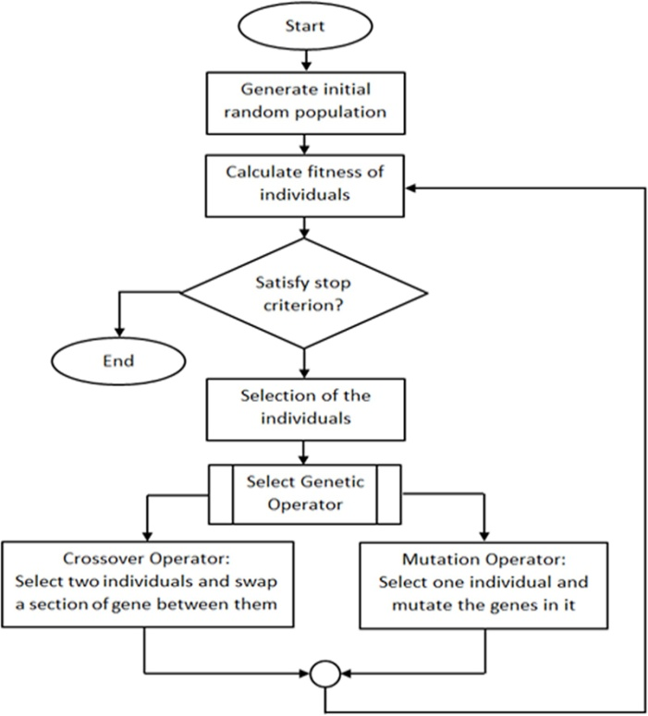

Source Code
pip install pygad

import numpy

def cal_pop_fitness(equation_inputs, pop):
# Calculating the fitness value of each solution in the current population.
# The fitness function calulates the sum of products between each input and its corresponding weight.
fitness = numpy.sum(pop*equation_inputs, axis=1)
return fitness

def select_mating_pool(pop, fitness, num_parents):
# Selecting the best individuals in the current generation as parents for producing the offspring of the next generation.
parents = numpy.empty((num_parents, pop.shape[1]))
for parent_num in range(num_parents):
max_fitness_idx = numpy.where(fitness == numpy.max(fitness))
max_fitness_idx = max_fitness_idx[0][0]
parents[parent_num, :] = pop[max_fitness_idx, :]
fitness[max_fitness_idx] = -99999999999
return parents

def crossover(parents, offspring_size):
offspring = numpy.empty(offspring_size)
# The point at which crossover takes place between two parents. Usually, it is at the center.
crossover_point = numpy.uint8(offspring_size[1]/2)

for k in range(offspring_size[0]):
# Index of the first parent to mate.
parent1_idx = k%parents.shape[0]
# Index of the second parent to mate.
parent2_idx = (k+1)%parents.shape[0]
# The new offspring will have its first half of its genes taken from the first parent.
offspring[k, 0:crossover_point] = parents[parent1_idx, 0:crossover_point]
# The new offspring will have its second half of its genes taken from the second parent.
offspring[k, crossover_point:] = parents[parent2_idx, crossover_point:]
return offspring

def mutation(offspring_crossover, num_mutations):
mutations_counter = numpy.uint8(offspring_crossover.shape[1] / num_mutations)
# Mutation changes a number of genes as defined by the num_mutations argument. The changes are random.
for idx in range(offspring_crossover.shape[0]):
gene_idx = mutations_counter - 1
for mutation_num in range(num_mutations):
# The random value to be added to the gene.
random_value = numpy.random.uniform(-1.0, 1.0, 1)
offspring_crossover[idx, gene_idx] = offspring_crossover[idx, gene_idx] + random_value
gene_idx = gene_idx + mutations_counter
return offspring_crossover

import numpy

"""
The y=target is to maximize this equation ASAP:
y = w1x1+w2x2+w3x3+w4x4+w5x5+6wx6
where (x1,x2,x3,x4,x5,x6)=(4,-2,3.5,5,-11,-4.7)
What are the best values for the 6 weights w1 to w6?
We are going to use the genetic algorithm for the best possible values after a number of generations.
"""

# Inputs of the equation.
equation_inputs = [4,-2,3.5,5,-11,-4.7]

# Number of the weights we are looking to optimize.
num_weights = len(equation_inputs)

"""
Genetic algorithm parameters:
Mating pool size
Population size
"""
sol_per_pop = 8
num_parents_mating = 4

# Defining the population size.
pop_size = (sol_per_pop,num_weights) # The population will have sol_per_pop chromosome where each chromosome has num_weights genes.
#Creating the initial population.
new_population = numpy.random.uniform(low=-4.0, high=4.0, size=pop_size)
print(new_population)

"""
new_population[0, :] = [2.4, 0.7, 8, -2, 5, 1.1]
new_population[1, :] = [-0.4, 2.7, 5, -1, 7, 0.1]
new_population[2, :] = [-1, 2, 2, -3, 2, 0.9]
new_population[3, :] = [4, 7, 12, 6.1, 1.4, -4]
new_population[4, :] = [3.1, 4, 0, 2.4, 4.8, 0]
new_population[5, :] = [-2, 3, -7, 6, 3, 3]
"""

best_outputs = []
num_generations = 1000
for generation in range(num_generations):
print("Generation : ", generation)
# Measuring the fitness of each chromosome in the population.
fitness = cal_pop_fitness(equation_inputs, new_population)
print("Fitness")
print(fitness)

best_outputs.append(numpy.max(numpy.sum(new_population*equation_inputs, axis=1)))
# The best result in the current iteration.
print("Best result : ", numpy.max(numpy.sum(new_population*equation_inputs, axis=1)))

# Selecting the best parents in the population for mating.
parents = select_mating_pool(new_population, fitness,
num_parents_mating)
print("Parents")
print(parents)

# Generating next generation using crossover.
offspring_crossover = crossover(parents,
offspring_size=(pop_size[0]-parents.shape[0], num_weights))
print("Crossover")
print(offspring_crossover)

# Adding some variations to the offspring using mutation.
offspring_mutation = mutation(offspring_crossover, num_mutations=2)
print("Mutation")
print(offspring_mutation)

# Creating the new population based on the parents and offspring.
new_population[0:parents.shape[0], :] = parents
new_population[parents.shape[0]:, :] = offspring_mutation

# Getting the best solution after iterating finishing all generations.
#At first, the fitness is calculated for each solution in the final generation.
fitness = cal_pop_fitness(equation_inputs, new_population)
# Then return the index of that solution corresponding to the best fitness.
best_match_idx = numpy.where(fitness == numpy.max(fitness))

print("Best solution : ", new_population[best_match_idx, :])
print("Best solution fitness : ", fitness[best_match_idx])

import matplotlib.pyplot
matplotlib.pyplot.plot(best_outputs)
matplotlib.pyplot.xlabel("Iteration")
matplotlib.pyplot.ylabel("Fitness")
matplotlib.pyplot.show()

Input
[4,-2,3.5,5,-11,-4.7]

Output
Best solution : [[[ -2.89912426 0.83788553 292.78011684 0.63803992 -3.46769682 -340.57104864]]]
Best solution fitness : [2653.47693409]
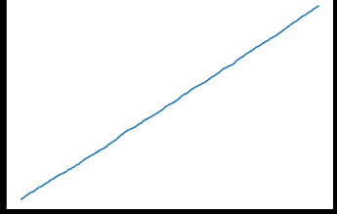
Fitness
Iterations

Viva questions
1) Give the main functionality of GA.
2) What is the significance of genetic operators .
3) Give the significance of fitness function.
4) Define maximization problem.
5) Define minimization problem.

Web Resources
1) https://towardsdatascience.com/genetic-algorithm-implementation-in-python-5ab67bb124a6
2) https://www.geeksforgeeks.org/traveling-salesman-problem-using-genetic-algorit

