**System Requirements**

* x86 Linux-based Operating System with X11 (Ubuntu, Fedora, etc)
* SFML 2.0RC runtimes
* LAN/Internet connection

**Source Code Build Instructions**

Ensure you have an active Internet connection before executing the bootstrap.

1. Download the latest source code from the Git repository <https://github.com/rbellido/Project/archive/master.zip>
2. Extract the zip file
3. Change directories into the newly extracted folder
4. Execute *./bootstrap*
5. Change directories into the /redesigned/ folder
6. Execute *make*

**How to run the Game Server**

To play, clients must join a game server. Once the server is started, other players on your LAN or on the Internet can join your game. Ensure that you know your IP address and port (default: 4545) so that client players can join your server!

1. Execute *./run-server*

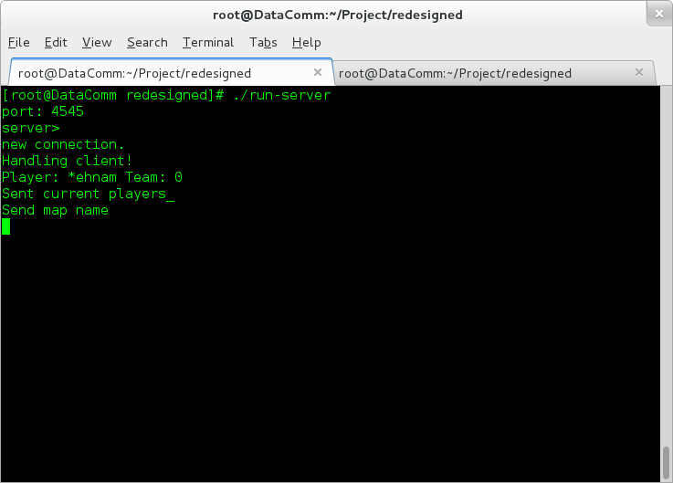

**How to run the Game Client**

To join the server, get the IP address and port (default: 4545) of the server then follow the instructions below.

|  |  |
| --- | --- |
| 1) Execute *./run-client* |  |
| 2) Once you start the game client, you should be able to see a game menu. Right now, there are three buttons:   * Test Game - A quick action button that will bring you to the game immediately. This is essentially a testing/practice mode to get the hang of the game before starting. * Join Game - Wait for other clients to join the game before starting. * Quit - Exit the game. |  |
| 3) Once you join the game, a form will pop up, prompting you to enter the following:   * User Name: A unique user name that will identify you in-game. Other clients will see this user name. * Server: The IP Address of the server to connect to. * Port: The port number of the server to connect to. (Default is 4545)   Click “join” to continue. |  |
| 4) Afterwards, you’re user name will be listed in the unassigned players list. Select an “Empty” slot in either Team One or Team Two and start the game.  You can exit the lobby to return to the main game menu. |  |
| 5) Once you start the game after selecting a team, you’ll be brought to this game interface where you can compete to win. |  |

**How to Play**

The objective of the game is to destroy the opposing team’s base, located in the opposite corner of the screen from your own base. Your base and the enemy base are connected by three lanes. Your team will have a constant flow of neutral attacking units called “creeps” that will make their way, on each of the three lanes, to enemy tower in order to destroy it. As you destroy enemy creeps, you will gain gold that can be used to purchase more powerful creeps for attacking or defensive “towers” to guard against the enemy creeps. In addition, you control a player-controlled creep called a “commander” to take part of the action as well.



**Commander:**

The commander is controlled with a WASD-scheme (W key moves up, D key moves right, etc).



**Shop:**

To buy towers or special creeps, select a lane with the “lane selector”, ensure you have enough gold for the item then click on the creep or tower icon to purchase.



**Item Costs:**

Special creeps - 10 gold

Tower - 100 gold

**Game Interface**

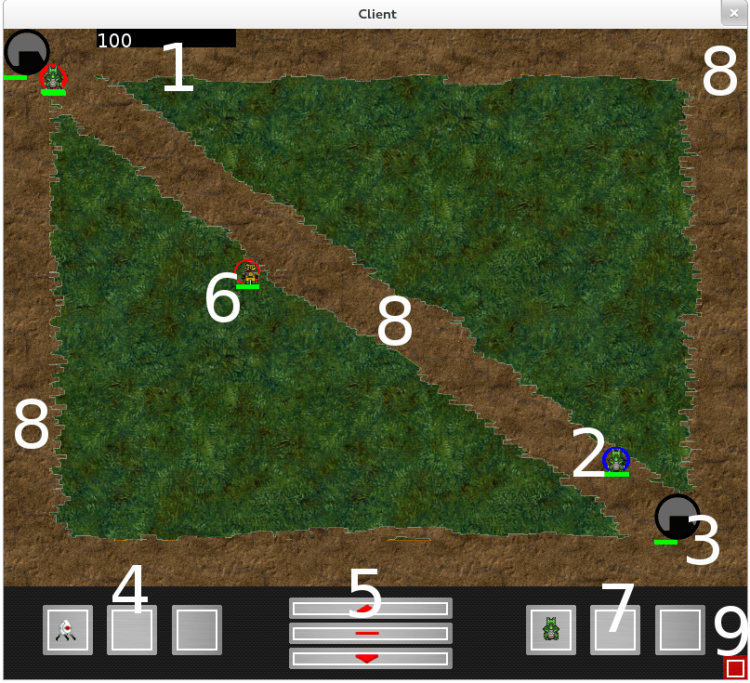

1. your team’s current gold
2. neutral creep
3. base
4. purchasable towers
5. lane selector (select top, mid, or bottom lane)
6. player-controlled commander
7. purchasable special creeps
8. lanes (top, mid, bottom)
9. surrender