Valencia College

Panino Perfetto Design Document

Danny Ken, Hammad Uddin, and Advier Ortiz

Web Site Development COP 2822C

Professor David Stendel

11/9/2023

Panino Perfetto Design Document

# **Goals and Purpose**

This project's primary goal is to create a visually appealing and user-friendly website for Panino Perfetto that effectively showcases the restaurant's offerings. The emphasis is on providing a seamless navigation experience that highlights Panino Perfetto's authentic Italian dining experience. Another important goal is to ensure that the website is cross-browser compatible and responsive, making it accessible and functional across various devices and web browsers. This strategy aims to provide Panino Perfetto with an engaging and convenient online presence that reflects the quality and authenticity of its culinary offerings.

# **Audience**

Families, couples, and food enthusiasts looking for authentic Italian cuisine experiences.

# **Design Requirements**

* **Simplicity**: The design will be clean and uncluttered, with an emphasis on usability and content.
* **Images**: The restaurant's dishes will be prominently featured in high-quality images.
* **Color Scheme**: Warm and welcoming colors with Italian themes, primarily beige, black, and white will be used on the website.
* **Fonts**: Elegant, easy-to-read fonts like Forum and DM Sans will be used on the website to complement the sophistication of Italian cuisine.
* **Responsiveness**: The design will adapt seamlessly to different screen sizes, ensuring a consistent user experience across all devices.

# **Delivery Requirements**

The website should display as required on the following browsers.

* Google Chrome
* Microsoft Edge
* Mozilla Firefox
* Safari

# **Content**

## **Home Page**

* **Hero Section**: A warm banner with a high-quality image of a signature dish and an enticing tagline.
* **About Section**: A brief overview of Panino Perfetto, its history, and its ethos.
* **Menu Teaser**: A sneak peek at popular dishes with the option to view the entire menu.
* Contact Information: A link to the Contact Us page and quick access to contact information.

## **Our Menu Page**

* **Menu Categories**: Clear categorization (e.g., Appetizers, Main Courses, Desserts).
* **Dishes Display**: Images and descriptions of each dish.
* **Specials Highlight**: Featured section for specials or seasonal offerings.

## **About Us Page**

* **Our Story**: A detailed account of Panino Perfetto's beginnings and growth.
* **Chef Highlights**: Profiles of key chefs with descriptions of their specialties.
* **Philosophy**: Emphasis is placed on the restaurant's dedication to authenticity.

## **Contact Us Page**

* **Contact Form**: A simple form for inquiries or reservations.
* **Location Map**: Integration of Google Maps for easy location tracking.
* **Additional Information**: Opening hours, phone number, email address, and social media links.

### **Flowchart**

Panino Perfetto

Home

Home

Menu

About Us

Contact

Hero Section

Appetizers

History

Location

Special Dish

Dinner

Chefs

Phone Number

Features

Philosophy

Email

Panino Perfetto Storyboard

# **Home Page**

## **Background Color**

* Different iterations of black will be used for the background.
  + hsla(210, 4%, 9%, 1)
  + hsla(30, 8%, 5%, 1)

## **Font Color**

* The font colors will mainly inherit the parent’s color, which is generally white.
  + hsla(0, 0%, 100%, 1)

## **Link Color**

* The navbar static color will be white.
  + hsla(0, 0%, 100%, 1)
* The top bar on hover effect will be beige.
  + hsl(51.76, 66.23%, 84.9%)
* Underline color links will be beige.
  + hsl(51.76, 66.23%, 84.9%)
* Subtitles and some links will be either beige or grey.
  + hsl(51.76, 66.23%, 84.9%)
  + hsla(0, 0%, 65%, 1)
* Headings, titles, and labels will be white.
  + hsla(0, 0%, 100%, 1)

## **Text Navigation Links**

|  |  |
| --- | --- |
| **Text Label:** | **Links To:** |
| Home | Index.html |
| Menu | Menu.html |
| About Us | About.html |
| Contact | Contact.html |

## **Accessibility**

Our homepage's HTML code will demonstrate a strong commitment to accessibility. It will use semantic HTML elements such as header, footer, nav, main, section, and article to help organize content in a way that screen readers can easily navigate. Alt attributes, which are important for visually impaired users, will be thoughtfully applied to images, with decorative images using empty alt attributes (alt="") appropriately. The presence of a tags and button elements on the website indicates that it will support keyboard navigation, catering to users who prefer keyboard input over mouse input. The use of ARIA labels and roles will improve accessibility even more by providing additional context for assistive technologies. The website will be adaptable across various devices thanks to the responsive design. The links and buttons on the site will also be well-defined and interactive, improving overall usability and accessibility.

## **Images**

All our photos will be from pexels.com, a website that provides a large collection of high-quality, completely free stock photos and videos shared by talented creators. These resources are available under the Pexels license, which allows for unrestricted use. As a result, Pexels is a popular choice for designers, bloggers, and anyone else looking for visually appealing imagery for a variety of projects.

The homepage will have the following images:

* Hero-slider-1.jpg
* Hero-slider-2.jpg
* Hero-slider-3.jpg
* Breakfast.jpg
* Appetizers.jpg
* Drinks.jpg
* About-abs-image.jpg
* About-banner.jpg
* Special-dish-banner.jpg
* Dish-1.jpg
* Dish-2.jpg
* Dish-3.jpg
* Dish-4.jpg
* Dish-5.jpg
* Dish-6.jpg
* Footer-bg.jpg
* Logo.svg

## **Text Style Definitions**

### **Font Family**

* “Forum,” “DM Sans,” and sans-serif.

### **Heading**

* "Forum."

### **Paragraphs**

* "DM Sans" and sans-serif.

### **Terms**

* “DM Sans” and sans-serif.

### **Wireframe**

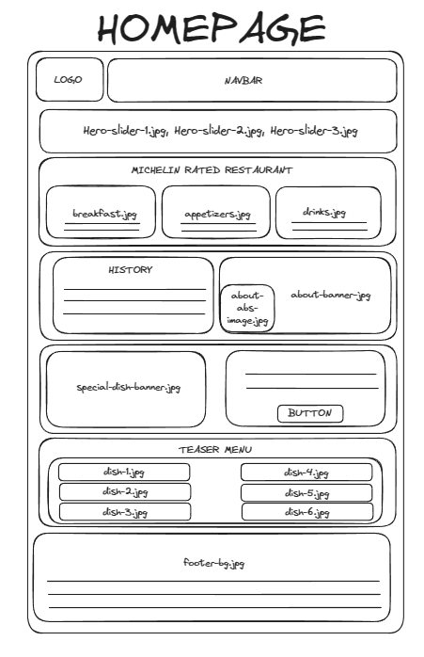

# **About Us Page**

## **Background Color**

* Different iterations of black will be used for the background.
  + hsla(210, 4%, 9%, 1)
  + hsla(30, 8%, 5%, 1)

## **Font Color**

* The font colors will mainly inherit the parent’s color, which is generally white.
  + hsla(0, 0%, 100%, 1)

## **Link Color**

* The navbar static color will be white.
  + hsla(0, 0%, 100%, 1)
* The top bar on hover effect will be beige.
  + hsl(51.76, 66.23%, 84.9%)
* Underline color links will be beige.
  + hsl(51.76, 66.23%, 84.9%)
* Subtitles and some links will be either beige or grey.
  + hsl(51.76, 66.23%, 84.9%)
  + hsla(0, 0%, 65%, 1)
* Headings, titles, and labels will be white.
  + hsla(0, 0%, 100%, 1)

## **Text Navigation Links**

|  |  |
| --- | --- |
| **Text Label:** | **Links To:** |
| Home | Index.html |
| Menu | Menu.html |
| About Us | About.html |
| Contact | Contact.html |

## **Images**

The about us page will have the following images:

* Chef-1.jpg
* Chef-2.jpg
* Chef-3.jpg
* Philosophy.jpg
* Footer-bg.jpg

## **Text Style Definitions**

### **Font Family**

* “Forum,” “DM Sans,” and sans-serif.

### **Heading**

* "Forum."

### **Paragraphs**

* "DM Sans" and sans-serif.

### **Terms**

* “DM Sans” and sans-serif.

### **Wireframe**

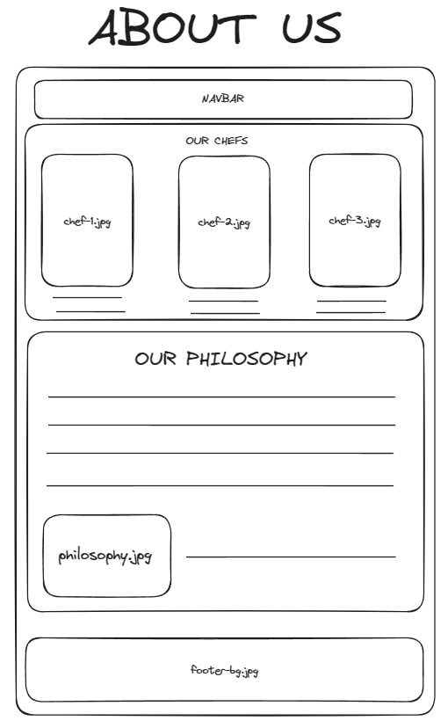

# **Menu Page**

## **Background Color**

* Different iterations of black will be used for the background.
  + hsla(210, 4%, 9%, 1)
  + hsla(30, 8%, 5%, 1)

## **Font Color**

* The font colors will mainly inherit the parent’s color, which is generally white.
  + hsla(0, 0%, 100%, 1)

## **Link Color**

* The navbar static color will be white.
  + hsla(0, 0%, 100%, 1)
* The top bar on hover effect will be beige.
  + hsl(51.76, 66.23%, 84.9%)
* Underline color links will be beige.
  + hsl(51.76, 66.23%, 84.9%)
* Subtitles and some links will be either beige or grey.
  + hsl(51.76, 66.23%, 84.9%)
  + hsla(0, 0%, 65%, 1)
* Headings, titles, and labels will be white.
  + hsla(0, 0%, 100%, 1)

## **Text Navigation Links**

|  |  |
| --- | --- |
| **Text Label:** | **Links To:** |
| Home | Index.html |
| Menu | Menu.html |
| About Us | About.html |
| Contact | Contact.html |

## **Images**

The about us page will have the following images:

* Dish-1.jpg
* Dish-2.jpg
* Dish-3.jpg
* Dish-4.jpg
* Dish-5.jpg
* Dish-6.jpg
* Appetizer-1.jpg
* Appetizer-2.jpg
* Appetizer-3.jpg
* Appetizer-4.jpg
* Appetizer-5.jpg
* Appetizer-6.jpg
* Alcohol-1.jpg
* Alcohol-2.jpg
* Alcohol-3.jpg
* Non-alcohol-1.jpg
* Non-alcohol-2.jpg
* Non-alcohol-3.jpg
* Dessert-1.jpg
* Dessert-2.jpg
* Dessert-3.jpg
* Dessert-4.jpg
* Dessert-5.jpg
* Dessert-6.jpg

## **Text Style Definitions**

### **Font Family**

* “Forum,” “DM Sans,” and sans-serif.

### **Heading**

* "Forum."

### **Paragraphs**

* "DM Sans" and sans-serif.

### **Terms**

* “DM Sans” and sans-serif.

### **Wireframe**

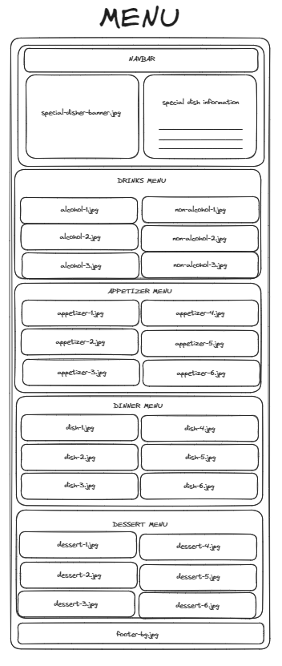

# **Contact Page**

## **Background Color**

* Different iterations of black will be used for the background.
  + hsla(210, 4%, 9%, 1)
  + hsla(30, 8%, 5%, 1)

## **Font Color**

* The font colors will mainly inherit the parent’s color, which is generally white.
  + hsla(0, 0%, 100%, 1)

## **Link Color**

* The navbar static color will be white.
  + hsla(0, 0%, 100%, 1)
* The top bar on hover effect will be beige.
  + hsl(51.76, 66.23%, 84.9%)
* Underline color links will be beige.
  + hsl(51.76, 66.23%, 84.9%)
* Subtitles and some links will be either beige or grey.
  + hsl(51.76, 66.23%, 84.9%)
  + hsla(0, 0%, 65%, 1)
* Headings, titles, and labels will be white.
  + hsla(0, 0%, 100%, 1)

## **Text Navigation Links**

|  |  |
| --- | --- |
| **Text Label:** | **Links To:** |
| Home | Index.html |
| Menu | Menu.html |
| About Us | About.html |
| Contact | Contact.html |

## **Google Maps iFrame**

A Google Maps iframe will be used to display a fictitious location in Orlando, Florida.

## **Contact Form**

A reservation form with input fields such as name, phone number, number of people, month/day/year, time, and an optional message will be created.

## **Images**

The about us page will have the following images:

* footer-bg.jpg

## **Text Style Definitions**

### **Font Family**

* “Forum,” “DM Sans,” and sans-serif.

### **Heading**

* "Forum."

### **Paragraphs**

* "DM Sans" and sans-serif.

### **Terms**

* “DM Sans” and sans-serif.

### **Wireframe**

