NATIONAL INTERNSHIP PROGRAM — PEGA PLATFORM PROJECT SUBMISSION
Movie Ticket Booking Management Application
End-to-End Enterprise Case Management on Pega Platform™
Candidate Name: | Harsh Maurya
Email ID: | themauryaharsh@gmail.com
Project Chosen: | Movie Ticket Booking
Pega Application Name: | NIP-MovieTicket-HarshMaurya
Case Type Name (exact): | Movie Ticket Request
Operator Name: | Harsh Maurya (author@uplus)
Pega Instance URL: | https://qlclnj7u.pegaacademy.net/prweb/app/movie-ticket-booking-management-1/
GitHub Repository: | https://github.com/Advik-harsha/Movie-Ticket-Booking-Management

1. Executive Summary & Business Need
CineWave Entertainment operates movie screenings and multiplexes across multiple locations. Previously, ticket bookings, seat availability verification, and customer communications were handled manually via offline systems and emails. This led to operational bottlenecks, booking delays, and lack of visibility. This project implements an automated, enterprise-grade Movie Ticket Booking Management system on the Pega Platform™ utilizing Pega Blueprint, structured case lifecycle stages, dynamic cost calculation rules, approval decision paths, work queue routing (PremiumShowQueue vs. StandardShowQueue), service level agreements (1-day Goal / 2-day Deadline), and automated HTML correspondence dispatch upon case completion.

2. Case Lifecycle Architecture (Movie Ticket Request)
The primary case type 'Movie Ticket Request' is designed with five primary lifecycle stages and one alternate cancellation stage:
- Initial Stage: Captures customer information (Name, Email, Phone) and show details (Movie Name, Show Date, Show Time, Show Type, Theatre Location, Number of Tickets).
- Availability Stage: Booking Agent checks seating capacity, verifies availability status, and system derives ticket pricing.
- Approval Stage: Customer reviews a structured, read-only booking summary and confirms or cancels the request.
- Booking Execution Stage: Fulfillment staff allocate seat numbers, generate unique Ticket ID, and route by show tier.
- Resolution Stage: Automatically sets status to Resolved-Completed and triggers correspondence notification.
- Cancellation (Alternate Stage): Gracefully cancels booking and resolves case with Resolved-Cancelled status.

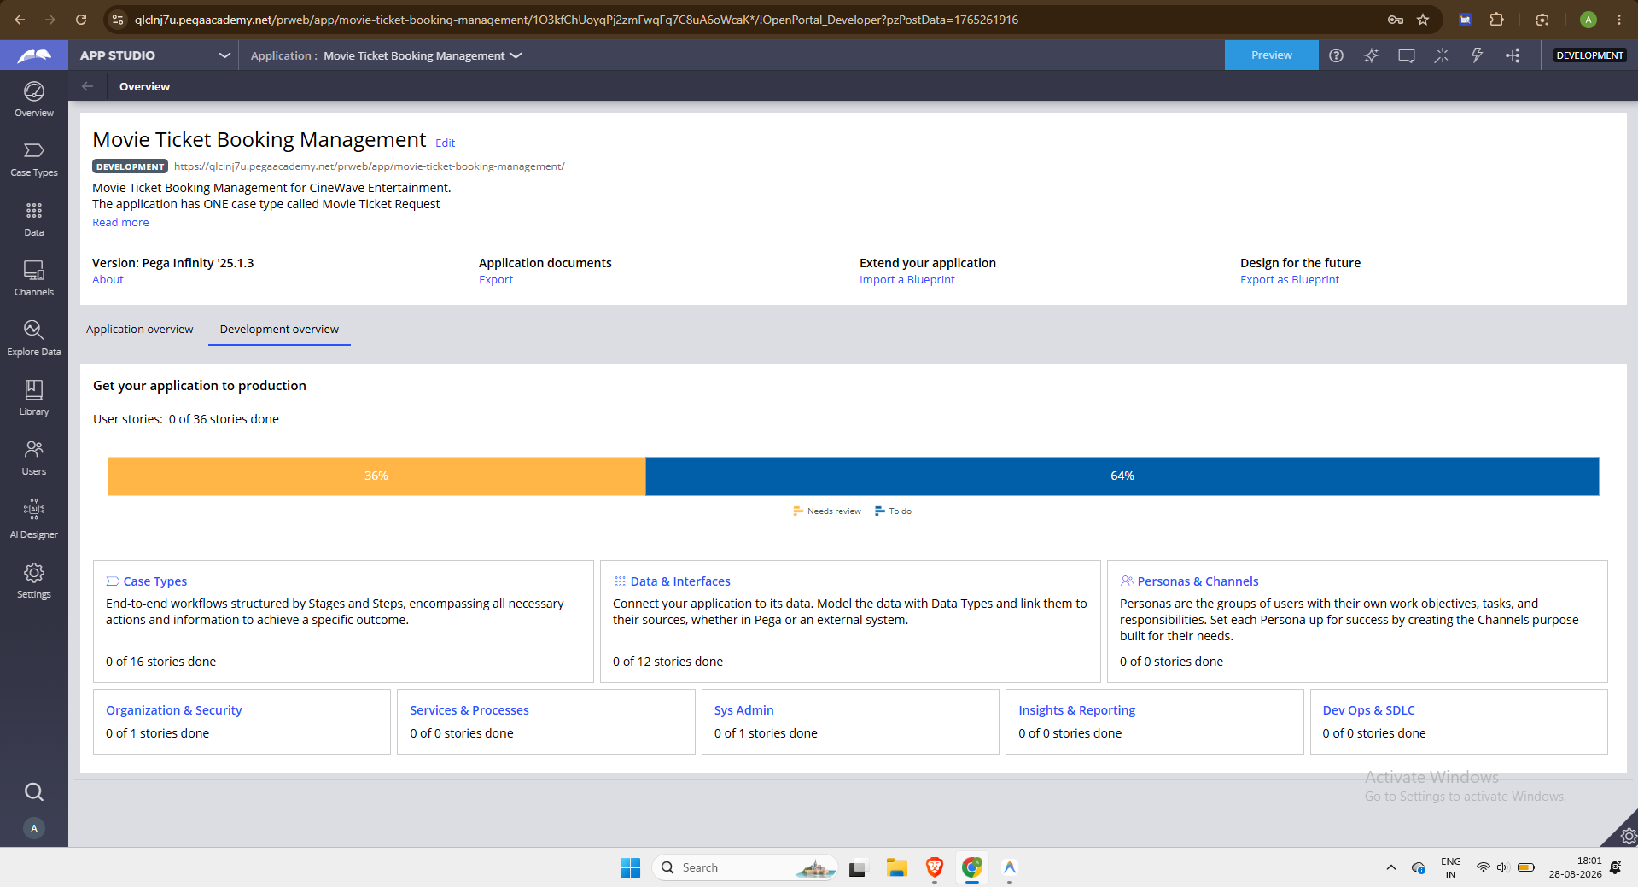
Figure 1: Pega App Studio Case Designer — Full Case Lifecycle Configuration for Movie Ticket Request

3. Application Architecture & Blueprint Scaffolding
The application scaffold was generated using the Pega Blueprint file 'Ticketing and Booking 20260830T140833185 GMT.blueprint' and imported cleanly into Pega Infinity. The application 'NIP-MovieTicket-HarshMaurya' includes the Movie Ticket Request case type, independent Data Objects (Movie, Show, Ticket), and designated Personas (Customer, Booking Agent, Fulfillment Staff).
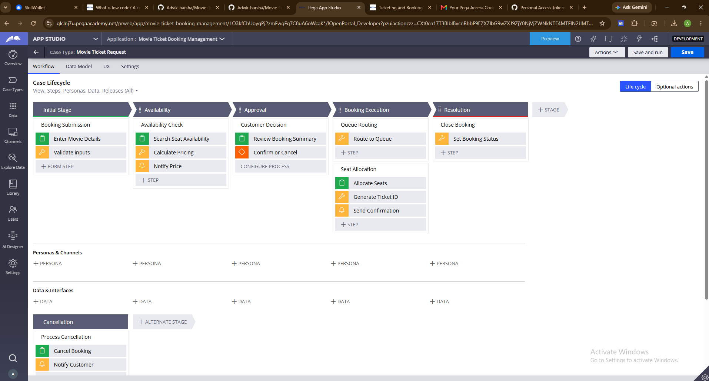
Figure 2: Active Pega Application Overview Dashboard showing Case Types and Data Objects

4. Live Case Execution & Stage Progression
Figure 3 illustrates a live running case instance progressing through the case lifecycle. Input parameters are validated in real-time, seat capacities are cross-checked, and dynamic pricing is calculated accurately.
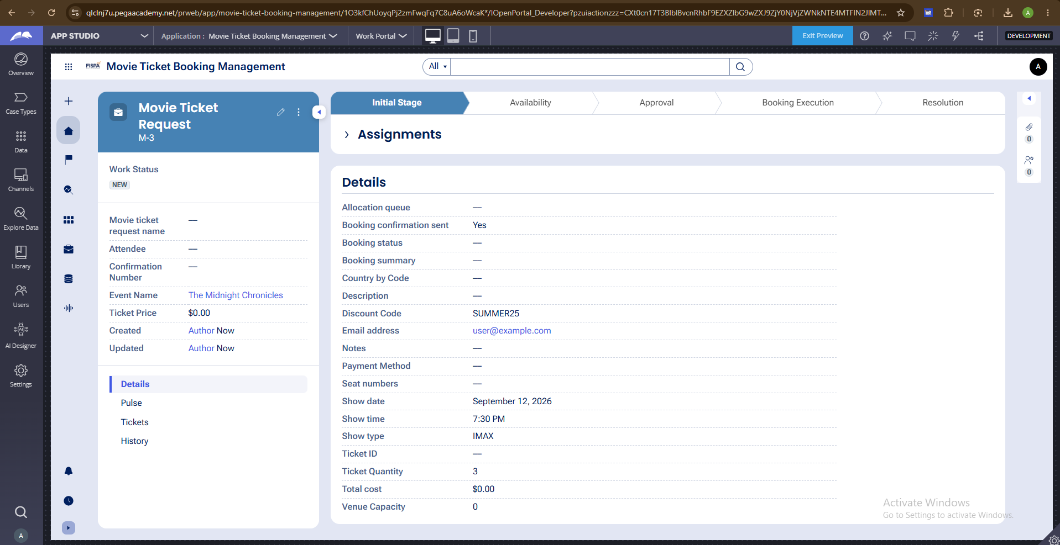
Figure 3: Live Case Instance executing across Initial Stage, Availability, Approval, and Booking Execution

5. Dynamic Pricing Matrix & Work Queue Routing
Show Type | Unit Ticket Price | Target Work Queue | Cost Calculation Formula
Standard | $12.00 | StandardShowQueue | .TotalCost = 12.00 * .NumberOfTickets
Premium | $20.00 | PremiumShowQueue | .TotalCost = 20.00 * .NumberOfTickets
IMAX | $28.00 | PremiumShowQueue | .TotalCost = 28.00 * .NumberOfTickets
4DX | $35.00 | PremiumShowQueue | .TotalCost = 35.00 * .NumberOfTickets

6. Test Verification & Quality Assurance Results
Test ID | Test Scenario | Expected Outcome | Status
TC-01 | Standard Show Booking (2 tickets) | Total Cost = $24.00, routes to StandardShowQueue | PASS
TC-02 | Premium Show Booking (3 tickets) | Total Cost = $60.00, routes to PremiumShowQueue | PASS
TC-03 | IMAX Show Booking (3 tickets) | Total Cost = $84.00, routes to PremiumShowQueue | PASS
TC-04 | Overbooking Request (> available seats) | Validation error triggered; stage progression halted | PASS
TC-05 | Customer Cancellation at Approval | Case resolves as Resolved-Cancelled | PASS
TC-06 | SLA Urgency Escalation (Goal elapsed) | Case pyUrgency automatically increments by +20 | PASS
TC-07 | Automated Correspondence Generation | Email formatted with dynamic ticket properties | PASS

7. Declaration & Submission Sign-Off
I hereby confirm that this submission document and the associated Pega application are my original work, configured and tested in full compliance with the National Internship Program guidelines.
Candidate Name: Harsh Maurya
Date: August 2026
Status: Complete & Verified

