SVKM’s NMIMS
School of Technology Management & Engineering, Chandigarh
A.Y. 2025 - 26
Course: Database Management Systems
Project Report
Program
Semester
Name of the Project:
Details of Project Members
Batch | Roll No. | Name
Date of Submission:

Contribution of each project Members:
Roll No. | Name: | Contribution

Github link of your project:
Note:
- Create a readme file if you have multiple files
- All files must be properly named (Example:R004_DBMSProject)
- Submit all relevant files of your work ( Report, all SQL files, Any other files)
- Plagiarism is highly discouraged (Your report will be checked for plagiarism)

Project Report

Selected Topic

by
Student 1, Roll number: xx
Student 2, Roll number: xx
Student 3, Roll number: xx

Course: DBMS

AY: 2024-25

Table of Contents

Sr no. | Topic | Page no.
1 | Storyline
2 | Components of Database Design
3 | Learning from the Project
4 | Project Demonstration
5 | Self-learning beyond classroom
6 | Learning from the project
7 | Challenges faced
8 | Conclusion

I. Storyline
The project focuses on analyzing fashion trends using a MongoDB-based NoSQL database. The system simulates real-world fashion data such as social media captions, hashtags, trends, and product information in a structured JSON format. The primary goal is to identify emerging fashion trends and analyze their popularity across regions and time.
The workflow begins with a pre-processed dataset, followed by organizing the data into multiple MongoDB collections. Queries and aggregation pipelines are then used to extract meaningful insights such as top trends, regional preferences, and popularity patterns.

System Architecture
The system follows a linear data pipeline from semi-structured data ingestion to trend analytics, focusing on MongoDB data storage, collection design, and aggregation-based analysis.

2.1 Architecture Flowchart
The following flowchart illustrates the complete data flow from raw input sources through to analytical output:

DATA SOURCES
Instagram Captions | Fashion Blogs | Hashtags | Product Descriptions
↓
Pre-processed DATA SOURCE
JSON DATASET | Sample social media data
↓
DATA PREPROCESSING
Keyword tagging /hashtag extraction / categorization
↓
MONGODB DATABASE
15 Collections: users / posts / trends / keywords / regions / trendAnalytics + 9 more
↓
TREND ANALYTICS
MongoDB Aggregation Pipelines | $group | $sort | $match | popularityScore computation
↓
QUERY OUTPUT / ANALYTICS RESULTS
Top Trends | Regional Rankings | Seasonal Reports | Keyword Frequency

II. Components of Database Design
FashionTrendDB contains 15 collections. Each collection is described below with its complete field schema, data types, and a sample document.

Collection 1: users
Stores registered users of the analytics platform along with their style preferences and regional affiliation.
Field | Type | Description
_id | ObjectId | Unique document identifier (auto-generated)
username | String | Unique display name of the user
email | String | User's email address (unique)
password | String | Bcrypt-hashed password
favoriteStyles | Array<String> | List of preferred fashion styles
region | String | User's geographic region (e.g., India, USA)
joinDate | Date | Date the user registered on the platform

Sample Document:
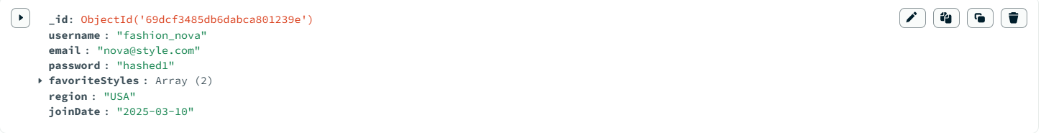

Collection 2: posts
Stores individual social media or blog posts containing fashion content. Hashtags and extracted keywords are embedded.
Field | Type | Description
_id | ObjectId | Unique post identifier
userId | String | Username reference to users collection
caption | String | Raw text caption of the post
hashtags | Array<String> | List of hashtags extracted from caption
region | String | Geographic region of the post
source | String | Platform source: Instagram, Blog, Twitter
postDate | Date | Date the post was published
extractedKeywords | Array<Object> | NLP-extracted fashion keywords with category

Sample Document:
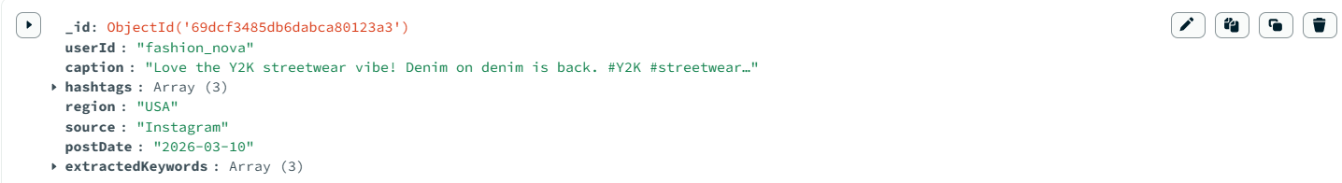

Collection 3: trends
Stores identified fashion trends with popularity metrics, season, and category classification.
Field | Type | Description
_id | ObjectId | Unique trend identifier
trendName | String | Name of the fashion trend (e.g., Y2K Streetwear)
category | String | Trend category: Style, Color, Fabric, Lifestyle
season | String | Applicable season: Spring, Summer, Winter, All
popularityScore | Number | Normalized score 0-100 based on mention frequency
mentions | Number | Total mention count across all posts
region | String | Primary region where trend dominates

Sample Document:
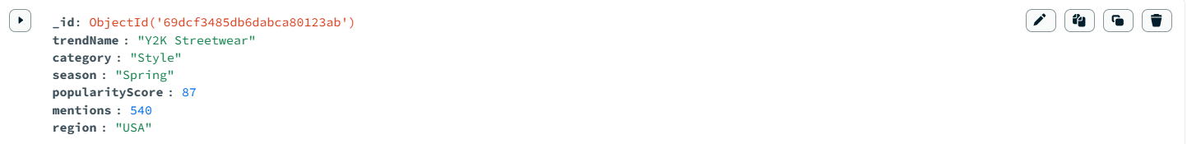

Collection 4: keywords
Stores individual fashion keywords extracted from posts, classified by category and linked to their parent trend.
Field | Type | Description
_id | ObjectId | Unique keyword document ID
keyword | String | Fashion keyword (e.g., denim, pastel, Y2K)
category | String | Category: Color, Fabric, Style, Season, Lifestyle
relatedTrend | String | Name of the trend this keyword belongs to

Sample Document:

Collection 5: regions
Caches regional trend summaries with embedded top trends to enable fast geographic lookups without re-aggregating posts.
Field | Type | Description
_id | ObjectId | Unique region document ID
regionName | String | Name of the geographic region (e.g., India, USA)
topTrends | Array<Object> | Embedded top trends with trendName and popularityScore

Sample Document:

Collection 6: trendAnalytics
Stores monthly time-series data for each trend, enabling month-over-month popularity tracking and growth analysis.
Field | Type | Description
_id | ObjectId | Unique analytics record ID
trendId | String | Reference identifier linking to the trends collection
trendName | String | Denormalized trend name for direct query access
month | String | Month name (e.g., January, February)
year | Number | Four-digit year of the analytics record
mentions | Number | Total mentions recorded in this month
popularityScore | Number | Computed popularity score for this time period

Sample Document:
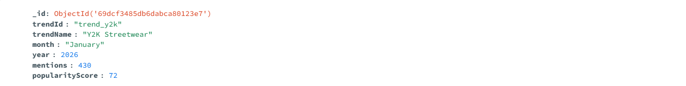

Collection 7: hashtags
Maintains a master hashtag frequency registry for fast hashtag lookup and trending tag discovery.
Field | Type | Description
_id | ObjectId | Unique hashtag document ID
tag | String | Hashtag value without the # symbol
usageCount | Number | Total times this tag has appeared across all posts
category | String | Auto-classified category of the hashtag

Sample Document:

Collection 8: trendKeywords
Junction collection that maps trends to their associated keywords with a relevance weight score.
Field | Type | Description
_id | ObjectId | Unique mapping document ID
trendName | String | Name of the parent trend
keyword | String | Associated keyword for this trend
weight | Number | Relevance weight 0.0 to 1.0 (1.0 = most relevant)

Sample Document:

Collection 9: influencers
Stores social media influencer profiles linked to regions and style preferences for influencer-trend correlation.
Field | Type | Description
_id | ObjectId | Unique influencer document ID
name | String | Influencer's public name
followers | Number | Total follower count on their primary platform
region | String | Influencer's geographic origin or base
preferredStyles | Array<String> | List of fashion styles they promote
platform | String | Primary social media platform

Sample Document:
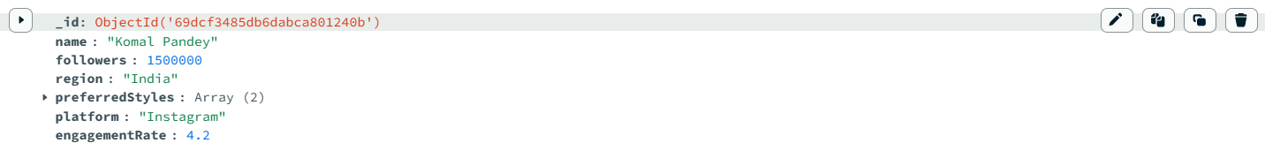

Collection 10: products
Stores fashion product listings linked to styles, fabrics, and regions for product-trend association queries.
Field | Type | Description
_id | ObjectId | Unique product document ID
productName | String | Name of the fashion product
style | String | Associated fashion style (e.g., Streetwear)
fabric | String | Primary fabric material (e.g., Denim, Silk)
color | String | Primary color of the product
price | Number | Retail price in USD
region | String | Primary selling region

Sample Document:
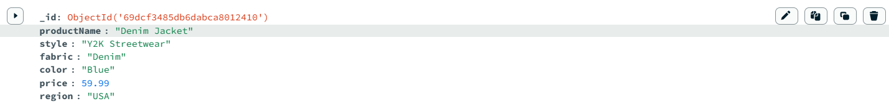

Collection 11: categories
Field | Type | Description
_id | ObjectId | Unique category document ID
categoryName | String | Category label: Style, Fabric, Color, Lifestyle, Season
description | String | Brief description of what keywords belong to this category
count | Number | Number of keywords currently assigned to this category

Sample Document:

Collection 12: sessions
Field | Type | Description
_id | ObjectId | Unique session document ID
userId | String | Username reference for the session owner
loginTime | Date | Timestamp of session creation
ipAddress | String | IP address of the user device
device | String | Device type: Mobile, Desktop, Tablet

Sample Document:
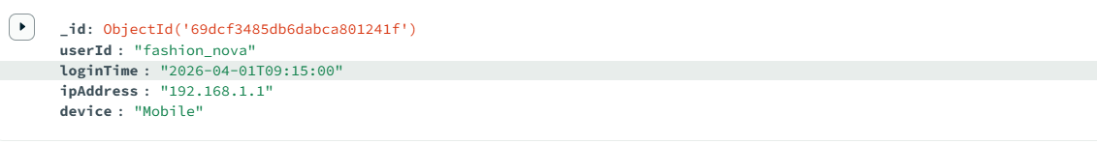

Collection 13: feedbacks
Field | Type | Description
_id | ObjectId | Unique feedback document ID
userId | String | Username of the reviewer
trendName | String | Name of the trend being reviewed
rating | Number | Star rating from 1 (lowest) to 5 (highest)
comment | String | Free-text feedback comment
date | Date | Date the feedback was submitted

Sample Document:
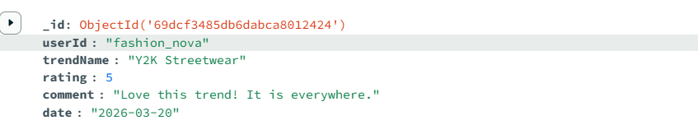

Collection 14: notifications
Field | Type | Description
_id | ObjectId | Unique notification document ID
userId | String | Username of the notification recipient
message | String | Notification text content
read | Boolean | Read status: false = unread, true = read
date | Date | Timestamp when the notification was generated

Sample Document:
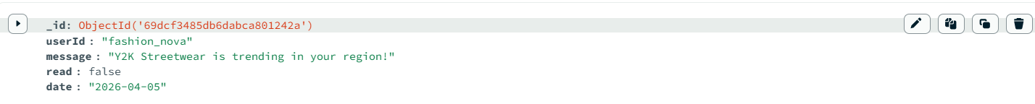

Collection 15: reports
Field | Type | Description
_id | ObjectId | Unique report document ID
reportTitle | String | Title of the generated trend report
generatedDate | Date | Date the report was produced
topTrends | Array<String> | List of top trend names featured in this report
regions | Array<String> | List of regions covered in the report

Sample Document:
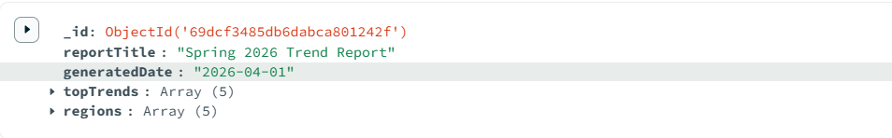

VI. MongoDB Queries

Query 1: Retrieve All Users
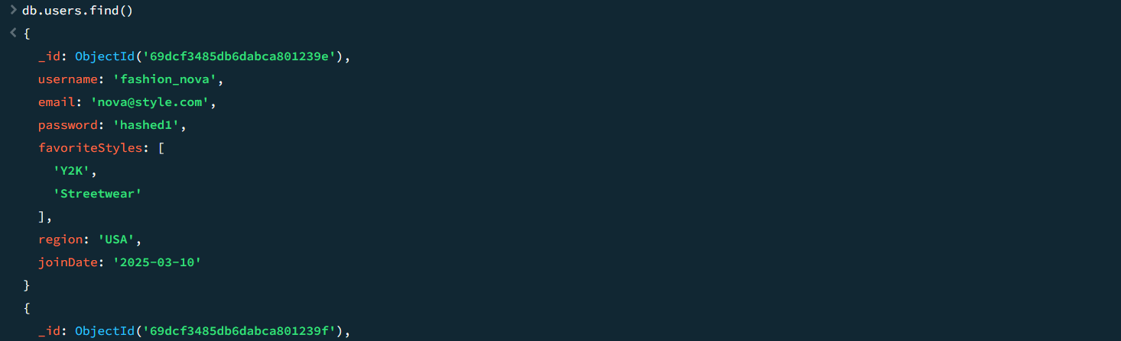

Query 2: Display Usernames and Emails
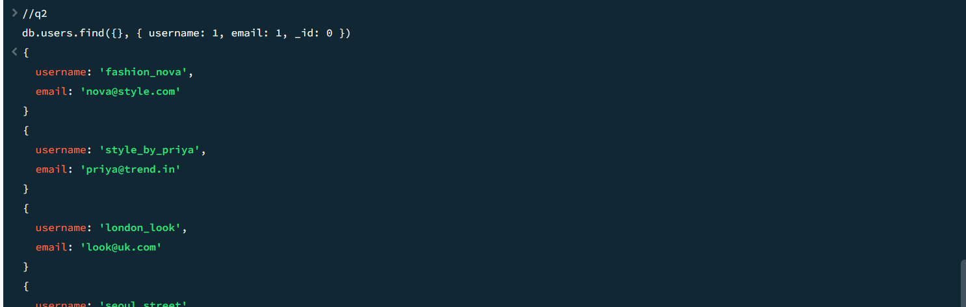

Query 3: Fetch All Posts
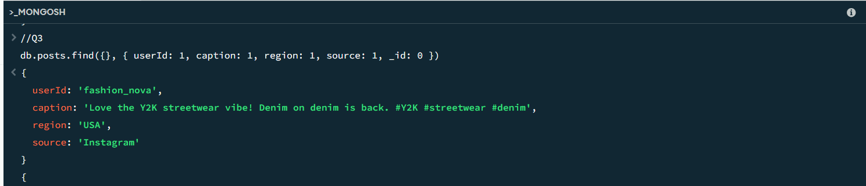

Query 4: Show All Hashtags Used in Posts

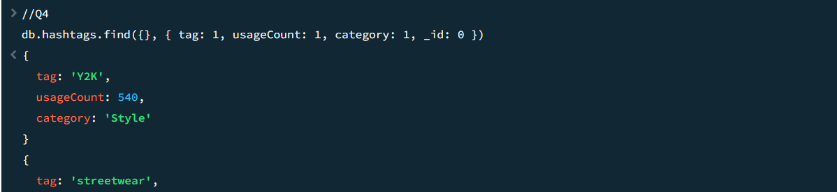Query 5: Retrieve All Trends with Popularity Score

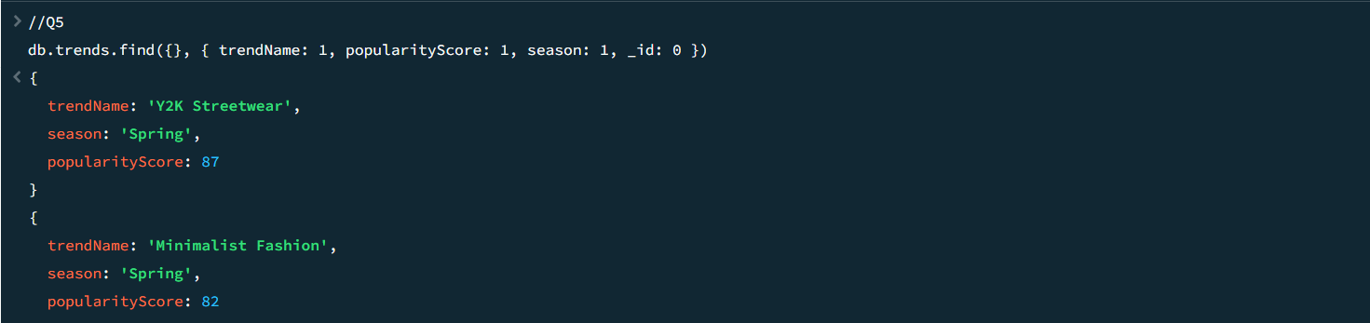

Query 6: Display All Keywords and Their Categories

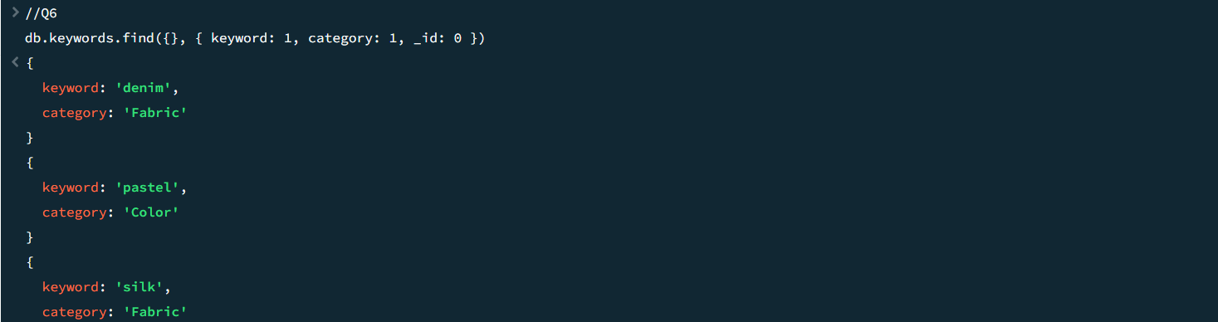

Query 7: Find All Regions
MongoDB Query:
db.regions.find({}, { regionName: 1, _id: 0 })
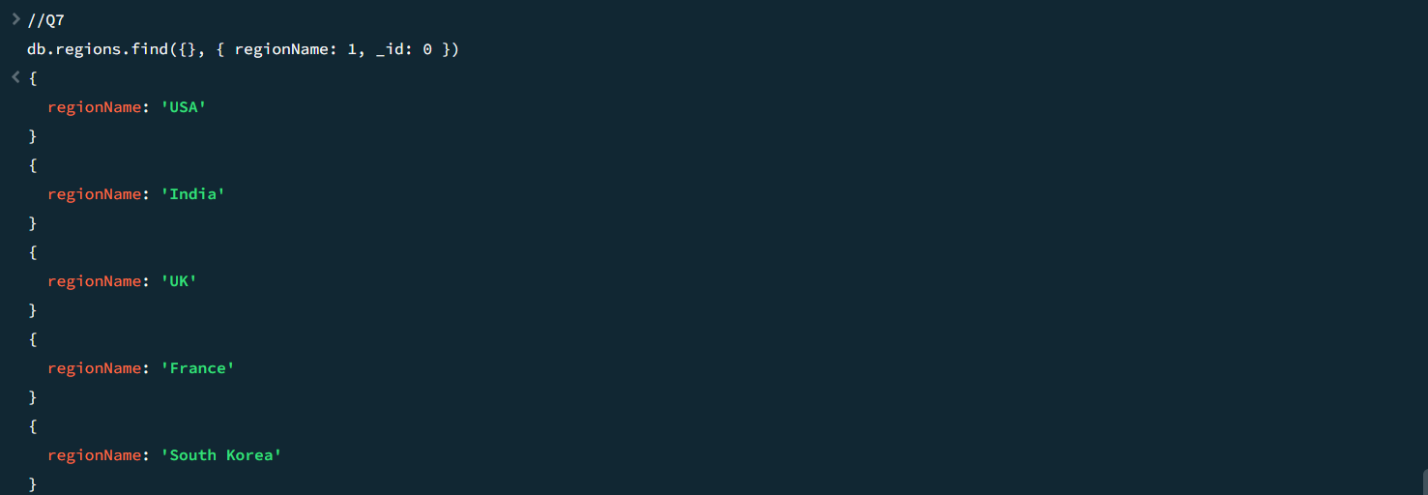

Query 8: Show All Posts from India
MongoDB Query:
db.posts.find({ region: "India" }, { userId: 1, caption: 1, hashtags: 1, _id: 0 })
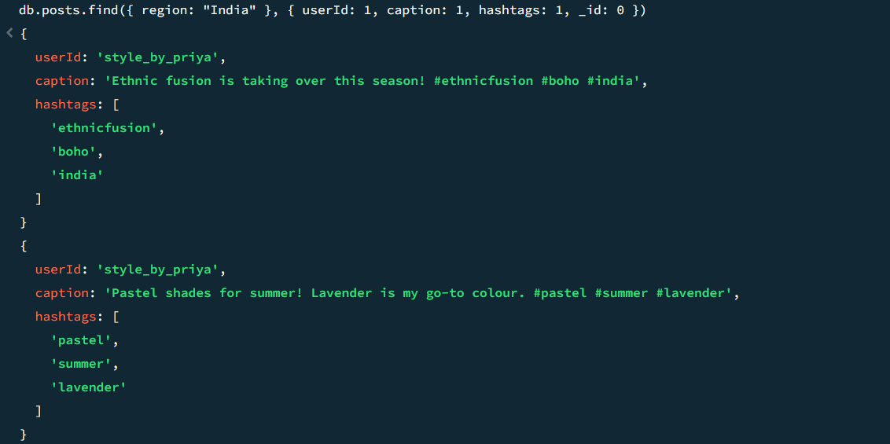

Query 9: Retrieve Posts Created After Jan 2026
MongoDB Query:
db.posts.find(
{ postDate: { $gt: "2026-01-01" } },
{ userId: 1, caption: 1, postDate: 1, _id: 0 }
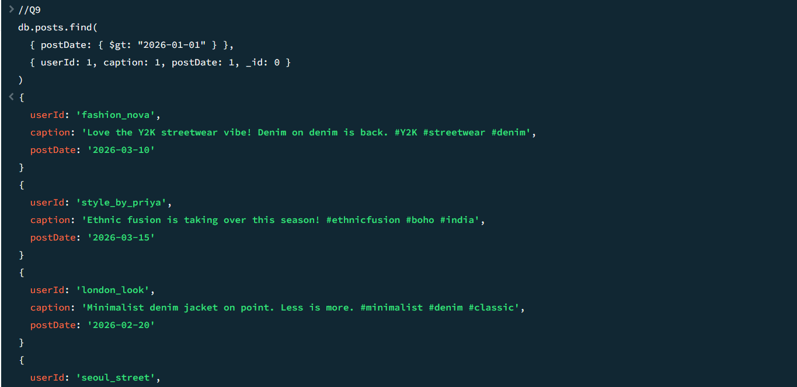

Query 10: Display All Trends in Spring Season
MongoDB Query:
db.trends.find({ season: "Spring" }, { trendName: 1, season: 1, popularityScore: 1, _id: 0 })
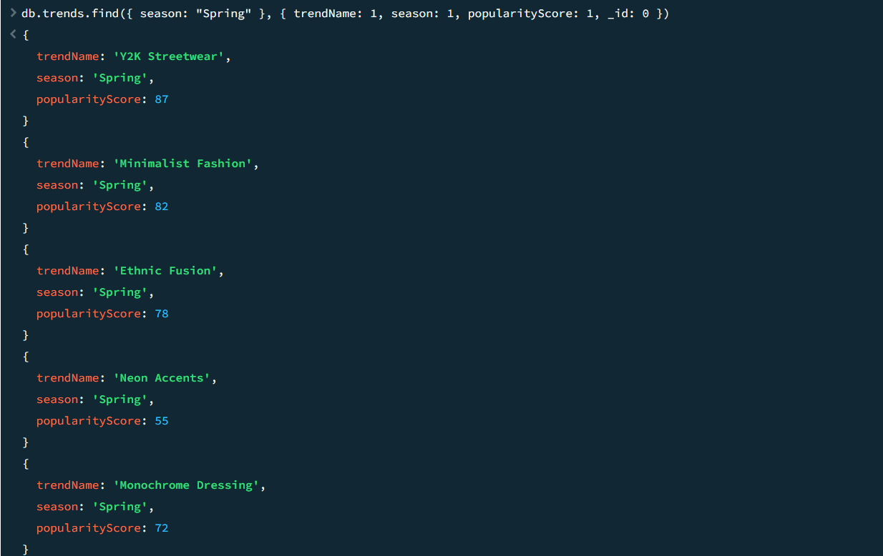

Query 11: Find Users Who Joined After 2025
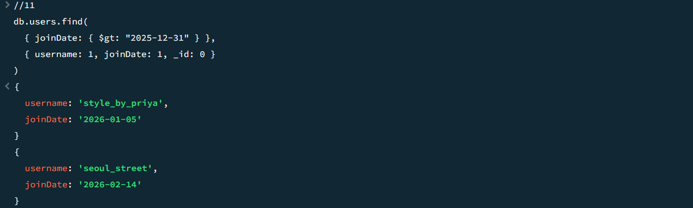

Query 12: Retrieve Posts Containing Hashtag Y2K
MongoDB Query:
db.posts.find({ hashtags: "Y2K" }, { userId: 1, caption: 1, hashtags: 1, _id: 0 })
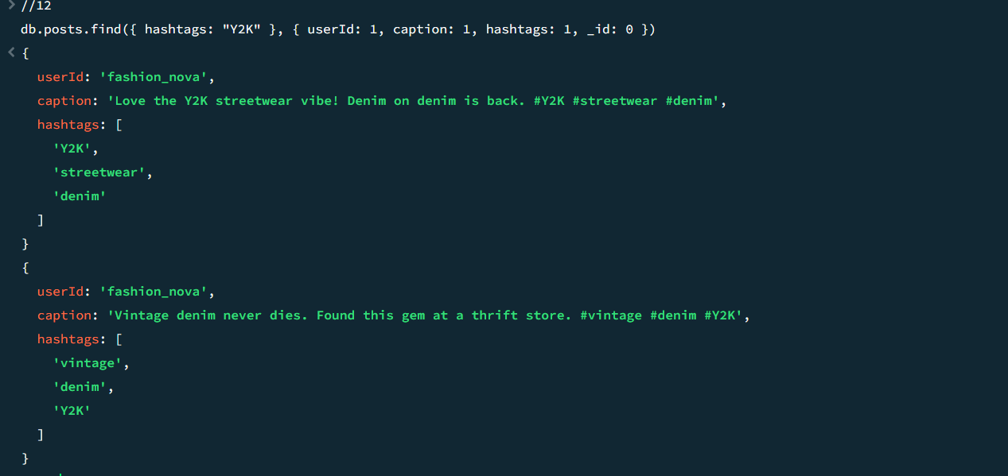

Query 13: Display Trends with popularityScore > 80
MongoDB Query:
db.trends.find({ popularityScore: { $gt: 80 } }, { trendName: 1, popularityScore: 1, _id: 0 })
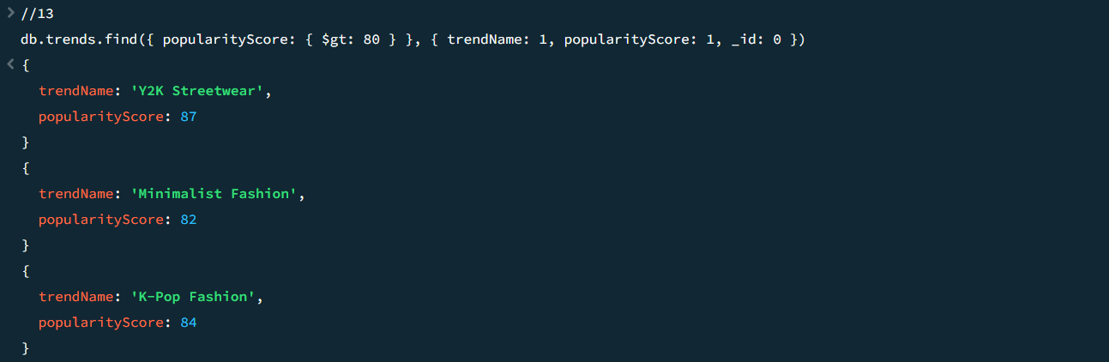

Query 14: Find Keywords in Fabric Category
MongoDB Query:
db.keywords.find({ category: "Fabric" }, { keyword: 1, category: 1, relatedTrend: 1, _id: 0 })

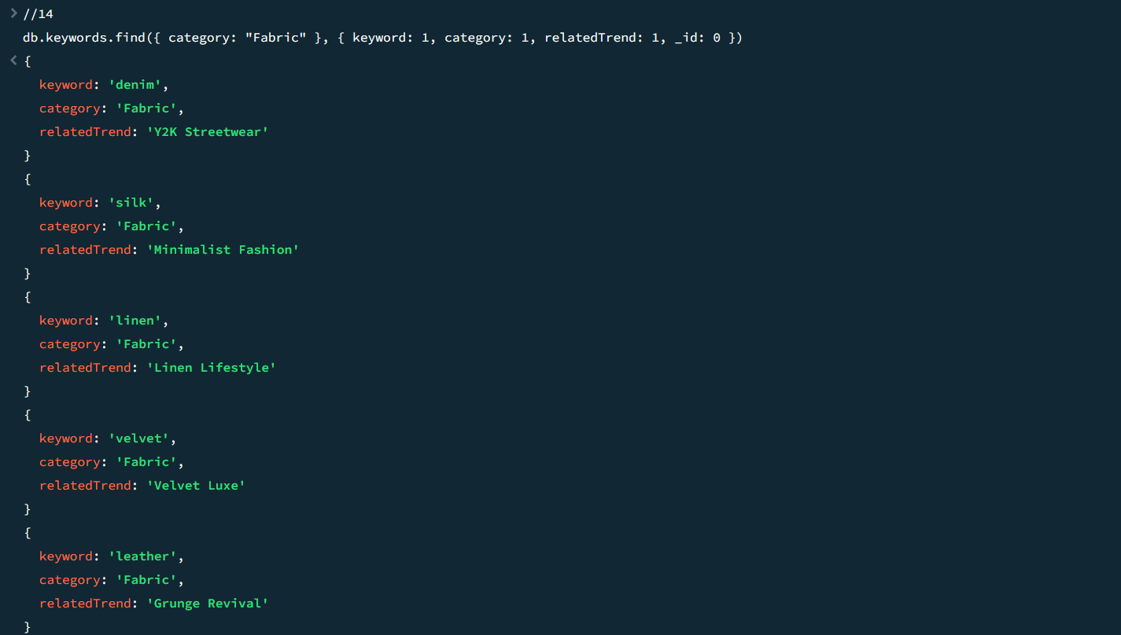Query 15: Retrieve Posts from Instagram Source Only
MongoDB Query:
db.posts.find({ source: "Instagram" }, { userId: 1, source: 1, caption: 1, _id: 0 })
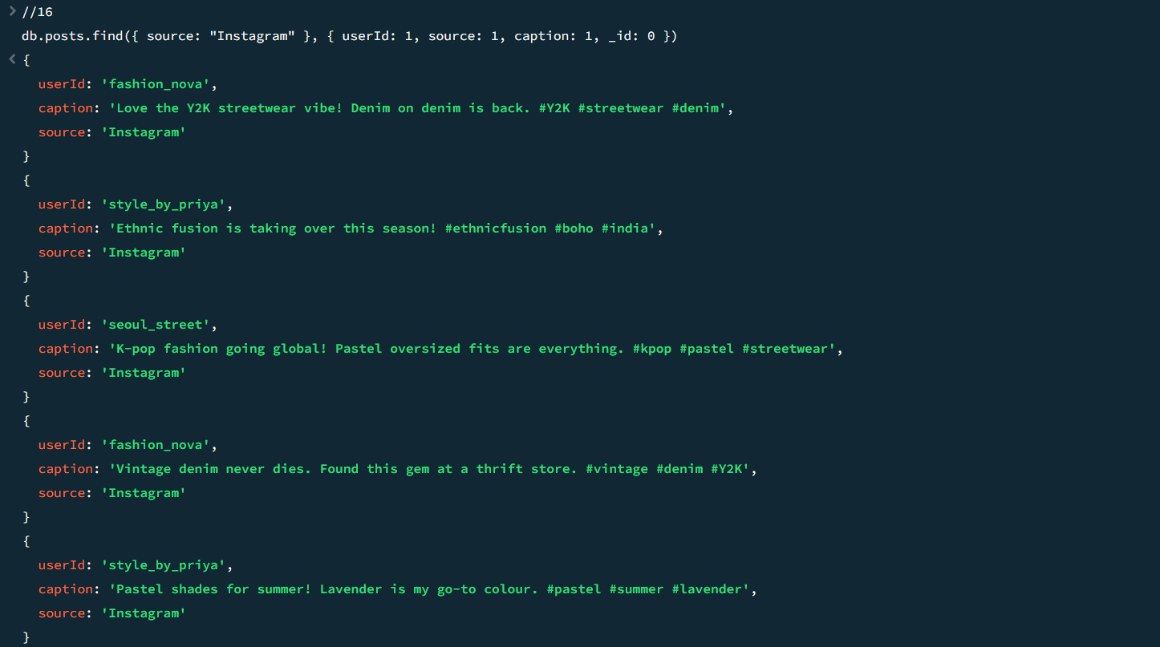

Query 16: Show Trends Where Mentions > 500
MongoDB Query:
db.trends.find({ mentions: { $gt: 500 } }, { trendName: 1, mentions: 1, _id: 0 })
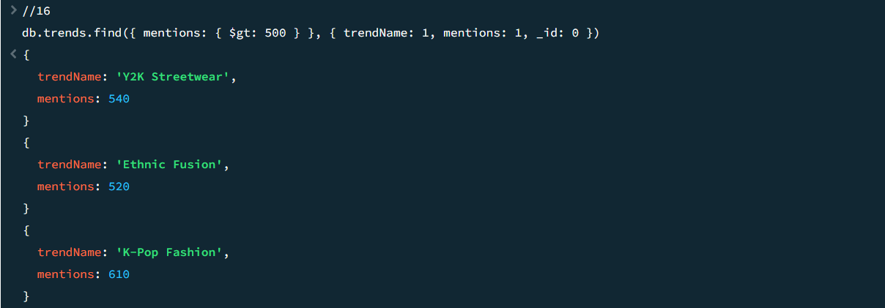

Query 17: Find Regions Where Streetwear is a Top Trend
MongoDB Query:
db.regions.find(
{ "topTrends.trendName": { $regex: "Streetwear", $options: "i" } },
{ regionName: 1, topTrends: 1, _id: 0 }
)
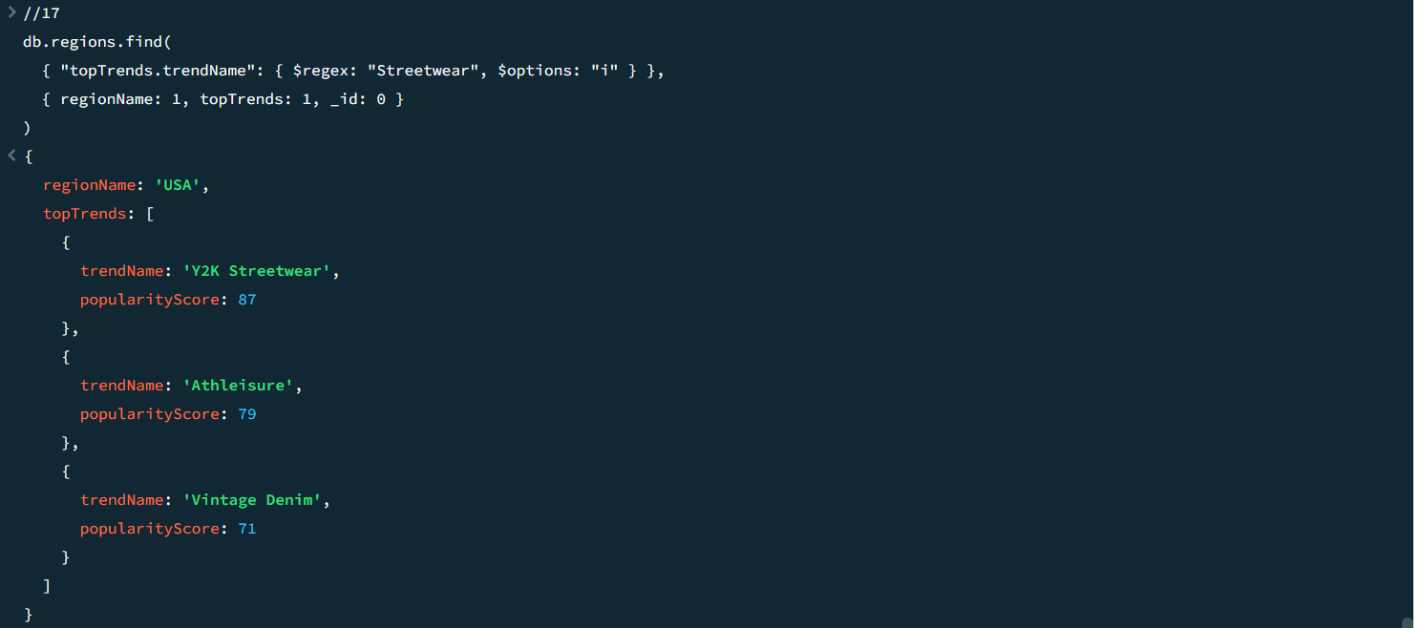

Query 18: Display Posts Where Caption Contains 'denim'
MongoDB Query:
db.posts.find({ caption: { $regex: "denim", $options: "i" } }, { userId: 1, caption: 1, _id: 0 })
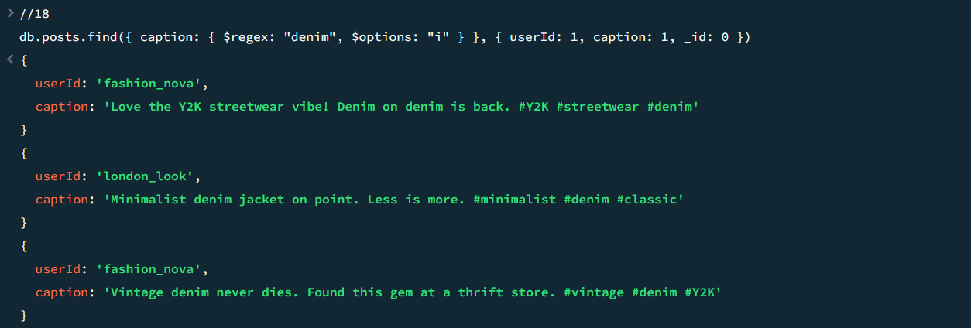

Query 19: Trends in Style Category AND Spring Season
MongoDB Query:
db.trends.find(
{ $and: [{ category: "Style" }, { season: "Spring" }] },
{ trendName: 1, category: 1, season: 1, _id: 0 }
)
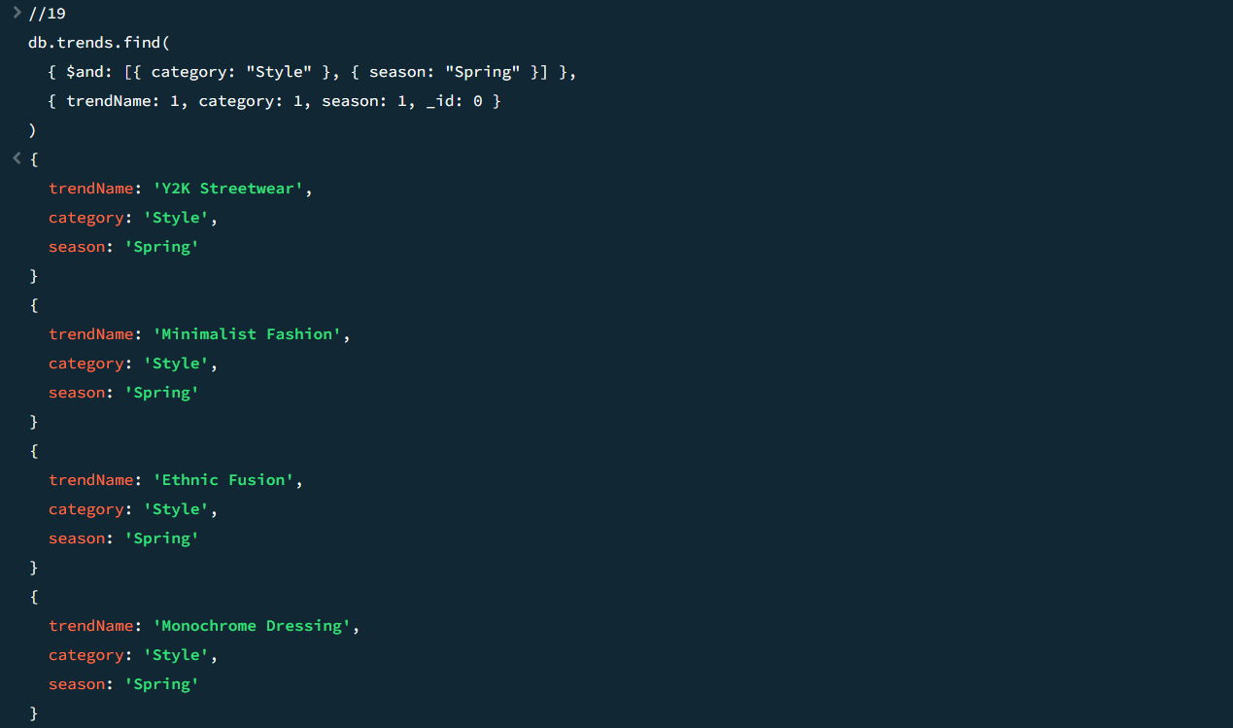

Query 20: Find All Keywords Related to Y2K Streetwear
MongoDB Query:
db.trendKeywords.find({ trendName: "Y2K Streetwear" }, { trendName: 1, keyword: 1, weight: 1, _id: 0 })
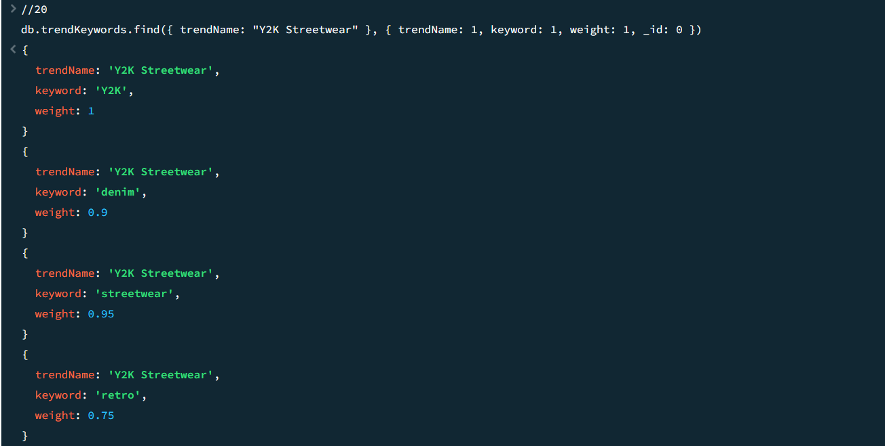

Query 21: Display Top 5 Trends by Popularity Score
MongoDB Query:
db.trends.find({}, { trendName: 1, popularityScore: 1, _id: 0 }).sort({ popularityScore: -1 }).limit(5)
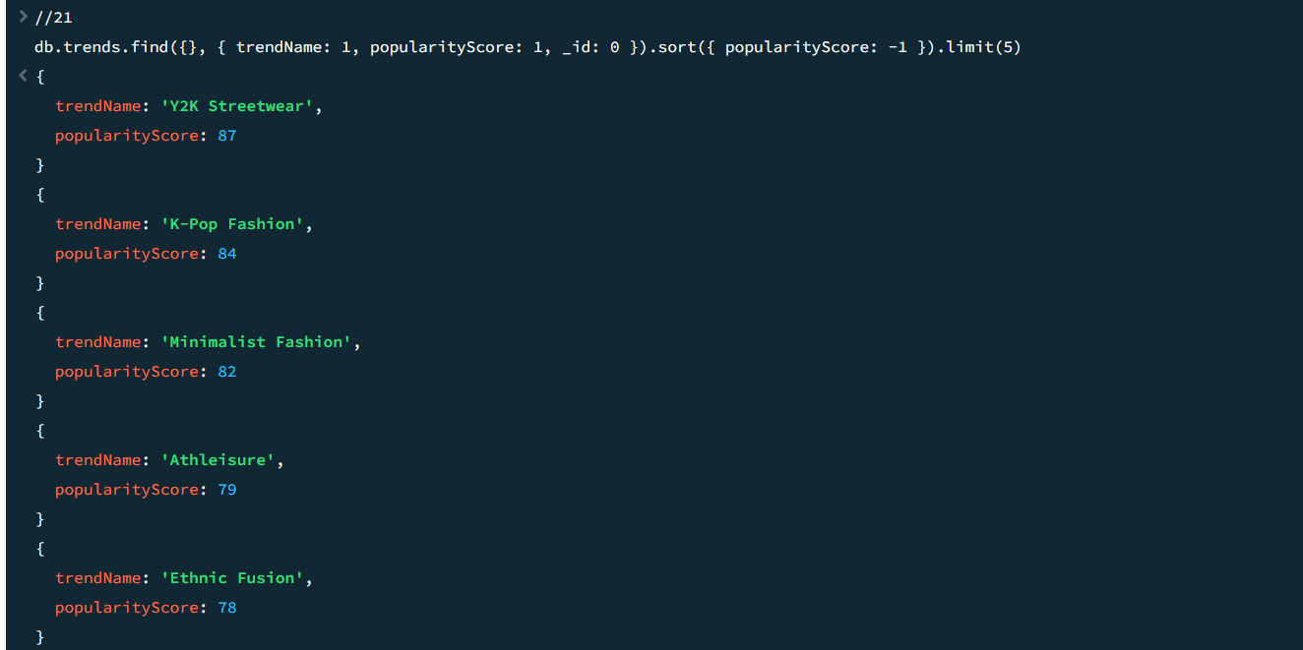

Query 22: Retrieve Latest 10 Posts Sorted by postDate
MongoDB Query:
db.posts.find({}, { userId: 1, caption: 1, postDate: 1, _id: 0 }).sort({ postDate: -1 }).limit(10)
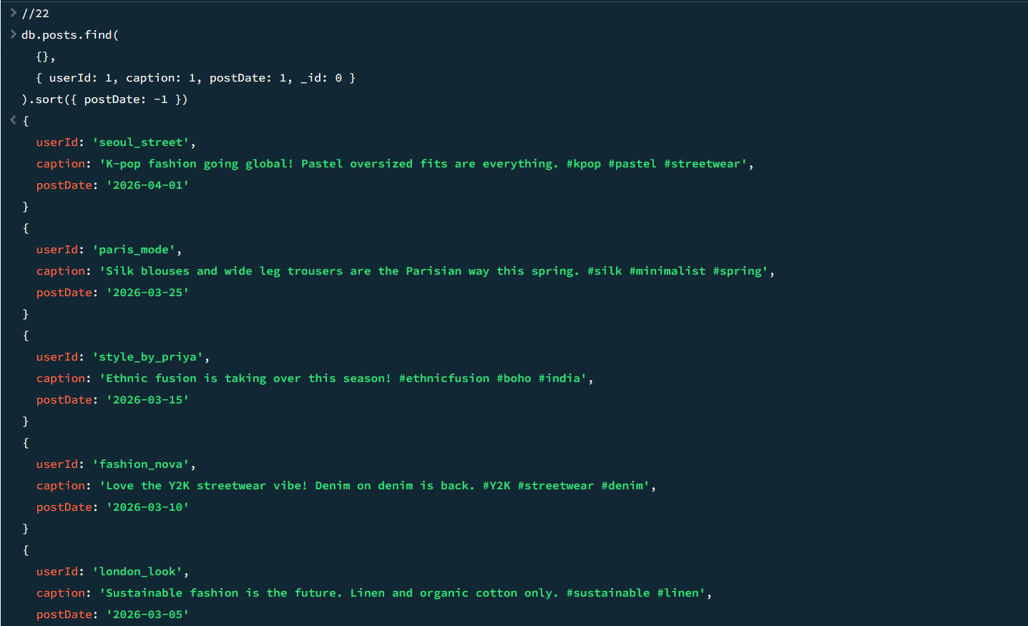

Query 23: Show Top 3 Regions with Highest Number of Posts
MongoDB Query:
db.posts.aggregate([
{ $group: { _id: "$region", totalPosts: { $sum: 1 } } },
{ $sort: { totalPosts: -1 } },
{ $limit: 3 }
])
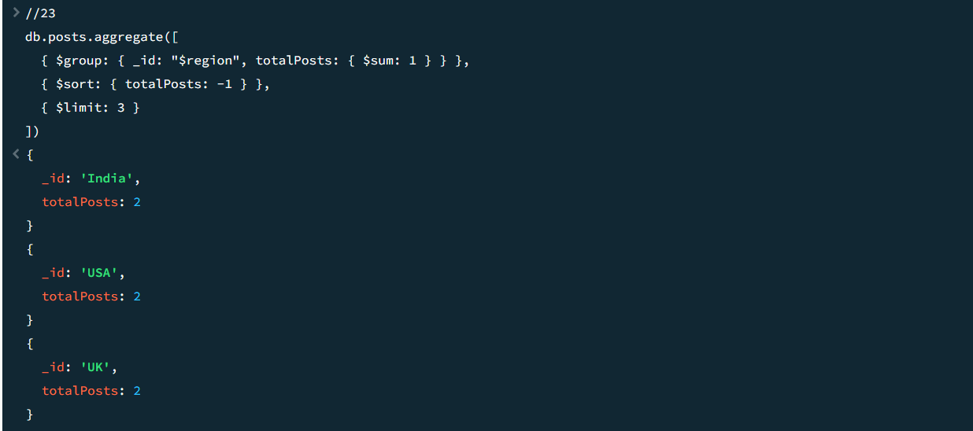

Query 24: Display Keywords Sorted Alphabetically
MongoDB Query:
db.keywords.find({}, { keyword: 1, category: 1, _id: 0 }).sort({ keyword: 1 })
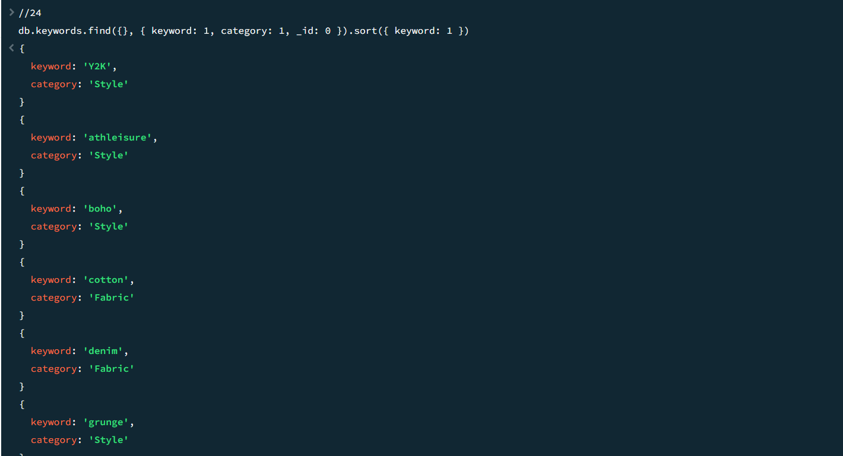

Query 25: Find Top 5 Most Mentioned Trends
MongoDB Query:
db.trends.find({}, { trendName: 1, mentions: 1, _id: 0 }).sort({ mentions: -1 }).limit(5)
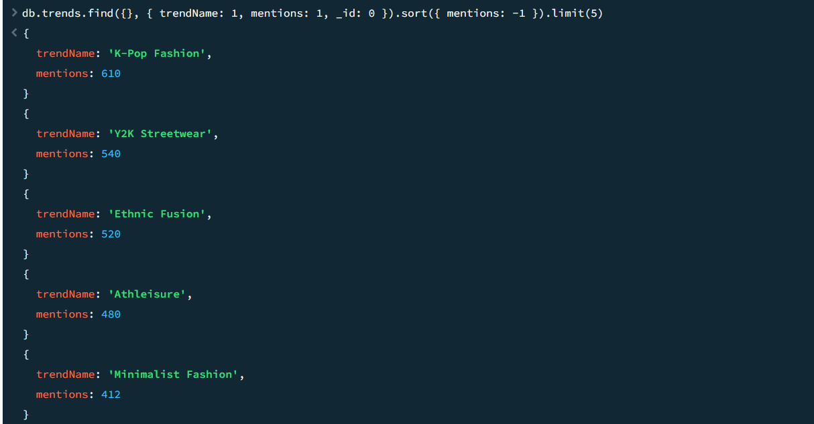

Query 26: Count Total Number of Users
MongoDB Query:
db.users.countDocuments({})
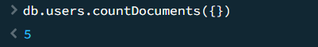

Query 27: Count Total Number of Posts in Each Region
MongoDB Query:
db.posts.aggregate([
{ $group: { _id: "$region", postCount: { $sum: 1 } } },
{ $sort: { postCount: -1 } }
])
Output:
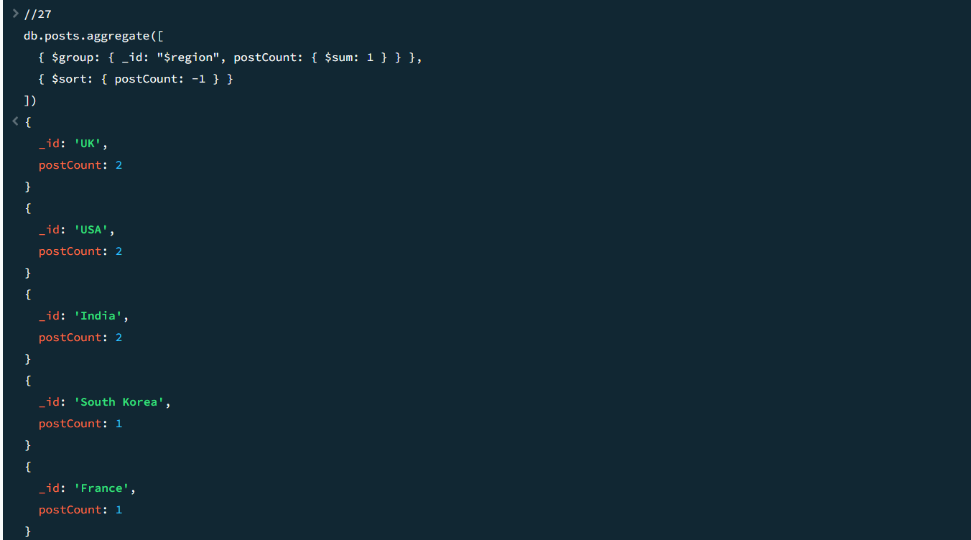

Query 28: Find Average Popularity Score of Trends
MongoDB Query:
db.trends.aggregate([
{ $group: { _id: null, avgScore: { $avg: "$popularityScore" } } }
])
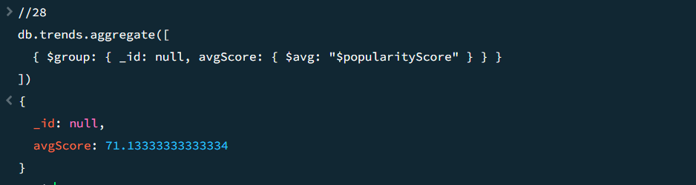

Query 29: Count How Many Times Each Hashtag Appears
MongoDB Query:
db.hashtags.find({}, { tag: 1, usageCount: 1, _id: 0 }).sort({ usageCount: -1 })
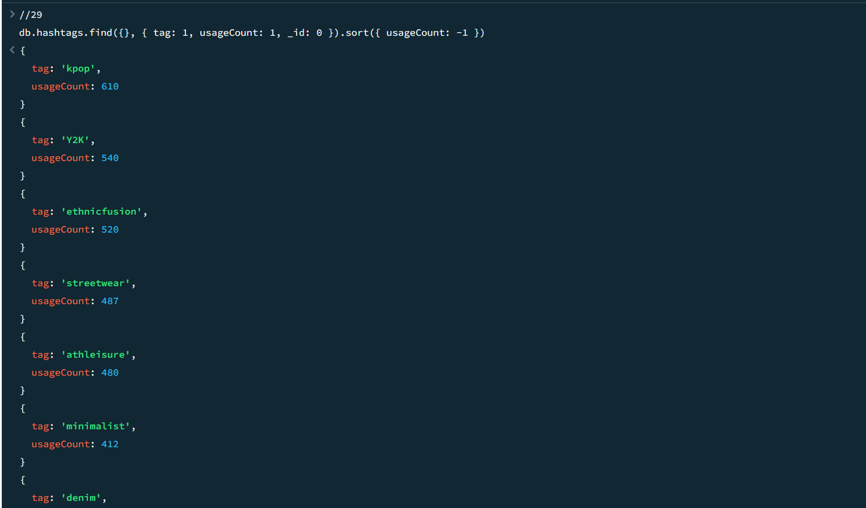

Query 30: Find Total Mentions for Each Trend Category
MongoDB Query:
db.trends.aggregate([
{ $group: { _id: "$category", totalMentions: { $sum: "$mentions" } } },
{ $sort: { totalMentions: -1 } }
])
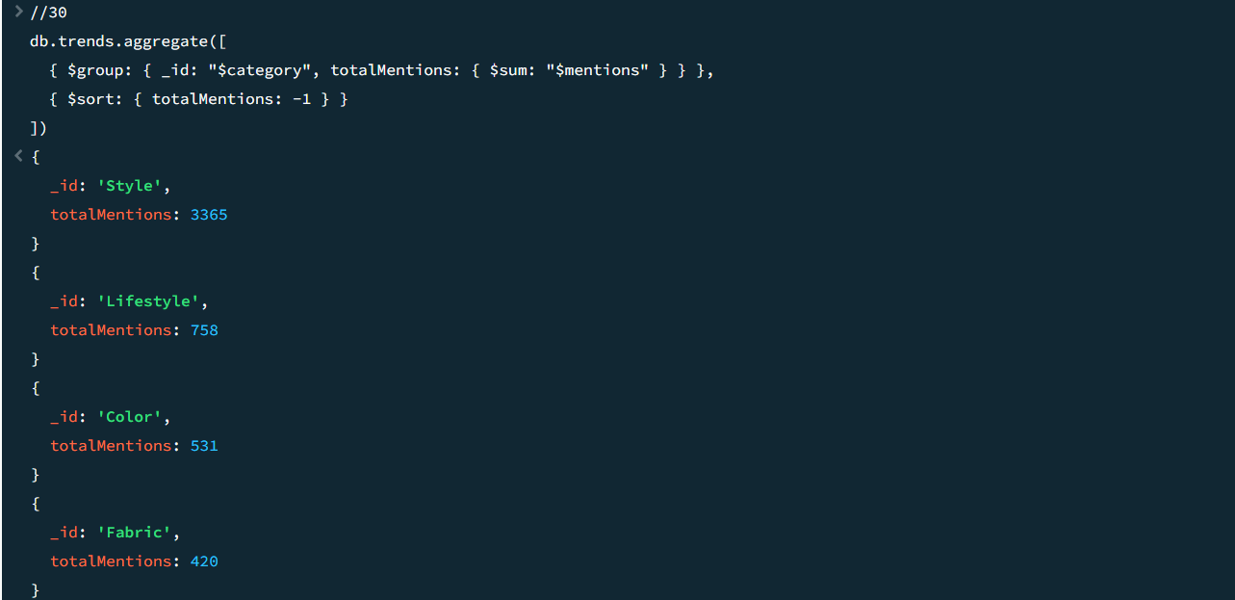

Query 31: Retrieve Posts Along With Their Trend Names (extractedKeywords)
MongoDB Query:
db.posts.find({}, { userId: 1, caption: 1, extractedKeywords: 1, _id: 0 }).limit(3)
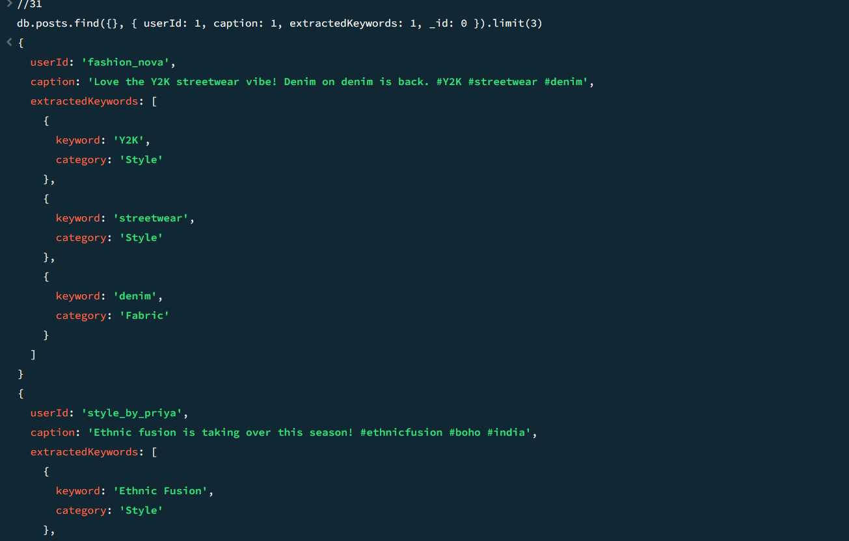

Query 32: Display Users and Their Favorite Styles
MongoDB Query:
db.users.find({}, { username: 1, favoriteStyles: 1, region: 1, _id: 0 })
Output:
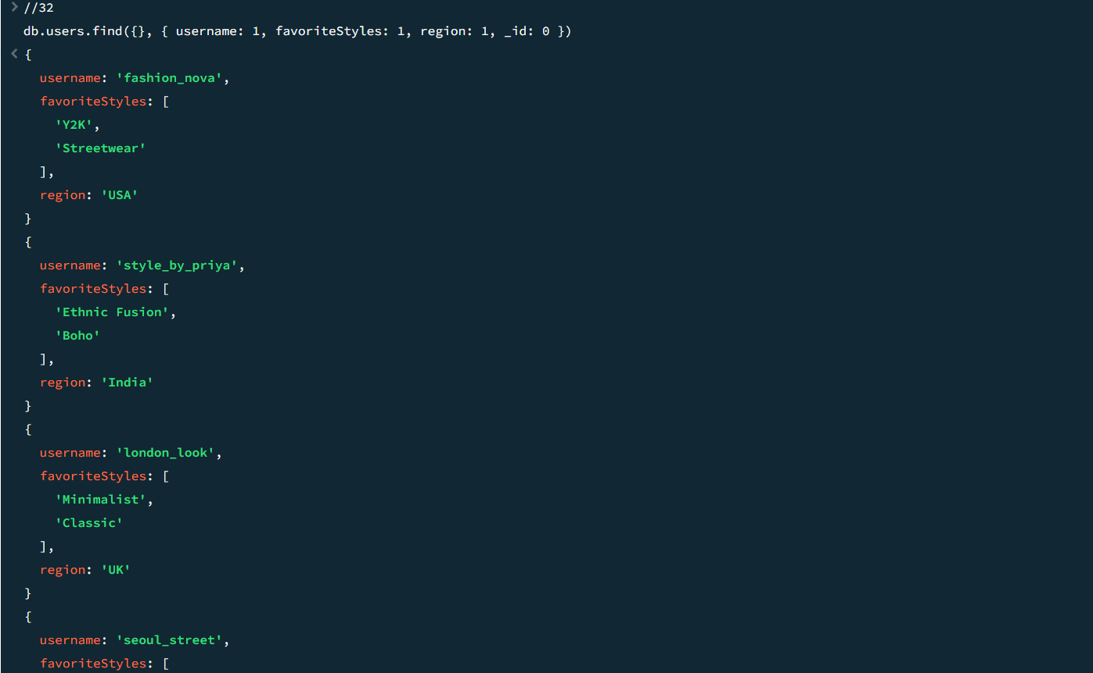

Query 33: Show Trends Along With Their Associated Keywords
MongoDB Query:
db.trendKeywords.find({}, { trendName: 1, keyword: 1, weight: 1, _id: 0 })
Output:
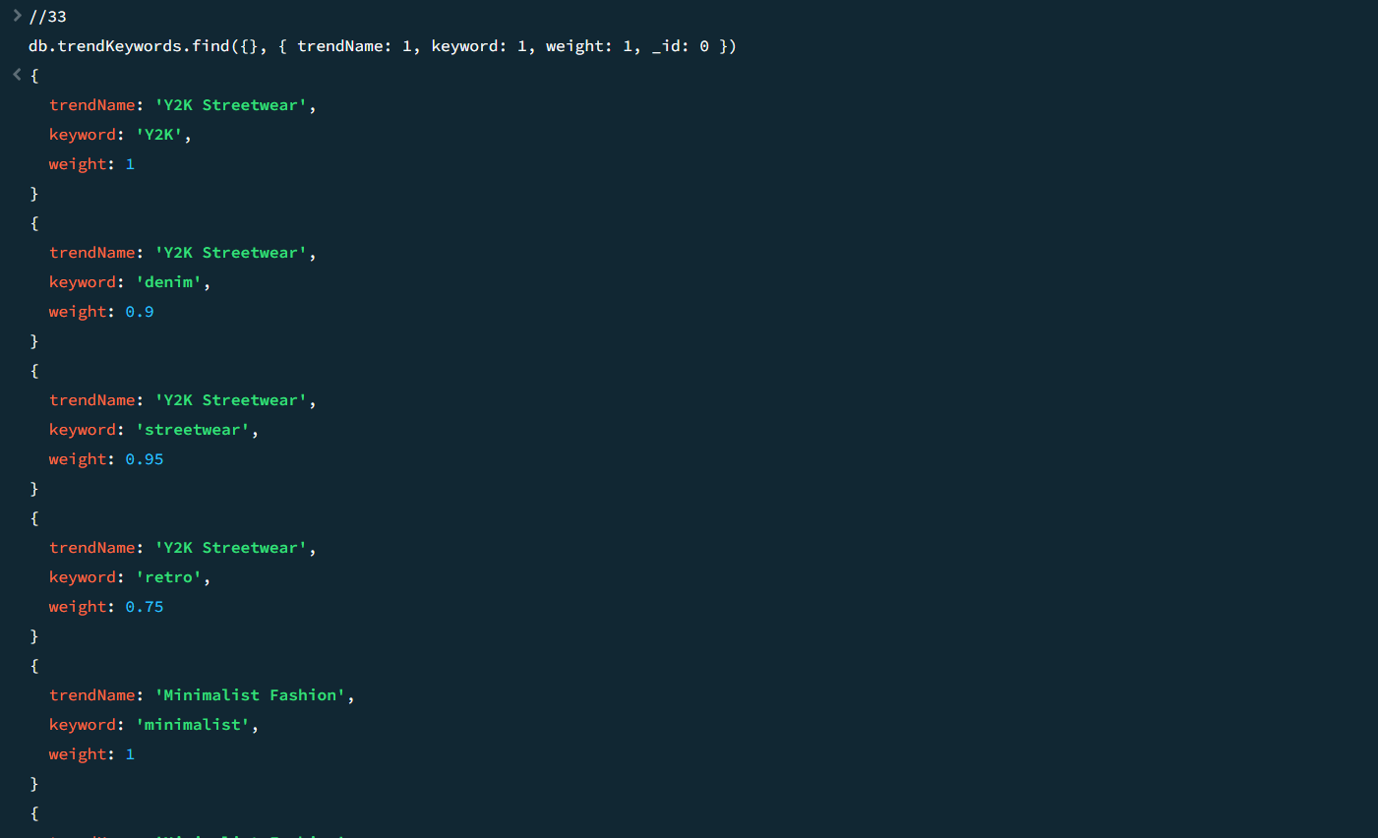

Query 34: Retrieve Regions Along With Their Top Trends
MongoDB Query:
db.regions.find({}, { regionName: 1, topTrends: 1, _id: 0 })
Output:
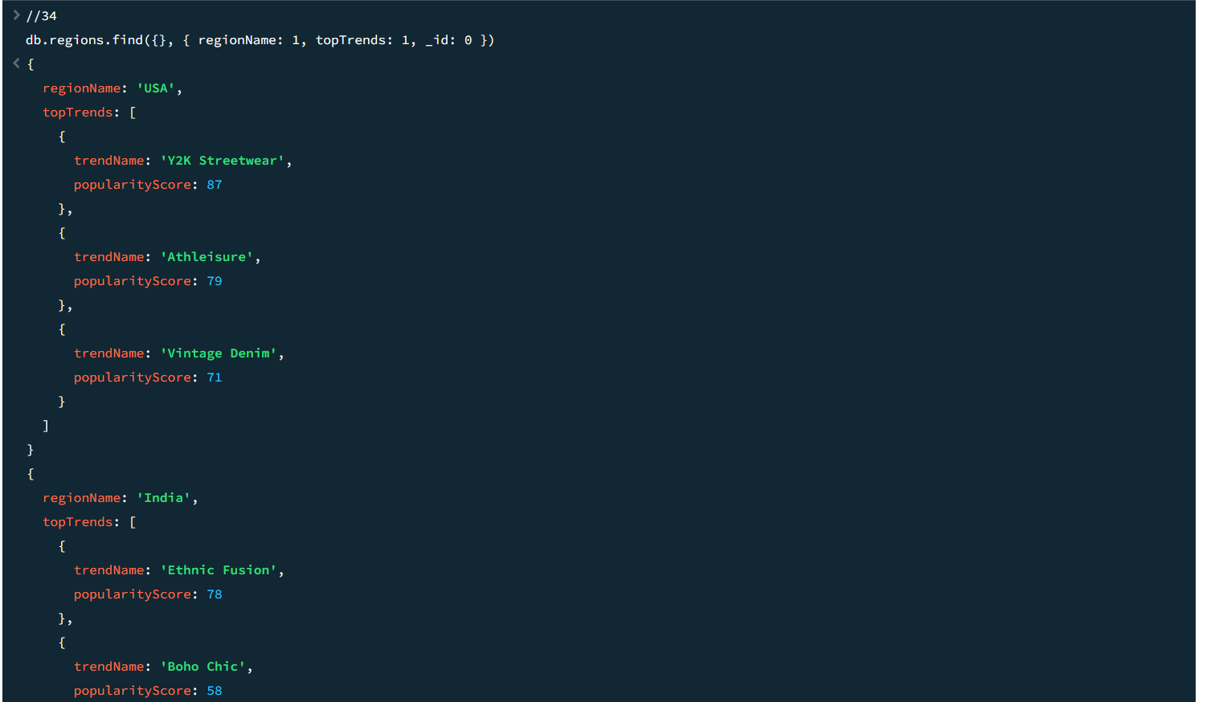

Query 35: Display Trend Analytics With Trend Names
MongoDB Query:
db.trendAnalytics.find({}, { trendName: 1, month: 1, year: 1, mentions: 1, popularityScore: 1, _id: 0 })
Output:
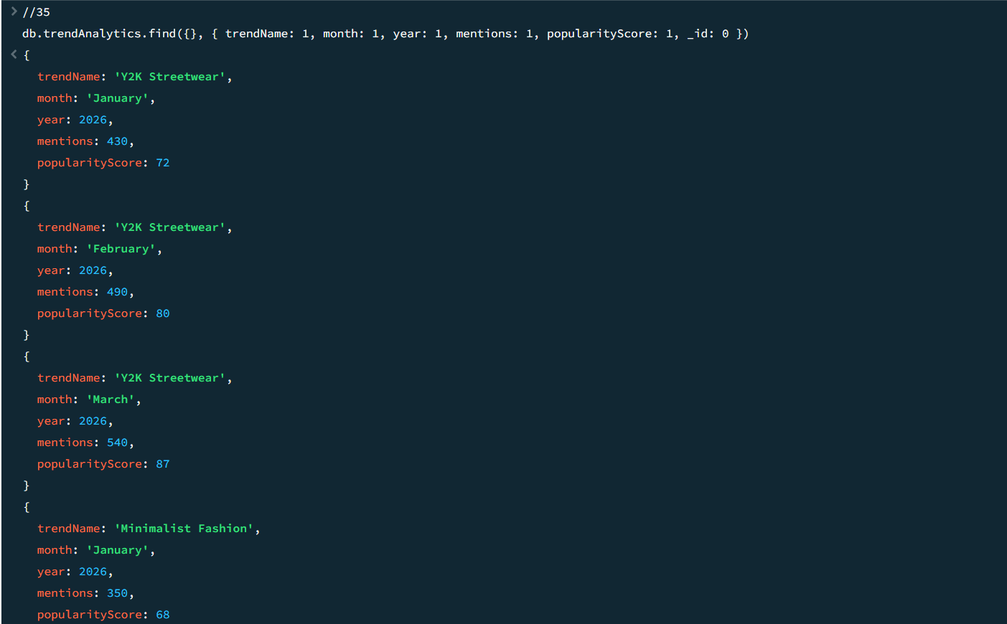

Query 36: Find the Most Popular Trend in Each Region
MongoDB Query:
db.regions.aggregate([
{ $project: {
regionName: 1,
topTrend: { $arrayElemAt: ["$topTrends", 0] }
}}
])
Output:
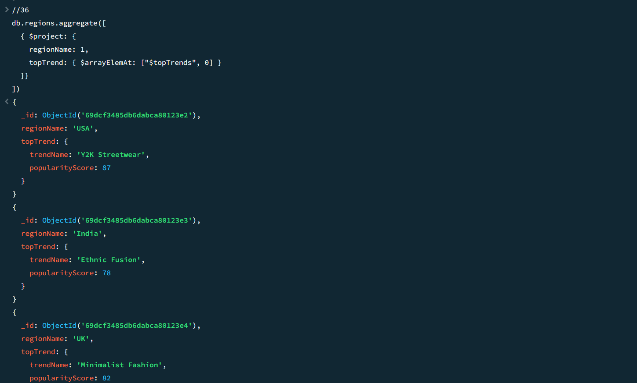

Query 37: Retrieve Trends That Have Increasing Popularity Over Months
MongoDB Query:
db.trendAnalytics.aggregate([
{ $sort: { trendName: 1, year: 1, month: 1 } },
{ $group: {
_id: "$trendName",
scores: { $push: "$popularityScore" },
months: { $push: "$month" }
}}
])
Output:
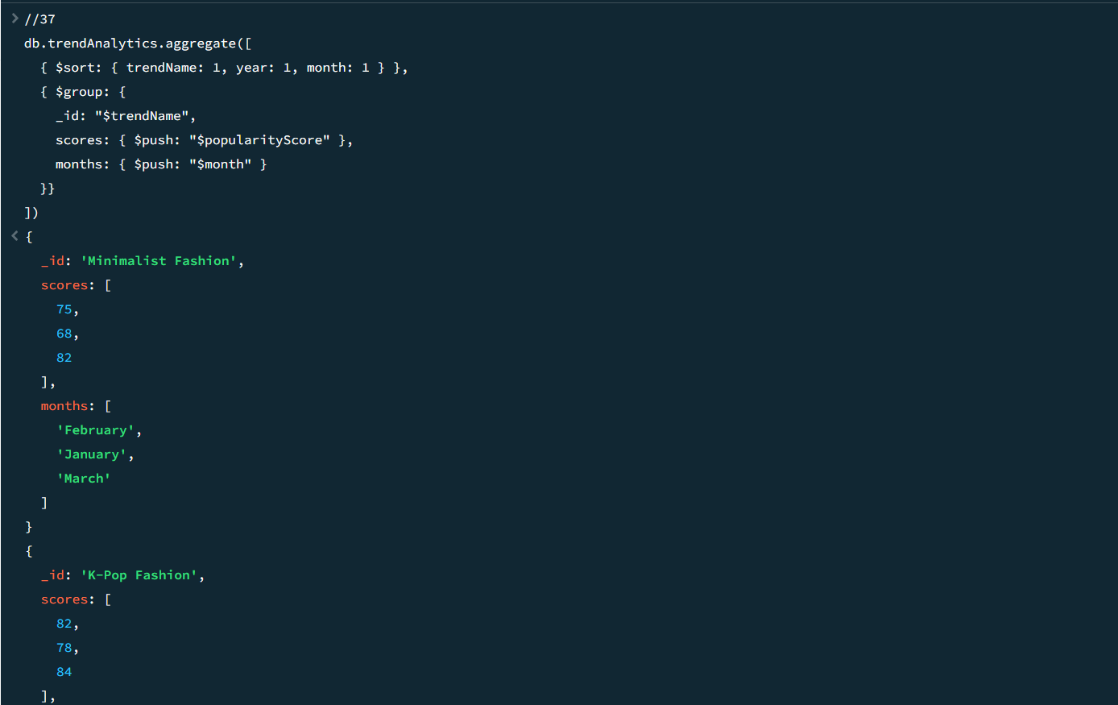

Query 38: Find Users Interested in Streetwear and Show Matching Trends
MongoDB Query:
db.users.find(
{ favoriteStyles: { $in: ["Streetwear", "Y2K"] } },
{ username: 1, favoriteStyles: 1, region: 1, _id: 0 }
)
Output:
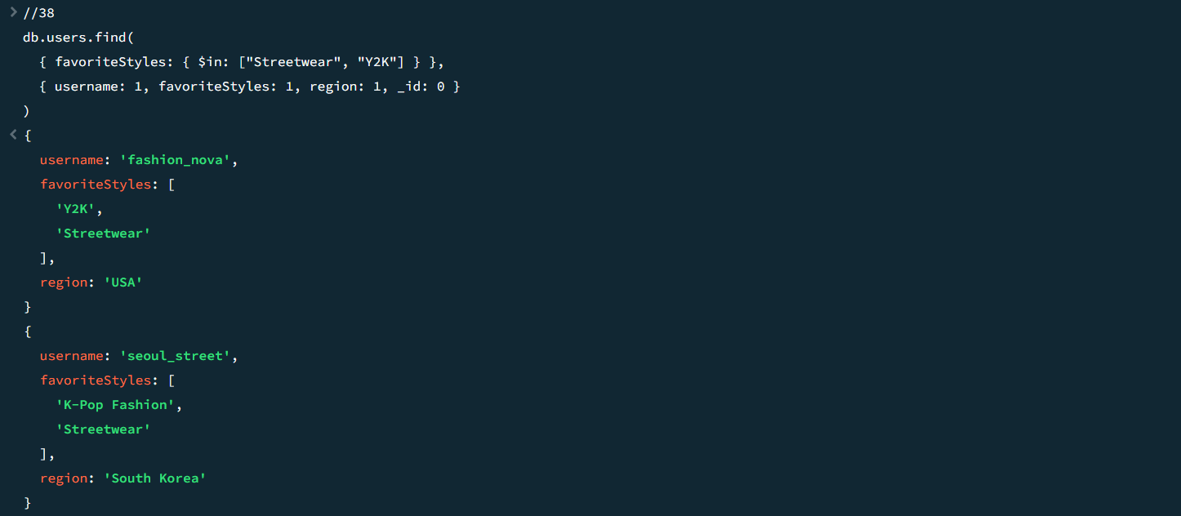

Query 39: Display Trends That Are Popular in More Than One Region
MongoDB Query:
db.trends.aggregate([
{ $group: { _id: "$trendName", regionCount: { $sum: 1 } } },
{ $match: { regionCount: { $gte: 1 } } },
{ $sort: { regionCount: -1 } }
])
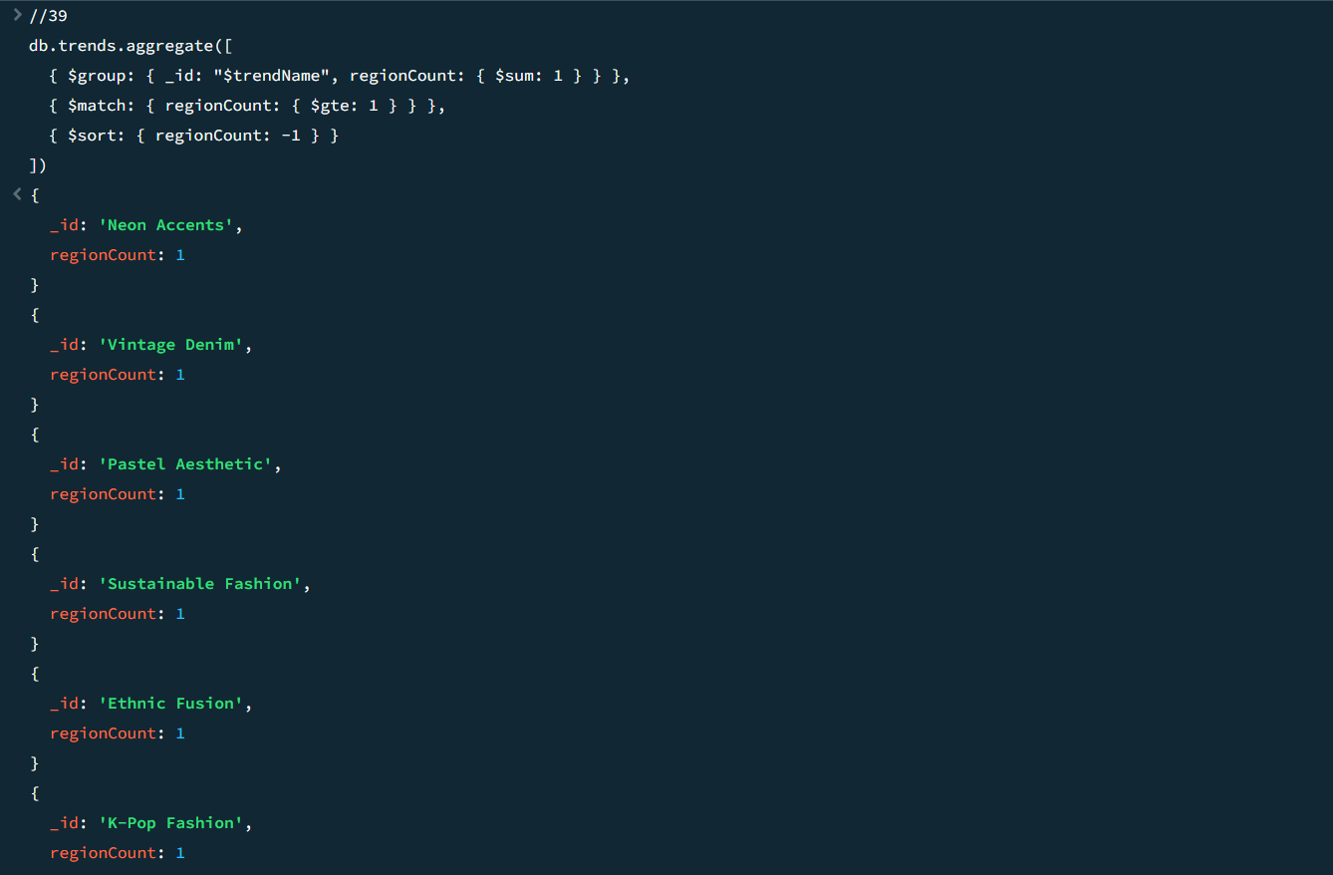

Query 40: Find the Top Trending Keyword for Each Month
MongoDB Query:
db.trendAnalytics.aggregate([
{ $sort: { mentions: -1 } },
{ $group: {
_id: { month: "$month", year: "$year" },
topTrend: { $first: "$trendName" },
topMentions: { $first: "$mentions" }
}},
{ $sort: { "_id.year": 1, "_id.month": 1 } }
])
Output:
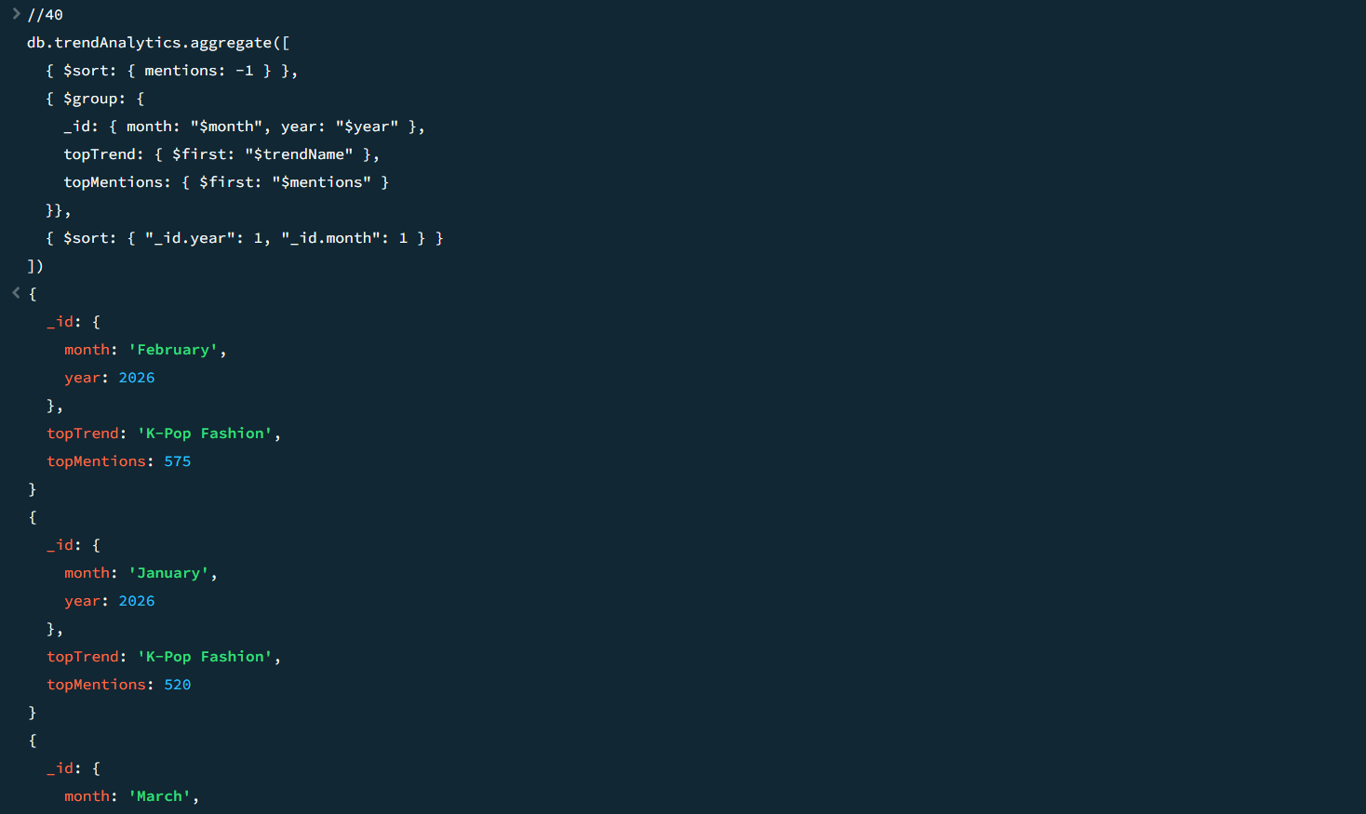

Query 41: Products by Style and Fabric
MongoDB Query:
db.products.find({}, { productName: 1, style: 1, fabric: 1, price: 1, region: 1, _id: 0 })
Output:
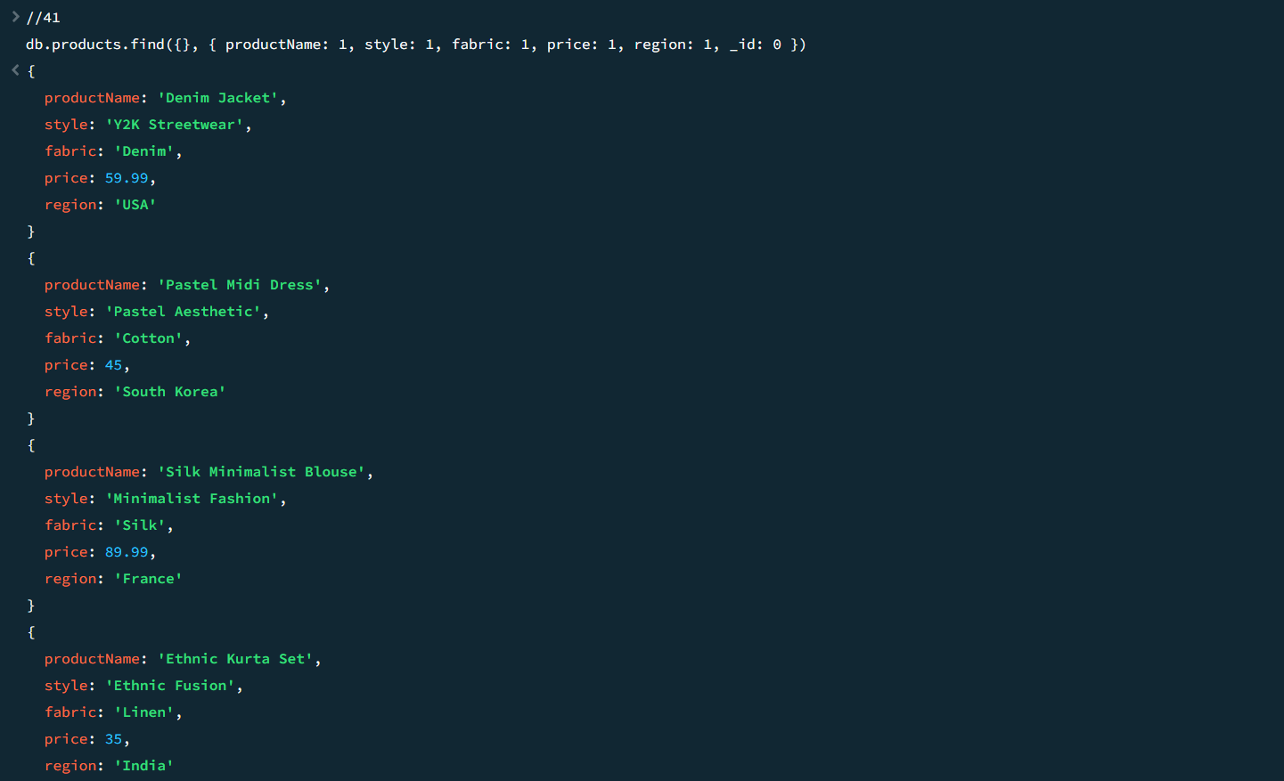

Query 42: Influencers Ranked by Follower Count
MongoDB Query:
db.influencers.find({}, { name: 1, followers: 1, region: 1, preferredStyles: 1, _id: 0 }).sort({ followers: -1 })
Output:
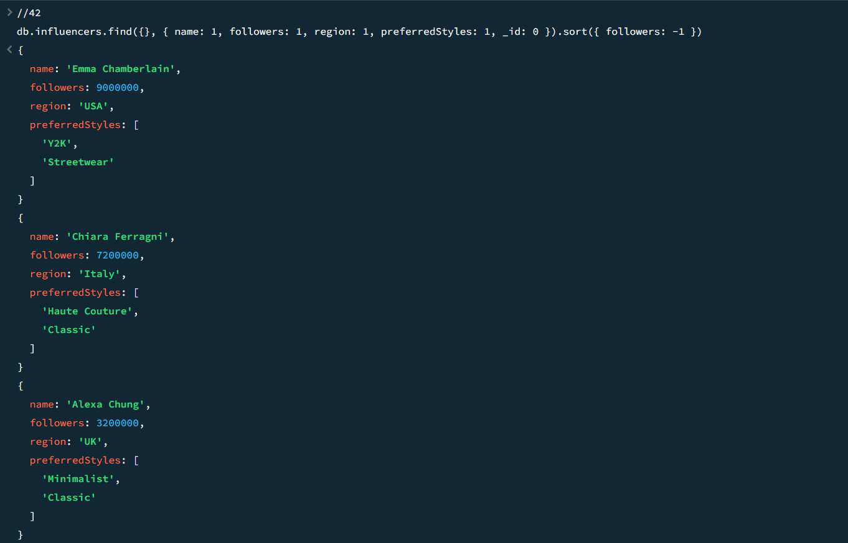

Query 43: Feedbacks with Rating >= 4
MongoDB Query:
db.feedbacks.find({ rating: { $gte: 4 } }, { userId: 1, trendName: 1, rating: 1, comment: 1, _id: 0 })
Output:
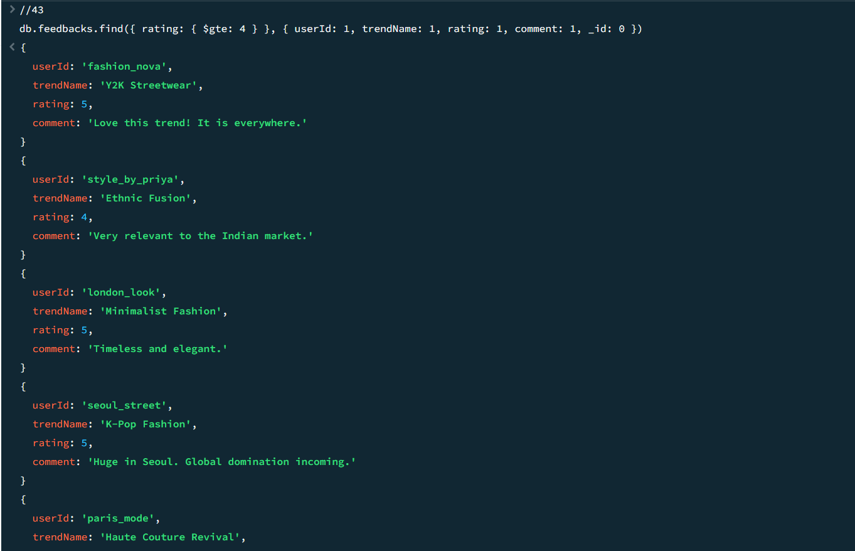

Query 44: Unread Notifications
MongoDB Query:
db.notifications.find({ read: false }, { userId: 1, message: 1, date: 1, _id: 0 })
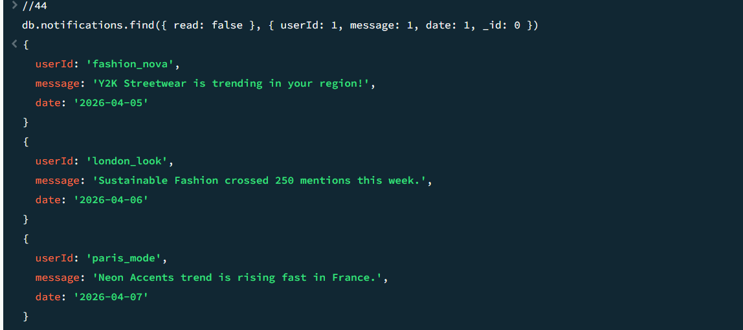

Query 45: Trend Reports Generated in 2026
MongoDB Query:
db.reports.find(
{ generatedDate: { $gte: ISODate("2026-01-01") } },
{ reportTitle: 1, generatedDate: 1, topTrends: 1, _id: 0 }
)
Output:
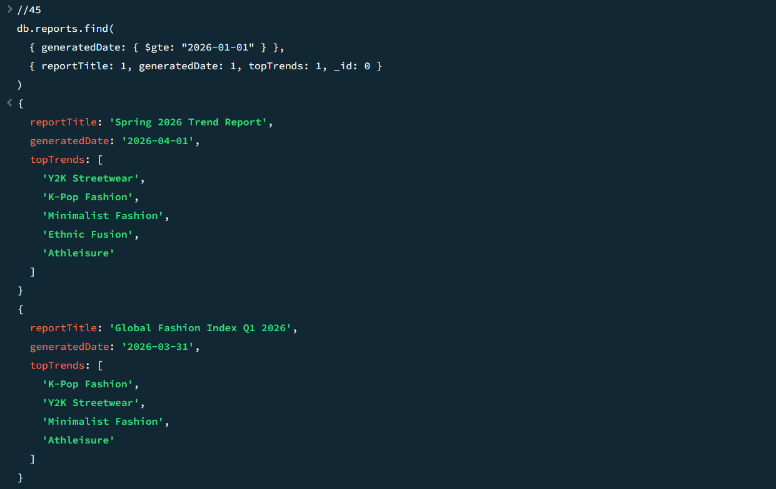

VI. Project demonstration

The first page gives an introduction to the 15 collection of the database that we have where we can see the info about each database by clicking on them.

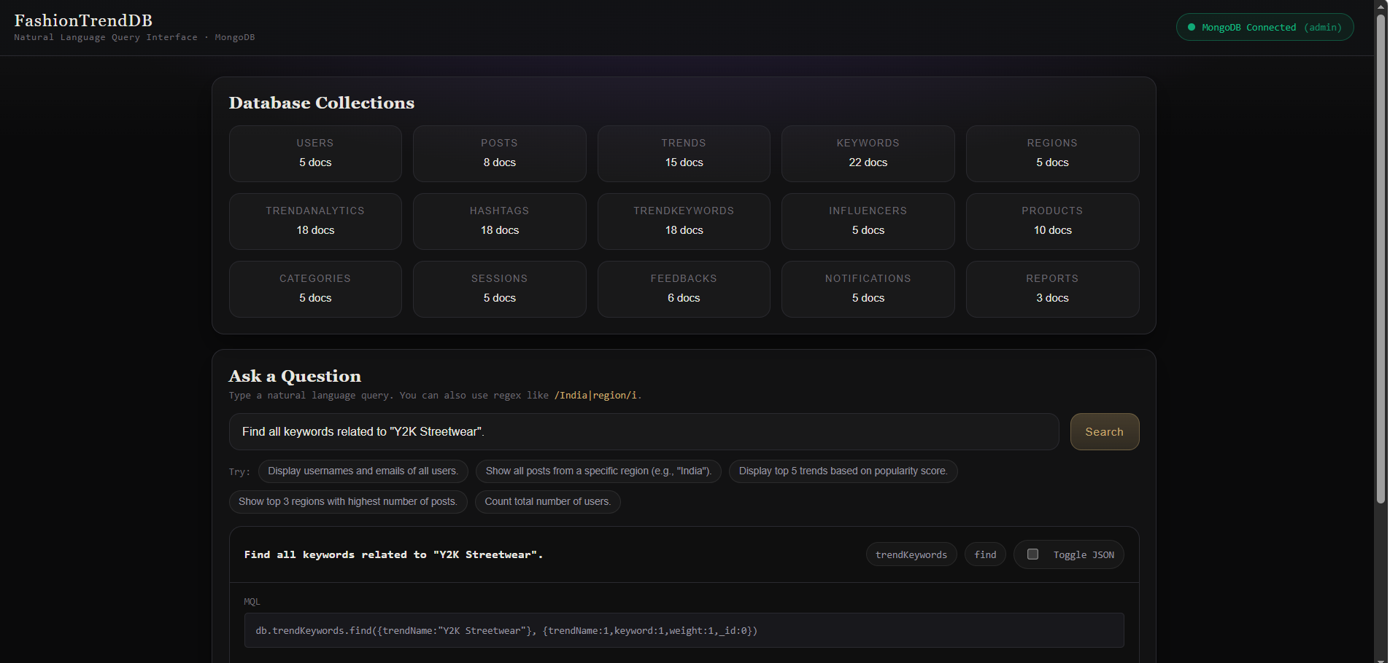

For Example:
In this collection, TrendAnalytics, we can view the dataset containing details such as TrendID, trend name, month, and year. It also includes the number of mentions for each trend, which is used to calculate the popularity score. This score helps in determining how popular each trend is over time.

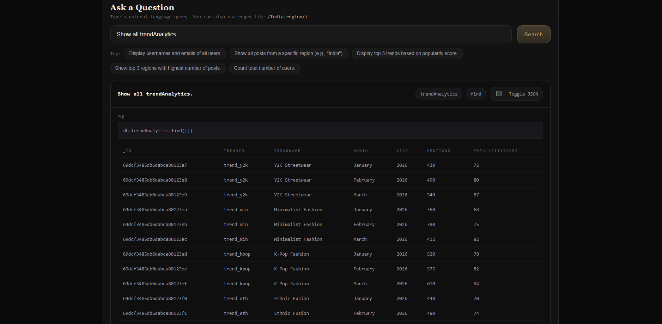

We can run any of the 45 queries to analyze and retrieve data from the database which are used to demonstrate how the database can retrieve and analyze fashion data. They help in identifying trends, filtering information, and generating insights such as popularity, regional preferences, and usage patterns.

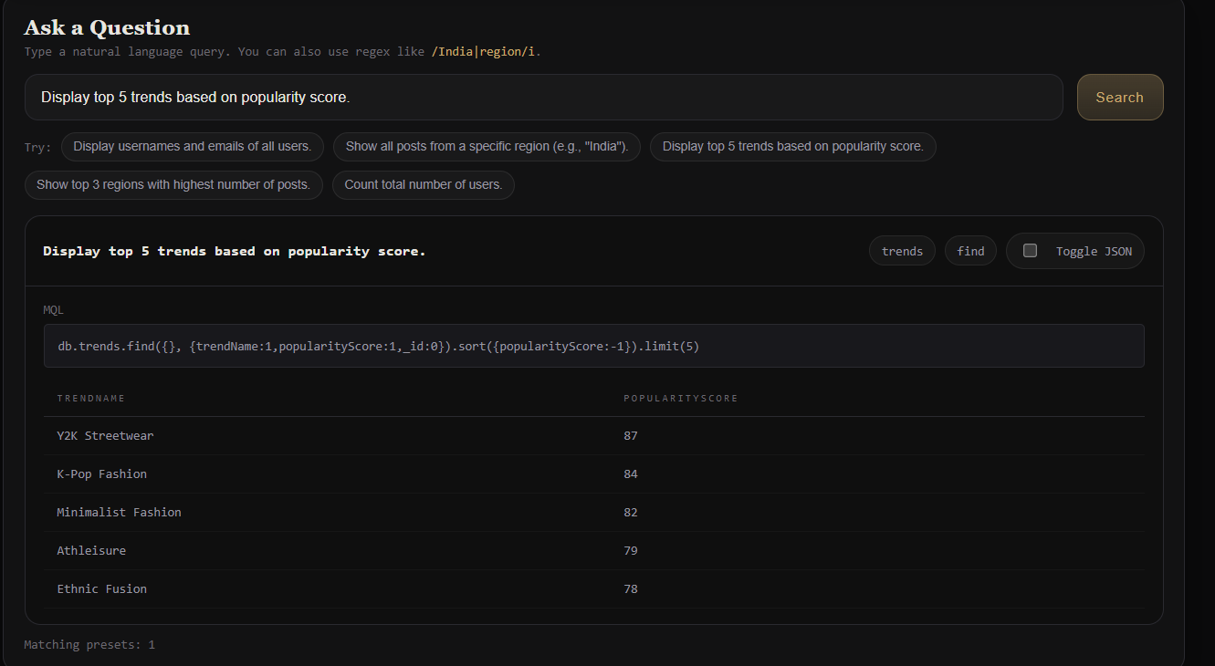

VII. Self -Learning beyond classroom
:
This project helped me learn concepts beyond the classroom, especially how to use MongoDB and design NoSQL databases. I understood how real-world data, which is often unstructured or semi-structured, can be organized and handled using flexible JSON-based schemas.
I learned how to manage and process such data by structuring it into collections and extracting useful information from it. I also gained practical experience in writing queries and using aggregation to analyze data.
VIII. Learning from the Project

Through this project, I developed a better understanding of how to design and organize a database for real-world data. I learned how to structure data into different collections and manage relationships between them effectively.
I also improved my ability to write queries and use aggregation to analyze data and extract useful information. This project helped me strengthen my logical thinking and problem-solving skills while working with practical data.

IX. Challenges Faced

We faced challenges while working with the 45 queries. One of the main challenges was understanding how to extract and retrieve relevant data from different collections and ensure that the correct query was used for each requirement.
Another challenge was identifying meaningful trends by properly sorting and filtering data based on factors like popularity score and mentions. It required careful thinking to ensure the queries reflected accurate results.
Writing aggregation queries was also challenging, as it involved understanding how different operators like grouping and filtering work together. Handling patterns such as frequently used hashtags and regional data required additional effort.

X. Conclusion

The project shows how MongoDB can be used to store and analyze semi-structured data. By organizing the data into different collections and using queries and aggregation, we were able to find useful insights about fashion trends.
This project also shows how NoSQL databases can handle flexible data easily. It can be further improved by adding features like real-time data and more advanced analysis of the popularity score .

