**Design Patterns And Principles**

**Exercise 1: Implementing the Singleton Pattern**

**Solution:**

class Logger {

    private static Logger instance;

    private Logger(){

        System.out.println("Logger created.");

    }

    public static Logger getInstance(){

        if (instance == null) {

            instance = new Logger();

        }

        return instance;

    }

     public void log(String msg) {

        System.out.println("Log: " + msg);

    }

}

public class Main{

    public static void main(String[] args){

        Logger a = Logger.getInstance();

        Logger b = Logger.getInstance();

        a.log("First Log");

        b.log("Second Log");

        System.out.println("Are a and b same? "+ (a == b));

    }

}

**Output:**

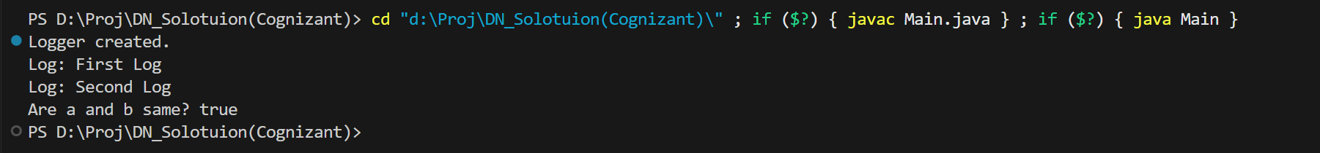

**Exercise 2: Implementing the Factory Method Pattern**

**Solution:**

interface Document {

    void open();

}

class WordDocument implements Document {

    public void open() {

        System.out.println("Opening Word document");

    }

}

class PdfDocument implements Document {

    public void open() {

        System.out.println("Opening Pdf document");

    }

}

class ExcelDocument implements Document {

    public void open() {

        System.out.println("Opening Excel document");

    }

}

abstract class DocumentFactory{

    public abstract Document createDocument();

}

class WordDocumentFactory extends DocumentFactory {

    public Document createDocument() {

        return new WordDocument();

    }

}

class PdfDocumentFactory extends DocumentFactory {

    public Document createDocument() {

        return new PdfDocument();

    }

}

class ExcelDocumentFactory extends DocumentFactory {

    public Document createDocument() {

        return new ExcelDocument();

    }

}

public class main2 {

    public static void main(String[] args) {

        DocumentFactory wordFactory = new WordDocumentFactory();

        Document wordDoc = wordFactory.createDocument();

        wordDoc.open();

        DocumentFactory pdfFactory = new PdfDocumentFactory();

        Document pdfDoc = pdfFactory.createDocument();

        pdfDoc.open();

        DocumentFactory excelFactory = new ExcelDocumentFactory();

        Document excelDoc = excelFactory.createDocument();

        excelDoc.open();

    }

}

**Output:**

