**Exercise 1: Mocking and Stubbing**

**Solution:**

MyService.java

interface ExternalApi {

    String getData();

}

public class MyService {

    private ExternalApi api;

    public MyService(ExternalApi api) {

        this.api = api;

    }

    public String fetchData() {

        return api.getData();

    }

}

MyServiceTest.java

import static org.mockito.Mockito.*;

import org.junit.jupiter.api.Assertions;

import org.junit.jupiter.api.Test;

import org.mockito.Mockito;

public class MyServiceTest {

    @Test

    public void testExternalApi() {

        ExternalApi mockApi = Mockito.mock(ExternalApi.class);

        when(mockApi.getData()).thenReturn("Mock Data");

        MyService service = new MyService(mockApi);

        String result = service.fetchData();

        Assertions.assertEquals("Mock Data", result);

    }

}

**Output:**

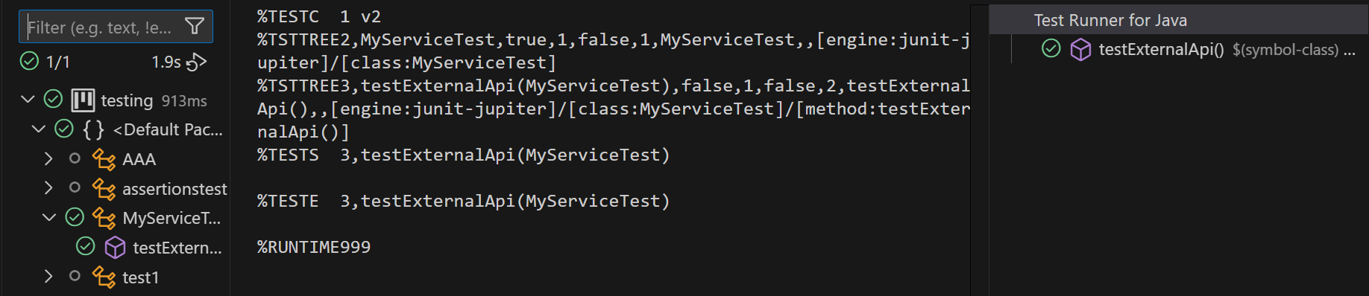

**Exercise 2: Verifying Interactions**

**Solution:**

import static org.mockito.Mockito.*;

import org.junit.jupiter.api.Test;

import org.mockito.Mockito;

public class MyServiceTest2 {

    @Test

    public void testVerifyInteraction() {

        ExternalApi mockApi = Mockito.mock(ExternalApi.class);

        MyService service = new MyService(mockApi);

        service.fetchData();

        verify(mockApi).getData();

    }

}

**Output:**

