**Exercise 1: Configuring a Basic Spring Application**  
**Solution:**

BookService.java -  
package com.library.service;

import com.library.repository.BookRepository;

public class BookService {

    private BookRepository bookRepository;

    public void setBookRepository(BookRepository bookRepository) {

        this.bookRepository = bookRepository;

    }

    public void addBook(String bookName) {

        System.out.println("Service: Adding book...");

        bookRepository.saveBook(bookName);

    }

}

BookRepositor.java –

package com.library.repository;

public class BookRepository {

    public void saveBook(String bookName) {

        System.out.println("Book saved: " + bookName);

    }

}

App.java –

package com.library;

import com.library.service.BookService;

import com.library.repository.BookRepository;

public class App {

    public static void main(String[] args) {

        BookRepository bookRepository = new BookRepository();

BookService bookService = new BookService();

bookService.setBookRepository(bookRepository);

        bookService.addBook("Atomic Habits");

    }

}

**Output:**

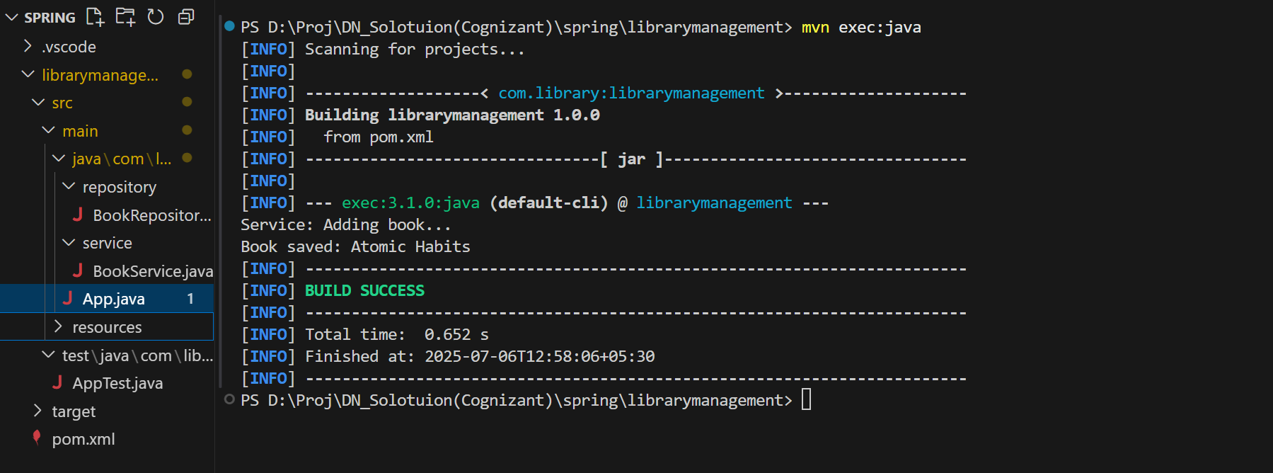

**Exercise 2: Implementing Dependency Injection**

**Solution:**

applicationContext.xml

<?xml version="1.0" encoding="UTF-8"?>

<beans xmlns="http://www.springframework.org/schema/beans"

       xmlns:xsi="http://www.w3.org/2001/XMLSchema-instance"

       xsi:schemaLocation="

          http://www.springframework.org/schema/beans

          http://www.springframework.org/schema/beans/spring-beans.xsd">

    <!--BookRepository bean-->

    <bean id="bookRepository" class="com.library.repository.BookRepository" />

    <!--BookService bean-->

    <bean id="bookService" class="com.library.service.BookService">

        <property name="bookRepository" ref="bookRepository" />

    </bean>

</beans>

App.java

package com.library;

import com.library.service.BookService;

import org.springframework.context.ApplicationContext;

import org.springframework.context.support.ClassPathXmlApplicationContext;

public class App {

    public static void main(String[] args) {

        ApplicationContext context = new ClassPathXmlApplicationContext("applicationContext.xml");

        BookService bookService = context.getBean("bookService", BookService.class);

        bookService.addBook("Harry Potter");

    }

}

**Output:**

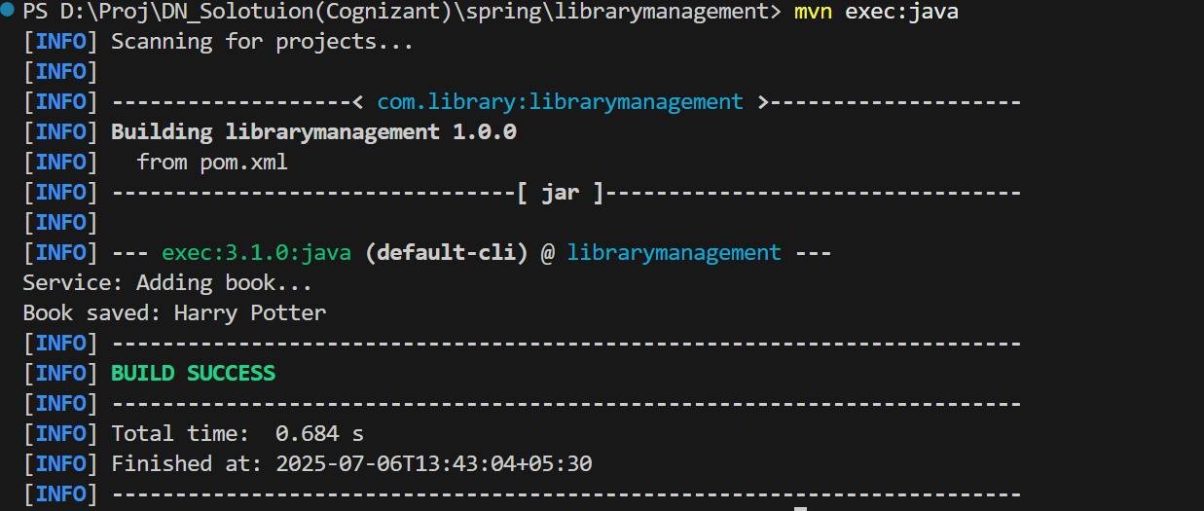

**Exercise 4: Creating and Configuring a Maven Project  
Solution:**

<project xmlns="http://maven.apache.org/POM/4.0.0"

         xmlns:xsi="http://www.w3.org/2001/XMLSchema-instance"

         xsi:schemaLocation="http://maven.apache.org/POM/4.0.0

         http://maven.apache.org/xsd/maven-4.0.0.xsd">

  <modelVersion>4.0.0</modelVersion>

  <groupId>com.library</groupId>

  <artifactId>librarymanagement</artifactId>

  <version>1.0.0</version>

  <properties>

    <java.version>1.8</java.version>

  </properties>

  <dependencies>

    <!--Spring-->

    <dependency>

      <groupId>org.springframework</groupId>

      <artifactId>spring-context</artifactId>

      <version>5.3.32</version>

    </dependency>

    <!--Spring AOP-->

    <dependency>

      <groupId>org.springframework</groupId>

      <artifactId>spring-aop</artifactId>

      <version>5.3.32</version>

    </dependency>

    <!--Spring WebMVC-->

    <dependency>

      <groupId>org.springframework</groupId>

      <artifactId>spring-webmvc</artifactId>

      <version>5.3.32</version>

    </dependency>

    <!--JUnit-->

    <dependency>

      <groupId>junit</groupId>

      <artifactId>junit</artifactId>

      <version>4.13.2</version>

      <scope>test</scope>

    </dependency>

  </dependencies>

  <build>

    <plugins>

      <plugin>

        <groupId>org.apache.maven.plugins</groupId>

        <artifactId>maven-compiler-plugin</artifactId>

        <version>3.11.0</version>

        <configuration>

          <source>1.8</source>

          <target>1.8</target>

        </configuration>

      </plugin>

      <plugin>

        <groupId>org.codehaus.mojo</groupId>

        <artifactId>exec-maven-plugin</artifactId>

        <version>3.1.0</version>

        <configuration>

          <mainClass>com.library.App</mainClass>

        </configuration>

      </plugin>

    </plugins>

  </build>

</project>