1. **Spring Rest -**

**HandsOn 1: Create a Spring Web Project using Maven**

**Solution:**

package com.cognizant.spring_learn;

import org.slf4j.Logger;

import org.slf4j.LoggerFactory;

import org.springframework.boot.SpringApplication;

import org.springframework.boot.autoconfigure.SpringBootApplication;

@SpringBootApplication

public class SpringLearnApplication {

    private static final Logger LOGGER = LoggerFactory.getLogger(SpringLearnApplication.class);

    public static void main(String[] args) {

        LOGGER.info("START");

        SpringApplication.run(SpringLearnApplication.class, args);

        LOGGER.info("END");

    }

}

**Output:**

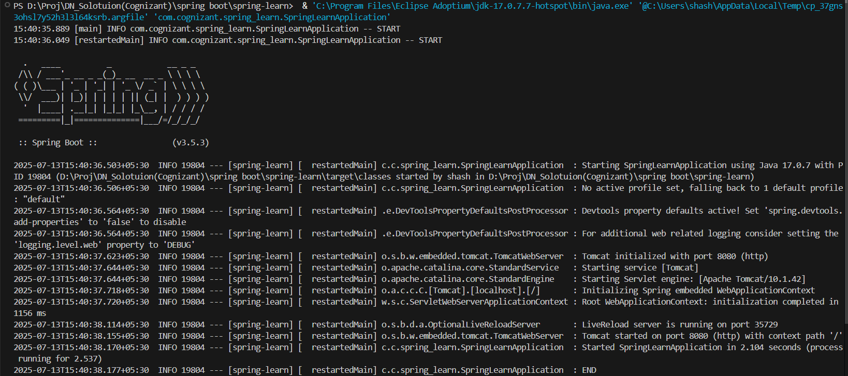

**Hands On 4: Spring Core – Load Country from Spring Configuration XML**

**Solution:**

Country.java –

package com.cognizant.spring_learn;

import org.slf4j.Logger;

import org.slf4j.LoggerFactory;

public class Country {

    private static final Logger LOGGER = LoggerFactory.getLogger(Country.class);

    private String code;

    private String name;

    public Country() {

        LOGGER.debug("Inside Country Constructor.");

    }

    public String getCode() {

        LOGGER.debug("Getting Code: {}", code);

        return code;

    }

    public void setCode(String code) {

        LOGGER.debug("Setting Code: {}", code);

        this.code = code;

    }

    public String getName() {

        LOGGER.debug("Getting Name: {}", name);

        return name;

    }

    public void setName(String name) {

        LOGGER.debug("Setting Name: {}", name);

        this.name = name;

    }

    @Override

    public String toString() {

        return "Country [code=" + code + ", name=" + name + "]";

    }

}

Country.xml-

<?xml version="1.0" encoding="UTF-8"?>

<beans xmlns="http://www.springframework.org/schema/beans"

       xmlns:xsi="http://www.w3.org/2001/XMLSchema-instance"

       xsi:schemaLocation="http://www.springframework.org/schema/beans

       http://www.springframework.org/schema/beans/spring-beans.xsd">

    <bean id="country" class="com.cognizant.spring_learn.Country">

        <property name="code" value="IN" />

        <property name="name" value="India" />

    </bean>

</beans>

SpringLearnApplication.java –

package com.cognizant.spring_learn;

import org.slf4j.Logger;

import org.slf4j.LoggerFactory;

import org.springframework.context.ApplicationContext;

import org.springframework.context.support.ClassPathXmlApplicationContext;

import org.springframework.boot.SpringApplication;

import org.springframework.boot.autoconfigure.SpringBootApplication;

@SpringBootApplication

public class SpringLearnApplication {

    private static final Logger LOGGER = LoggerFactory.getLogger(SpringLearnApplication.class);

    public static void main(String[] args) {

        SpringApplication.run(SpringLearnApplication.class, args);

        displayCountry();

    }

    public static void displayCountry() {

        ApplicationContext context = new ClassPathXmlApplicationContext("country.xml");

        Country country = context.getBean("country", Country.class);

        LOGGER.debug("Country : {}", country.toString());

    }

}

**Output:**

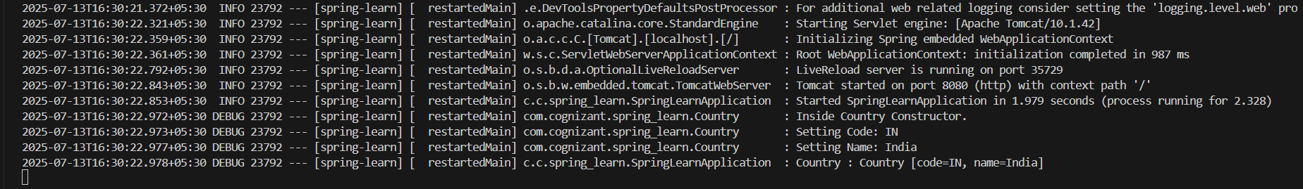

1. **Spring Rest -**

**Hands On : Hello World RESTful Web Service**

**Solution:**

HelloController.java –

package com.cognizant.spring_learn.controller;

import org.slf4j.Logger;

import org.slf4j.LoggerFactory;

import org.springframework.web.bind.annotation.GetMapping;

import org.springframework.web.bind.annotation.RestController;

@RestController

public class HelloController {

    private static final Logger LOGGER = LoggerFactory.getLogger(HelloController.class);

    @GetMapping("/hello")

    public String sayHello() {

        LOGGER.info("START - sayHello()");

        LOGGER.info("END - sayHello()");

        return "Hello World!!";

    }

}

SpringLearnApplication.java –

package com.cognizant.spring_learn;

import org.slf4j.Logger;

import org.slf4j.LoggerFactory;

import org.springframework.boot.SpringApplication;

import org.springframework.boot.autoconfigure.SpringBootApplication;

@SpringBootApplication

public class SpringLearnApplication {

    private static final Logger LOGGER = LoggerFactory.getLogger(SpringLearnApplication.class);

    public static void main(String[] args) {

        SpringApplication.run(SpringLearnApplication.class, args);

    }

}

**Output:**

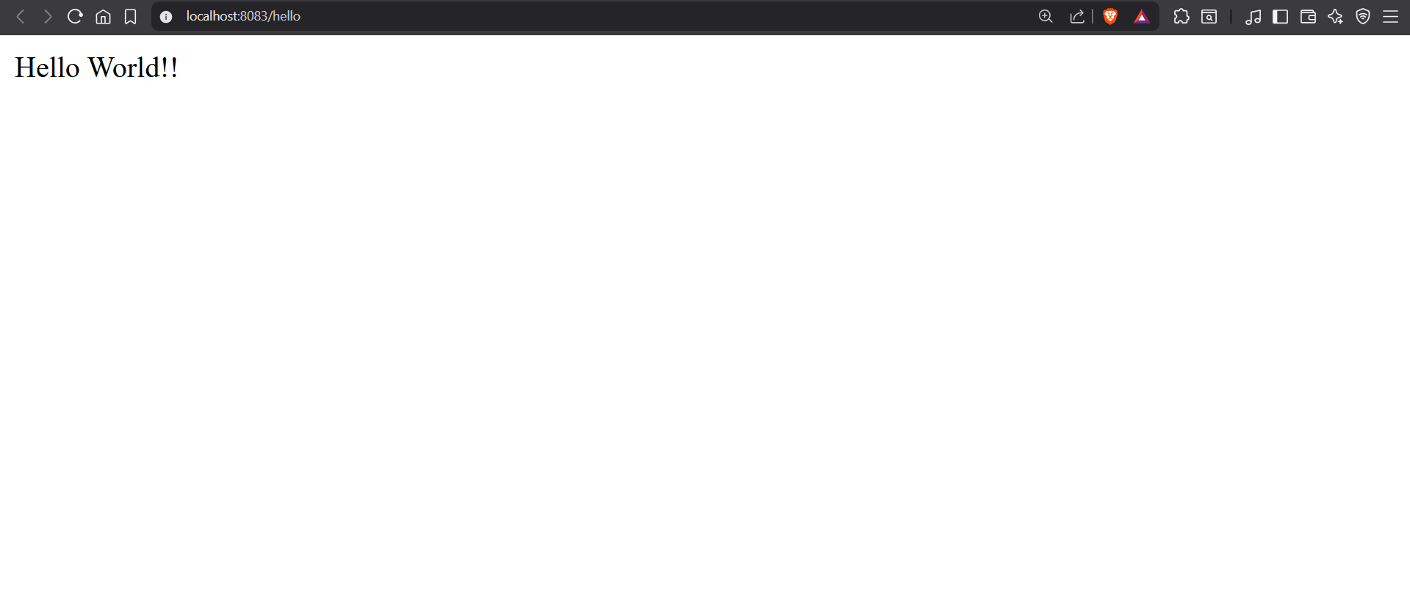

**Hands On: REST - Country Web Service**

**Solution:**

CountryController.java –

package com.cognizant.spring_learn.controller;

import com.cognizant.spring_learn.Country;

import org.slf4j.Logger;

import org.slf4j.LoggerFactory;

import org.springframework.context.ApplicationContext;

import org.springframework.context.support.ClassPathXmlApplicationContext;

import org.springframework.web.bind.annotation.RequestMapping;

import org.springframework.web.bind.annotation.RestController;

@RestController

public class CountryController {

    private static final Logger LOGGER = LoggerFactory.getLogger(CountryController.class);

    @RequestMapping("/country")

    public Country getCountryIndia() {

        LOGGER.debug("START - getCountryIndia()");

        ApplicationContext context = new ClassPathXmlApplicationContext("country.xml");

        Country country = context.getBean("country", Country.class);

        LOGGER.debug("END - getCountryIndia()");

        return country;

    }

}

**Output:**

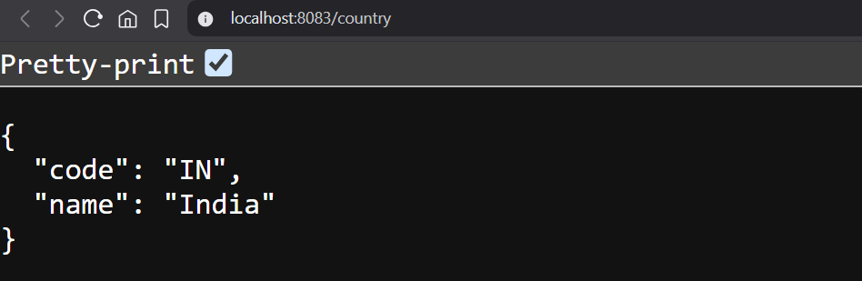

**Hands On: REST - Get country based on country code**

**Solution:**

Country.xml –

<?xml version="1.0" encoding="UTF-8"?>

<beans xmlns="http://www.springframework.org/schema/beans"

       xmlns:xsi="http://www.w3.org/2001/XMLSchema-instance"

       xsi:schemaLocation="http://www.springframework.org/schema/beans

       http://www.springframework.org/schema/beans/spring-beans.xsd">

    <bean id="country" class="com.cognizant.spring_learn.Country">

        <property name="code" value="IN"/>

        <property name="name" value="India"/>

    </bean>

    <bean id="countryList" class="java.util.ArrayList">

        <constructor-arg>

            <list>

                <ref bean="country"/>

                <bean class="com.cognizant.spring_learn.Country">

                    <property name="code" value="US"/>

                    <property name="name" value="United States"/>

                </bean>

                <bean class="com.cognizant.spring_learn.Country">

                    <property name="code" value="JP"/>

                    <property name="name" value="Japan"/>

                </bean>

                <bean class="com.cognizant.spring_learn.Country">

                    <property name="code" value="DE"/>

                    <property name="name" value="Germany"/>

                </bean>

            </list>

        </constructor-arg>

    </bean>

</beans>

CountryService.java –

package com.cognizant.spring_learn.service;

import com.cognizant.spring_learn.Country;

import org.springframework.context.ApplicationContext;

import org.springframework.context.support.ClassPathXmlApplicationContext;

import org.springframework.stereotype.Service;

import java.util.List;

@Service

public class CountryService {

    public Country getCountry(String code) {

        ApplicationContext context = new ClassPathXmlApplicationContext("country.xml");

        List<Country> countryList = context.getBean("countryList", List.class);

        for (Country c : countryList) {

            if (c.getCode().equalsIgnoreCase(code)) {

                return c;

            }

        }

        return null;

    }

}

CountryController.java –

package com.cognizant.spring_learn.controller;

import com.cognizant.spring_learn.Country;

import com.cognizant.spring_learn.service.CountryService;

import org.slf4j.Logger;

import org.slf4j.LoggerFactory;

import org.springframework.beans.factory.annotation.Autowired;

import org.springframework.web.bind.annotation.*;

@RestController

public class CountryController {

    private static final Logger LOGGER = LoggerFactory.getLogger(CountryController.class);

    @Autowired

    private CountryService countryService;

    @GetMapping("/countries/{code}")

    public Country getCountry(@PathVariable String code) {

        LOGGER.debug("START - getCountry with code: {}", code);

        Country country = countryService.getCountry(code);

        LOGGER.debug("END - getCountry");

        return country;

    }

}

**Output:**

