**Ex1: 1.ReactJS-HOL  
  
Solution:**

App.js -

import React from "react";

function App(){

  return (

      <h1>Welcome to the first session of React</h1>

  );

}

export default App

folder Structure –

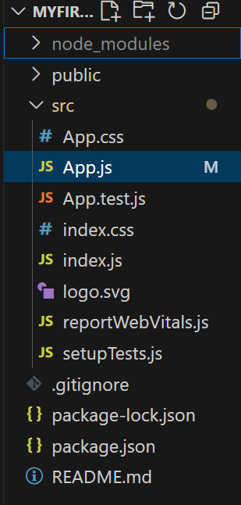

**Output:**

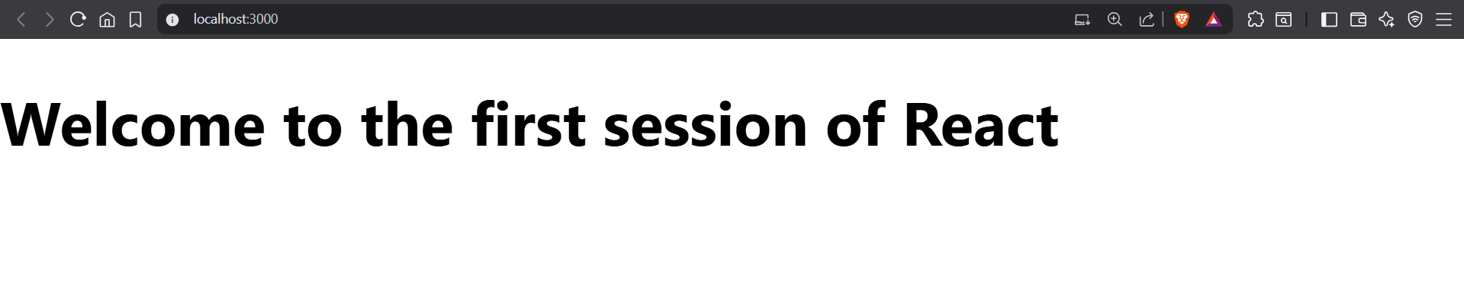

**Ex2: 2.ReactJS-HOL**

**Solution:**

Home.js -

import React from 'react';

function Home() {

  return (

    <div>

      <h2>Welcome to the Home page of Student Management Portal</h2>

    </div>

  );

}

export default Home;

About.js -

import React from 'react';

function About() {

  return (

    <div>

      <h2>Welcome to the About page of Student Management Portal</h2>

    </div>

  );

}

export default About;

Contact.js –

import React from 'react';

function Contact() {

  return (

    <div>

      <h2>Welcome to the Contact page of Student Management Portal</h2>

    </div>

  );

}

export default Contact;

App.js –

import React from 'react';

import Home from './Components/Home';

import About from './Components/About';

import Contact from './Components/Contact';

function App() {

  return (

    <div>

      <h1>Student Management Portal</h1>

      <Home />

      <About />

      <Contact />

    </div>

  );

}

export default App;

**Output:**

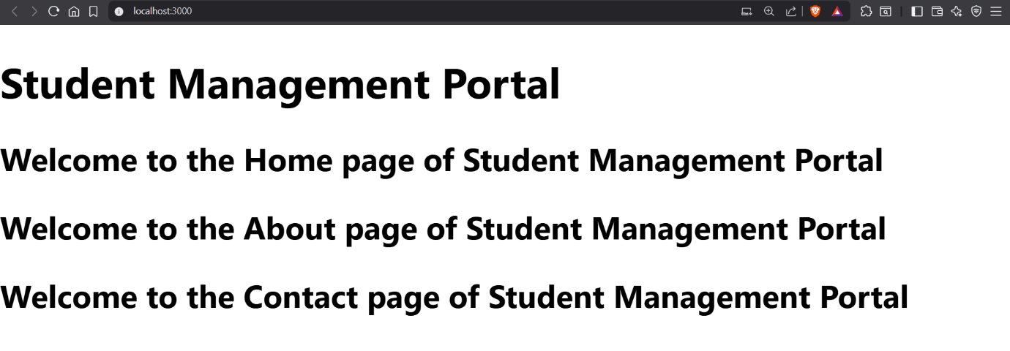

**Ex 3: 3.ReactJS-HOL**

**Solution:**

CalculatorScore.js –

import'../Stylesheets/mystyle.css'

const percentToDecimal= (decimal)=>{

    return (decimal.toFixed(2)+ '%')

}

const calcScore = (total, goal)=> {

    return percentToDecimal(total/goal)

}

export const CalculateScore = ({ Name, School, total, goal }) => (

  <div className="formatstyle">

    <h1><font color="Brown">Student Details:</font></h1>

    <div className="Name">

      <b><span>Name: </span></b>

      <span>{Name}</span>

    </div>

    <div className="School">

      <b><span>School: </span></b>

      <span>{School}</span>

    </div>

    <div className="Total">

      <b><span>Total: </span></b>

      <span>{total}</span>

      <span> Marks</span>

    </div>

    <div className="Score">

      <b>Score:</b>

      <span> {calcScore(total, goal)}</span>

    </div>

  </div>

);

mystyle.css –

.Name

{

    font-weight:300;

    color:blue;

}

.School

{

    color:crimson;

}

.Total

{

    color:darkmagenta;

}

.formatstyle

{

    text-align:center;

    font-size:large;

}

.Score

{

    color:forestgreen;

}

App.js –

import React from "react";

import {CalculateScore} from "../src/Components/CalculateScore";

function App() {

    return (

        <div>

            <CalculateScore Name={"Steeve"}

            School={"DVN Public School"}

            total={284}

            goal={3}

            />

        </div>

    );

}

export default App;

**Output:**

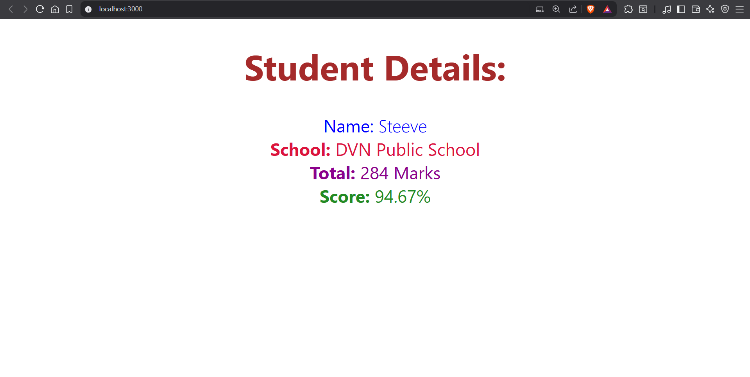

**Ex 4: 4.ReactJS-HOL**

**Solution:**

Post.js –

class Post{

    constructor(id, title, body){

        this.id = id;

        this.title = title;

        this.body = body;

    }

}

export default Post;

Posts.js –

import React from "react";

import Post from "./Post";

class Posts extends React.Component {

    constructor(props){

        super(props);

        this.state = {

            posts: [],

            error: null

        };

    }

    loadPosts(){

        fetch("https://jsonplaceholder.typicode.com/posts")

            .then((response) => {

                if (!response.ok) {

                    throw new Error("Failed to fetch posts");

                }

                return response.json();

            })

            .then((data) => {

                // convert each fetched post to a Post object

                const postObjects = data.map(

                    (post) => new Post(post.id, post.title, post.body)

                );

                this.setState({ posts: postObjects });

            })

            .catch((error) => {

                this.setState({ error });

            });

    }

    componentDidMount(){

        this.loadPosts();

    }

    render(){

        const { posts, error } = this.state;

        if (error) {

            return <p>Error loading posts: {error.message}</p>;

        }

        return (

            <div>

                <h1>Blog Posts</h1>

                {posts.map((post) => (

                    <div key={post.id}>

                        <h3>{post.title}</h3>

                        <p>{post.body}</p>

                        <hr />

                    </div>

                ))}

            </div>

        );

    }

    componentDidCatch(error, info){

        alert("An error occurred: " + error.message);

    }

}

export default Posts;

**Output:**

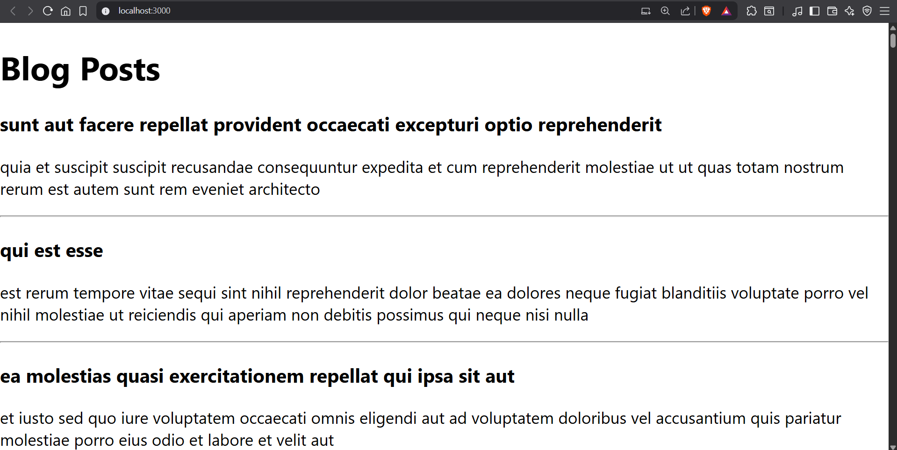

**Ex 5: 5.ReactJS-HOL**

**Solution:**

CohoretDetails.js –

import React from "react";

import styles from "./CohortDetails.module.css";

function CohortDetails({ name, startDate, status, coach, trainer }) {

  const headingStyle = {

    color: status === "Ongoing" ? "green" : "blue",

  };

  return (

    <div className={styles.box}>

      <h3 style={headingStyle}>{name}</h3>

      <dl>

        <dt>Started On</dt>

        <dd>{startDate}</dd>

        <dt>Current Status</dt>

        <dd>{status}</dd>

        <dt>Coach</dt>

        <dd>{coach}</dd>

        <dt>Trainer</dt>

        <dd>{trainer}</dd>

      </dl>

    </div>

  );

}

export default CohortDetails;

CohortDetails.module.css –

.box {

  width: 300px;

  display: inline-block;

  margin: 10px;

  padding: 10px 20px;

  border: 1px solid black;

  border-radius: 10px;

}

dt {

  font-weight: 500;

}

App.js –

import React from "react";

import CohortDetails from "./components/CohortDetails";

function App() {

  return (

    <div>

      <h1>Cohorts Details</h1>

      <CohortDetails

        name="INTADMDF10 - .NET FSD"

        startDate="22-Feb-2022"

        status="Scheduled"

        coach="Aathma"

        trainer="Jojo Jose"

      />

      <CohortDetails

        name="ADM21Jf014 - Java FSD"

        startDate="10-Sep-2021"

        status="Ongoing"

        coach="Apoorv"

        trainer="Elisa Smith"

      />

      <CohortDetails

        name="CDBJF21025 - Java FSD"

        startDate="24-Dec-2021"

        status="Ongoing"

        coach="Aathma"

        trainer="John Doe"

      />

    </div>

  );

}

export default App;

**Output:**

