**Hands On 9:  
  
Solution:**

ListOfPlayer.js-

import React from "react";

function ListofPlayers({ players }) {

  return (

    <div>

      {players.map((item, index) => (

        <div key={index}>

          <li>

            Mr. {item.name} <span>{item.score}</span>

          </li>

        </div>

      ))}

    </div>

  );

}

export default ListofPlayers;

IndianPlayer.js –

import React from "react";

export function OddPlayers({ team }) {

  const [first, , third, , fifth] = team;

  return (

    <ul>

      <li>First: {first}</li>

      <li>Third: {third}</li>

      <li>Fifth: {fifth}</li>

    </ul>

  );

}

export function EvenPlayers({ team }) {

  const [, second, , fourth, , sixth] = team;

  return (

    <ul>

      <li>Second: {second}</li>

      <li>Fourth: {fourth}</li>

      <li>Sixth: {sixth}</li>

    </ul>

  );

}

export function ListofIndianPlayers({ players }) {

  return (

    <ul>

      {players.map((player, index) => (

        <li key={index}>{player}</li>

      ))}

    </ul>

  );

}

ScoreBelow70.js –

// src/Scorebelow70.js

import React from "react";

function Scorebelow70({ players }) {

  const filtered = players.filter(item => item.score <= 70);

  return (

    <div>

      {filtered.map((item, index) => (

        <div key={index}>

          <li>

            Mr. {item.name} <span>{item.score}</span>

          </li>

        </div>

      ))}

    </div>

  );

}

export default Scorebelow70;

App.js –

import React from "react";

import ListofPlayers from "./ListofPlayers";

import Scorebelow70 from "./ScoreBelow70";

import { OddPlayers, EvenPlayers, ListofIndianPlayers } from "./IndianPlayers";

function App() {

  const flag = true;

  const players = [

    { name: "Virat", score: 80 },

    { name: "Rohit", score: 60 },

    { name: "Dhoni", score: 95 },

    { name: "Jadeja", score: 40 },

    { name: "Bumrah", score: 70 },

    { name: "Gill", score: 82 },

    { name: "Surya", score: 68 },

    { name: "Shreyas", score: 73 },

    { name: "Hardik", score: 65 },

    { name: "Pant", score: 90 },

    { name: "Ashwin", score: 45 }

  ];

  if (flag) {

    return (

      <div>

        <h1>List of Players</h1>

        <ListofPlayers players={players} />

        <hr />

        <h1>List of Players having Scores Less than 70</h1>

        <Scorebelow70 players={players} />

      </div>

    );

  } else {

    const IndianTeam = [

      "Rohit Sharma1",

      "Virat Kohli2",

      "Shubman Gill3",

      "KL Rahul4",

      "Jasprit Bumrah5",

      "Ravindra Jadeja6"

    ];

    const IndianPlayers = ['p1', 'p2', 'p3', 'p4', 'p5', 'p6'];

    return (

      <div>

        <h2>Odd Players</h2>

        <OddPlayers team={IndianTeam} />

        <hr />

        <h2>Even Players</h2>

        <EvenPlayers team={IndianTeam} />

        <hr />

        <h2>List of Indian Players Merged:</h2>

        <ListofIndianPlayers players={IndianPlayers} />

      </div>

    );

  }

}

export default App;

**Output:**

Flag = false 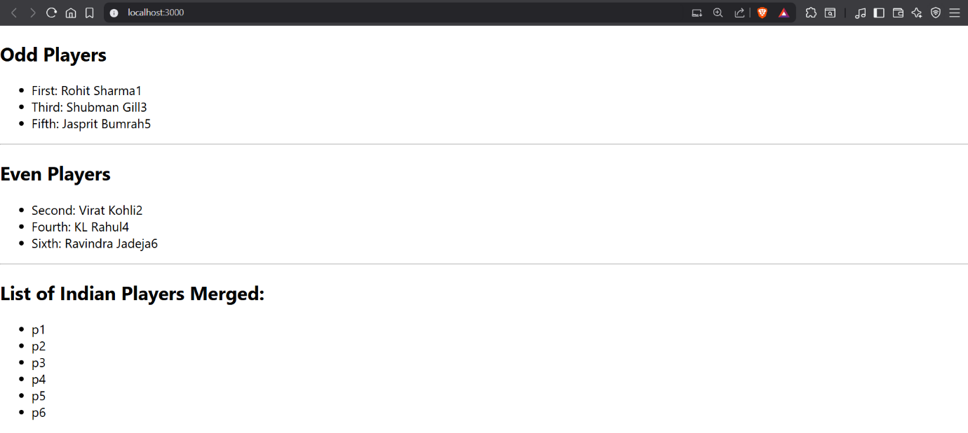

Flag = true

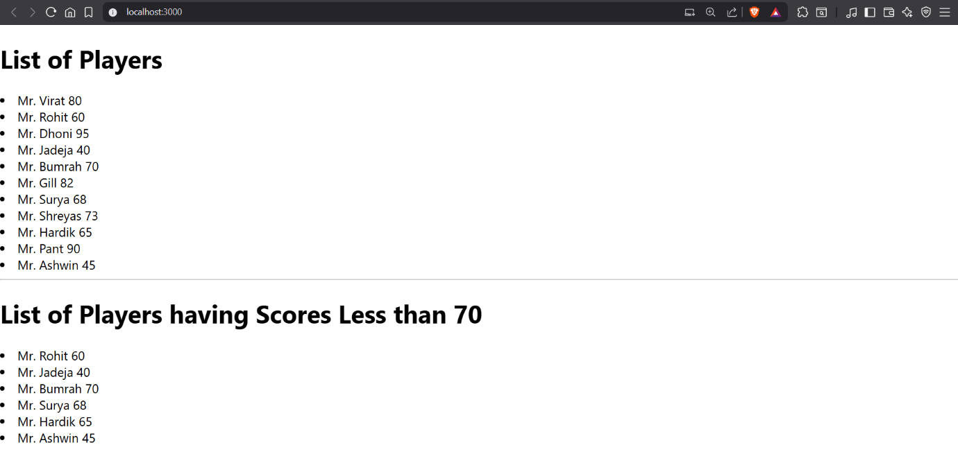

**Hands On 10:  
  
Solution:**

OfficeItem.js –

// src/OfficeItem.js

import React from "react";

import './App.css';

function OfficeItem({ office }) {

  const rentColor = office.Rent <= 60000 ? "textRed" : "textGreen";

  return (

    <div className="office-card">

      <h2>Name: {office.Name}</h2>

      <h3 className={rentColor}>Rent: ₹{office.Rent}</h3>

      <h3>Address: {office.Address}</h3>

    </div>

  );

}

export default OfficeItem;

App.css –

.textRed {

  color: red;

}

.textGreen {

  color: green;

}

App.js –

import React from "react";

import "./App.css";

import img from "./office.jpg";

function App() {

  const element = "Office Space";

  const jsxatt = (

    <img

      src={img}

      width="25%"

      height="25%"

      alt="Office Space"

      style={{ borderRadius: "8px" }}

    />

  );

  const ItemName = { Name: "DBS", Rent: 50000, Address: "Chennai" };

  const rentClass = ItemName.Rent <= 60000 ? "textRed" : "textGreen";

  return (

    <div style={{ padding: "20px" }}>

      <h1>{element}, at Affordable Range</h1>

      {jsxatt}

      <h2>Name: {ItemName.Name}</h2>

      <h3 className={rentClass}>Rent: ₹{ItemName.Rent}</h3>

      <h3>Address: {ItemName.Address}</h3>

    </div>

  );

}

export default App;

**Output:**

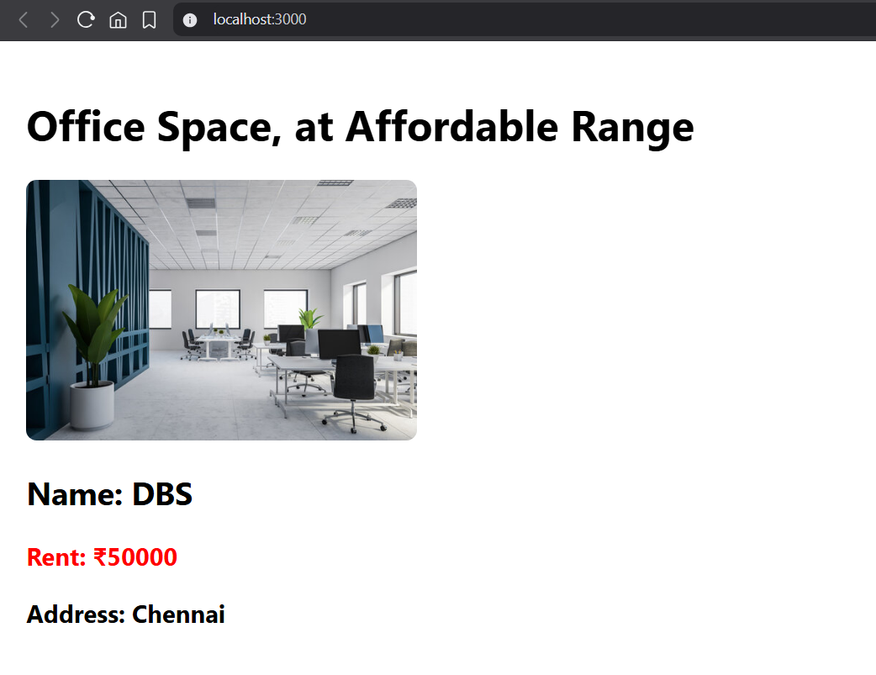

**Hands On 11:  
  
Solution:**CurrencyConvertor.js –

import React, { useState } from "react";

function CurrencyConvertor() {

  const [rupees, setRupees] = useState("");

  const [euro, setEuro] = useState(null);

  const handleChange = (e) => {

    setRupees(e.target.value);

  };

  const handleSubmit = () => {

    const conversionRate = 0.011;

    const converted = parseFloat(rupees) * conversionRate;

    setEuro(converted.toFixed(2));

  };

  return (

    <div>

      <h2 style={{ color: "green" }}>Currency Convertor</h2>

      <label htmlFor="amount"><strong>Amount: </strong></label>

      <input

        id="amount"

        type="number"

        value={rupees}

        placeholder="Enter Rupees"

        onChange={handleChange}

      />

      <button onClick={handleSubmit}>Convert</button>

      {euro !== null && <p>Euro: €{euro}</p>}

    </div>

  );

}

export default CurrencyConvertor;

App.js –

import React, { useState } from "react";

import CurrencyConvertor from "./CurrencyConvertor";

function App() {

  const [count, setCount] = useState(0);

  const handleIncrement = () => {

    increment();

    sayHello();

  };

  const increment = () => {

    setCount(count + 1);

  };

  const decrement = () => {

    setCount(count - 1);

  };

  const sayHello = () => {

    alert("Hello! This is a static message.");

  };

  const sayWelcome = (msg) => {

    alert(msg);

  };

  const onPress = () => {

    alert("I was clicked");

  };

  return (

    <div style={{ padding: "20px" }}>

      <h2>Counter: {count}</h2>

      <button onClick={handleIncrement}>Increment</button>

      <button onClick={decrement}>Decrement</button>

      <br /><br />

      <button onClick={() => sayWelcome("Welcome!")}>Say Welcome</button>

      <br /><br />

      <button onClick={onPress}>Click Me</button>

      <hr />

      <CurrencyConvertor />

    </div>

  );

}

export default App;

**Output:**  
Increment Button: 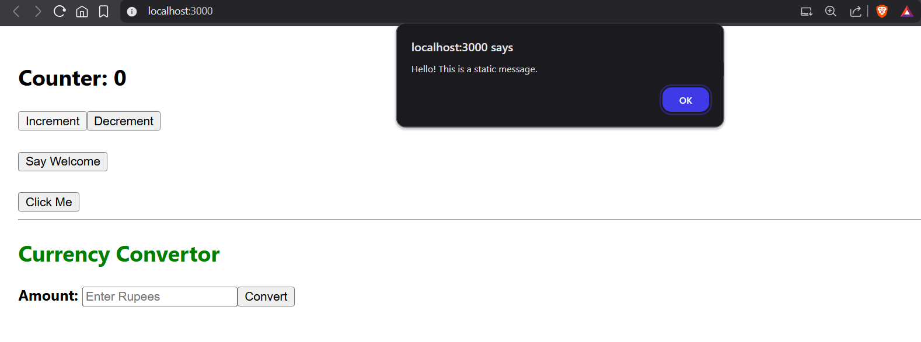

Say Welcome Button :

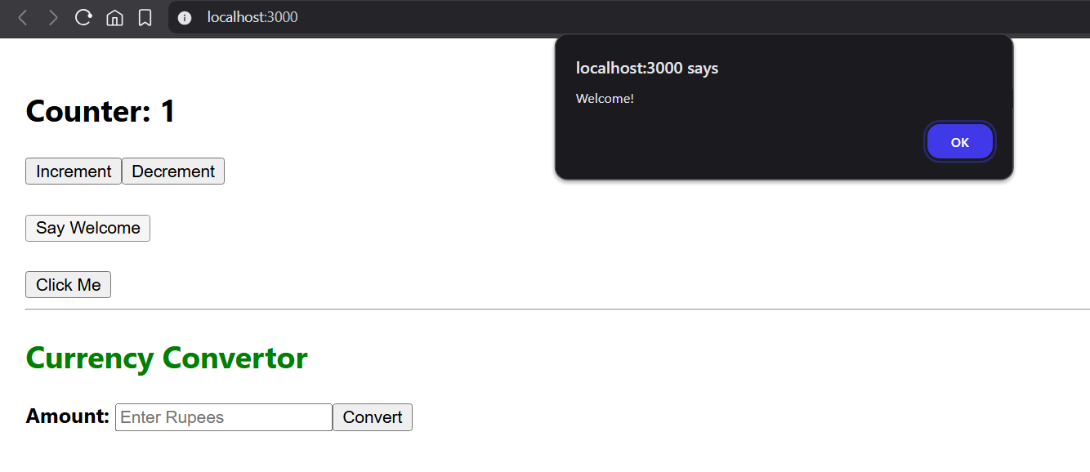

Convertor :

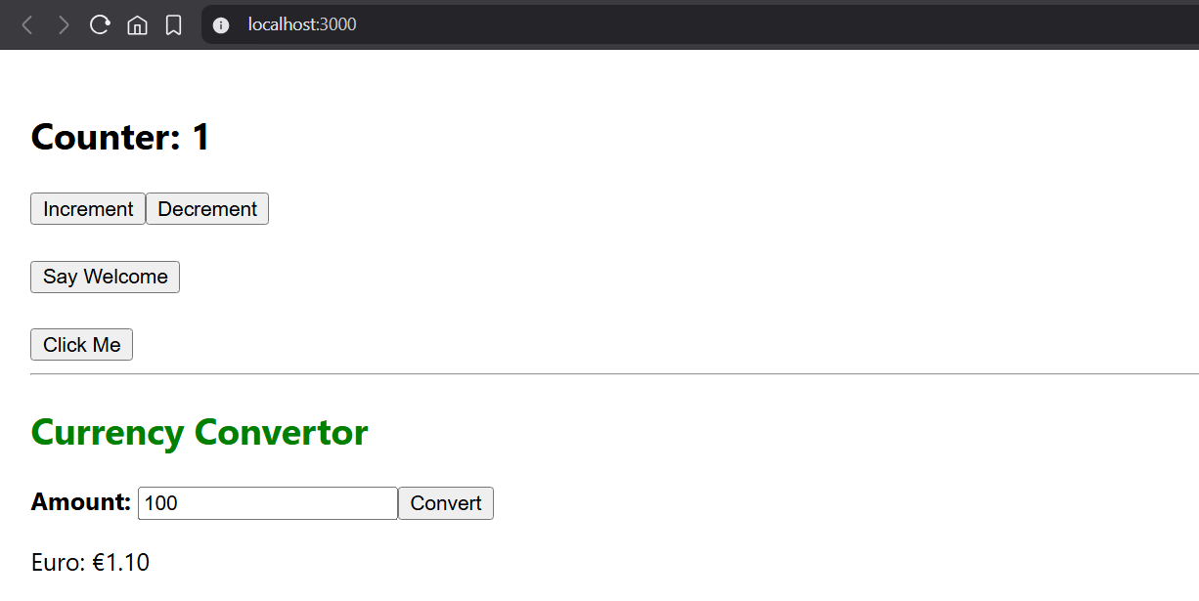

**Hands On 12:  
  
Solution:**LoginButton.js –

import React from "react";

function LogoutButton({ onClick }) {

  return <button onClick={onClick}>Logout</button>;

}

export default LogoutButton;

LogoutButton.js –

import React from "react";

function LoginButton({ onClick }) {

  return <button onClick={onClick}>Login</button>;

}

export default LoginButton;

Greeting.js –

// src/Greeting.js

import React from "react";

function Greeting(props) {

  const isLoggedIn = props.isLoggedIn;

  if (isLoggedIn) {

    return <h2>Welcome Back!</h2>;

  }

  return <h2>Please log in</h2>;

}

export default Greeting;

App.js –

// src/App.js

import React, { useState } from "react";

import Greeting from "./Greeting";

function LoginButton(props) {

  return <button onClick={props.onClick}>Login</button>;

}

function LogoutButton(props) {

  return <button onClick={props.onClick}>Logout</button>;

}

function App() {

  const [isLoggedIn, setIsLoggedIn] = useState(false);

  const handleLogin = () => setIsLoggedIn(true);

  const handleLogout = () => setIsLoggedIn(false);

  return (

    <div>

      <Greeting isLoggedIn={isLoggedIn} />

      {isLoggedIn ? (

        <LogoutButton onClick={handleLogout} />

      ) : (

        <LoginButton onClick={handleLogin} />

      )}

    </div>

  );

}

export default App;

**Output:**

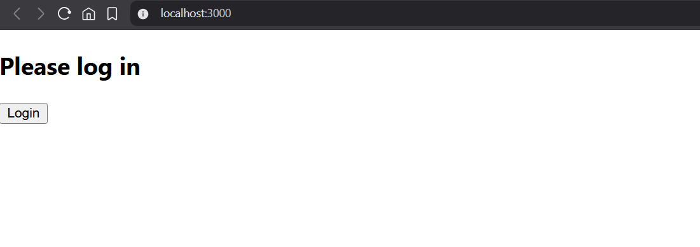

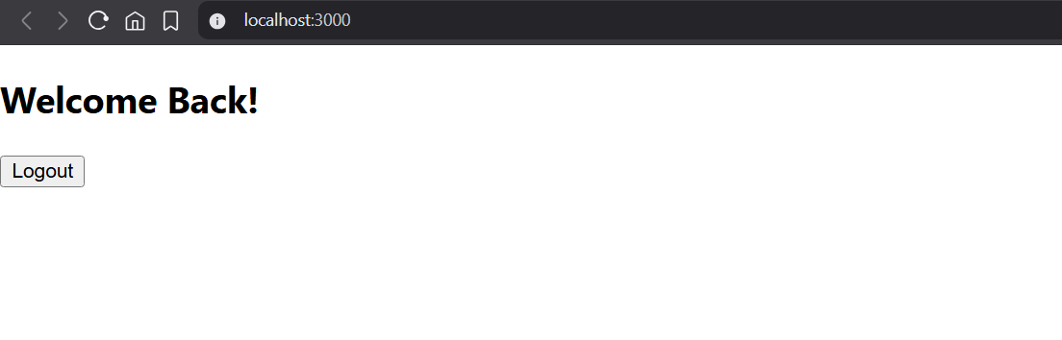

**Hands On 13:  
  
Solution:**

BookDetails.js –

import React from "react";

function BookDetails() {

  const books = [

    { id: 101, bname: "Master React", price: 670 },

    { id: 102, bname: "Deep Dive into Angular 11", price: 800 },

    { id: 103, bname: "Mongo Essentials", price: 450 },

  ];

  return (

    <div className="section">

      <h2>Book Details</h2>

      <ul>

        {books.map((book) => (

          <li key={book.id}>

            <strong>{book.bname}</strong>

            <br />

            Rs. {book.price}

          </li>

        ))}

      </ul>

    </div>

  );

}

export default BookDetails;

BlogDetails.js –

import React from "react";

function BlogDetails() {

  return (

    <div className="section">

      <h2>Blog Details</h2>

      <ul>

        <li>

          <strong>React Learning</strong>

          <br />

          Stephen Biz

          <br />

          Welcome to learning React

        </li>

        <li>

          <strong>Installation</strong>

          <br />

          Schewzdenier

          <br />

          You can install React from npm

        </li>

      </ul>

    </div>

  );

}

export default BlogDetails;

CourseDetails.js –

import React from "react";

function CourseDetails() {

  return (

    <div className="section">

      <h2>Course Details</h2>

      <ul>

        <li>Angular</li>

        <li>Date</li>

        <li>React</li>

        <li>Dat</li>

      </ul>

    </div>

  );

}

export default CourseDetails;

data.js –

import React from "react";

function CourseDetails() {

  return (

    <div className="section">

      <h2>Course Details</h2>

      <ul>

        <li>Angular</li>

        <li>Date</li>

        <li>React</li>

        <li>Dat</li>

      </ul>

    </div>

  );

}

export default CourseDetails;

App.css –

.container {

  display: flex;

  justify-content: space-around;

  padding: 20px;

}

.section {

  width: 30%;

  padding: 10px;

  border-right: 2px solid green;

}

.section:last-child {

  border-right: none;

}

App.js –

import React from "react";

import CourseDetails from "./CourseDetails";

import BookDetails from "./BookDetails";

import BlogDetails from "./BlogDetails";

import "./App.css";

function App() {

  return (

    <div className="container">

      <CourseDetails />

      <BookDetails />

      <BlogDetails />

    </div>

  );

}

export default App;

**Output:**

