TRASHED

Federation Hangar E-552

--------------------------------------------------------------------------------------

**AUTOMATED CREW ROLL CALL – Kestrel Miner “Trash Compactor”**

TRACKER576 (Protogen, Ex-Infantryman, Spaceship Pilot) - CAPTAIN

RAPTOR576 (Primagen, Ex-Infantryman, Weapons Technician)

Cheese (Sergal, Mechanic)

??? (Unknown Entity)

--------------------------------------------------------------------------------------

*This short roll call lay before the artificial and technically non-existent eyes of TRACKER – since his strange promotion to the rank of spaceship captain despite having been trained as ground infantry he’s had one simple mission – go to the Federation capital and deliver extremely important knowledge about the ever-advancing Rebel Fleet.*

Since the Rebel insurgence had already captured the First Earth and bashed most of the civilian Militia to bits, and are quickly heading towards the Federation capital sector, every single capable pilot was given whatever spaceship was available to fight – no matter how ill-prepared.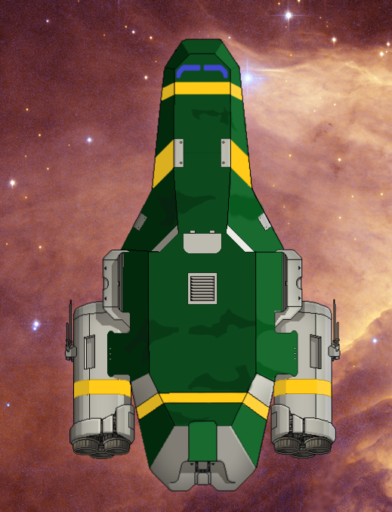

The Kestrel Miner that was handed to this particular protogen was previously used in asteroid mining by a civilian corporation. Said corporation had to abandon their entire fleet of miner ships after a disastrous incident involving a squad of Rockmen – but that’s beside the point now. Despite its battered exterior and even worse interior, this Kestrel was outfitted with decent enough weaponry – a garbage ejector artillery, to be exact. Using its scrap arms to collect space garbage and other useless metallic things, this improvised weapon may pack quite a punch (provided the enemy pilot doesn’t know what a functional engine is supposed to do, is unaware of the “autopilot on” button, or is currently blind, deaf and a quadruple amputee.)

The first crewman to board this Miner was Cheese the sergal – the disorderly cheesehead and current RSA Technician is the ship’s Mechanic, and a damn fine one at that. Next was his lover and/or husband, Raptor, the mostly artificial military primagen. How they met and why, I don’t know and I’m frankly too afraid to find out. I haven’t asked ‘em. I have to agree though, there’s something endearing about a pink-furred sergal with minimal clothing and leather toolbelts being engaged to a 2.4 meter tall dark orange robotic machine of destruction. They do keep it to themselves most of the time, so I can’t complain.

The next was I, their newly-appointed captain. I’ve known Raptor for quite a while since we served as Federation ground troops for a pretty darn long while. I’ve heard plenty about Cheese and his legendary exploits… heard, not listened, since I zoned out after two minutes.

Even robots can feel boredom, by the way.

We had two hours to leave the Federation hangar where our lovely little Trash Compactor was parked – and in those two hours, after sending Cheese to set up the trash cannon and Raptor to assist, I’ve done a royal-sized goof. You see, this ship, like many others, comes pre-equipped with a clonebay. It’s a pretty nifty thing, once your life signs go bye-bye this machine makes another body and transports whatever’s left of your soul to said new body. Meaning you can’t really die.

Did I ever mention what the number next to my name means? It’s the clone iteration. 575 of me existed, and 575 of me died, alongside the same number of Raptor clones. I’m the 576th, and somehow, I do remember all of the deeds and wrongs of all past lives. **All of them**. At least two of ‘em had funny deaths. At least one involved a toaster.

Since I’ve had my literal millennia’s worth of experience with clone bays, I took to tinkering with this one, seeing if I could make it clone faster or something. It was the latest NEW-ME!™ model… or at least it claimed to be, but the Hektar™ label below seems to suggest it’s a cheap knock-off. Nevertheless, I checked its diagnostics and was pleasantly surprised to see a backup DNA bank attached to its system! You see, for the cloning process to work with a traditional clonebay, you need the dead body of the recently deceased subject for its DNA, and also to serve as the base for the new body. But the DNA banks would skip the former requirement! I absent-mindedly tried configuring it, first on myself, then on Cheese and Raptor.

Even tried the micro-cloning feature to fix the barbed wire scarring on my legs that I have since 300 iterations ago. I thought it was fun to keep for said 300 iterations, scars attract women apparently. But I guess that look is 3000 years out of fashion by now.

And it worked, moderately, as we’d all successfully scanned, and I’d added some extra tissue to my legs to fix the scarring – problem is, this stupid machine must’ve malfunctioned somehow, since there were now four of us. Before me stood a lanky, pink-furred creature, resembling me in body shape… it even has a protogen visor! And yet, it has the double set of ears and right arm scars of Cheese.

Not to mention the blood, oil and coolant leaking out of most of its orifices, since clearly it wasn’t supposed to exist in the first place.

Whatever it was, we were all way to preoccupied to kill it, so we left it in the clonebay and sealed the room.

I went to the pilot room, ordered everyone to their stations, and jumped to the next sector.

Civilian Outskirts – Distress Beacon Detected – 5 Fuel Left

Did I ever mention we don’t have enough fuel for the trip? ‘cause we don’t. Started with 6 cells, and we’ve 5 left. That means 5 sector jumps. The capital is 20 sectors away, and my basic understanding of algebra points to the fact that 5 might be a smaller number than 20.

Since we’re all (metaphorically) drooling over the piloting desk, I could as well check the ship’s sensors to see what’s happening around us.

...Our sensors are cooked. Most are not even installed. Should’ve checked before we left, but no, I just HAD TO tinker with the clonebay. Speaking of… Let’s test this new PA speaker system. I just have to pick this phone up and just say anything, for example…

Tracker: Cheese? Please go to the clonebay immediately and check on your brother. Technically it’s not related to you, but I’m calling that thing your brother now.

Cheese: Aye aye, capp’n.

Tracker: Ah, you can even talk back to me!

Cheese: Affirmative, ship’s PA has response speakers installed. More stuff to invade our collective privacy.

Tracker: You won’t care about privacy if we get blasted to smithereens after our first battle. Speaking of, please get to the clonebay and see if the thing’s responsive, and if not, toss it in the flak cannon.

…

Tracker: Charging faster than light jump, we’re leaving to next sector.

Raptor: Sir? Uh, there’s a distress beacon ‘round here.

Tracker: Says who?

Raptor: The onboard map, sir.

Tracker: (sigh) I’ll take a look around while the FTL is charging.

The Kestrel makes a guttural groan as I push the steering wheel, but it soon stops making creaky noises.

Cheese: Captain. Uh. The thing is trying to leave.

Tracker: What?

Cheese: It’s got no forearms and it’s falling apart but it’s bashing its visor against the blast doors of the clonebay.

Tracker: (sigh) We’ll deal with this later.

This sector, despite being having a civilian beacon, is surprisingly barren – a few merchant ships whizzed past the Compactor, but the source of the distress beacon wasn’t anywhere to be seen, heard or otherwise detected.

Tracker: FTL full, jump in 3, 2, …

Abandoned Sector – 4 Fuel Left

Cheese: Captain, please tell me why we didn’t just jump to the civilian coreworlds instead of taking this weird shortcut.

Tracker: Ah, it’s simple. We need to conserve fuel. Got only 4 units left.

Cheese: Please explain how 4 fuel is going to get us to the capital.

Tracker: ...We’ll have to find some on the way.

Cheese: We could’ve bought some at the civvie coreworlds.

Tracker: With what?

Cheese: With scrap, capp’n. We have 12 units’ worth of scrap laying around in the hold. If memory serves, that’d mean 3 extra cells were we to exchange them at a shop. Speaking of, this Kestrel has a scrap arm underneath it, have you tried extending it to grab more scrap?

Tracker: Sounds like a good idea. There’s a torn Civilian Carryship right under us, let’s see how much scrap we can get out of it.

Cheese: Seems pretty badly sliced, probably got on the wrong side of a laser beam.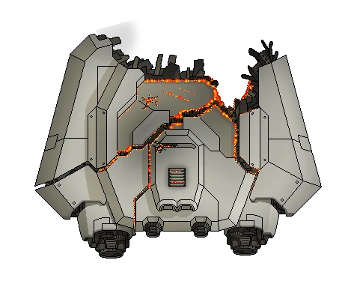

Raptor: Sir, we’re not alone.

Tracker: Yeah, the thing in the clonebay…

Raptor: Sir, there’s a civilian outrider behind us with the purple markings of a pirate.

Suddenly, the communication system flares up, filling the piloting room in a yellow glow, and displaying the piloting room of the ship behind them. Before Tracker lay a short, angry slug.

???: Dear trasssssssh sssssship pilot, may we have ssssssome ssssscrap?

Tracker: Uh, 2 units of scrap for 1 fuel cell.

Cheese: Cap, the exchange rate is-

Tracker: Shut up, I’m negotiating!

???: You don’t get it. We’ll blassssst a hole right through your sssssssship if you don’t empty your cargo hold now.

Seeing that we don’t have proper weaponry and don’t even have a shield, I glance at the FTL charging bar.

5… 4…

???: Dammit, they’re leaving, ssssssshoot out their engines!

3… 2…

Zoltan Forward Outpost – 3 Fuel Left, 37 Scrap

Tracker: Heh, you absolute goof.

Raptor: Sir, we got away unscathed, but that’s because they had the crappiest weapons this side of the multiverse – we may not be so lucky next time. Please, next time we get to a shop, we’re getting a competent weapon.

Tracker: And fuel. Don’t forget the fuel!

Raptor: If we’re dead, we won’t need any fuel.

Tracker: Shut up, there’s a zolty on the comms.

Truly enough, a tall, green, transparent and bioluminescent Zoltan secretary is sitting in a cramped office, clearly not being too enthusiastic about his job.

Zoltan Guard: Dear visitors, welcome to our outpost, we have checked your Federation ID and it seems good, blah blah blah, please don’t break anything.

Tracker: Any shops ‘round here?

The Zoltan flares up, not expecting communications to continue past the introductory phase. He wipes his translucent brow and starts paying actual attention to the conversation.

Zoltan Guard: No, mister pilot. We’re a military outpost sent by the ministry to fight against the rebel threat. We’ve got two fighter ships and a station – you might get a trade at the station, but it’s not guaranteed. Shall I tell them that you want to trade?

Tracker: Go ahead. Thank you.

Zoltan Guard: Good luck.

The communicator closes itself as the zoltan guard disconnected. The zoltan are a peaceful yet fragile race but their craftsmanship is truly something to fear. We’re lucky the Federation are their closest allies. We are also unlucky that they are one of the laziest races ever. Bureaucracy is unfun, and the Zoltan are all about bureaucracy, and laws, and taxes, *and exemptions, and paperwork, and taxes…*

A short Zoltan miner exits the station via its main airlock and seems surprised by our ship visiting them – they quickly scurry back inside, and return with a box of military supplies. They’ve recognized us as a Federation ship and are offering us a gift! How nice of these hardlight beings.

Inside the crate, alongside a pile of scrap and deprecated office equipment (aka: more scrap!), we found a 'Marksman' Booster Laser! Finally, as Raptor would consider it, a competent weapon.

Gently surprised by the Zoltan’s generosity, we leave our farewells and wishes of good luck and prepare to jump.

Tracker: Back to your seats everyone. Jumping in 3, 2, ...

Zoltan Liberated Sector – 2 Fuel Left, 47 Scrap

The Trash Compactor whirs gutturally, and comes to a complete standstill – the FTL jump has left us right next to a ship of the Zoltan Ministry Border Patrol.

We decide not to hail or engage the patrol, so I reroute all power to engines and prepare to jump immediately.

While waiting, Raptor gets the new Booster online, and I route whatever power he needs for it to the weapons room.

Pirate Infested Sector – 1 Fuel Left, 47 Scrap

AUTOMATED WARNING – LOW FUEL

THIS AUTOMATED WARNING HAS BEEN SPONSORED BY HEKTAR(TM)

Raptor: Sir, there’s someone behind us!

Tracker: Do they have fuel for sale?

Raptor: No, they have multiple weapons and are powering them up! We need to fight!

Tracker: Dammit, uh… Shields are down, sensors are cooked, left afterburner is busted, we can barely hold this ship together! Raptor, get to the weapons room ASAP and have the flak charge to max and fire on the enemy’s shields room!

Cheese: We’ve got a hull breach in our engines room, moving in to repair.

Tracker: Dammit, get it fixed immediately so we can jump away! Anybody got eyes on the enemy?

Cheese: Our sensors are down and I won’t get to ‘em-

The communications are interrupted by a loud explosion, having torn some of the roof apart.

Raptor: (yelling, nearby) MULTIPLE BREACHES, GOING EVA TO FIX THEM!

Seeing most lights on my control panel are now rapidly blinking red, I decide to open the pilot room blast doors and start fixing the breaches before we lose too much pressure.

I find raptor toiling away at the roof, and join him in trying to mend it back to a more… usable state.

Raptor: The life signs on the enemy ship are fading, what the hell is happening?

Tracker: I’m not sure, maybe our booster laser is that good?

Raptor: Our laser managed to get 40% charge before the weapons room cracked, something else must be engaging them…

Tracker: Cheese, status on engines.

Cheese: Fixed, crank’em and jump! Now, captain!

Tracker: Calm down, we’re still losing air!

Cheese: Damn the air, we’re gonna lose the whole ship!

Tracker: Get a life support helm on and start fixing them! Raptor! RAPTOR! What the hell’s the enemy ship doing?

Raptor: Sir, my onboard sensors are erroring badly, I’m seeing a dead hostile moving around the enemy ship.

Tracker: Uh, alright? F#@king hell, I don't have time for this!

Raptor: Sir, they’ve got teleporter lock-on with one crew left, they’re gonna board us!

Tracker: Ditching their own ship… they’ve got guts. Everybody, grab your weapons!

Cheese: Sir, I don’t have a-

The slow whir of the teleporter signals an enemy beaming onboard in the clonebay.

Tracker: Raptor, get your rifle and go kill ‘em! I’ve got the roof!

The door control room was being actively worked on by Raptor, who I gently bashed with my legs in a sign of “dude, get my orders done.”.

After running through the ship and opening the clonebay blast doors, Raptor is surprised to see the last remaining enemy – the abhorrent failure of the clonebay! It’s stormed the enemy ship, managed to kill everything it found and even returned! Despite currently falling apart and being severely beaten up, it’s standing in a corner, seemingly docile and content.

Raptor: Hey… What are you?

…

Raptor: Can’t even talk, I see. Cheese, get to the clonebay asap, we need to perform some emergency surgery. We may have a new crewmember.

Lanius Training Grounds - !0 FUEL LEFT!, 71 scrap

A few hours have passed, and the thing has been nursed back to… full health, if you even call it that. With a newly rebuilt chestplate, several metal bars to hold its abdomen together and two bionic arms, including one equipped with a “Mantis” blade and a simple artificial voice box – this… thing is our new crewmember. 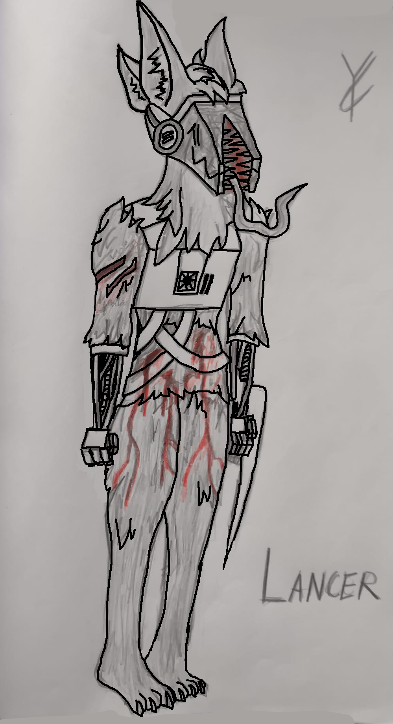

Just in time, since we’re floating around in hostile territory without any fuel.

I decided to turn on our distress beacon in order to seek help, and in the meantime sat down with the new being to talk.

It’s now taken a spot in our teleporter, seemingly waiting to perform its next task.

Tracker: So… you mind talking to me a bit?

???: (garbled, heavily artificial but happy sounding voice) Negative!

Tracker: What’s your name?

???: Name and address (whir) 404, not found.

Tracker: Well, uh…

???: (whir) Arm, weapon safety regulations?

Tracker: Uhm… That’s a mantis lance. Also known as a random part of space debris that Cheese stuck in your arm as a weapon.

???: (whir) Lance-ERRR

Tracker: Yeah, Lancer! That’s a great name!

Lancer: ERRRRrrrRR- voice box problem solved. New name registered succesfully! Your toaster is now known as Lance-ERR.

Tracker: Sounds fun. Wanna eat? We’ve got insta-noodles. *Only* insta-noodles, in fact.

Lancer: (whir) Delicious! **WHERE**.

Raptor: Sir? Hate to interrupt your multiversal insta-noodle based friendship, but we’ve got company, I’m patching you into their comms now...

???: (unintelligible) Multiverse ship, more rebels? ...I don’t care, board them anyway… more war trophies…

Raptor: They’re Lanius, and they’re gonna board us! Everyone, to arms!

Lancer: (whir) The following presentation is not suited for faint of heart!

I scurry back to the piloting room and get maximum power to the weapons room – we’re charging at max speed, and the enemy doesn’t appear to have any weapons – they do, however, have a teleport room. And lock-on on our ship.

Tracker: We’re being boarded! Someone, tell me where they went so I can flush them out of the ship!

Raptor: Sir, detecting 4 hostiles onboard, location unclear, none left on the enemy ship.

Tracker: Rookies. Heh. Find them already! Cheese, get back to engines and crank them to full, we’re hightailing it out of here!

Cheese: Uh, with what fuel?

Tracker: With your mo- uh. Right. Uhm. Lancer, care to board these guys and find a fuel cell? It’s a cylinder, it smells funny, um, *I don’t know how to describe a fuel cell in more detail*.

Lancer: Great (whir) VACATION PLANNING (whir) sir.

Tracker: Just Tracker is fine, now go get it.

Lancer: Just (whir) Tracker.

The commotion quickly subsides as our clonefail (I technically created the… thing, so I get to name it, right?) manages to toss the enemies out of the main airlock, most of their bodies sliced to shreds. Lancer is extremely effective, and he seems docile. For now. Note to self – keep a stock of Insta-Noodles.

The Lanius ship is of a strange new design – nonetheless, we managed to off them. Most of them, at least. I take great joy in every Lanius life taken, and love to see their dead ship as a war trophy. Can’t really take it with me, but I can scrap most of it.

Speaking of, the comms log on their ship's main computer is quite concerning - it talks about someone called The Trash Eater making his "final transformation" and getting read to "eat everything - blood and metal for the blood and metal god."

I disregard these messages as mad ramblings of these so-called Scrapper Lanius.

Speaking of, Lancer brought me a gift! 3 fuel cells. Could be far worse.

He was also trying to chew on a Lanius’ severed head. Good for him, but he’s apparently adverse to eating metal. Insta-noodles are the way.

Sylvan’s Lodge – Merchant Beacon Detected – 2 Fuel Left, 104 scrap

Tracker: Lancer, please remind me who this Sylvan guy is.

Lancer: (whir) SEARCHING DATABASE. MATCH FOUND. (whir) *Go buy missiles at Sylvan’s! We have the biggest missiles this side of the multiverse! The size of the missile really DOES matter! (like really, don’t buy the wrong ones, we don’t give refunds you twat!)* (whir) TRACKER CONTENT WITH RESULT?

Tracker: Yeah thanks. Let’s see if this dude has fuel.

Suddenly, a purple dressed lavish looking slug appears on the main screen, startling me.

Sylvan: I’m Sssssssylvan, and before you asssssk, we don’t sssssell fuel! (we’re sssshort on it oursssssselves!)

Tracker: Well, there goes my chance to appease both Raptor and Cheese at the same time.

Sylvan: I mean, if you ssso desssire, I know where to get fuel. Lotsssssss.

This simple sentence has made me jump out of my pilot seat, flail my robotic limbs in excitement, jump back into my pilot seat, then realize I probably look like some sort of lunatic.

Tracker: Say no more! We crawled out of literal hell and I’m not afraid to get my paws dirty!

Sylvan: Ssssshut up. There’sss a guy in the next sector, a merchant. He insulted my husband! Pleassse kill him for me.

Tracker: Okay… what about my reward?

Sylvan: Fear not, sssstranger… He has rewardssss aplenty in hissss cargo hold. Like, a ton. Just go fetch them. Easssssssssssssssssssy!

Tracker: Murder and/or bloodshed? Sounds like a fun Friday night to me! Now then, what do you *have* for sale?

Sylvan: For you, sssssstranger? For you, I have a deal! I can get you a sssshield system with one layer on it for… a hundred sssscrap. The besssst deal anyone can fetch you, yessss.

Tracker: Deal! Shake my hand!

Not having learned my lesson from earlier, I enthusiastically jump out of my seat towards the projection in front of me – only to realize I’m making an idiot of myself in front of a businessman.

Sylvan: …We’re talking through a computer, dumbass.

Tracker: (sigh) … Cheese, please send Sylvan 100 scrap.

Cheese: Did you buy insta-noodles again?

Lancer: CONVERSATION MAKES LANCER DESIRE **NOODLES**.

Tracker: Nah, I just bought defences.

Sylvan: Right. Have fun with that. *No refunds, by the way.* So, the guy’s name is Slugton. Wears pink and yellow tinted glasses. Very idiotic and annoying and... He hassss a Free Mantis as hissss right hand man, I have no idea what’s hissss name. (Sylvan gestures something, but the translator does not account for gestures. It does seem rude in nature so it’s probably related to his ire against the two that crossed him.) Kill them both, pleassse. Make it… painful.

Tracker: Slugton, annoying glasses, murder. Gotcha. *CHEESE! CRANK THE ENGINES! WE’RE GONNA PAY A WELFARE VISIT TO A SLUG, A FREE MANTIS AND LOTS OF FUEL CELLS!*

SALE SALE SALE SALE SALE – Merchant Beacon Detected – 1 Fuel Left, 4 scrap

The main console immediately gets bombarded with shills of all kinds – almost every product known to mortals (and probably gods too) was advertised in the span of around 10 seconds. Did you know they made peg legs out of uncut diamonds? Well, you do now.

I quickly get to work on shutting the thing down before I get completely overwhelmed by advertisements, and instruct the others to try and do the same.

Cheese: Sir… there’s an ad about hot gay sergals at our sector on the engines PC. …uh, permission to click?

Tracker: **NO!**

…The internal lighting shuts off moments later, being replaced by blaring advertisements on the PA followed by the lights glowing in erratic pink and yellow patterns.

Tracker: CHEESE I TOLD YOU EXPLICITLY NOT TO CLICK THE F$@KING AD

Raptor: Sir, my on-board sensors are going absolutely haywire, but even then, I can see a gigantic ship approaching us. I advise HEAVILY against-

The transmission cuts, being replaced by the obnoxious, salty, completely unhinged voice of…

Slugton: HELLLLLLLLO EVERY OOONEEEE! It’sss ssoo **nice** to have sssome company! Yess… You want to buy sssstuff, yesss? BUY BUY BUY BUY!

Oh no. He’s even worse than what Sylvan said, or at least implied. But wait, there’s more…

???: Slugton be makings dealing of century, yes! Me not know what long century is, but century extremely long, and for sale! Everything for sale!

That’s got to be the Free Mantis, given the poor speech. The translator software is barely keeping up, with them spouting random nonsense in all languages they could muster.

Tracker: Trust me, I have seen centuries, of war, death and-

Slugton: THEN YOU WILL BUY CENTURIES! WITH SCRAP – **CASH MONEY!**

Tracker: No, we’re-

???: 100 scrap for one centuries! You even getting… 0.5 U.W.U. points! Deal of several lifetimes!

Slugton: (whispering, most likely to his Free Mantis subordinate) Half a point? Dude, that’sss offering quite much. Go a quarter, ssssee if they bite.

???: I becoming real businessmantis! Deal? Yes/no?

My confused gesturing is utterly useless. They’re not paying attention to me, they’re apparently browsing some kind of furniture ad brochure right now.

Tracker: **Can you not cut me off for-**

Slugton: So, that’ll be 500 scrap. Do you want/need/desire/request financing? We offer-

The transmission cuts yet again, but this time it’s not Slugton, or his… “businessmantis”.

It’s Cheese.

Cheese: Sir, apologies for earlier. It was an opportunity I had to research for… scientific reasons. Anyway, I’ve managed to isolate their signal and jam them – should hold out for a hot minute. Team, what’s our plan?

Lancer: (whir) (enthusiastically) MURDER.

Raptor: Lancer made a solid point and an excellent tactical assessment of the situation at hand. I’m bored, I’ll just take my gun and teleport with Lancer aboard their ship. Whack all of them. No exceptions, no prisoners.

Tracker: Cheese, you stay here and keep the engines online – wait, do you know how to steer a Kestrel?

Cheese: I’ve played a few hours of Hektarsoft Flight Simulator, yes, but I don’t think-

Tracker: Congratulations on your new promotion as a (temporary) pilot! …by the way, I call dibs on any and all assault rifles.

Raptor: Sir, all we have is two basic pistols. 7 rounds in the mag, .45 Earth-standard caliber, 10 mags total. I already took 9 mags. *Sorry.*

Tracker: *We really need to 3D print an assault rifle.* 7 bullets, my old bayonet, and if all else fails, I still have my claws. Wait, what weapon does Lancer get?

Raptor: He has a sword permanently attached to his right arm, what weapon do you *expect* him to get?

Slugton: I’M SSSSORRY! AM I NOT BEING **ENTERTAINING** ENOUGH THAT YOU *DAZED OFF* AND DIDN’T **LISSSSTEN** TO MY *AMAZING DEALSSSS*???? YOU **INSSSSOLENT**, **INSSSSINCERE**…

Tracker: That’s it, I’m sufficiently insulted to commit first degree murder. Cheese, keep the ship moving, and keep our fire away from us! Raptor, Lancer, let’s board them!

Raptor: Aye. To the tele room, cap!

Lancer: (whir) *aye aye, el capitano*.

Suddenly, an explosion throws the entire kestrel off course, making me trip and fall on the shield operation console.

Raptor: WE'VE LEFT WITHOUT YOU, BUT WE'RE TAKING HEAVY FIRE! NEED BACKUP!

Lancer: (whir) DO YOU KNOW WHAT TIME IT IS?

Cheese: We've lost the weapons room, going EVA to attempt a fix.

Tracker: I'm going to the piloting room to… uh, f£©k this! We need to escape ASAP!

Cheese: Brilliant - not even my time in the RSA was as chaotic as this.

Tracker: I'm on the- Cheese we're going down! We're nearing the orbit of a nearby planet!

Cheese: This isn't good, this isn't-

Raptor: Taking heavy fire, I'm dying over here!

Lancer: PLEASE DO NOT COME IN CONTACT WITH FORKLIFT WHILE IN OPERATION.

Cheese: we're gonna have to pull you out of that ship - we're gonna sustain a planet entry!

The sounds of the teleporter reassure me that both of our crew have successfully returned - well, not really succesfully, given that we're now plummeting towards a planet.

Slugton: Leaving so ssssoon? Don't worry… we'll come with you! HAHAHAHAHA- freebus, please mute comms immed-

Cheese: WE'VE LOST AN ENTIRE ENGINE, WE'RE GOING TO CRASH LAND, EVERYONE HOLD ON TO YOUR A£&ES!

Lancer: (whir) PLEASE PUT ON SEATBELT BEFORE TAKEOFF.

With a horrible crack, the kestrel splits in half as we plummet to a desert planet's surface - I attempt to do some kind of emergency FTL jump, anything that'd give us an advantage - but I failed. My best was not enough. We are down, and our ship is in bits.

While tugging on the steering wheel, a part of the ship crashes onto me, taking me out.

…

The cold clanging of the void is taking me back - or rather, creating me from nothingness - I open the camera above my visor to attempt to see, and I do indeed manage to see Cheese.

I'm in the clonebay, and just finished being cloned.

Cheese: Welcome to the world, Tracker 577.

Tracker: Cheese… have you ever died before?

A strong breeze hits my grey fur, and I look around myself.

The Kestrel is now torn apart completely, strewn across about a kilometer of land.

Cheese: Yes. Numerous times. When I was working for the Recycling and Salvage Association. Unrelated, but I'm glad they let me join Raptor in this weird journey across the multiverse.

Tracker: You really do love him, do you?

I look again for anyone familiar, and do indeed notice both Lancer and Raptor searching through ship parts.

Cheese: I do, I really do.

He's the one that saved us, by the way - he was so heavily armored he managed to sustain both being shot at by angry slugs and their automatic turrets AND being crumpled between kestrel parts.

(To RAPTOR, teasingly) I REALLY LOVE YOU, YOU DUMBASS!

Raptor: HAH! Is the Captain fine?

Tracker: I indeed am. What's the plan?

Raptor: Well, here's the deal. We're on a hektar owned planet, which means that we're in great danger of being tracked down and swarmed. We need to remake some kind of ship… immediately.

I point to the broken Kestrel, and ask…

Tracker: Out of this?

Raptor points to the sky behind me, and says "no, sir. Out of that."

I turn my head and immediately get scared as I realize a Hektar Loyalty Assurance ship is standing above us, weapons going hot.

Tracker: Well, sh¥te.