# Welcome to 2014

Microsoft updated their operating system in 2012. In 2013, they updated their Windows based software.

As of the last couple years, Microsoft has been pushing forward new developments in mobile. The operating system has been conceived as a mobile first interface. Having taken the cue from Apple and Android, Microsoft is distributing software as downloadable apps (and seems to be [integrating the stores into a single marketplace](http://www.engadget.com/2013/09/27/microsoft-close-to-unified-app-store/)).

Microsoft’s partnership with (and all but certain acquisition of) Nokia has resulted in a [smartphone with the best camera on the market](http://readwrite.com/2013/07/23/nokia-lumia-1020-review). With the 2012 release of the [Surface](http://www.microsoft.com/surface/en-us/products/overview), Microsoft is even *making* mobile hardware now.

It seems that Microsoft has caught on: mobile is the future.

Among the updated Microsoft software products are Project, Project Server, and SharePoint. The graphical user interface of each of these has been aligned to Windows 8 (aka, “Metro”). While the majority of the power in these applications is still housed in the desktop arena, each of these are becoming more and more mobile aware.

In order to remain relevant to the Microsoft project management community, we need to produce new editions of our books with new content. We need to cover the newest features available in each product. We need to come up with solutions to the [deprecated](http://msdn.microsoft.com/en-us/library/office/ee767690.aspx) [features](http://office.microsoft.com/en-us/sharepoint-help/discontinued-features-and-modified-functionality-in-microsoft-sharepoint-2013-HA102892827.aspx).

And we need to do this knowing that Microsoft’s presence in mobile is increasing.

## Modularization

With mobile in mind, we are [modularizing our content](http://www.scientificamerican.com/article.cfm?id=reading-paper-screens). We are separating our books into modularized chunks. Each of these modules (a rough equivalent to chapters in our previous books) should ultimately be able to stand on their own.

Modules are concise, focused on a topic, and independent. Modules increase our ability to be quick, adaptive, and iterative.

We can distribute just one module and solve a specific customer need. We can use multiple modules to address more comprehensive concerns while continuing to focus on the needs at hand. Books become collections of modules, and an update to a single module updates each book that uses that module.

Nobody knows our customers better than our customers do. With access to modularized content, our customers gain the power to customize the solutions they receive.

Still, a module is a guide, not a course. No single module, book, movie, video, or [robot](http://pando.com/2013/09/09/when-your-teacher-is-a-robot/) can yet replace the efficiency of an expert educator in facilitating knowledge transfer.

### The State of Modularization

As of October 2013, the manuscripts of each of our 2010 books have been modularized.

Now, this doesn’t mean that our 2010 books are ready to be treated as full modules themselves. Each book has been split up by chapter, and each chapter has been converted to Microsoft Word format. However, the modules don’t stand alone. They don’t make sense outside of the context of the book.

Since the 2010 content needs the context of the book in order to be sensible, each module has been confined to its own book’s siloed document library. That means that despite similar, repeating content from book to book, an update to one doesn’t update all. That makes iteration expensive.

Our 2010 books aren’t sharing. Our 2013 books will.

The modularized 2010 books are:

* [Microsoft Business Intelligence](https://intranet.advisicon.com:447/dept/Authoring/BI/Forms/AllItems.aspx)
* [Managing Projects with Microsoft Project 2010](https://intranet.advisicon.com:447/dept/Authoring/Project%20Codename%20broken%20speaker/Forms/AllItems.aspx)
* [Microsoft Project Server 2010: Administrator’s Guide](https://intranet.advisicon.com:447/dept/Authoring/Microsoft%20Project%20Server%202010%20Administrators%20guide/Forms/AllItems.aspx)
* [Microsoft Project Server 2010: Project Manager’s Guide](https://intranet.advisicon.com:447/dept/Authoring/MSPS2010PM/Forms/AllItems.aspx)
* [Microsoft Project Server 2010: Team Member’s Guide](https://intranet.advisicon.com:447/dept/Authoring/MSPS2010TM/Forms/AllItems.aspx)
* [SharePoint 2010 for Effective Project Management](https://intranet.advisicon.com:447/dept/Authoring/SP2010fEPM/Forms/AllItems.aspx)
* [Making Effective Business Decisions Using Microsoft Project](https://intranet.advisicon.com:447/dept/Authoring/Wiley/Forms/AllItems.aspx)

In addition to the 2010 books, we’ve also modularized our two methodology books.

* [Mastering Requirements Gathering](https://intranet.advisicon.com:447/dept/Authoring/MRG/Forms/AllItems.aspx)
* [Practical Project Management](https://intranet.advisicon.com:447/dept/Authoring/PPM/Forms/AllItems.aspx)

### Modular Structure for 2013

The state we’re moving to will allow us to keep all of our modules in a single collection. Books will live outside of the collection of modules and will be built by referencing and ordering.

Or, to describe the structure of a book built from modules in other words: the modules will all live in one place. We make a book by declaring,

1. Which group of modules will make up the content of the book, and
2. The order each of those modules within the group will appear.

The implications of this are both the enormous strength of modularization and the weakness.

By building a new book from an ordering of modules, we greatly speed up the time it takes to create a new offering. With modularization, the cost of customizing the selection of content for any particular customer falls dramatically.

Additionally, as we update a module we are automatically updating every book the module appears in. Modules give us ability to much more easily keep our books up to date. On the other hand, errors introduced into a module populate to every book the module appears in just as easily as updates.

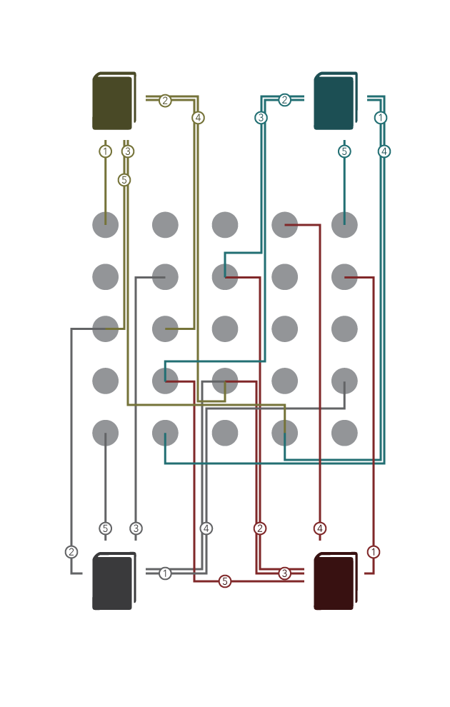

We have been working on a few books with 2013 content already, however none of the modules within the books are yet ready to be considered discreet modules. The modules are not yet able to stand on their own. As we move into the 2013 Vault, we’ll be refining the modules we have to take full advantage of the new module structure.

### Screenshots in 2013

We are using a slightly different process to capture screenshots in Microsoft’s new 2013 suite of products. Luckily, the process isn’t too difficult.

We’ve created [Screen-Capture Guidelines](https://intranet.advisicon.com:447/dept/Authoring/_layouts/WordViewer.aspx?id=/dept/Authoring/Book%20Writing%20Guides/Screen-Capture%20Guidelines.docx&Source=https%3A%2F%2Fintranet%2Eadvisicon%2Ecom%3A447%2Fdept%2FAuthoring%2FBook%2520Writing%2520Guides%2FForms%2FAllItems%2Easpx&DefaultItemOpen=1&DefaultItemOpen=1) for our authors and our screenshot extraordinaire. The guidelines serve to provide some context for the final use of the screenshots and to provide a list of best practices to keep our screenshots looking legible and consistent.

### Writing Template

To assist in the modular generation, we’ve standardized the Microsoft Word [writing template](https://intranet.advisicon.com:447/dept/Authoring/_layouts/WordViewer.aspx?id=/dept/Authoring/Book%20Writing%20Guides/book%20template.dotx&Source=https%3A%2F%2Fintranet%2Eadvisicon%2Ecom%3A447%2Fdept%2FAuthoring%2FBook%2520Writing%2520Guides%2FForms%2FAllItems%2Easpx&DefaultItemOpen=1&DefaultItemOpen=1). Compliance with the template eases our transition of the manuscripts into their final formats and provides some structure to work within, allowing our authors to focus on the content they need to write rather than the way to make it look.

### Microsoft Project Pro 2013

For our 2013 version of Managing Projects with Microsoft Project, we’ve begun to separate the content into a book targeted at advanced users of Project Pro 2013 and a book targeting beginning users of Project Pro 2013.

Preliminary editions of these two books (**Introduction to Scheduling with Microsoft Project** and **Advanced Scheduling with Microsoft Project**) have been roughly composed.

These books have been a true team effort: managed by Pam Greensky, written in a collaboration between three Project MVPs (Cindy Lewis, Ellen Lehnert, and Tim Runcie), and screenshots contributed by Jesse Phillips-Mead.

In 2014, we will be performing thorough proofreading and full functional reviews in order to ensure the quality of our content is up to Advisicon standards. We will also work to strengthen the modularization of this content so that we can move it into the 2013 Vault.

### Microsoft Project Server 2013 for Administrators

Our fearless leader, Tim Runcie, is spearheading work on the **Project Server Administrator’s Guide**. He is focusing his efforts on the first four modules. These first modules will be methodology focused. The methodology modules will provide Project Server administrators with enough of a background in project management thinking to inform their administrative decisions, allowing them to better optimize Project Server for the managers they support.

Several of these modules are likely to appear in the other Project Server 2013 books as well.

### Microsoft Project Server 2013 for Project Managers

Cindy Lewis has begun working on modules for the **Project Server Project Manager’s Guide**. She has been whipping through writing the content; we’ve made solid progress on six new modules over the past month.

So far, we are covering scheduling, working with views, resource management (in both Project Pro and PWA), finalizing schedules, and tracking and approval management.

This is another authoring project that has been succeeding under the management of Pam Greensky. Jesse Phillips-Mead has been grabbing screenshots. Jesse will also be assisting in a full functional review.

## A New Look

As we update our content to support the 2013 products, we are updating the look of our books. We are tightening the layout, creating new icons, and driving toward a semantic approach.

## eBooks

Our approach to the 2013 content also takes into consideration eBook formats for final delivery. With eBooks, our production materials costs are significantly cheaper (just the cost of storage), we are able to cut our shipping costs (delivering digitally instead of physically), and our shipping speed is dramatically increased (a shift from days to seconds).

Due to their digital nature, eBooks offer a few additional advantages.

### Hyperlinks

Hyperlinks are the fundamental user interaction element of the internet age. Nearly all eBook readers today support the hyperlink concept.

We can use hyperlinks to aid our readers’ ability to skip to the content they want by making the Table of Contents interactive. We can also reference other sections of content. If the reader would like to learn more, they can skip to the relevant section or be brought to an online store to purchase the relevant module.

### Multimedia

With EPUB3 and KF8, the newest eBook reader engines support HTML5 and CSS3.

That means we can start creating more complex user interaction within supported eBook readers. We can begin inserting Scalable Vector Graphics, native audio, and native video.

# Sales

We had a wonderful outlier in January: a high count and high sales. Since then, things have been slower, but relatively steady.

The highest count performers were beginner’s books: PPM, Project, and Team Member Project Server.

# The Vault

Tye Trepanier and Jesse Phillips-Mead are leading the upgrade of our internal SharePoint install to SharePoint 2013. Press is designing the tiles that will be used for the initial touch point with our install.

After Jesse and Tye have finished setting up the all of the sites, Press will begin migrating data from 2010 to 2013. In doing so, we’ll be working to push the Vault to its limits. By stressing our implementation of SharePoint 2013, we can discover weaknesses in our implementation to address. This will improve the quality of the product we both provide to our customers and use in-house.

In the meantime, the materials ordering process continues to be refined.

## Peer Training

Already, Press has had the opportunity to train Peers at Advisicon on some ways to use SharePoint 2013. We’ve come up with a method to display custom graphics and descriptions in the promoted links lists.

We’ve also produced an [internal training video](https://intranet.advisicon.com:447/KnowledgeSharing/Internal%20Training%20Docs%20%20Videos/materials-orders.mp4) for the materials ordering process. This has lead to an increased rate of internally placed orders through the online system.

# Website redesign

Press is engaged in the redesign of our current website. We are making use of a user focused design process to identify and construct user stories.

## Website 1.0

We’ve managed to make a number of improvements to our current website over the past year as well.

### Citrix Integration

In the current version of our website, Press has integrated the new merged Citrix accounts (GoToTraining, GoToMeeting, and GoToWebinar) with our listed courses.

### Facebook

Our store is now integrated with facebook.com. Customers can view an up to date listing of our products and skip directly to the product page so that they can learn more, see detailed images, and place purchases.

### Form Implimentation

In cooperation with Chetan Patel from our products division, we’ve implemented an aspx form that takes contact information from people who are interested in our Project Online trial.

### Speed Improvements

By cleaning up the markup, we’ve increased page load time by 400%.

# (Re)Branding

Blah

## Posters

Blah

### Trustify

Blay

### Collaborative Identity

Blah

### Identity Words

Blah

# Department Logos

Press is designing logos for each department at Advisicon.

# Cross-Functional Support

Along with pursuing our major goals, Press steps up to the plate when called upon. We’ve supported Advisicon’s relationship with the Northern Tier Transmission Group by troubleshooting problematic documentation and draft reports.

We have created vector assets for Services to use in Visio projects.

We have written custom CSS to improve the presentation of our SharePoint environments for Colloquium Health and Portfolio 21. Our work for Portfolio 21 has included responsive images, responsive layout, and a fixed width top nav.