Technical Guide

August 5, 2014

# Purpose

This document provides technical implementation of Project Issues and Status Excel Web Part.

# Design

The Risk and Issues Surfacer retrieves data already cached in the Project Center in the root of the PWA. This data is presented as a dashboard component rendered by the Excel Services Web Part.

# Development

## Overview

Initial development had called for workflows to populate a separate list in the Project Web App when items in the risks and issues lists were changed. According to this site http://msdn.microsoft.com/en-us/library/office/ee767687(v=office.15).aspx this is already performed for us. So development then changed to be centered on surfacing the data that was already cached by Project Server.

## Data Connections

Excel Services Pivot Tables gave us all the functionality (plus more) called for, and making the data connections from within the site was simplified because the Excel Services web part allowed for automatic user authentication.

Example: https://advisicondemo2.sharepoint.com/sites/pwa/_api/ProjectData/Issues

Available queries visible at https://advisicondemo2.sharepoint.com/sites/pwa/_api/ProjectData/$metadata

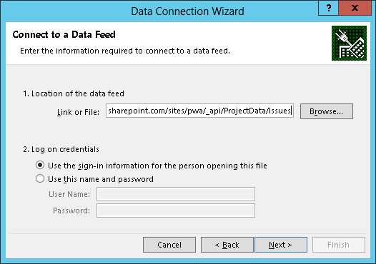 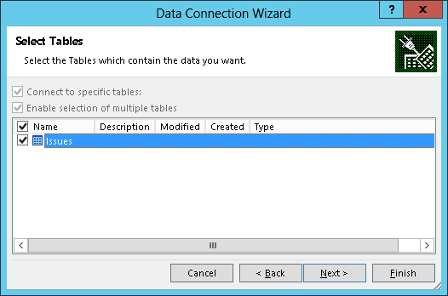

Excel 2013 allowed for combining multiple queries into a related dataset, giving us the ability to present the relationship between the Risks and Issues Data and the Project table. This is how we present all projects even when they do not have Risks or Issues associated with them.

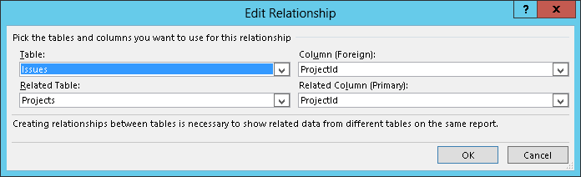

We combine multiple queries into a related dataset

# Deployment

## Updating Spreadsheet

The Excel spreadsheet "Risk_Issues_RollUp.xlsx" need to be configured to draw data from the company's project center.

**STEP 1**: Open the spreadsheet in Excel

**STEP 2**: Navigate to Data tab -> Connections group -> Connections

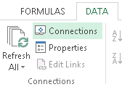

The connections option on the ribbon

**STEP 3**: Configure the Properties for each connection: Risks, Issues, and Projects:

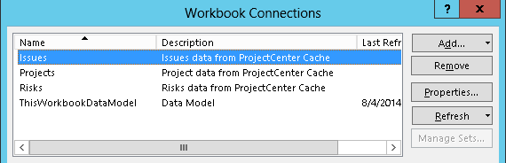

Configuring connection properties

**STEP 3.1**: On the definition tab update the connection string:

Remove the 2 URLs: https://advisicondemo2.sharepoint.com/sites/pwa replacing them with the URL for the Project Web App ex: https://ormutual.sharepoint.com/sites/pwa/

**STEP 3.2**: Save changes by clicking "OK"

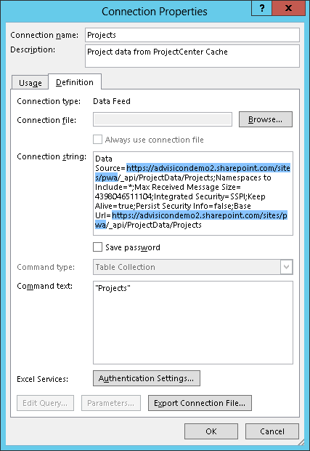

Update the URLs in the source and base url variables

**STEP 3.3 – 3.6**: Update each of the 3 connections in the same way: Issues, Risks, and Projects

## Set up "Advisicon Reports" Document Library

On the website where you would like the dashboard

**STEP 1**: Gear -> Add and App

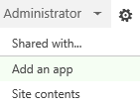

Add an app to PWA

**STEP 1.1**: Click "Document Library"

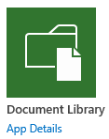

Add a document library app

**STEP 1.2**: Click "Advanced Options"

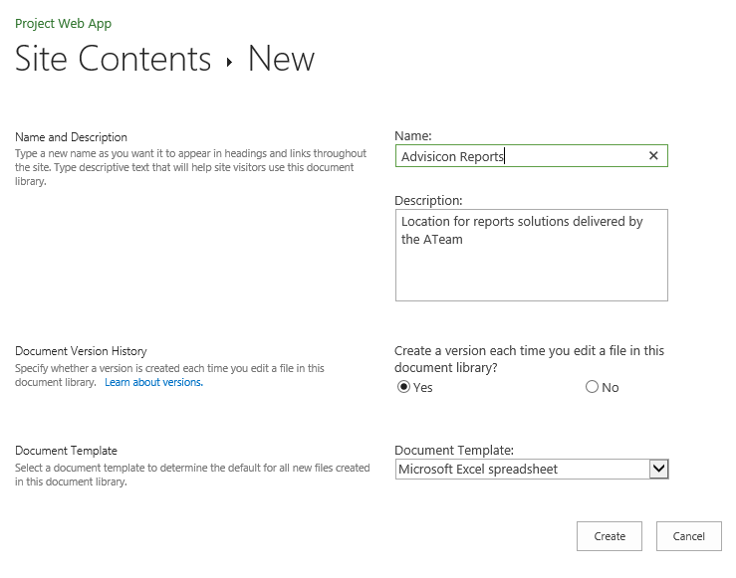

Advanced options gets you more options

**STEP 1.3**: Name it "Advisicon Reports"

**STEP 1.4**: Give it a description

**STEP 1.5**: Create a version… Yes

**STEP 1.6**: Document Template: Microsoft Excel Spreadsheet

**STEP 2**: Upload the excel report "Risks_Issues_RollUp.xlsx" to the SharePoint library

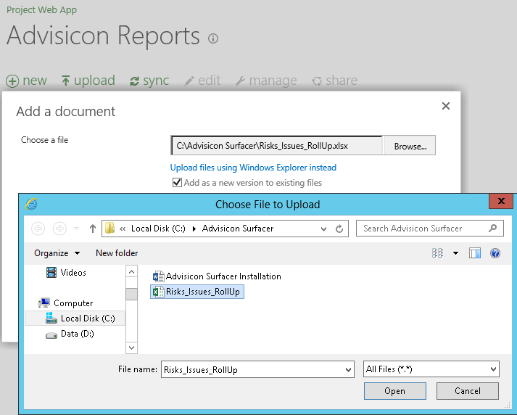

Uploading a local Excel file to a SharePoint document library

**STEP 3**: Test the refresh process to confirm the connections work:

**STEP 3.1**: Open excel document by clicking on the Name link.

**STEP 3.2**: If warned about the queries choose yes.

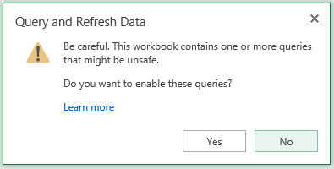

Enable queries

**STEP 3.3**: Right-click on the table and select refresh.

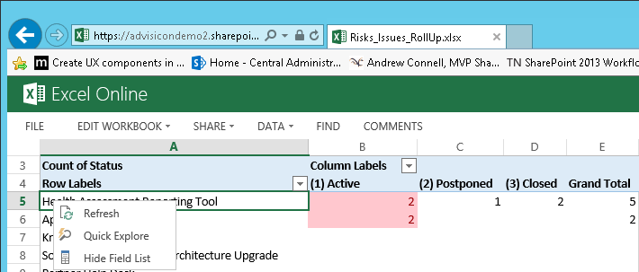

Refresh the table

**STEP 3.4**: If asked whether you trust the document choose yes

**STEP 3.5**: If no errors, then query is working. If there are errors contact Advisicon to help edit the connection strings and/or verify permissions.

# Implementation/Configuration

## Add and Configure Web Parts

*Repeat this process once each for issues data and risks data*

**STEP 1**: Get URL for workbook

**STEP 1.1**: Go to Advisicon Reports library

**STEP 1.2**: Right click on the Name and choose "Copy Shortcut"

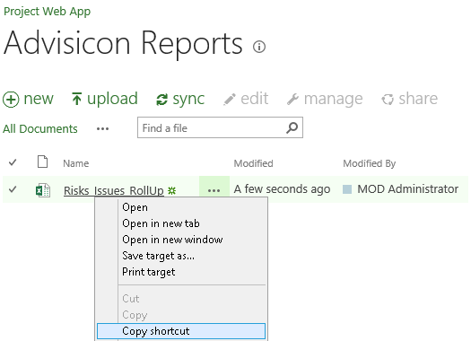

Copying a url to a resource

**STEP 2**: Add web part to the dashboard page.

**STEP 2.1**: Click on the Gear -> Edit Page

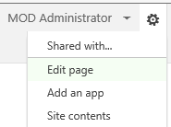

Enter page edit mode

**STEP 2.2**: In the Area where you would like the list to appear, click on Add a Web Part



Add a Web Part link

**STEP 2.3**: From the list of web parts choose Business Data -> Excel Web Access and click "Add"

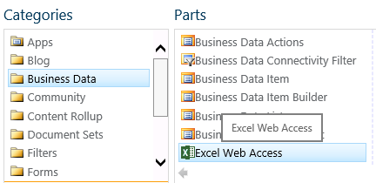

Add an Excel Web Access Web Part

**STEP 3**: Configure the Web Part

**STEP 3.1**: In the top right-hand corner of the recently added web part click on the little down arrow and select "Edit Web Part"

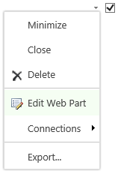

Edit the Web Part

**STEP 3.2**: The Configuration Editor will open on the right.

**STEP 3.3**: Paste the URL copied in step 5.a.ii to the Workbook box

**STEP 3.4**: Set the named entry fields to RisksTable or IssuesTable to meet need.

**STEP 3.5**: Configure to remove all options to keep the dashboard looking right.

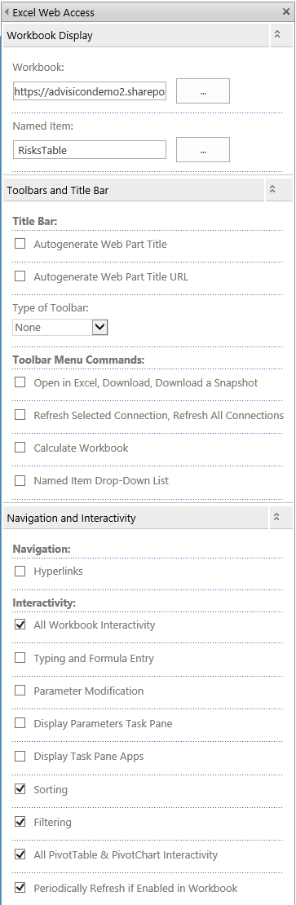

Configure the Web Part

**STEP 3.6**: On the bottom click "OK"

**STEP 4**: When the page layout and lists look like you want click "Stop Editing"

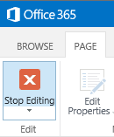

Stop editing the page

## Verify Functionality

**STEP 1**: Verify the spreadsheet refreshes when you go to the page

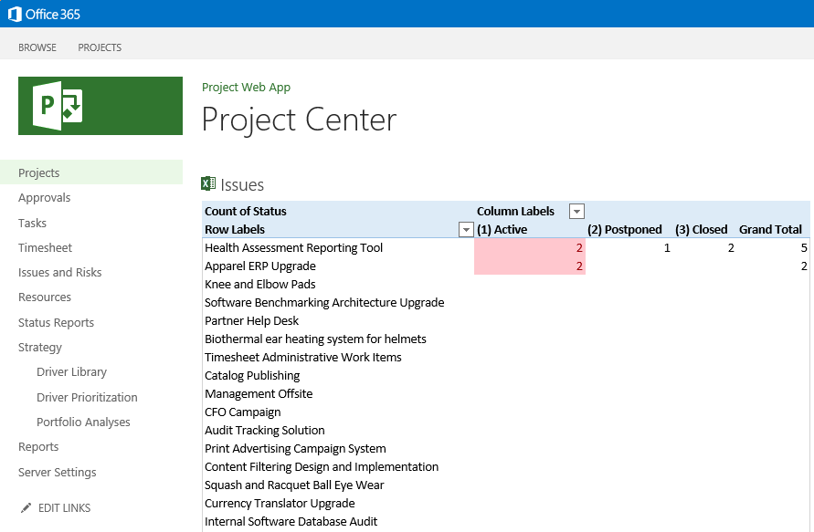

The spreadsheet should now refesh

# Troubleshooting