SOFTWARE ENGINEERING

Lab1:
Name: Advitha D Shetty | SRN:PES1UG24AM337 | Section: F

Functional Requirement = WHAT the system does

ID | Type |  |  | Acceptance Criteria | Rationale
  Description
  Priority
FR-001 | Functional | The system shall compute the optimal debt settlement graph using a minimum-flow algorithm to minimize the total number of peer-to-peer payment transactions. | High | Pass: The group balance settles to net zero and the settlement uses the minimum possible payment edges.  Fail: The sum of debts does not equal the sum of credits or unnecessary payment edges are generated. | This is the core purpose of the system and simplifies group debt settlement.
FR-002 | Functional | The system shall allow a Group Traveler or Trip Admin to record an expense by specifying the payer, amount, currency, participants, and expense details. | High | Pass: A valid expense containing all required information is successfully stored.  Fail: The expense is rejected when required information is missing or invalid. | Expenses must be recorded before balances and settlements can be calculated.
FR-003 | Functional | The system shall convert foreign-currency expenses into the trip's base currency using the applicable daily exchange rate. | High | Pass: The system applies the correct daily exchange rate and displays the converted amount.  Fail: An incorrect rate is applied or conversion cannot be completed. | The system must support expenses made in multiple currencies.
FR-004 | Functional | The system shall calculate the net amount owed or receivable by each  traveler based on recorded expenses and their assigned shares. | High | Pass: Individual balances are displayed and the sum of all travelers' net balances equals zero.  Fail: The calculated balances do not reconcile to zero. | Net balances are required to determine who owes money and who should receive money.
FR-005 | Functional | The system shall display the recommended peer-to-peer payment transactions required to settle the travelers' outstanding balances. | Medium | Pass: The system displays the payer, receiver, and payment amount for each recommended transaction, and applying them results in zero outstanding balance. Fail: One or more balances remain unsettled. | Travelers need a clear payment plan showing exactly who should pay whom.

2.Non-Functional Requirement = HOW WELL the system performs
ID | Type |  | Priority | Acceptance Criteria
  Description
  Rationale
NFR-001 | Performance | The settlement calculation engine shall execute in under 100 ms for groups of up to 50 travelers and 500 expenses. | High | Pass: Benchmark testing confirms that settlement calculation completes in less than 100 ms for 50 travelers and 500 expenses.  Fail: Calculation takes 100 ms or longer under the specified conditions. | Ensures the settlement engine remains responsive for the specified group size and workload.
NFR-002 |  |  | High | Pass: An authenticated trip member can access the trip's data, while an unauthorized user is denied access.  Fail: An unauthorized user can access another trip's expense or settlement information. | Expense and financial information should be protected from unauthorized access.
  Security
  The system shall restrict access to trip expense and settlement data to authenticated members of the corresponding trip.

3. UML Use-Case Diagram

Actors:
- Group Traveler
- Trip Admin
- Daily Exchange Rate Service

Primary Use Cases
- Create Trip
- Add Traveler
- Record Expense
- Convert Currency
- Calculate Balances
- Generate Settlement Plan
- View Settlement Plan
- Split Expense Unequally
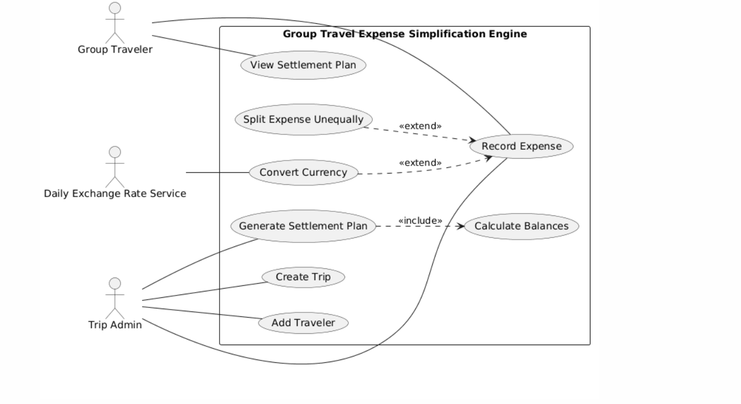

4.Use-Case Flow Specification

Primary Actors: Group Traveler, Trip Admin

1. Preconditions
- A trip has been created in the system.
- At least two travelers are members of the trip.
- Expenses have been recorded for the selected trip.
- Required daily exchange-rate information is available for foreign-currency expenses.

2. Postconditions
- The net balance of each traveler has been calculated.
- The system has generated an optimized settlement plan.
- The recommended peer-to-peer transactions settle all outstanding balances.
- The settlement plan is displayed to the Group Traveler or Trip Admin.

3. Main Success Scenario
- The Group Traveler or Trip Admin selects Generate Settlement Plan.
- The system retrieves all recorded expenses for the selected trip.
- The system validates the recorded expense information.
- The system identifies expenses recorded in foreign currencies.
- The system retrieves the applicable daily exchange rates.
- The system converts foreign-currency expenses into the trip's base currency.
- The system calculates each traveler's total contribution and assigned share.
- The system calculates the net balance of each traveler.
- The system separates travelers into debtors and creditors.
- The system applies the minimum-flow settlement algorithm to minimize the number of payment transactions.
- The system generates the recommended peer-to-peer payment transactions.
- The system verifies that the resulting group balance settles to net zero.
- The system displays the recommended settlement plan to the user.
- The use case ends successfully.

4. Alternate Flow : Exchange Rate Unavailable
- The system identifies the currency and date for which the exchange rate is unavailable.
- The system displays an appropriate error message to the user.
- The system does not proceed with settlement calculation using an unavailable exchange rate.
- The system prompts the user to retry the operation.
- When the required exchange rate becomes available, the user can initiate the settlement calculation again.

