Fast Food Nutrition Analysis
Diagnostic Report

Project: CDACL-004 | Rubixe Internship Project

Prepared by: Advitiya Srivastava
Date: 29/08/2026

1. Introduction
For this project, I worked on nutrition data of 8 popular fast food restaurants. The idea was to look at the data, find some patterns, and build a dashboard that shows how healthy (or unhealthy) different menu items are. I picked one restaurant to study in more detail, and also compared it with the rest.
This report covers where the data came from, what cleaning I had to do before using it, the main findings from one restaurant I picked, a comparison across all restaurants, and a few noticeable things that I think are worth pointing out.

2. About the Dataset
The dataset has nutrition information for 513 menu items across 8 restaurants: McDonald's, Chick-Fil-A, Sonic, Arby's, Burger King, Dairy Queen, Subway, and Taco Bell. For every item, there is data like calories, total fat, saturated fat, trans fat, cholesterol, sodium, carbs, fiber, sugar, protein, and a few vitamin/mineral columns (vitamin A, vitamin C, calcium).
Before using the data, following are the steps involved to clean it:
- Removed 2 duplicate rows that had the exact same values repeated.
- Dropped a column called 'satish' — was 100% empty, so it had no use.
- Dropped a column called 'age' — every single row had the value 0 in it, so it didn't help with anything.
- The 'salad' column had the same value ('Other') in every row, so didn't use it anywhere in the analysis or dashboard filters.
- Some columns had missing values — fiber (12 rows), protein (1 row), and vitamin A / vitamin C / calcium (around 41% of rows, mostly from Taco Bell, Burger King and Arby's). So left these blank instead of guessing or filling them with random numbers, to avoid inaccurate analysis.
One thing to mention — the dataset doesn't have a 'price' column, so average price per dish could not calculated, but was also mentioned in the problem statement. I've treated this as a limitation rather than making up prices.

3. Restaurant Picked: McDonald's
Picked McDonald's for the deep-dive part of this project because it has a good mix of items (burgers, chicken, salads) and is one of the most well-known chains, so the results feel easy to relate to.
McDonald's has 57 items in the dataset. Here's what stood out:
- On average, a McDonald's item has about 640 calories, 32g of fat, 1438mg of sodium, and 40g of protein.
- The highest calorie item is the '20 piece Buttermilk Crispy Chicken Tenders' — 2430 calories, 141g of fat and a huge 6080mg of sodium. This is also the highest sodium item in the whole dataset, not just McDonald's.
- The lowest calorie item is the 'Premium Asian Salad w/o Chicken' at just 140 calories, with only 20mg of sodium.
- If someone wants a high-protein but lower-calorie option, the grilled chicken salads (like the Premium Bacon Ranch Salad with Grilled Chicken) are the best pick — they give the most protein per calorie compared to other McDonald's items.
Basically, McDonald's menu has two very different sides — the big combo/tender items are very high in calories and sodium, while the grilled chicken salads are a much lighter option.

4. Comparing All Restaurants
Also compared the average nutrition numbers across all 8 restaurants, to see which ones tend to be heavier or lighter overall:
Restaurant | Items | Avg Calories | Avg Fat (g) | Avg Sodium (mg) | Avg Sugar (g) | Avg Protein (g)
Mcdonalds | 57 | 640.4 | 31.8 | 1437.9 | 11.1 | 40.3
Sonic | 53 | 631.7 | 37.6 | 1350.8 | 6.5 | 29.2
Burger King | 70 | 608.6 | 36.8 | 1223.6 | 8.2 | 30.0
Arbys | 55 | 532.7 | 27.0 | 1515.3 | 7.6 | 29.3
Dairy Queen | 42 | 520.2 | 28.9 | 1181.8 | 6.4 | 24.8
Subway | 96 | 503.0 | 18.5 | 1273.0 | 10.1 | 30.3
Taco Bell | 113 | 443.0 | 20.9 | 1012.4 | 3.7 | 17.4
Chick Fil-A | 27 | 384.4 | 16.1 | 1151.5 | 4.1 | 31.7

A few noticeable points from this table:
- McDonald's and Sonic have the highest average calories (640 and 632), and Chick-Fil-A has the lowest (384).
- Arby's has the highest average sodium (1515mg) even though its calories aren't the highest — so it's a sodium-heavy menu overall.
- Taco Bell has the lowest average sodium and lowest average sugar, but it also has the lowest average protein (17.4g), so its items are lighter but not very filling.
- Chick-Fil-A has the best protein-to-calorie ratio of all 8 restaurants, followed by Subway. This means, on average, their items give more protein for the same number of calories, which is usually considered a healthier trait.
- Taco Bell has the worst protein-to-calorie ratio, meaning its items are comparatively higher in calories for the protein they offer.

5. Dashboard
Along with this report, I've built an interactive dashboard in Power BI (file: FFA_Dashboard.pbix) with the following visuals:
- Average calories and average sodium by restaurant (bar charts)
- A scatter plot of calories vs protein for all 513 items, colored by restaurant, to see healthy vs unhealthy items at a glance
- Cards showing the highest calorie item, lowest calorie item, and highest sodium item
- A restaurant slicer so anyone viewing the dashboard can filter and explore on their own

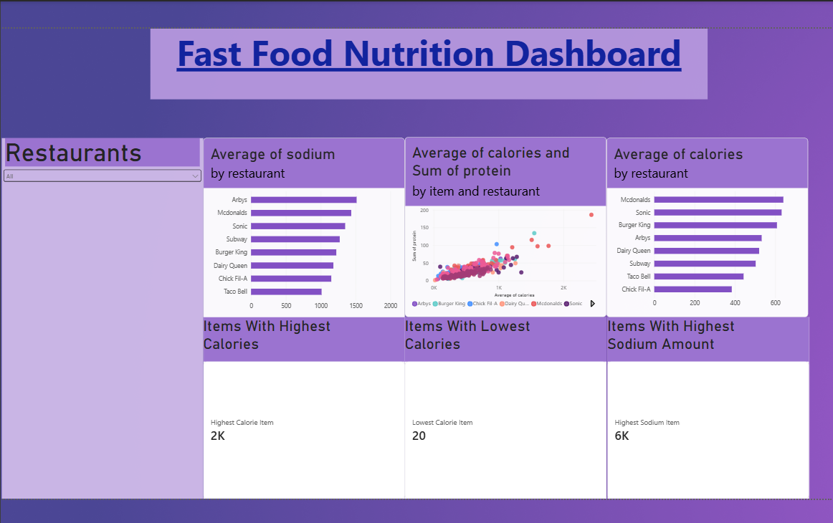

6. Limitations
- vitamin A, vitamin C and calcium values are missing for about 41% of the items, mostly from Taco Bell, Burger King and Arby's, so any conclusion involving these columns should be taken as partial, not complete.
- The 'salad' column was constant across all rows, so it couldn't be used to compare salad vs non-salad items like the problem statement hinted at.
- There's no price data available, so the 'average price per dish' metric from the assignment could not be calculated.
- This is nutrition data only from the menu, it doesn't account for portion sizes people actually eat or how items are customized (extra cheese, no mayo, etc.).

7. Conclusion
Overall, this project helped to understand that 'fast food' isn't one single thing — there's a big difference between restaurants, and even within one restaurant's menu, some items are very heavy (like McDonald's tenders) and some are quite light (like grilled chicken salads).
The calories, fat, sodium and protein comparison already gives a fairly good picture of which restaurants and items are heavier or lighter.

