11814605
Advitya
Q1>
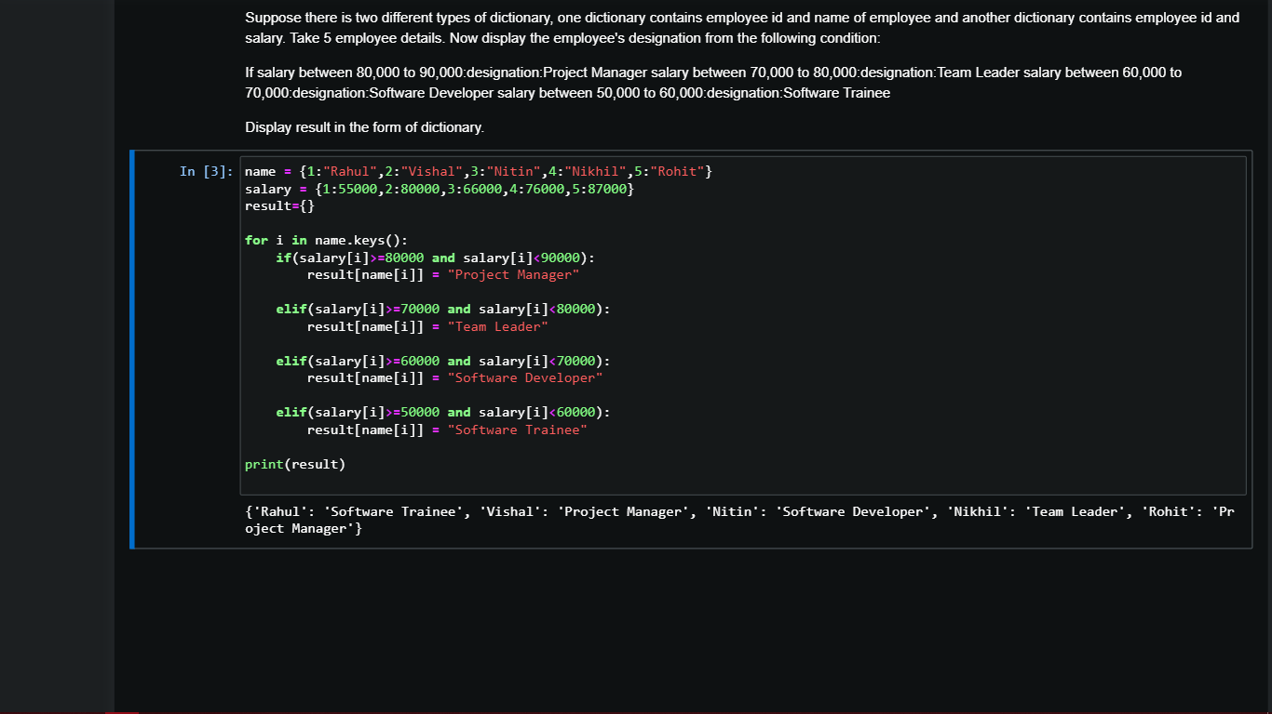

name = {1:"Rahul",2:"Vishal",3:"Nitin",4:"Nikhil",5:"Rohit"}
salary = {1:55000,2:80000,3:66000,4:76000,5:87000}
result={}

for i in name.keys():
if(salary[i]>=80000 and salary[i]<90000):
result[name[i]] = "Project Manager"

elif(salary[i]>=70000 and salary[i]<80000):
result[name[i]] = "Team Leader"

elif(salary[i]>=60000 and salary[i]<70000):
result[name[i]] = "Software Developer"

elif(salary[i]>=50000 and salary[i]<60000):
result[name[i]] = "Software Trainee"

print(result)

Q2>
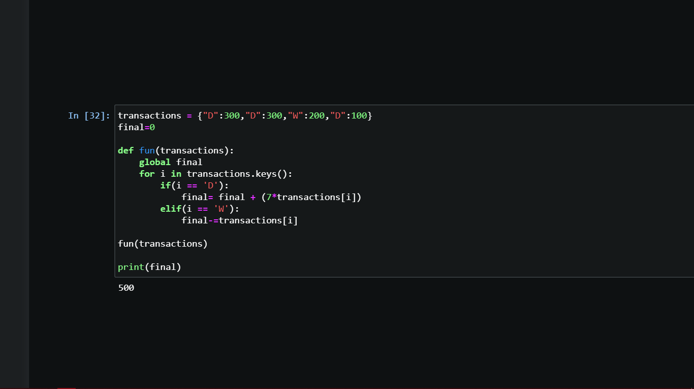

transactions = {"D":300,"D":300,"W":200,"D":100}
final=0

def fun(transactions):
global final
for i in transactions.keys():
if(i == 'D'):
final= final + (7*transactions[i])
elif(i == 'W'):
final-=transactions[i]

fun(transactions)

print(final)

Q3>

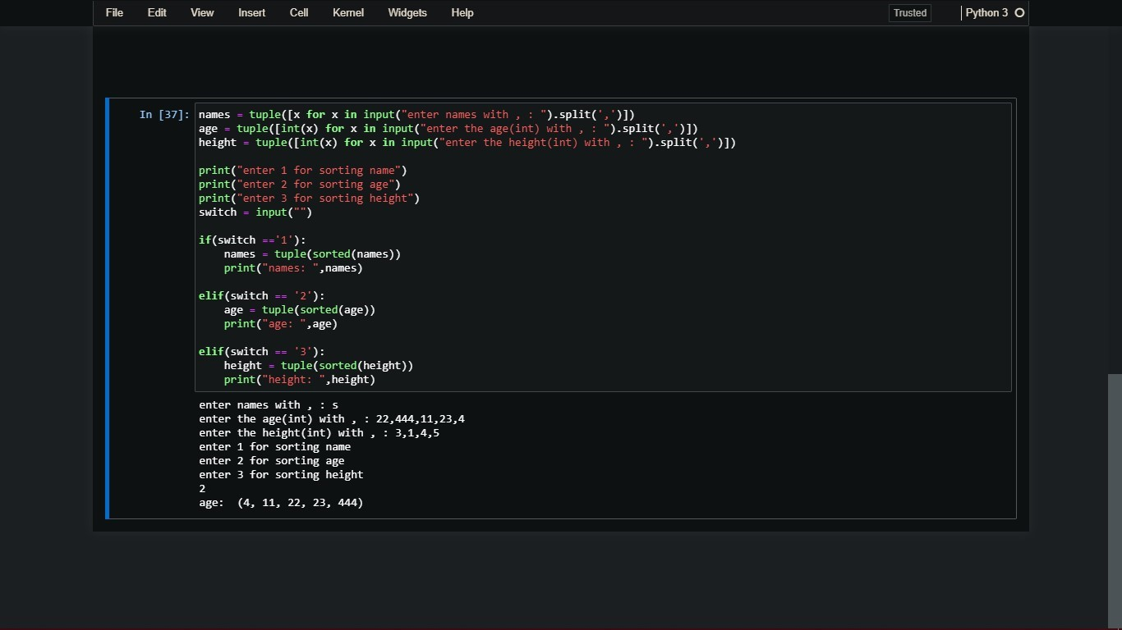

names = tuple([x for x in input("enter names with , : ").split(',')])
age = tuple([int(x) for x in input("enter the age(int) with , : ").split(',')])
height = tuple([int(x) for x in input("enter the height(int) with , : ").split(',')])

print("enter 1 for sorting name")
print("enter 2 for sorting age")
print("enter 3 for sorting height")
switch = input("")

if(switch =='1'):
names = tuple(sorted(names))
print("names: ",names)

elif(switch == '2'):
age = tuple(sorted(age))
print("age: ",age)

elif(switch == '3'):
height = tuple(sorted(height))
print("height: ",height)

