Name : Adwait Shelare PRN : 25070521169
8.1.1 Multiplication of two square matrix
Algorithm
Step 1] Start
Step 2] Read the dimension n of the matrix.
Step 3] Display "First Matrix".
Step 4] Initialize an empty list A.
Step 5] Use a loop from i = 0 to n-1 and read n rows of the first matrix.
Step 6] Store each row in matrix A.
Step 7] Display "Second Matrix".
Step 8] Initialize an empty list B.
Step 9] Use a loop from i = 0 to n-1 and read n rows of the second matrix.
Step 10] Store each row in matrix B.
Step 11] Create a result matrix result of size n × n and initialize all elements to 0.
Step 12] Use three nested loops:
i from 0 to n-1
j from 0 to n-1
k from 0 to n-1
Step 13] Compute matrix multiplication using
result[i][j] = result[i][j] + A[i][k] * B[k][j].
Step 14] Display "Resultant Matrix".
Step 15] Print the elements of matrix result.
Step 16] Stop.
Flowchart
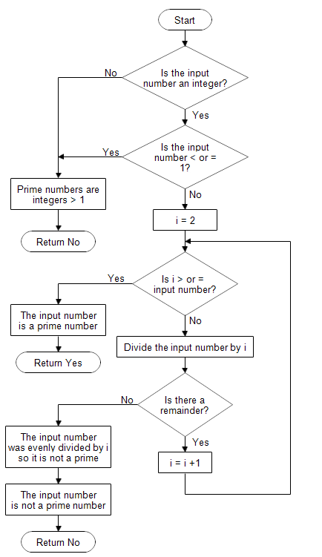
Python code
start=int(input())
stop=int(input())
f=False
for num in range(start,stop+1):
if num> 1:
flag= True
for i in range(2,int(num**0.5)+1):
if num % i ==0:
flag = False
break
if flag:
print(num)
f=True

if not f:
print("No primes")
EXCECUTION
