Name : Adwait Shelare PRN : 25070521169
10.1.1 Remove Punctiation from string
Algorithm
Step 1: Start
Step 2: Input a string a
Step 3: Initialize an empty string chk = ""
Step 4: Read each character i from string a
Step 5: Check if character is alphabet OR number OR space
Step 6: If Yes, add character to chk
Step 7: Repeat steps 4–6 for all characters
Step 8: Print chk
Step 9: Stop
Flowchart
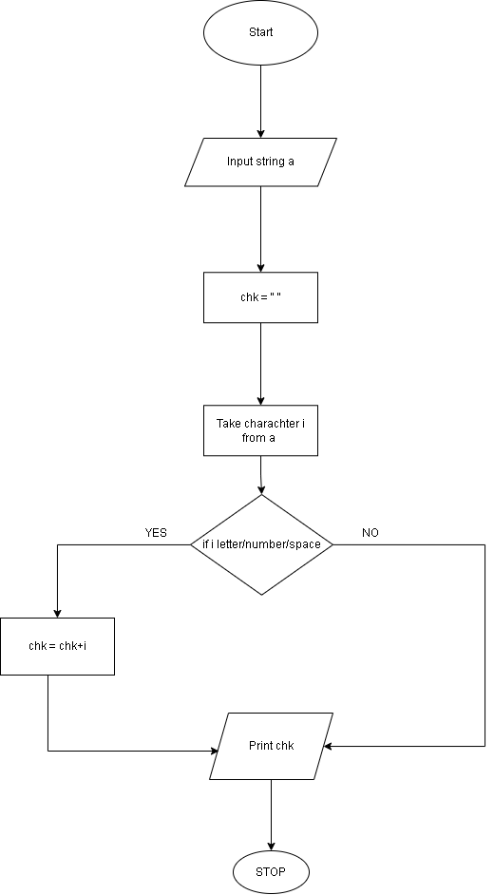

Python code
a= input()
chk=""
for i in a:
if i.isalnum() or i.isspace():
chk += i
print(chk)
EXCECUTION
