Name : Adwait Shelare PRN : 25070521169
10.1.2 Reverse a String
Algorithm
Step 1: Start
Step 2: Input a string user_input
Step 3: Set re = "" (empty string)
Step 4: Find length of string l = len(user_input)
Step 5: Set loop from i = l-1 to 0
Step 6: Add character to new string → re = re + user_input[i]
Step 7: Repeat until loop ends
Step 8: Print reversed string re
Step 9: Stop
Flowchart
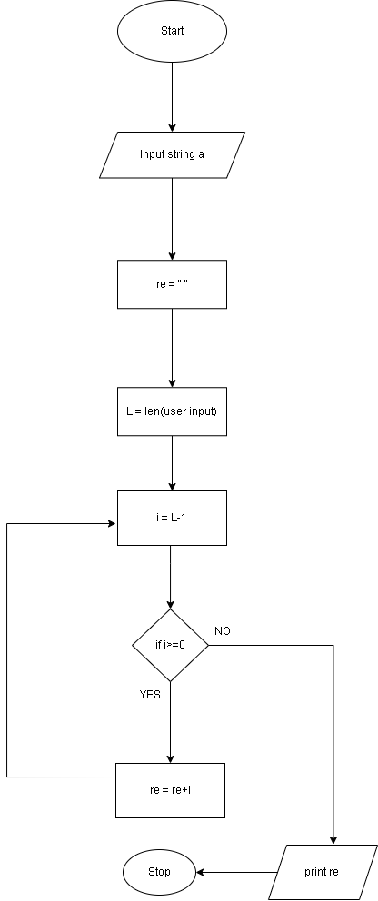

Python code
def reverse_string(input_string):
# Write the code...
re= ""
l = len(user_input)
for i in range(l-1,-1,-1):
re += user_input[i]
return re
user_input = input("Enter a string: ")
result = reverse_string(user_input)
print(f"Original String: {user_input}")
print(f"Reversed String: {result}")
EXCECUTION
