Name : Adwait Shelare PRN : 25070521169
11.1.1 Sum of digits of number
Algorithm
Step 1: Start
Step 2: Input number num
Step 3: Set sum = 0
Step 4: Check num > 0
Step 5: Find digit → digit = num % 10
Step 6: Add digit → sum = sum + digit
Step 7: Remove last digit → num = num // 10
Step 8: Repeat from Step 4 until num = 0
Step 9: Print sum
Step 10: Stop
Flowchart
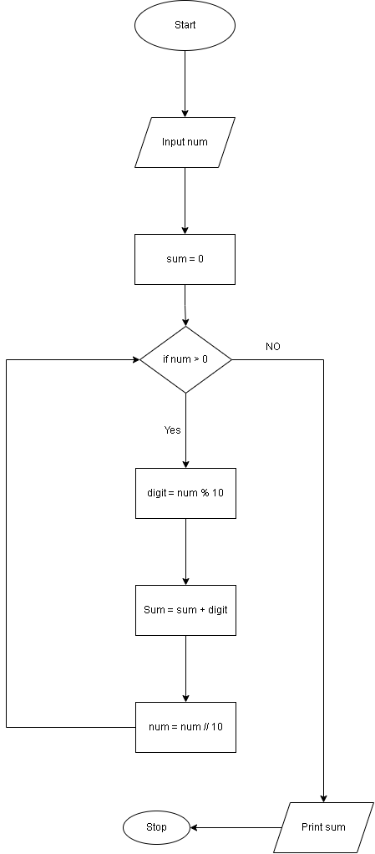
Python code
num = int(input("Enter a number: "))
sum=0
while num>0:
digit = num % 10
sum = sum+digit
num = num//10
print("Sum of digits:", sum )
EXCECUTION
