Name : Adwait Shelare PRN : 25070521169
11.1.2 Sum of digits using recursion
Algorithm
Step 1: Start
Step 2: Input number n
Step 3: Check if n == 0
Step 4: If Yes → Return 0
Step 5: If No → Return (n % 10) + sum_of_digits_recursive(n // 10)
Step 6: Print result
Step 7: Stop
Flowchart
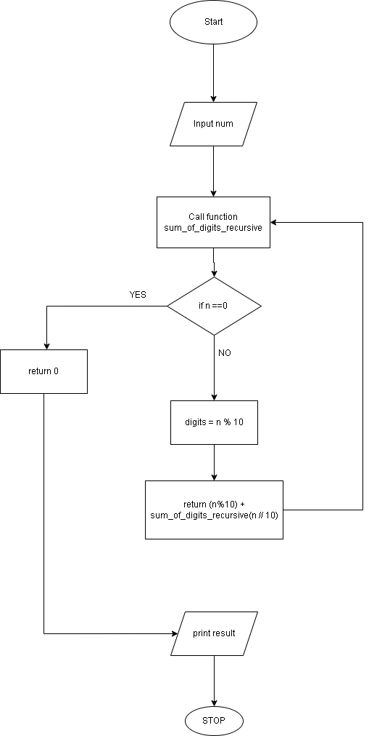
Python code
def sum_of_digits_recursive(n):
# Write your code here
if n == 0:
return 0
else:
return (n%10) + sum_of_digits_recursive(n//10)
number = int(input())
result = sum_of_digits_recursive(number)
print(result)

EXCECUTION
