Name : Adwait Shelare PRN : 25070521169
9.1.2 Palindrome or not
Algorithm
Step 1: Start
Step 2: Input string inp
Step 3: Set f = True
Step 4: Find length of string l = len(inp)
Step 5: Repeat for i = 0 to l-1
Step 6: If inp[i] != inp[l-1-i] then
Set f = False
Step 7: If f == True then print "Palindrome"
Step 8: Else print "Not a Palindrome"
Step 9: Stop
Flowchart
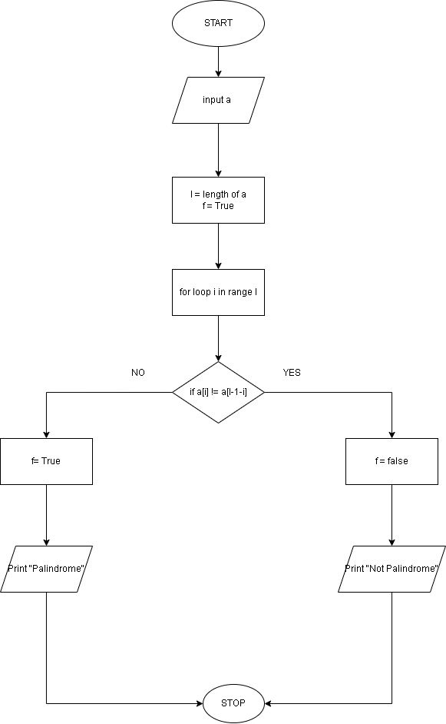
Python code
inp = input()
f = True
l = len(inp)
for i in range (l):
if inp[i] != inp[l-1-i]:
f = False

if f:
print("Palindrome")
else:
print("Not a Palindrome")
EXCECUTION
