**NAME: ADWAIT MILIND INGLE**

**ID: 20004054**

**PROJECT: LINE FOLLOWER BOT**

**ABSTRACT**

This abstract introduces the development and implementation of an autonomous Line Follower Robot, a significant advancement in the realm of robotics, engineered through the utilization of an Arduino Uno microcontroller, an L298 motor driver, and infrared (IR) sensors. The Line Follower Robot exemplifies a pivotal application in automation, encompassing fields ranging from industrial automation to STEM education.

The foundational control system of the Line Follower Robot centers around the Arduino Uno, renowned for its versatility and user-friendliness. Programmed to interpret data acquired from IR sensors, the Arduino Uno dynamically regulates motor speed and direction, thereby ensuring the robot's alignment with a designated path. The L298 motor driver acts as a pivotal enabler, efficiently governing the movement of the robot's motors, affording precise control over both speed and direction.

Integral to the Line Follower Robot's operation, IR sensors continuously scan the underlying surface. Emitting infrared light and gauging the intensity of reflected light, these sensors discern between the contrasting features of a designated path, be it a black line on a white background or the inverse. This real-time information is pivotal in making instantaneous determinations regarding motor control, thus enabling the robot to maintain accurate alignment with the desired path.

This project provides comprehensive insights into the hardware configuration and the software development process underpinning the Line Follower Robot's realization. Elaborate discussion of the algorithms employed for line detection and motor control is included, along with the Arduino code that forms the backbone of this autonomous system.

The salience of this project lies in its role as an educational tool, serving as an accessible and practical exemplar for enthusiasts, students, and hobbyists to understand and explore the intricacies of robotics and automation. The Line Follower Robot epitomizes the fusion of innovative hardware and intelligent software, opening doors to the ever-evolving world of robotics.

**INDEX**

|  |  |
| --- | --- |
| **Chapter 1:** | **Introduction**  **1.1 Objective**  **1.2 Problem statement** |
| **Chapter 2:** | **Methodology**  **2.1 Working**  **2.2 Circuit Diagram**  **2.3 Circuit Connections** |
| **Chapter 3:** | **Process & Requirement**  **3.1 Hardware Requirements**  **3.2 Component Description**  **3.2.1 Arduino UNO**  **3.2.2 I**R **Sensor**  **3.2.3 L298 Motor Driver**  **3.2.4 9v Battery and Connecting wires** |
| **Chapter 4:** | **Codes** |
| **Chapter 5:** | **Conclusion** |

## 1. INTRODUCTION:

The development of autonomous robots has garnered significant attention in the fields of robotics and automation, offering innovative solutions for various applications. In this context, the Line Follower Robot stands as a compelling example of intelligent automation, utilizing a combination of cutting-edge technologies. This project focuses on the design and implementation of a Line Follower Robot, where the core components include an Arduino Uno microcontroller, an L298 motor driver, and infrared (IR) sensors. The integration of these components enables the robot to autonomously navigate predefined paths, making real-time decisions based on IR sensor data. This introductory paragraph sets the stage for exploring the intricate details of this fascinating project, which combines hardware and software to create a versatile and educational robotic platform.

* 1. **OBJECTIVIES**:

1. Assemble a physically robust and well-structured Line Follower Bot incorporating Arduino Uno, L298 motor driver, and IR sensors, ensuring stability and durability of the platform.

2. Successfully integrate and calibrate IR sensors to detect and differentiate between the contrasting features of the predefined path (e.g., black line on a white surface) with high accuracy and reliability.

3. Develop software routines to continuously collect real-time sensor data, facilitating prompt decision-making for motor control based on the detected line.

4. Implement algorithms for motor control that enable the bot to follow the designated path accurately, adjusting motor speed and direction as necessary.

5. Achieve autonomy in the Line Follower Bot's movement, allowing it to navigate a variety of curved and straight-line paths without human intervention.

* 1. **PROBLEM STATEMENT:**

In the field of robotics and automation, there is a growing demand for autonomous systems capable of intelligently following predefined paths with precision and adaptability. The challenge lies in designing and implementing a Line Follower Bot that utilizes Arduino Uno, L298 motor driver, and IR sensors to autonomously navigate diverse paths, efficiently detecting and responding to line markings on contrasting surfaces. This problem statement aims to address the need for a versatile, cost-effective, and educational solution that can serve as a fundamental platform for understanding robotics, automation, and sensor-based control systems, while also demonstrating practical applicability in various real-world scenarios.

### 2. METHODOLOGY

**2.1 WORKING:**

The line follower bot, powered by an Arduino Uno and equipped with an L298 motor driver and IR sensors, operates by continuously scanning its surroundings. The IR sensors detect the contrast between the black line and the lighter background, allowing the bot to make real-time decisions. Based on this input, the Arduino Uno controls the L298 motor driver to adjust the speed and direction of the motors, enabling precise navigation along the line's path. This seamless coordination between sensors, microcontroller, and motor driver ensures the bot effectively follows the desired line, making it an efficient and reliable autonomous vehicle for various applications.

**2.2 CIRCUIT DIAGRAM:**

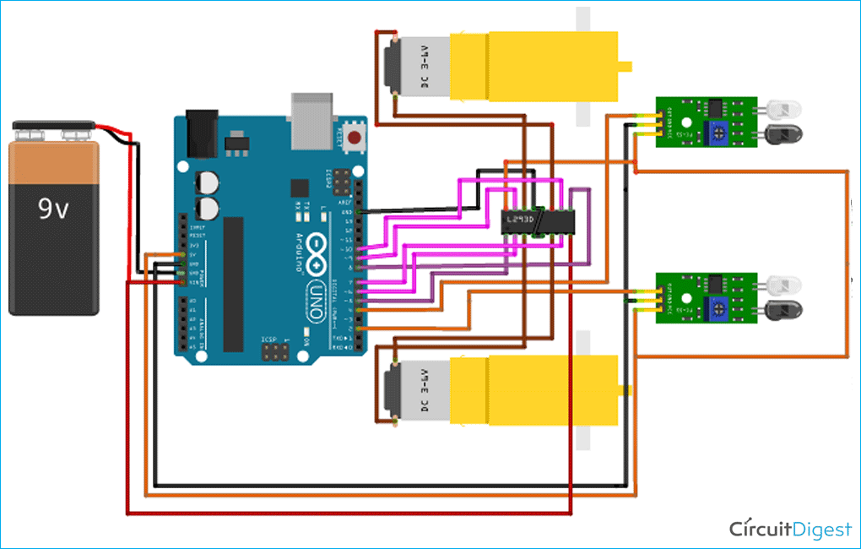

Figure 1: Line Follower Bot

[Courtesy: https://circuitdigest.com/microcontroller-projects/arduino-uno-line-follower-robot]

**2.3 CIRCUIT CONNECTIONS:**

1. Motor Driver Connections:

- Connect the DC motors to the L298 motor driver module. Each motor has two terminals, usually labeled as "+", "-", or "A", "B". Connect the wires as follows:

- Motor 1: Connect one terminal to the "OUT1" of the L298 and the other terminal to "OUT2".

- Motor 2: Connect one terminal to "OUT3" and the other terminal to "OUT4".

- Connect the L298 module to the Arduino Uno:

- Connect "ENA" to any PWM-enabled pin on the Arduino (e.g., Pin 9).

- Connect "ENB" to another PWM-enabled pin on the Arduino (e.g., Pin 10).

- Connect "IN1" to Arduino Pin 7.

- Connect "IN2" to Arduino Pin 8.

- Connect "IN3" to Arduino Pin 11.

- Connect "IN4" to Arduino Pin 12.

2. IR Sensor Connections:

- Connect the IR sensors to the Arduino:

- Connect the VCC (power) pin of both IR sensors to the 5V output of the Arduino.

- Connect the GND (ground) pin of both IR sensors to the GND (ground) of the Arduino.

- Connect the OUT pins of the IR sensors to digital input pins on the Arduino, e.g., Pin 2 and Pin 3.

3. Power Supply:

- Connect the positive (red) wire of the DC motors to the motor driver's VCC.

- Connect the negative (black) wire of the DC motors to the motor driver's GND.

- Connect the power supply (battery or external power source) to the motor driver's external power input (usually labeled as "+12V").

## 3. PROCESS AND REQUIREMENTS

**3.1 HARDWARE REQUIREMENTS:**

The following components are required to make Panic Alarm Circuit

| **S. NO** | **Component** | **Value** | **Qty** |
| --- | --- | --- | --- |
| 1. | Breadboard |  | 1 |
| 2. | Battery | 9v | 1 |
| 3. | Connecting Wires |  | 1 |
| 4. | Arduino UNO |  | 1 |
| 5. | IR Sensor |  | 2 |
| 6. | L298 Motor Driver |  | 1 |
| 7. | DC Motors | 60 rpm | 2 |

**3.2 COMPONENT DESCRIPTION:**

* **ARDUINO UNO**
* **IR SENSOR**
* **L298 MOTOR DRIVER**
* **DC MOTORS (60 rpm)**
* **9V BATTERY AND CONNECTIONS WIRES**

### 3.2.1 ARDUINO UNO:

The Arduino Uno is a popular and versatile microcontroller board widely used in electronics and robotics projects. It boasts an ATmega328P microcontroller at its core, providing a reliable and easy-to-program platform for a wide range of applications. With a plethora of digital and analog input/output pins, the Arduino Uno enables seamless interfacing with sensors, actuators, and other components. Its open-source nature, along with a supportive community, allows users to access an extensive library of pre-written code and resources, simplifying the development process. The Arduino Uno's user-friendly IDE (Integrated Development Environment) makes programming accessible to both beginners and experienced engineers, making it an ideal choice for prototyping, automation, and educational projects.



Figure 2: Arduino UNO

[Courtesy: https://www.instructables.com/Obstacle-Avoiding-Robot-Arduino-1/]

**3.2.2 IR SENSOR:**

An infrared (IR) sensor is an electronic device that detects and responds to infrared radiation, a type of electromagnetic radiation with wavelengths longer than visible light but shorter than radio waves. Typically comprising an IR emitter (such as an IR LED) and a detector (commonly a photodiode or phototransistor), IR sensors operate on the principle that objects at varying temperatures emit differing levels of infrared radiation. They are utilized in diverse applications, from proximity sensing in smartphones to non-contact temperature measurements in industrial and medical settings. IR sensors can work in reflective modes, where they emit and measure the intensity of reflected IR light, or as emitter-detector pairs, enabling them to perform tasks like obstacle detection in robotics and remote control signal reception, making them invaluable for a multitude of technological and automation purposes.

**3.2.3 L298 MOTOR DRIVER:**

The L298 motor driver is a popular integrated circuit designed for controlling and driving DC motors and stepper motors. Developed by SGS-Thomson Microelectronics (now STMicroelectronics), the L298 is widely used in robotics, automation, and other electronic projects where motor control is essential. This dual H-bridge motor driver offers several key features that make it a versatile choice for motor control applications. It can handle a wide range of voltage inputs, typically ranging from 7V to 46V, and provide a maximum current output of 2A per channel. This capability allows it to control a variety of motors, from small hobbyist motors to larger industrial-grade ones

The L298 features four input pins for each H-bridge, enabling precise control of motor direction and speed. By manipulating these input pins, you can make motors rotate clockwise, counterclockwise, or stop them altogether. Additionally, the L298 includes built-in flyback diodes, which help protect the circuit from voltage spikes generated by the motor when it is turned off.

One of the advantages of the L298 motor driver is its compatibility with various microcontrollers, such as Arduino, Raspberry Pi, and other popular development boards. This compatibility simplifies the process of integrating motor control into your projects, as you can easily interface the L298 with these platforms.

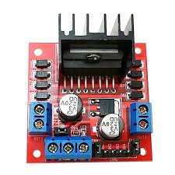

Figure 3: L298 Motor Driver

[Courtesy: https://www.instructables.com/Obstacle-Avoiding-Robot-Arduino-1/]

##### 3.2.4 9V BATTERY AND CONNECTING WIRES

The 9V battery and connecting wires are essential elements in a panic alarm system, providing the necessary power and interconnections to ensure the reliable operation of the system.

#### 4. CODES

#define MOTOR_SPEED 60

int mot1=9;

int mot2=6;

int mot3=5;

int mot4=3;

int left=13;

int right=12;

int Left=0;

int Right=0;

void LEFT (void);

void RIGHT (void);

void STOP (void);

void setup() {

  pinMode(mot1,OUTPUT);

  pinMode(mot2,OUTPUT);

  pinMode(mot3,OUTPUT);

  pinMode(mot4,OUTPUT);

  pinMode(left,INPUT);

  pinMode(right,INPUT);

  digitalWrite(left,HIGH);

  digitalWrite(right,HIGH);

}

void loop() {

analogWrite(mot1,MOTOR_SPEED);

analogWrite(mot2,0);

analogWrite(mot3,MOTOR_SPEED);

analogWrite(mot4,0);

while(1) {

  Left=digitalRead(left);

  Right=digitalRead(right);

  if((Left==0 && Right==1)==1)

  LEFT();

  else if((Right==0 && Left==1)==1)

  RIGHT();

}

}

void LEFT (void) {

   analogWrite(mot3,0);

   analogWrite(mot4,30);

   while(Left==0) {

    Left=digitalRead(left);

    Right=digitalRead(right);

    if(Right==0) {

      int lprev=Left;

      int rprev=Right;

      STOP();

      while(((lprev==Left)&&(rprev==Right))==1) {

         Left=digitalRead(left);

         Right=digitalRead(right);

      }

    }

    analogWrite(mot1,MOTOR_SPEED);

    analogWrite(mot2,0);

   }

   analogWrite(mot3,MOTOR_SPEED);

   analogWrite(mot4,0);

}

void RIGHT (void) {

   analogWrite(mot1,0);

   analogWrite(mot2,30);

   while(Right==0) {

    Left=digitalRead(left);

    Right=digitalRead(right);

    if(Left==0) {

      int lprev=Left;

      int rprev=Right;

     STOP();

      while(((lprev==Left)&&(rprev==Right))==1) {

         Left=digitalRead(left);

         Right=digitalRead(right);

      }

    }

    analogWrite(mot3,MOTOR_SPEED);

    analogWrite(mot4,0);

    }

   analogWrite(mot1,MOTOR_SPEED);

   analogWrite(mot2,0);

}

void STOP (void) {

analogWrite(mot1,0);

analogWrite(mot2,0);

analogWrite(mot3,0);

analogWrite(mot4,0);

}

**5. CONCLUSION:**

In conclusion, the line follower bot, built upon the foundation of an Arduino Uno, an L298 motor driver, IR sensors, and 60 RPM DC motors, embodies the synergy of electronics, control, and automation. With its precision in detecting and tracing lines using IR sensors, and the motor driver's ability to translate sensor inputs into precise motor control, this bot serves as a remarkable example of autonomous robotics. It showcases the capabilities of modern microcontroller technology, offering a glimpse into the world of versatile and adaptable automation solutions. As it tirelessly follows its designated path, the line follower bot underscores the potential of technology to simplify complex tasks and paves the way for a myriad of practical applications in fields ranging from industrial automation to educational robotics.