Database Lab

Name: Ayush Wadalkar

PRN :-

1. Select * from table_name shows all the data inside that table.

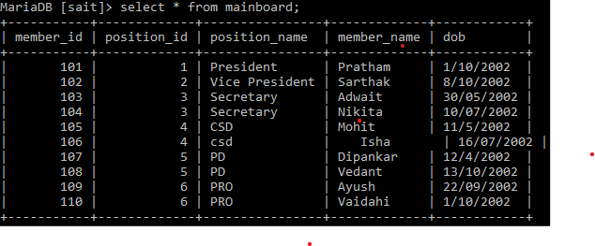

1. Select * from mainboard where member_id = 101
2. 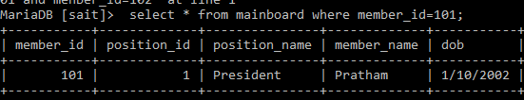
3. Select * select * from mainboard where member_id in (101,102);

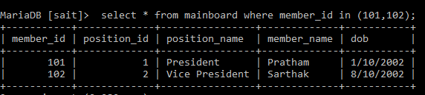

1. select position_name from mainboard;

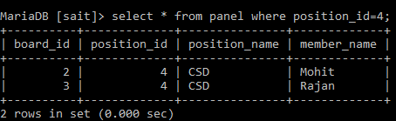.

6) select * from panel where position_id<=5;

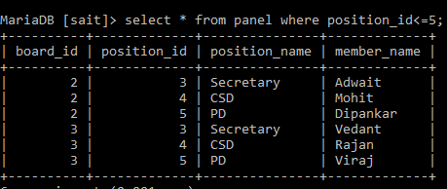

7) select * from mainboard where position_id between 2 and 6;

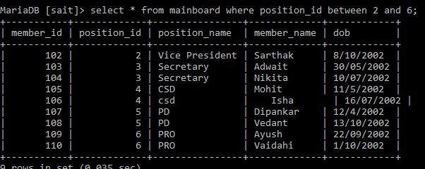

1. select * from mainboard where member_name like 'a%';.

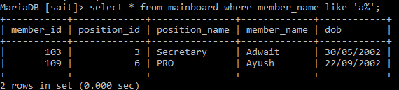

9)select * from mainboard where position_name='President' or position_name='CSD';

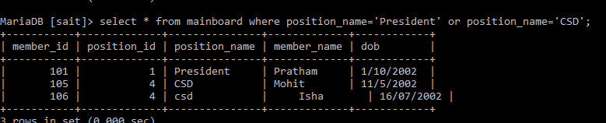

1. select * from mainboard where position_id IN(1,4);.

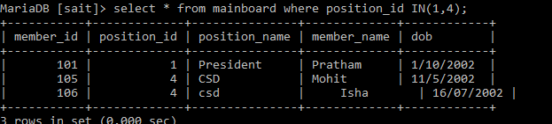

insert into mainboard values(112,7,'Treasurer','Harshal','1/01/2002');

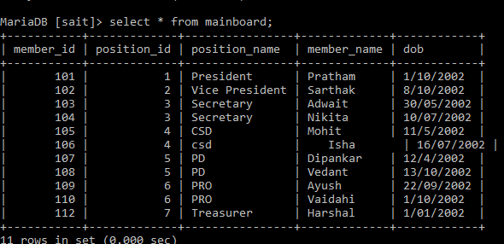

1. delete from assistantboard where position_id=4;

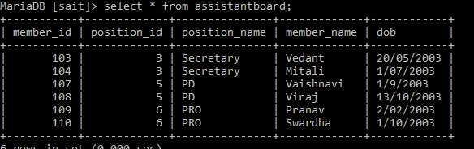

11)select min(position_id) as smallerid from panel;

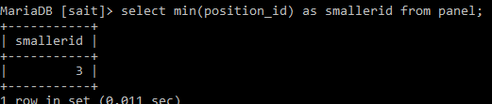

12)select max(position_id) as largerid from mainboard;

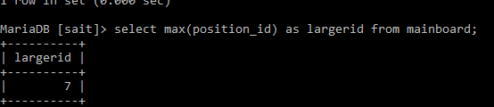

13) select count(position_id) from mainboard;

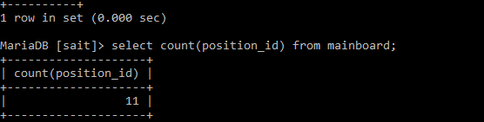

14) select sum(position_id) from mainboard;

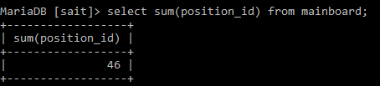

15) select * from mainboard where member_id between 101 and 108;

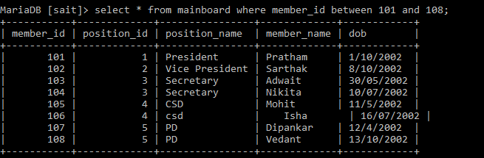

16) select count(member_id),member_name from mainboard group by position_name;

