FORENSIC SCIENCE LABORATORY ANALYSIS REPORT
Narcotic Substance Identification & Quantification Report
Case No: KRP-2025-0822-DT08 | Kerala State Police — Ernakulam District
1. CASE & SEIZURE PARTICULARS

Case Reference | KRP-2025-0822-DT08
Incident Classification | Drug Trafficking — Narcotic Substances Act, 1985
Reporting Authority | Ernakulam District Police — Anti-Narcotics Cell (ANC)
Date of Seizure | 22 August 2025
Time of Seizure | Approximately 6:35 PM IST
Location of Seizure | Kaloor Junction area, Kaloor, Kochi, Kerala — near Kaloor International Stadium approach road
Seizure Circumstances | Suspect vehicle flagged during routine ANC mobile patrol; upon search, packages discovered concealed in engine bay and under-bonnet compartment — see Exhibit Photo FME-01
Seized From | Two suspects in a private hatchback vehicle — registration details per police report
Seizing Officer | [Name & Badge No. withheld — Demo], Anti-Narcotics Cell, Ernakulam
Date Received at FSL | 23 August 2025, 9:10 AM
FSL Reference No. | FSL/ERN/2025/NDPS/0691
Analysing Scientist | Dr. [Name Withheld — Demo], Senior Scientific Officer, FSL Kerala
Date of Analysis | 23–25 August 2025
Date of Report | 26 August 2025

2. ACCUSED / SUSPECTS

# | Name | Age | Role | Custody Status
1 | Accused D [Demo] | 27 | Driver / Primary Accused | Remanded — Judicial Custody
2 | Accused E [Demo] | 33 | Courier / Co-Accused | Remanded — Judicial Custody

3. EXHIBIT DESCRIPTION & CHAIN OF CUSTODY
The following exhibits were received at FSL Ernakulam in sealed condition. All seals were intact on receipt. The concealment method — inside the engine bay cavity and under-bonnet compartment — is documented in Exhibit Photo FME-01 below.

Exhibit No. | EX-DT08/01 to EX-DT08/14 (14 individual packages)
Concealment Location | Engine bay cavity (8 packages) and under-bonnet compartment (6 packages) of seized hatchback; accessed via screwdriver-release panels, indicating prior vehicle modification for concealment purposes
Outer Packaging | Brown polypropylene adhesive tape wrapping over heat-sealed plastic inner liner; rectangular compressed blocks, uniform in appearance
Package Dimensions | Approx. 22 cm × 16 cm × 6 cm per block (variable ±2 cm)
Package Count | 14 blocks (counted at scene; evidence markers applied — see FME-01)
Total Gross Weight | Approximately 14.2 kg (gross, including packaging material)
Condition on Receipt | All seals intact; firm mechanical compression; slight petroleum lubricant odour on outer tape surfaces of 3 packages — consistent with prolonged concealment in engine bay environment
Sealing Officer | Sub-Inspector [Name Withheld — Demo], Anti-Narcotics Cell
Received at FSL By | Duty Scientific Officer, FSL Ernakulam — 23 August 2025, 9:10 AM
Storage Condition | Secured narcotics storage vault, FSL Ernakulam

Figure 1: Seized Consignment — Packages Discovered in Engine Bay — Exhibit Photo FME-01
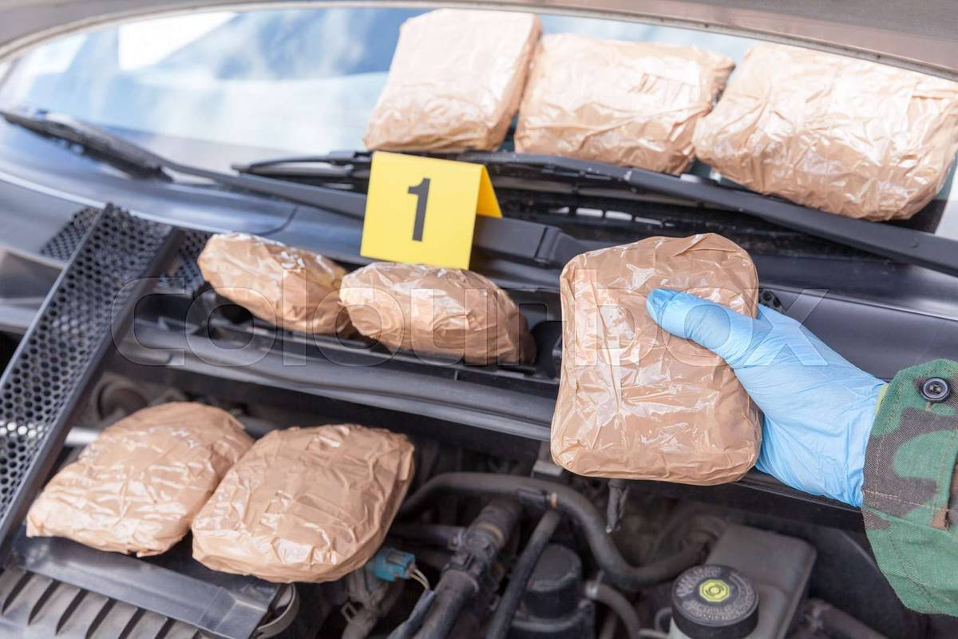
Exhibit FME-01 | Photographed at seizure location: 22/08/2025, 6:48 PM IST | Engine bay concealment — 14 packages; evidence marker #1 visible | Gloved officer recovering Package EX-DT08/09
4. PACKAGING FORENSIC EXAMINATION
Physical examination of the outer packaging was conducted prior to extraction of analytical samples. Observations are recorded in full for evidentiary completeness.

Tape Type | Brown polypropylene adhesive tape — 48 mm width; embossed micro-grid pattern on backing material; consistent commercial grade
Inner Liner | Heat-sealed clear polyethylene liner, continuous weld bond; weld width 4–5 mm; consistent mechanical heat-sealing across all 14 packages
Compression | Uniform mechanical compression across all packages; cross-section density consistent with machine-press origin; no hand-pressed irregularities
Tape Layers | Triple-layer wrapping on all packages; consistent binding technique and overlap angle across full consignment
Surface Contamination | Engine oil trace (petroleum-based lubricant) detected on outer tape of packages EX-DT08/04, EX-DT08/07, EX-DT08/11; attributable to engine bay concealment; not indicative of substance adulteration
Seal Integrity | All 14 packages received with factory-applied seals intact; no evidence of prior opening or tampering

5. SAMPLING PROTOCOL
Sampling conducted in accordance with NDPS Act, 1985 protocols and FSL Standard Operating Procedure No. FSL/NDPS/SOP-04 (Revised 2022).

Packages Sampled | 4 of 14 — randomly selected via stratified method (packages 2, 6, 9, 13)
Sample Weight per Pack | 5.0 g extracted per selected package
Total Analytical Sample | 20.0 g
Remaining Material | Unsampled portions re-sealed; remaining 10 packages maintained in sealed vault custody
Sampling Officer | Dr. [Name Withheld — Demo], witnessed by Senior Scientific Officer
Sampling Date | 23 August 2025

6. PRELIMINARY COLOUR REACTION TESTS
Standard presumptive colorimetric tests were performed on extracted samples at FSL Ernakulam narcotics laboratory.

Test | Method / Reagent | Result
Duquenois–Levine Test | Cannabis-specific colorimetric reagent | POSITIVE — Purple-violet coloration; characteristic cannabis resin response
Fast Blue B Salt Test | Diazonium compound — cannabinoid-specific | POSITIVE — Orange-red coloration; confirmatory for THC-type cannabinoids
Scott Test (Cocaine) | Cobalt thiocyanate reagent | NEGATIVE — No blue precipitate observed
Marquis Test (Opiates) | H₂SO₄ + Formaldehyde reagent | NEGATIVE — No orange-to-brown reaction
Mandelin Test (Stimulants) | Ammonium metavanadate in H₂SO₄ | NEGATIVE — No characteristic colour change
Mecke Test (Opioids) | Selenious acid in H₂SO₄ | NEGATIVE — No blue-green reaction observed

7. CONFIRMATORY ANALYTICAL RESULTS
Confirmatory analysis was performed by GC-MS and HPLC at FSL Ernakulam narcotics division. Instrument calibration verified against certified reference standards prior to analysis.

Analytical Method 1 | Gas Chromatography–Mass Spectrometry (GC-MS) — substance identification and characterisation
GC-MS Finding | Δ⁹-Tetrahydrocannabinol (Δ⁹-THC) confirmed — retention time 12.31 min; mass spectrum match >98.5% against NIST 2020 spectral library reference compound
Analytical Method 2 | High Performance Liquid Chromatography (HPLC) — cannabinoid quantification
Δ⁹-THC Content | 14.6% w/w (± 0.4%) — indicative of high-potency resin; consistent with cultivar-specific processing
CBD Content | Cannabidiol (CBD): 3.3% w/w — minor cannabinoid constituent
Minor Cannabinoids | CBN: trace (<0.3%); CBG: not detected — cannabinoid ratio consistent with mature cannabis resin of probable highland/mountain cultivar origin
Adulterants Detected | Henna powder and compressed plant matter (non-narcotic); no toxic cutting agents identified
Negative Findings | No cocaine, opioids, amphetamines, or synthetic cannabinoids detected
Substance Classification | Cannabis Resin (Charas/Hashish) — Schedule I, NDPS Act, 1985

8. QUANTIFICATION & ESTIMATED MARKET VALUE

Total Packages | 14
Average Net Weight | Approximately 950 g per package (net, after deducting packaging weight — derived from sampled packages)
Estimated Total Net Wt. | Approximately 13.3 kg (cannabis resin — net)
NDPS Threshold | Commercial quantity: >1 kg. This seizure is approximately 13× the commercial threshold
Estimated Street Value | ₹ 24,00,000 – ₹ 28,00,000 at prevailing illicit market rates in Kerala
Alleged Destination | Kochi city distribution network — per preliminary interrogation of Accused D
Exhibit Disposition | Full consignment retained in sealed vault custody; court sample (50 g) prepared for production as evidence

9. APPLICABLE STATUTORY PROVISIONS
- Section 20(b)(ii)(C), NDPS Act, 1985 — Production, possession, sale, purchase, transport, import, export or use of cannabis resin in commercial quantity — punishable with rigorous imprisonment of 10–20 years and fine of ₹1–2 lakhs.
- Section 29, NDPS Act, 1985 — Abetment of and criminal conspiracy to commit offences under the Act.
- Section 8(c), NDPS Act, 1985 — General prohibition on production, possession, sale, transport, purchase, use and consumption of narcotic drugs and psychotropic substances.
- Section 54, NDPS Act, 1985 — Presumption of culpable mental state where accused found in possession of commercial quantity.

10. FORENSIC OPINION & CONCLUSIONS
1. The seized material (14 packages, estimated net weight approximately 13.3 kg) is conclusively identified as Cannabis Resin (Charas/Hashish) containing Δ⁹-THC at 14.6% w/w (± 0.4%), confirmed by GC-MS identification and HPLC quantification.
2. The substance is a narcotic drug within the meaning of Section 2(xiv), NDPS Act, 1985. The quantity seized (approximately 13.3 kg net) constitutes a commercial quantity, being approximately 13 times the prescribed commercial quantity threshold for cannabis resin.
3. Adulterant analysis identified henna powder and compressed plant matter as non-narcotic extenders. No toxic adulterants or additional controlled substances were found.
4. Packaging examination reveals uniform mechanical compression, consistent heat-seal weld dimensions, and identical tape type and binding technique across all 14 packages — indicating production from a single packing facility or operation.
5. The cannabinoid profile (THC 14.6%, CBD 3.3%, CBN trace) and the adulterant composition (henna, plant matter) are internally consistent across all sampled packages, indicating a uniform single-batch production origin.
6. This report is admissible as expert scientific evidence under BSA 2023, Section 39, and may be produced before any court of competent jurisdiction. The analysing scientist is available to provide oral expert testimony if required.

11. CERTIFICATION
I, the undersigned Senior Scientific Officer, certify that the analysis described in this report was conducted in accordance with the Standard Operating Procedures of the Forensic Science Laboratory, Kerala, and that the findings and opinions expressed herein are based on objective analytical data and reflect my expert scientific judgment.

Analysing Scientist:  Dr. [Name Withheld — Demo]  Senior Scientific Officer (Narcotics)  Forensic Science Laboratory, Kerala  NABL Accreditation No: TC-4521 [Demo]  Signature: _______________________  Date: 26 August 2025 | Countersigned:  [Investigating Officer Name]  Inspector of Police  Anti-Narcotics Cell, Ernakulam  Badge No: [DEMO]  Signature: _______________________  Date: ___________________________

— END OF FSL ANALYSIS REPORT KRP-2025-0822-DT08 —

⚠ THIS IS A DEMONSTRATION DOCUMENT GENERATED FOR CASE ILLUSTRATION PURPOSES ONLY ⚠

