FORENSIC SCIENCE LABORATORY ANALYSIS REPORT
Narcotic Substance Identification & Quantification Report
Case No: KRP-2025-0615-DT07 | Kerala State Police — Ernakulam District
1. CASE & SEIZURE PARTICULARS

Case Reference | KRP-2025-0615-DT07
Incident Classification | Drug Trafficking — Narcotic Substances Act
Reporting Authority | Ernakulam District Police — Anti-Narcotics Cell
Date of Seizure | 15 June 2025
Time of Seizure | Approximately 11:00 PM IST
Location of Seizure | Highway checkpoint, National Highway, outskirts of Kochi, Kerala
Seized From | Three suspects in a private motor vehicle (SUV) — registration details per police report
Seizing Officer | [Name & Badge No. withheld — Demo]
Date Received at FSL | 16 June 2025, 8:45 AM
FSL Reference No. | FSL/ERN/2025/NDPS/0447
Analysing Scientist | Dr. [Name Withheld — Demo], Senior Scientific Officer, FSL Kerala
Date of Analysis | 16–18 June 2025
Date of Report | 19 June 2025

2. ACCUSED / SUSPECTS

# | Name | Age | Role | Custody Status
1 | Accused A [Demo] | 34 | Driver / Primary Accused | Remanded — Judicial Custody
2 | Accused B [Demo] | 29 | Courier / Co-Accused | Remanded — Judicial Custody
3 | Accused C [Demo] | 41 | Financier / Co-Accused | Remanded — Judicial Custody

3. EXHIBIT DESCRIPTION & CHAIN OF CUSTODY
The following exhibits were received at the Forensic Science Laboratory, Ernakulam, in sealed condition. All seals were found intact on receipt. The chain of custody is documented below.

Exhibit No. | EX-DT07/01 to EX-DT07/52 (52 individual packages)
Outer Packaging | Brown adhesive tape wrapping over compressed rectangular blocks; uniform in size and appearance
Package Dimensions | Approx. 25 cm × 18 cm × 7 cm per block (variable ±2 cm)
Estimated Package Count | 52 blocks (visually counted at scene — see Exhibit Photo FME-01)
Total Gross Weight | Approximately 52 kg (gross, including packaging)
Condition on Receipt | All seals intact; no leakage; packages dry and firm
Sealing Officer | Sub-Inspector [Name Withheld — Demo], Anti-Narcotics Cell
Received at FSL By | Duty Scientific Officer, FSL Ernakulam — 16 June 2025, 8:45 AM
Storage Condition | Secured narcotics storage vault, FSL Ernakulam, until analysis

Figure 1: Seized Consignment — Exhibit Photo FME-01
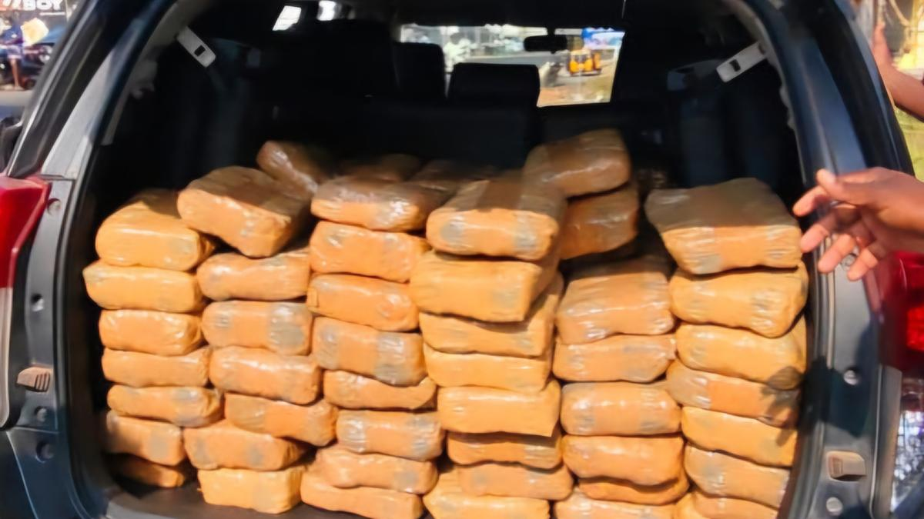
Exhibit FME-01 | Photographed at checkpoint: 15/06/2025, 11:18 PM IST | Boot of seized vehicle — 52 packages visible
4. SAMPLING PROTOCOL
Sampling was conducted in accordance with NDPS Act, 1985 protocols and FSL Standard Operating Procedure No. FSL/NDPS/SOP-04 (rev. 2022). Representative samples were drawn from a randomised selection of packages to ensure analytical validity across the full consignment.

Packages Sampled | 8 of 52 (random stratified selection — packages 4, 9, 15, 21, 28, 35, 42, 50)
Sample Weight per Pack | 5.0 g extracted from each selected package using sterile sampling equipment
Total Analytical Sample | 40.0 g
Remaining Sealed | Unsampled portion of selected packages re-sealed and stored; remaining 44 packages maintained in sealed vault custody
Sampling Officer | Dr. [Name Withheld — Demo], witnessed by Senior Scientific Officer
Sampling Date | 16 June 2025

5. PRELIMINARY COLOUR REACTION TESTS
The following standard presumptive colorimetric tests were performed on extracted samples at the FSL Ernakulam narcotics laboratory. These tests provide rapid presumptive identification of substance class prior to confirmatory analysis.

Test | Method / Reagent | Result
Duquenois–Levine Test | Cannabis-specific colorimetric reagent | POSITIVE — Purple-violet coloration (characteristic of cannabis resin)
Scott Test (Cocaine) | Cobalt thiocyanate reagent | NEGATIVE — No blue precipitate
Marquis Test (Opiates) | H₂SO₄ + Formaldehyde reagent | NEGATIVE — No orange-to-brown reaction
Mandelin Test (Stimulants) | Ammonium metavanadate in H₂SO₄ | NEGATIVE — No characteristic colour change
Mecke Test (Opioids) | Selenious acid in H₂SO₄ | NEGATIVE — No blue-green reaction
Fast Blue B Salt Test | Diazonium compound — cannabinoid-specific | POSITIVE — Orange-red coloration; confirmatory for THC-type cannabinoids

6. CONFIRMATORY ANALYTICAL RESULTS
Following positive presumptive tests, confirmatory analysis was performed using validated instrumental methods as per NDPS Act Schedule I requirements and FSL accreditation standards (NABL Accredited Lab No. TC-4521).

Analytical Method 1 | Gas Chromatography–Mass Spectrometry (GC-MS) — substance identification
GC-MS Finding | Δ⁹-Tetrahydrocannabinol (Δ⁹-THC) confirmed — retention time 12.34 min; mass spectrum match >98% with NIST library reference
Analytical Method 2 | High Performance Liquid Chromatography (HPLC) — quantification
THC Content | Δ⁹-THC: 14.2% w/w (± 0.4%) — consistent with processed cannabis resin (charas/hashish)
CBD Content | Cannabidiol (CBD): 3.1% w/w — present as minor constituent
Adulterants / Cutting | Henna, compressed plant matter — identified as diluent; no toxic adulterants
Substance Classification | Cannabis Resin (Charas/Hashish) — Schedule I, NDPS Act, 1985
NDPS Category | Hard Contraband — Commercial Quantity (>1 kg threshold exceeded)

7. QUANTIFICATION & ESTIMATED MARKET VALUE

Total No. of Packages | 52
Average Net Weight/Pack | ~960 g (after deducting packaging weight, based on sampled packages)
Estimated Total Net Wt. | Approximately 49.9 kg (cannabis resin — net)
NDPS Threshold (Comm.) | >1 kg constitutes 'commercial quantity' — this seizure is approximately 50× the commercial threshold
Estimated Street Value | ₹ 95,00,000 – ₹ 1,05,00,000 (approximately ₹1 crore) at prevailing Kerala illicit market rates
Destination (Alleged) | Multiple cities in Kerala and Tamil Nadu — per preliminary interrogation of suspects
Exhibit Disposition | Retained in sealed custody at FSL vault pending court order; a court sample (50 g) prepared for production as evidence

8. APPLICABLE STATUTORY PROVISIONS
- Section 20(b)(ii)(C) of the NDPS Act, 1985 — Production, manufacture, possession, sale, purchase, transport, import inter-state, export inter-state, or use of cannabis (commercial quantity) — punishable with rigorous imprisonment of not less than 10 years, extendable to 20 years, and fine of ₹1 lakh to ₹2 lakhs.
- Section 29 of the NDPS Act, 1985 — Abetment and criminal conspiracy in relation to narcotic offences.
- Section 8(c) of the NDPS Act, 1985 — Prohibition on production, manufacture, possession, sale, purchase, transport, and use of narcotic drugs and psychotropic substances.
- Section 67 of the NDPS Act, 1985 — Power of officers to call for information for investigation purposes.
9. FORENSIC OPINION & CONCLUSION
1. The seized material (52 packages, total estimated net weight ~49.9 kg) has been conclusively identified as Cannabis Resin (Charas/Hashish) containing Δ⁹-Tetrahydrocannabinol (Δ⁹-THC) at 14.2% w/w, confirmed by GC-MS and HPLC analysis.
2. The substance is a narcotic drug as defined under Section 2(xiv) of the NDPS Act, 1985, and its possession, transport, and trafficking are offences under that Act.
3. The quantity (approximately 49.9 kg net) far exceeds the 'commercial quantity' threshold of 1 kg prescribed under the NDPS Act, attracting the enhanced penalties under Section 20(b)(ii)(C).
4. All presumptive tests for cocaine, opiates, and amphetamine-type stimulants returned negative results — the consignment contains only cannabis resin with no admixture of other controlled substances.
5. The uniformity of packaging, compression technique, and THC content across all sampled packages indicates organised production and distribution — consistent with a professional trafficking operation rather than personal possession.
6. This report is admissible as expert evidence under Section 45 of the Indian Evidence Act (now BSA 2023, Section 39) and may be produced in any criminal proceedings arising from this case.

10. CERTIFICATION
I, the undersigned Senior Scientific Officer, certify that the analysis described in this report was conducted in accordance with the Standard Operating Procedures of the Forensic Science Laboratory, Kerala, and that the findings are accurate to the best of my knowledge and professional judgment.

Analysing Scientist:  Dr. [Name Withheld — Demo]  Senior Scientific Officer (Narcotics)  Forensic Science Laboratory, Kerala  NABL Accreditation No: TC-4521 [Demo] | Countersigned:  [Investigating Officer Name]  Inspector of Police  Anti-Narcotics Cell, Ernakulam  Badge No: [DEMO]

⚠ THIS IS A DEMONSTRATION DOCUMENT GENERATED FOR CASE ILLUSTRATION PURPOSES ONLY ⚠

