FORENSIC MEDICAL EXAMINATION REPORT
Wound Documentation & Injury Analysis
Case No: KRP-2024-0111-KC01 | Kerala State Police — Ernakulam District
1. CASE IDENTIFICATION

Case Reference | KRP-2024-0111-KC01
Incident Title | Taxi Stand Murder — Kochi Railway Station
Reporting Authority | Ernakulam District Police, Kerala
Date of Incident | 11 January 2024
Time of Incident | Approximately 01:10 AM IST
Location | Taxi stand adjacent to Kochi Railway Station, Ernakulam, Kerala
Date of Examination | 11 January 2024 (post-mortem, same day)
Examining Physician | Dr. [Name Withheld for Demo Purposes]
Designation | Senior Forensic Pathologist, Government Medical College, Ernakulam

2. VICTIM PARTICULARS

Full Name | Sharan Kumar
Age | 35 Years
Gender | Male
Occupation | Night-Shift Taxi Driver
Identification | Aadhaar & Vehicle Registration (Verified by Investigating Officer)
Found At | Inside parked taxi, Kochi Railway Station taxi stand
Reported By | Railway Security Personnel (approx. 01:15 AM)

3. EXTERNAL EXAMINATION FINDINGS
The body was received in a supine position. The deceased was clothed in a white half-sleeve shirt and dark trousers. Clothing showed a single penetrating tear on the left lateral mid-torso region with visible bloodstaining around the defect, consistent with a stab wound entry point.
General body condition: Well-nourished adult male. Rigor mortis partially established at time of examination; lividity fixed and consistent with position of discovery. No signs of decomposition.
No defensive wounds observed on the hands, forearms, or upper limbs. No contusions, abrasions, or signs of blunt force trauma to the face, scalp, or extremities. No evidence of ligature marks or restraint injuries.

4. WOUND DESCRIPTION & PHOTOGRAPHIC EVIDENCE
A single penetrating stab wound was identified on the left lateral thoraco-abdominal wall. The wound is the sole external injury on the body and is the cause of death (pending histology and toxicology confirmation).

Wound Type | Incised stab wound — single entry, no exit wound identified
Location on Body | Left lateral thoraco-abdominal region, approximately 3 cm inferior to the 10th rib
Orientation | Oblique — directed supero-inferiorly at approximately 30° to the sagittal plane
Length (External) | Approximately 3.5 cm
Wound Margins | Clean and sharp; no bridging of tissue; no bevelling of edges
Upper Margin | Squared — consistent with the spine (non-cutting edge) of the blade
Lower Margin | Tapered (acute angle) — consistent with the cutting edge of the blade
Surrounding Tissue | Mild peri-wound abrasion and contusion consistent with hilt/guard impact; moderate haemorrhage
Depth of Track | Estimated 12–14 cm (internal dissection to follow)
Track Direction | Medial and slightly posterior; penetrates abdominal musculature
Wound Age | Consistent with ante-mortem infliction; vital reaction confirmed

Figure 1: Photographic Documentation of Stab Wound — Exhibit FME-01
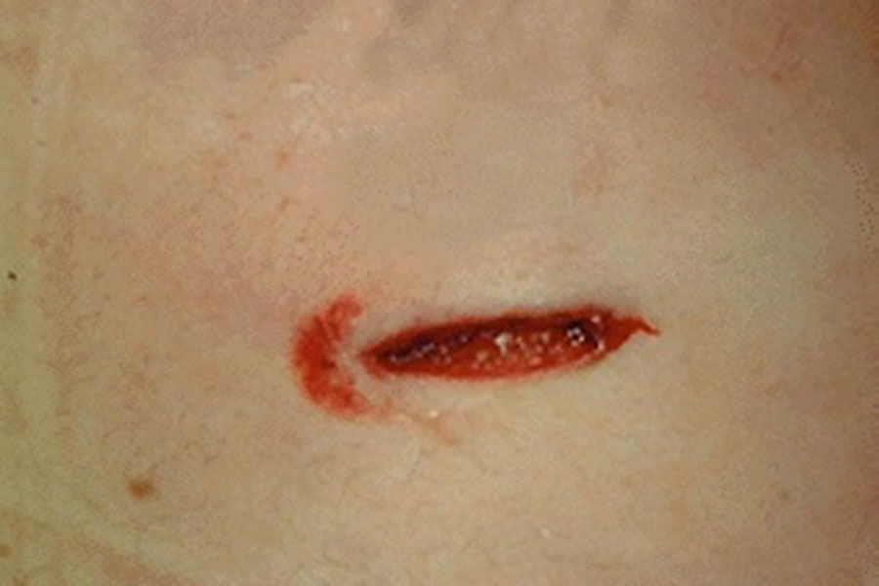
Exhibit FME-01 | Photographed at scene: 11/01/2024, 01:55 AM IST | Scale: 1:1 approximation
5. WOUND PATTERN ANALYSIS & WEAPON CHARACTERISTICS
Based on wound morphology, the following inferences regarding the causative weapon are made:
- Single-edged bladed instrument — indicated by the squared (blunt) upper margin and sharp lower margin of the wound.
- Estimated blade width: 3.0–3.5 cm, consistent with a medium-sized knife (e.g., folding knife, kitchen knife, or tactical blade).
- Blade length: Minimum 12 cm, based on depth of penetration track.
- Hilt mark: Mild surrounding contusion indicates a guarded or cross-guarded handle, suggestive of a forceful single thrust to the hilt.
- No blade tip fracture fragments detected externally. Radiological examination recommended pre-autopsy.
6. INTERNAL EXAMINATION (PRELIMINARY)
Full internal dissection was performed. The wound track was traced through the left lateral abdominal wall musculature into the peritoneal cavity. The track penetrated the descending colon and caused significant haemorrhage into the peritoneal space (haemoperitoneum, estimated volume: 800–1000 mL).
The left lobe of the liver showed no direct penetration. No pneumothorax identified; diaphragm intact. The splenic capsule showed superficial contact but no laceration. No major vascular structures directly lacerated; haemorrhage pattern suggests mesenteric vessel involvement.
Cause of death: Haemorrhagic shock secondary to penetrating abdominal stab wound with mesenteric and colonic laceration. (Pending histopathology and toxicology — final cause of death to be confirmed in supplementary report.)

7. FORENSIC OBSERVATIONS & INVESTIGATIVE SIGNIFICANCE
Manner of Death | Homicide (single deliberate stab wound)
Initial Investigative Theory | Robbery or passenger dispute
Wound Consistency | A single, precise, deep wound with no hesitation marks suggests familiarity with infliction or intent to kill — argues against an impulsive robbery scenario
Entry Angle | Oblique downward angle suggests the assailant was positioned to the victim's left side, possibly seated alongside or standing outside the driver's window
Absence of Defence Wounds | Indicates the victim was caught off-guard — possible sudden attack without prior altercation
Blood Pattern | Bloodstaining confined to driver's seat and door panel; no cast-off pattern inside vehicle — consistent with victim remaining seated after infliction
Specimen Collected | Blood (toxicology), wound swab (DNA), clothing (trace evidence), peritoneal fluid

8. CONCLUSIONS
1. The deceased, Sharan Kumar (35), sustained a single penetrating stab wound to the left lateral thoraco-abdominal region, inflicted ante-mortem with a single-edged bladed weapon.
2. Death resulted from haemorrhagic shock due to internal haemorrhage secondary to colonic and mesenteric laceration.
3. The nature of the wound — single, deep, deliberate, with no hesitation or defensive injuries — is consistent with a planned or targeted assault rather than an incidental robbery confrontation.
4. Investigating officers are advised to broaden inquiries beyond passenger/robbery motive, and to investigate the victim's personal associations, financial disputes, or prior threats.
5. Final medico-legal cause of death report and toxicology results to follow within 14 working days.

9. TRACE EVIDENCE — FIBRE ANALYSIS
9a. Fibre Recovery & Scene Context
During examination of the victim’s clothing, a cluster of dark-coloured fibres was recovered from the left lateral outer surface of the victim’s white half-sleeve shirt, in the peri-wound zone adjacent to the stab wound entry point. The fibres were adhered to the fabric in a localised grouping, consistent with transfer from a garment worn by the assailant at the moment of close-contact stabbing.
The fibres were carefully lifted using adhesive tape transfer and individually isolated under sterile conditions. Recovery was documented photographically at 1:1 scale prior to submission to the Forensic Science Laboratory, Ernakulam, for analysis.
9b. Exhibit Details
Exhibit No. | EX-KC01/FIB-01 (Fibre Bundle — 12 individual fibres)
Recovery Location | Outer surface, left lateral mid-torso of victim’s white shirt; peri-wound zone, within 2 cm of stab entry point
Recovery Method | Adhesive tape lifting (3M Scotch 810); individual isolation under stereomicroscope; stored in sealed glassine envelope
Submitted to FSL | 11 January 2024 — FSL Ernakulam, Trace Evidence Division (Ref: FSL/ERN/2024/TR/0089)
9c. Microscopic Examination — Polarised Light Microscopy (PLM)
Individual fibres were mounted on glass slides and examined under a Leica DM2500 polarised light microscope at 100× and 400× magnification. The following morphological characteristics were recorded:
Colour | Dark charcoal-black; opaque under transmitted light; no visible colour variation between fibres
Cross-Section Shape | Circular to sub-circular (characteristic of synthetic nylon monofilament)
Fibre Diameter | 18–22 micrometres (µm) — consistent with fine-denier nylon yarn used in woven fabrics such as jackets, windbreakers, and outerwear
Surface Texture | Smooth, continuous surface; no striations or medulla (confirming synthetic origin); slight longitudinal striations consistent with mechanical drawing during manufacture
Birefringence (PLM) | Moderate to high birefringence observed under crossed polars — characteristic interference colours consistent with polyamide (nylon) polymer structure
Fibre Count | 12 individual fibres isolated and examined; all of uniform type and colour, indicating a single-source garment
Figure 2: Microscopic Image of Dark Nylon Fibres — Exhibit EX-KC01/FIB-01
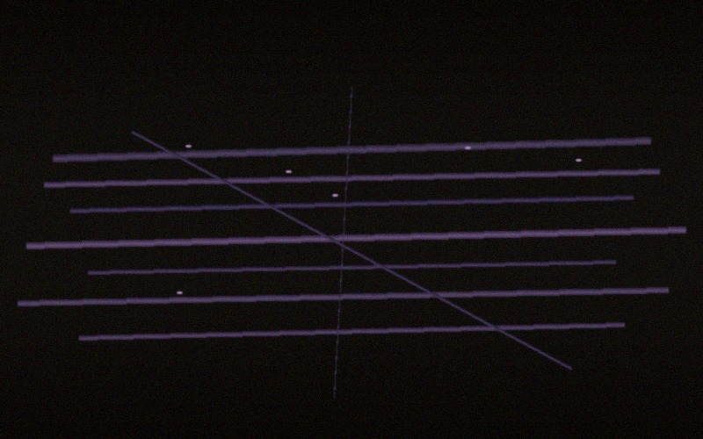
Exhibit EX-KC01/FIB-01 | Polarised Light Microscopy, 400× magnification | Dark nylon fibres recovered from peri-wound zone of victim’s shirt | FSL Ernakulam, 12 January 2024
9d. Chemical Analysis — FTIR Spectroscopy
Fourier Transform Infrared (FTIR) spectroscopy was performed on three randomly selected fibres using a Thermo Scientific Nicolet iS50 FTIR spectrometer with attenuated total reflectance (ATR) attachment, enabling direct analysis without sample preparation.
FTIR Result | Spectrum matches Nylon 6,6 (Polyamide 6,6) reference standard with 96.4% library match confidence (Thermo Scientific OMNIC v9.8 spectral library)
Key Absorption Bands | 3300 cm⁻¹ (N–H stretch, amide A); 1640 cm⁻¹ (C=O stretch, amide I); 1540 cm⁻¹ (N–H bend + C–N stretch, amide II) — all diagnostic for polyamide (nylon) class
Dye Analysis | Acid dye class identified — consistent with black dyeing of nylon using CI Acid Black 1 or equivalent. Dye uniformity across all 12 fibres confirms batch-consistent manufacturing origin
Confirmed Substance | Dark Nylon 6,6 (Polyamide 6,6) — acid-dyed black — CONFIRMED
9e. Forensic Significance
1. The dark nylon 6,6 fibres are foreign to the victim’s clothing (victim’s white shirt is 100% cotton — confirmed by separate analysis). Their presence in the peri-wound zone is consistent with secondary transfer from the assailant’s garment during close-contact stabbing.
2. The fibre type — fine-denier black nylon 6,6 (18–22 µm diameter) — is commonly used in the production of dark outerwear such as jackets, windbreakers, hooded garments, and tactical clothing. Investigators should seek to recover a dark nylon jacket or similar outerwear from the suspect(s).
3. If a suspect’s garment is recovered, fibre-to-fibre comparison should be conducted (FTIR, PLM, and dye batch analysis) to determine whether the recovered fibres and the suspect’s garment share a common origin — a finding that would constitute strong associative trace evidence linking the suspect to the crime scene and victim.
4. No matching fibres were found on the victim’s trousers or any other garment item, suggesting a highly localised transfer consistent with a single brief close-contact event — supporting the single-thrust attack mechanism established by wound analysis.

10. CERTIFICATION
I, the undersigned, certify that this report reflects my findings on examination of the deceased to the best of my knowledge and professional judgment.

Examining Physician:  Dr. [Name Withheld — Demo]  Senior Forensic Pathologist  Govt. Medical College, Ernakulam  Reg. No: MCI/KER/[DEMO] | Countersigned:  [Investigating Officer Name]  Inspector of Police  Ernakulam North Police Station  Badge No: [DEMO]

⚠ THIS IS A DEMONSTRATION DOCUMENT GENERATED FOR CASE ILLUSTRATION PURPOSES ONLY ⚠

