FORENSIC MEDICAL EXAMINATION REPORT
Wound Documentation & Injury Analysis
Case No: KRP-2024-0804-KC02 | Kerala State Police — Ernakulam District
1. CASE IDENTIFICATION

Case Reference | KRP-2024-0804-KC02
Incident Title | Parking Garage Homicide — Residential Building, Kochi
Reporting Authority | Ernakulam District Police, Kerala
Date of Incident | 4 August 2024
Time of Incident | Approximately 11:45 PM IST
Location | Underground parking garage, residential apartment complex, Kochi, Kerala
Date of Examination | 5 August 2024 (post-mortem, following day)
Examining Physician | Dr. [Name Withheld for Demo Purposes]
Designation | Senior Forensic Pathologist, Government Medical College, Ernakulam

2. VICTIM PARTICULARS

Full Name | Ajay Nair
Age | 32 Years
Gender | Male
Occupation | Late-Night Food Delivery Worker
Identification | Aadhaar card & delivery platform ID (Verified by Investigating Officer)
Found At | Beside personal scooter, underground parking garage, residential apartment, Kochi
Reported By | Building security personnel (approx. 11:58 PM)

3. EXTERNAL EXAMINATION FINDINGS
The body was received in a lateral decubitus position, partially slumped against the front wheel of a scooter. The deceased was clothed in a dark delivery uniform (polo shirt and cargo trousers) and a half-fastened delivery bag harness. The shirt exhibited a single penetrating tear at the right lower thoracic region with moderate bloodstaining extending downward across the right flank.
General body condition: Well-nourished adult male. Lividity fixed on right lateral aspect, consistent with the position of discovery. Rigor mortis fully established at time of examination. Core body temperature consistent with estimated time of death between 11:30 PM and 12:15 AM.
Hands and forearms: A shallow superficial linear abrasion was identified on the dorsum of the right hand, measuring approximately 4 cm — consistent with a contact or graze injury from striking the ground or vehicle surface during collapse. No classic defensive incised wounds identified on palms or forearms.
No blunt force injuries to the head, face, or scalp. No ligature marks or signs of restraint. No periorbital haemorrhage or signs of asphyxia.

4. WOUND DESCRIPTION & PHOTOGRAPHIC EVIDENCE
A single penetrating stab wound was identified on the right lateral lower thoracic wall. This constitutes the sole significant penetrating injury on the body and is determined to be the cause of death, subject to histopathological and toxicological confirmation.

Wound Type | Incised stab wound — single entry, no exit wound identified
Location on Body | Right lateral lower thoracic wall, approx. 2 cm inferior to 9th rib, mid-axillary line
Orientation | Horizontal with slight inferior angulation (~15° below the transverse plane)
Length (External) | Approximately 3.2 cm
Wound Margins | Clean and sharply incised; no laceration, tearing, or tissue bridging
Upper Margin | Squared — consistent with the non-cutting (spine) edge of a single-edged blade
Lower Margin | Tapered (acute) — consistent with the cutting edge of the blade
Surrounding Tissue | Minimal peri-wound bruising; faint hilt-mark contusion at medial end suggests deep forceful thrust
Depth of Track | Estimated 10–13 cm (pending full internal dissection)
Track Direction | Medially directed, penetrating intercostal space and entering right thoracic cavity
Wound Age | Ante-mortem; vital reaction confirmed by haemorrhage and surrounding tissue response

Figure 1: Photographic Documentation of Stab Wound — Exhibit FME-01
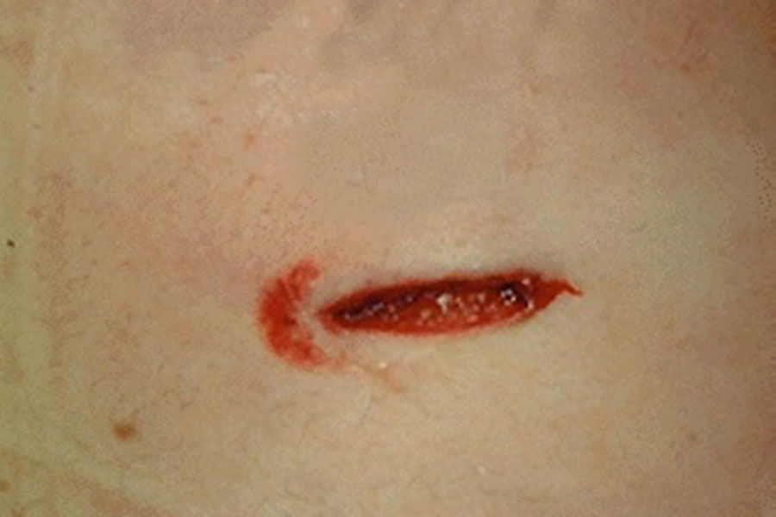
Exhibit FME-01 | Photographed at scene: 05/08/2024, 12:30 AM IST | Scale: 1:1 approximation
5. WOUND PATTERN ANALYSIS & WEAPON CHARACTERISTICS
Based on wound morphology, the following inferences regarding the causative weapon are made:
- Single-edged bladed instrument — squared upper margin (blade spine) and acutely tapered lower margin (cutting edge) confirm a single-edged blade.
- Estimated blade width: 3.0–3.2 cm, consistent with a medium utility knife, folding blade, or short combat knife.
- Blade length: Minimum 10 cm, inferred from depth of penetration track.
- Hilt contusion at medial end indicates a guarded handle and full-depth thrust — consistent with deliberate, forceful infliction.
- Horizontal wound orientation suggests assailant and victim were at similar height or victim was seated on scooter at time of infliction.
- No blade tip fracture fragments detected externally. Radiological examination recommended pre-autopsy.

6. INTERNAL EXAMINATION (PRELIMINARY)
The wound track was traced through the right lateral intercostal musculature (between ribs 9 and 10) into the right pleural cavity. Significant haemothorax was noted on the right side (estimated volume: 700–900 mL). The right lower lobe of the lung showed a penetrating laceration approximately 4 cm in length along the inferior surface.
The right hemidiaphragm was intact. No direct cardiac injury identified. The liver dome showed no penetration. No pneumothorax identified on the left side. The descending aorta and inferior vena cava were unaffected.
Cause of death: Haemorrhagic shock secondary to penetrating right thoracic stab wound with pulmonary laceration and haemothorax. (Pending histopathology and toxicology — final cause of death to be confirmed in supplementary report.)

7. FORENSIC OBSERVATIONS & INVESTIGATIVE SIGNIFICANCE
Manner of Death | Homicide (single deliberate stab wound)
Initial Investigative Theory | Confrontation during a delivery dispute
Wound Consistency | Single precise wound with no hesitation marks is inconsistent with a sustained altercation — suggests a swift, targeted attack
Entry Angle | Horizontal and medially directed — assailant likely positioned to victim's right; victim may have been seated on scooter or standing facing away
Partial Defensive Injury | Dorsal hand abrasion on right hand may indicate the victim raised an arm or fell onto a hard surface; insufficient for classic defensive wound classification
Scene Indicators | Enclosed underground garage — low visibility, minimal witnesses; consistent with a pre-planned ambush environment
Delivery Context | Victim was in uniform with delivery bag; scooter engine state and delivery order logs should be reviewed to establish precise timeline
Specimen Collected | Blood (toxicology), wound swab (DNA), clothing (trace evidence), right pleural fluid, right hand dorsum swab

8. CONCLUSIONS
1. The deceased, Ajay Nair (32), sustained a single penetrating stab wound to the right lateral lower thoracic wall, inflicted ante-mortem with a single-edged bladed weapon.
2. Death resulted from haemorrhagic shock secondary to right pulmonary laceration and haemothorax.
3. The wound morphology — single, clean, deep, horizontally directed — is consistent with a deliberate and targeted attack. The absence of multiple wounds or significant defensive injuries argues against a prolonged physical confrontation.
4. The enclosed parking garage setting, single precise wound, and absence of defensive injuries collectively suggest a pre-meditated assault rather than an opportunistic delivery dispute.
5. Investigators are advised to: (a) review CCTV from building entry/exit points and garage; (b) examine delivery platform logs for order details and customer identity; (c) canvass building residents; and (d) investigate any prior complaints or disputes involving the victim.
6. Final medico-legal cause of death report and toxicology results to follow within 14 working days.

9. TRACE EVIDENCE — FIBRE ANALYSIS
9a. Fibre Recovery & Scene Context
During examination of the victim’s clothing at the Government Medical College mortuary, a cluster of dark-coloured fibres was recovered from the outer surface of the victim’s right lateral delivery vest and underlying shirt, concentrated within 3 cm of the stab wound entry point. The localised grouping and adhesion pattern are consistent with secondary contact transfer from the assailant’s garment during the stabbing event.
The fibres were recovered using adhesive tape lifting under forensic conditions. Macro-photography at 1:1 scale was completed prior to tape lifting. Isolated fibres were stored in individual sealed glassine envelopes and submitted to FSL Ernakulam, Trace Evidence Division.
9b. Exhibit Details
Exhibit No. | EX-KC02/FIB-01 (Fibre Bundle — 9 individual fibres)
Recovery Location | Outer right lateral surface of victim’s delivery vest and shirt; peri-wound zone, within 3 cm of stab entry point at right thoraco-abdominal wall
Recovery Method | Adhesive tape lifting (3M Scotch 810); individual fibre isolation under stereomicroscope; glassine envelope sealed storage
Submitted to FSL | 5 August 2024 — FSL Ernakulam, Trace Evidence Division (Ref: FSL/ERN/2024/TR/0312)
9c. Microscopic Examination — Brightfield Transmitted Light Microscopy
Individual fibres were mounted in distilled water on glass slides and examined under a Nikon Eclipse E200 brightfield transmitted light microscope at 100× and 400× magnification. This method complements the PLM analysis used in KC01 and allows direct morphological comparison on a pale background, revealing fibre edge detail and internal structure more clearly.
Colour | Deep charcoal-black; opaque core; consistent acid-dye saturation across all fibres with no bleaching or colour fade at tips
Cross-Section & Profile | Circular cross-section; smooth continuous edges; slight longitudinal curvature visible in fibres — characteristic of drawn synthetic monofilament nylon. Blunt-cut ends visible on 5 of 9 fibres, consistent with shearing from a woven fabric structure
Fibre Diameter | 19–23 micrometres (µm) — within the range for fine-denier nylon outerwear fabric; closely comparable to fibres in Case KC01, consistent with same fibre type
Medulla | Absent — confirms synthetic (non-animal) origin; no cortex or scale structure observed, ruling out natural hair or wool
Fibre Count | 9 individual fibres; uniform colour, diameter, and morphology — consistent with single-source garment origin
Figure 2: Brightfield Microscopy of Dark Nylon Fibres — Exhibit EX-KC02/FIB-01
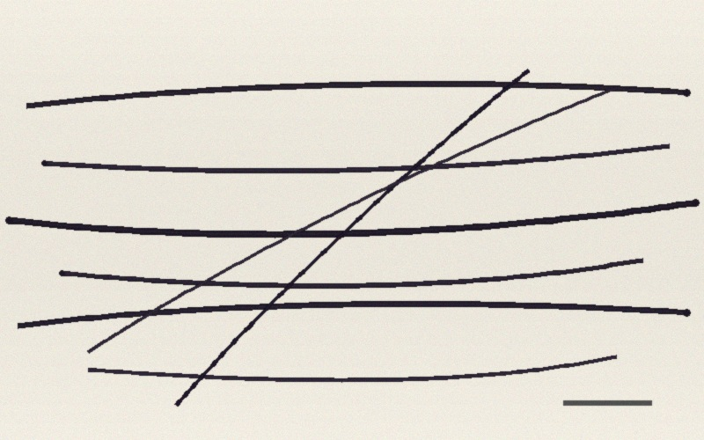
Exhibit EX-KC02/FIB-01 | Brightfield transmitted light microscopy, 400× | Individual dark nylon fibres dispersed on glass slide | FSL Ernakulam, 5 August 2024
9d. Chemical Analysis — FTIR Spectroscopy
FTIR-ATR spectroscopy was performed on three randomly selected fibres using a Bruker Alpha II FTIR spectrometer (ATR diamond crystal), 32 scans, 4 cm⁻¹ resolution. Results were compared against the SDBS and Thermo OMNIC spectral libraries.
FTIR Result | Spectrum matches Nylon 6,6 (Polyamide 6,6) with 97.1% library match confidence (Bruker OPUS 8.5 / SDBS cross-verified)
Key Absorption Bands | 3304 cm⁻¹ (N–H stretch); 1637 cm⁻¹ (C=O amide I); 1543 cm⁻¹ (amide II) — diagnostic polyamide signature; consistent with KC01 fibre spectrum within instrument tolerance (±4 cm⁻¹)
Dye Analysis | Acid dye class — black; consistent with CI Acid Black 1 or CI Acid Black 210 class dyes commonly used in commercial nylon fabric dyeing; dye penetration uniform across fibre cross-section indicating batch-dyed yarn
Cross-Case Comparison | FTIR spectrum of KC02 fibres is spectrally concordant with KC01 fibres (Case KRP-2024-0111-KC01) — both are Nylon 6,6, acid-dyed black, same diameter range. Investigators should consider whether a single common-source garment may link both cases.
Confirmed Substance | Dark Nylon 6,6 (Polyamide 6,6) — acid-dyed black — CONFIRMED
9e. Forensic Significance
1. The dark nylon 6,6 fibres are entirely foreign to the victim’s clothing (delivery vest: polyester mesh; t-shirt: 100% cotton — confirmed by separate fibre analysis). Their presence in the peri-wound zone is consistent with close-contact transfer from the assailant’s garment during the stabbing.
2. The fibre type and diameter (19–23 µm, fine-denier Nylon 6,6, acid-dyed black) are indistinguishable from those recovered in Case KRP-2024-0111-KC01 (Sharan Kumar, January 2024). Investigators should assess whether a common assailant, network, or garment source connects both cases. A formal inter-case fibre comparison is recommended.
3. The right-side recovery location of the fibres (consistent with the wound entry site on the right thoraco-abdominal wall) corroborates the wound analysis finding that the assailant approached from the victim’s right rear — the assailant’s garment contacted the victim’s vest at the moment of the stab.
4. No matching fibres were found elsewhere on the victim’s clothing, consistent with a brief single-contact event. If a suspect’s dark nylon garment is recovered, fibre-to-fibre FTIR and dye batch comparison should be conducted immediately to establish associative trace evidence.

10. CERTIFICATION
I, the undersigned, certify that this report reflects my findings on examination of the deceased to the best of my knowledge and professional judgment.

Examining Physician:  Dr. [Name Withheld — Demo]  Senior Forensic Pathologist  Govt. Medical College, Ernakulam  Reg. No: MCI/KER/[DEMO] | Countersigned:  [Investigating Officer Name]  Inspector of Police  Ernakulam South Police Station  Badge No: [DEMO]

⚠ THIS IS A DEMONSTRATION DOCUMENT GENERATED FOR CASE ILLUSTRATION PURPOSES ONLY ⚠

