**DBMS PROJECT**

PROJECT NAME: PlsLetMeGo

PROJECT TOPIC: Leave Management System

STUDENT NAME: Nakul Krishnakumar

ROLL NO: 2023BCS0010

GROUP NO: 3

Entities and Attributes

|  |
| --- |
| **User** |
| * User_id * Password * User_type |

|  |
| --- |
| **Student** |
| * Student_ID * Student_Name * Email_ID * Address * Guardian_Phone_No |

|  |
| --- |
| **Warden** |
| * Warden_ID * Warden_Name * Email_ID |

|  |
| --- |
| **Faculty advisor** |
| * FA_ID * FA_Name * Email_ID |

|  |
| --- |
| **Application** |
| * App_no * Application_status * Reason_for_leave * Start_date * End_date * Total_no_of_working_days |

|  |
| --- |
| **Hostel** |
| * Hostel_name * Strength * On_leave * Present |

|  |
| --- |
| **Gate** |
| * Out_date * In_date |

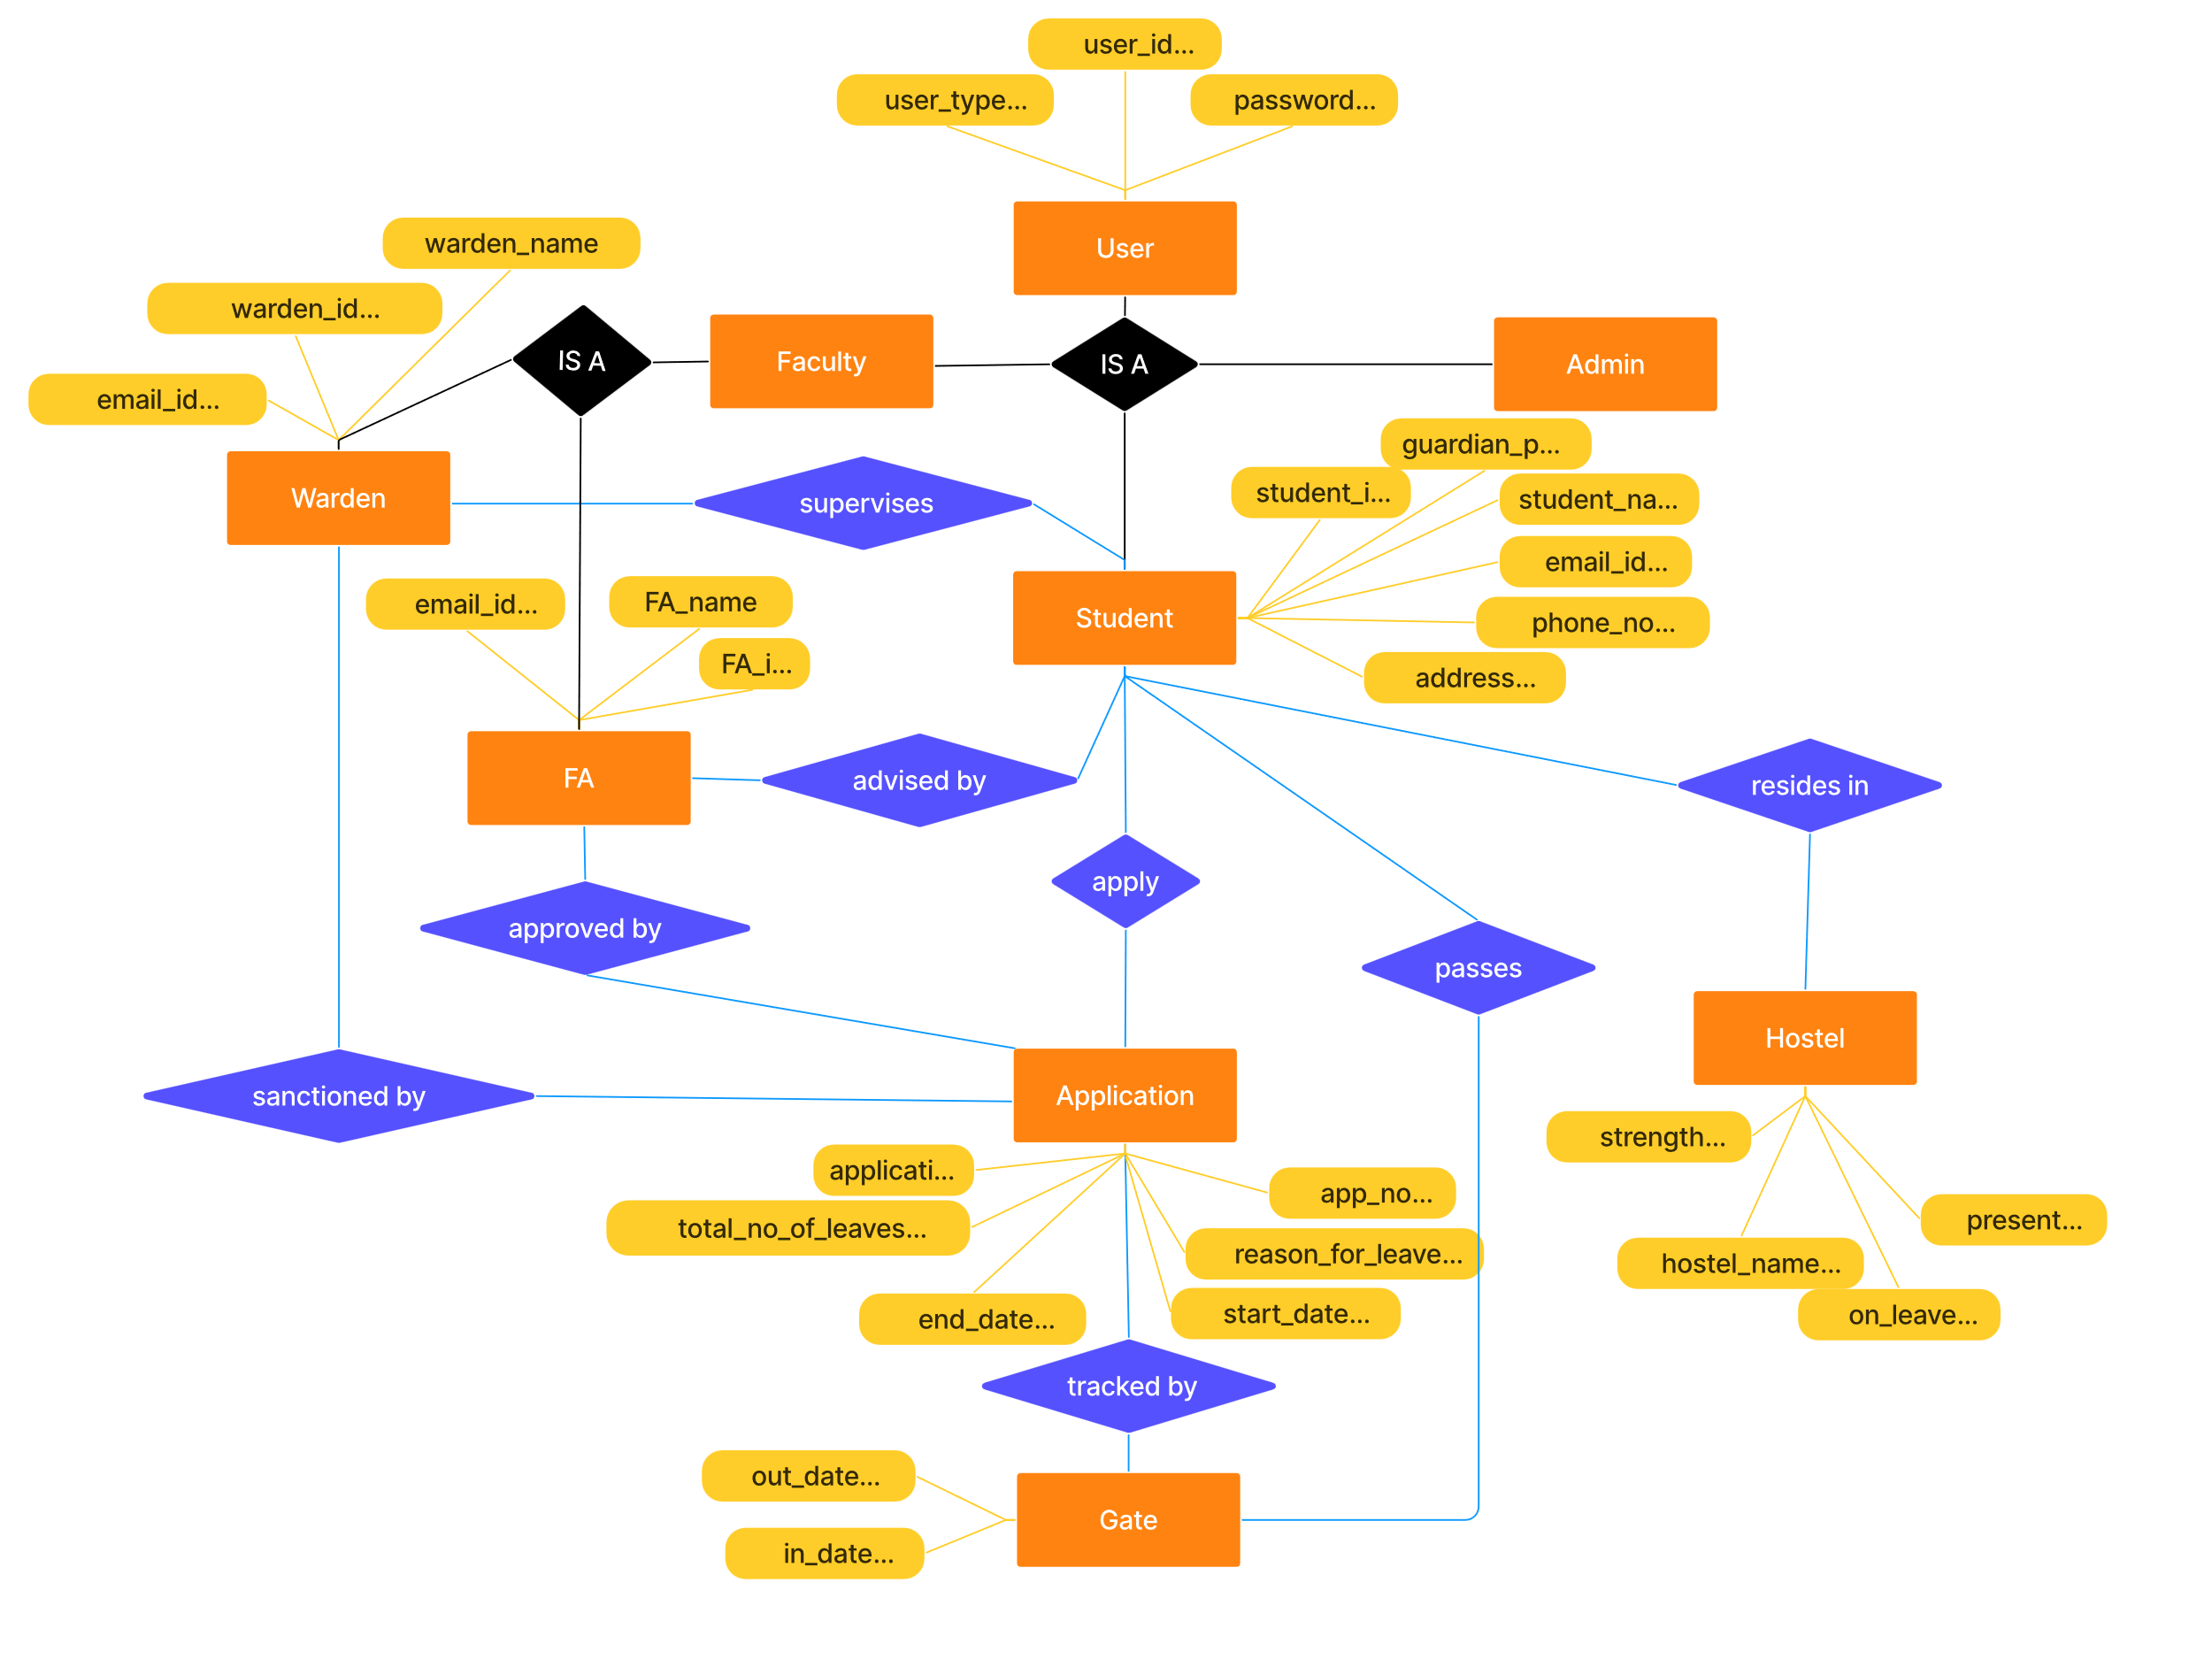ER Diagram

**Relations and their Cardinality and Participation**

**STUDENT apply APPLICATION**

* **Cardinality (One-to-many):** Each student can submit multiple applications, but each application is linked to only one student.
* **Participation (Partial-partial):** Not every student submits an application, and not all applications are submitted.

**STUDENT advised by FA**

* **Cardinality (Many-to-one):** Multiple students may share the same faculty advisor, but each student has only one assigned advisor.
* **Participation (Total-total):** Every student must have an advisor, and each advisor is responsible for students.

**APPLICATIONS approved by FA**

* **Cardinality (Many-to-one):** Each application is approved by only one faculty advisor, but an advisor can approve multiple applications.
* **Participation (Total-partial):** All applications require approval, but not every advisor needs to approve applications.

**APPLICATIONS sanctioned by WARDEN**

* **Cardinality (Many-to-many):** Multiple wardens can sanction the same application, and a warden can sanction multiple applications.
* **Participation (Total-partial):** All applications are eligible for sanction, but not every application will require it.

**APPLICATIONS tracked by GATE**

* **Cardinality (One-to-one):** Each application is uniquely tracked by a specific gate, and each gate entry tracks a specific application.
* **Participation (Total-total):** Every application has a corresponding gate entry, and all gate entries are linked to applications.

**STUDENT passes GATE**

* **Cardinality (One-to-many):** Each student can pass through the gate multiple times, but each gate entry is linked to only one student.
* **Participation (Total-partial):** All students have the opportunity to pass through, though some may not.

**STUDENT resides in HOSTEL**

* **Cardinality (Many-to-one):** Multiple students may stay in the same hostel, but each student resides in only one hostel at a time.
* **Participation (Partial-partial):** Not all students are required to stay in a hostel, and not all hostels may be occupied by students.

**USER represent STUDENT/FACULTY/ADMIN**

* **Cardinality (One-to-one):** Each user account uniquely represents one entity (student, faculty, or admin), with no overlap.
* **Participation (Total-total):** Every user must represent exactly one role, and each role requires a corresponding user.

**WARDEN supervises STUDENT**

* **Cardinality (Many-to-many):** Each warden can supervise multiple students, and each student can be supervised by multiple wardens.
* **Participation (Total-total):** Every student must have a supervising warden, and each warden must oversee students in the hostel system.

**Relational Schema**

# **USER** ( User_id, Password, User_type)

# **STUDENT** ( Student_id, Student_name, Email_ID, Phone_No, Guardian_Phone_No, FA_id)

# **FA**( FA_id, FA_Name, Email_ID)

# **WARDEN**( Warden_id, Warden _Name, Email_ID, Hostel_Name)

# **APPLICATION**(app_no, reason, start_date, end_date, no_working_days, application_status, student_id)

# **GateEntry**(entry_id, app_no, out_date, in_date)

**Hostel**( hostel_name strength on_leave )

**Application_Warden**( app_no warden_id )

**Student_Warden**( student_id warden_id )

**Functional Dependencies**

|  |  |
| --- | --- |
| **USER** | user_id → password  user_id → user_type |
| **STUDENT** | student_id → (student_name, email_id, phone_no, address, guardian_phone_no, FA_id, hostel_name)  email_id → (student_id, student_name, phone_no, address, guardian_phone_no, FA_id, hostel_name)  phone_no → (student_id, student_name, address, email_id, guardian_phone_no, FA_id, hostel_name) |
| **FACULTY_ADVISOR** | fa_id →( fa_name, email_id)  email_id → (fa_id, fa_name) |
| **WARDEN** | warden_id → (wd_name, email_id, hostel_name) |
| **APPLICATION** | app_no → (reason, start_date, end_date, no_working_days, application_status, student_id, fa_id)  student_id → fa_id |
| **GATE_ENTRY** | entry_id → (app_no, out_date, in_date)  app_no → (out_date, in_date) |
| **HOSTEL** | hostel_name → (strength, on_leave) |
| **APPLICATION_WARDEN** | (app_no, warden_id) → (app_no, warden_id) |
| **STUDENT_WARDEN** | (student_id, warden_id) → (student_id, warden_id) |

**NORMALIZATION APPLIED**

**USER :**

* Table is already in 1NF as no multivalued attribute exists.
* Both user_type and password are fully dependent on candidate key (user_id), hence the table is in 2NF.
* In all functional dependency, the LHS is candidate (which is subset of super key), hence table is in 3NF.

**STUDENT :**

* Table is already in 1NF as no multivalued attribute exists.
* Since each candidate key is a single attribute, there is no possibility of partial dependency. Each non-prime attribute depends on a whole candidate key.
* In each case, non-prime attributes (student_name, address, guardian_phone, FA_id, hostel_name) are directly dependent on the candidate keys and not on any other non-prime attribute.Thus, there are no transitive dependencies, and the table is in 3NF.

**FACULTY_ADVISOR:**

* Table is already in 1NF as no multivalued attribute exists.
* Since both candidate keys (fa_id and email_id) are single attributes, there can’t be any partial dependency (as partial dependency only occurs with composite keys). fa_name is fully functionally dependent on each candidate key (fa_id and email_id), so there are no partial dependencies. Conclusion: The table is in 2NF.
* Here, we have two FDs: fa_id → fa_name, email_id and email_id → fa_id, fa_name. Both fa_id and email_id are superkeys (candidate keys) for this table. The non-prime attribute fa_name is directly dependent on candidate keys without any intermediary dependencies. Conclusion: The table is in 3NF.
* Both FDs (fa_id → fa_name, email_id and email_id → fa_id, fa_name) have superkeys on the left side (fa_id and email_id are candidate keys), which satisfies BCNF.

**WARDEN:**

* Table is already in 1NF as no multivalued attribute exists.
* Since there is only one candidate key (warden_id), and all non-prime attributes are fully dependent on warden_id, this table is in 2NF.
* In this case, there are no transitive dependencies. All non-prime attributes depend directly on the candidate key (warden_id), so the table is in 3NF.
* Here, the only functional dependency is warden_id → (wd_name, email_id, hostel_name). Since warden_id is a candidate key (and hence a super key), the table is also in BCNF.

**APPLICATION** :

* Table is already in 1NF as no multivalued attribute exists.
* Here, fa_id is only dependent on student_id and not directly on app_no, creating a partial dependency. To bring the table into 2NF, we need to remove this partial dependency by separating fa_id into a different table. Since student table contains fa_id we remove it from the application table
* The table is in 3NF form as there are no transitive dependency present.

**GATE_ENTRY:**

* Table is already in 1NF as no multivalued attribute exists.
* In this case, all non-prime attributes (app_no, out_date, in_date) are fully dependent on entry_id, the candidate key.Therefore, the GateEntry table is already in 2NF.

**HOSTEL:**

* Table is already in 1NF as no multivalued attribute exists.
* Here, strength and on_leave are fully dependent on hostel_name, which is the only candidate key. Therefore, the Hostel table is already in 2NF.
* In this table, there are no transitive dependencies. strength and on_leave are directly dependent on hostel_name, the candidate key. Therefore, the Hostel table is already in 3NF.
* Since hostel_name is the only candidate key and all functional dependencies have hostel_name as their determinant, the table is also in BCNF.

**APPLICATION_WARDEN:**

* Table is already in 1NF as no multivalued attribute exists.
* All attributes (in this case, app_no and warden_id as the composite key) are fully functionally dependent on the entire candidate key.
* There are no transitive dependencies, as there are no non-key attributes.
* The table is also in BCNF because: For every functional dependency, the determinant is a superkey. Here, the only functional dependency is the primary key itself, which is also a superkey.

**STUDENT_WARDEN:**

* Table is already in 1NF as no multivalued attribute exists.
* All attributes (in this case, student_id and warden_id as the composite key) are fully functionally dependent on the entire candidate key.
* There are no transitive dependencies, as there are no non-key attributes.
* The table is also in BCNF because: For every functional dependency, the determinant is a superkey. Here, the only functional dependency is the primary key itself, which is also a superkey.

**VALUES ENTERED INTO TABLES**

**TABLE -Users**

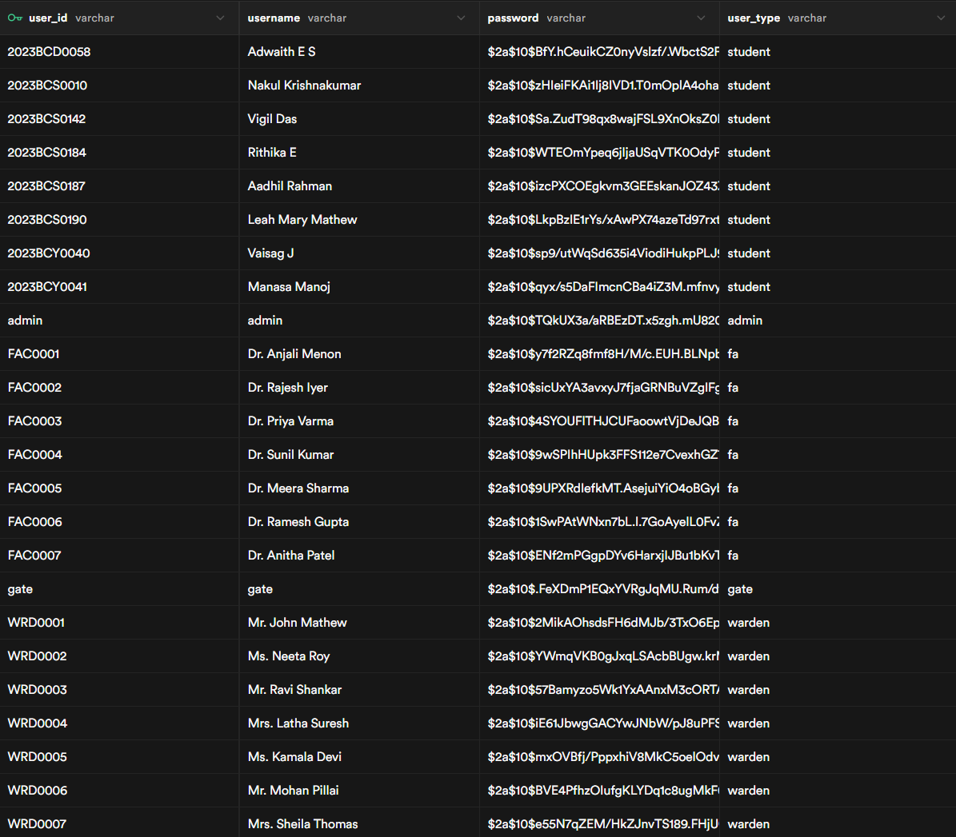

**TABLE-FacultyAdvisor**

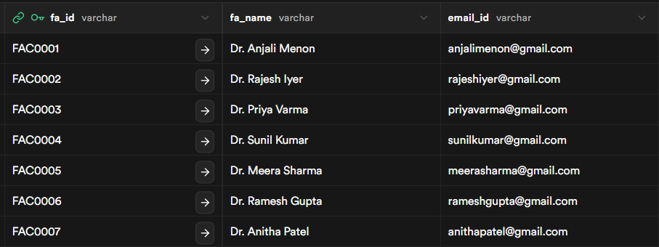

**TABLE-Warden**

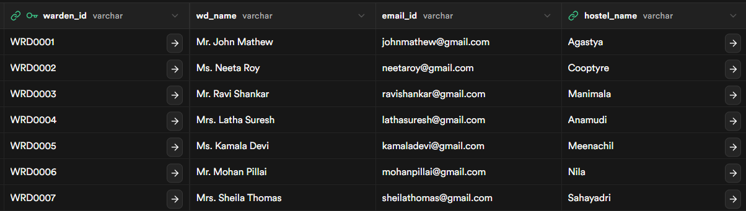

**TABLE – GateEntry**

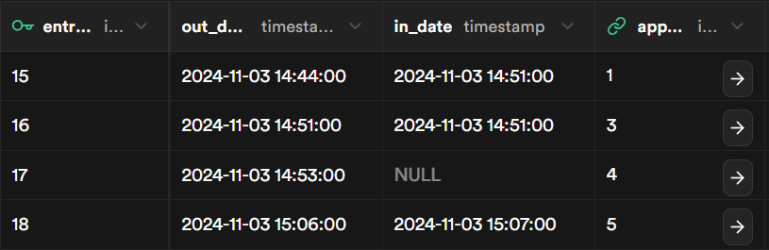

**TABLE-Hostel**

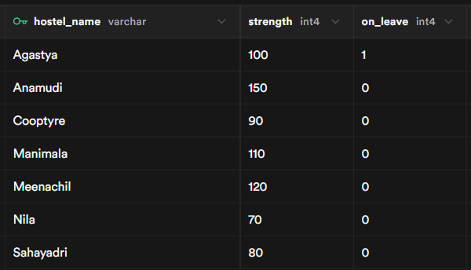

**Table-Student**

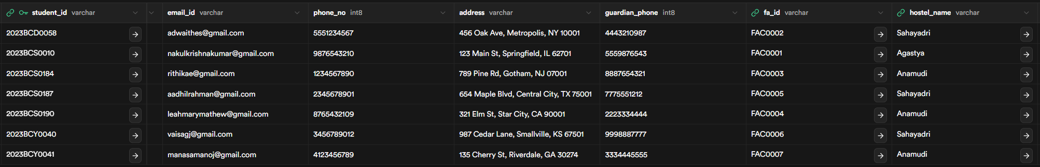

**Table – Application**

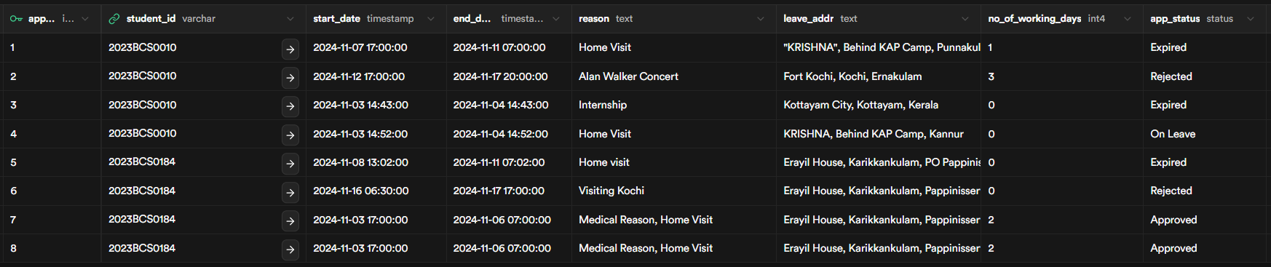

**Table – Application_warden**

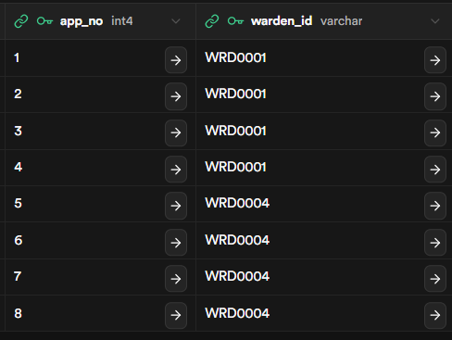

**Table – Student_warden**

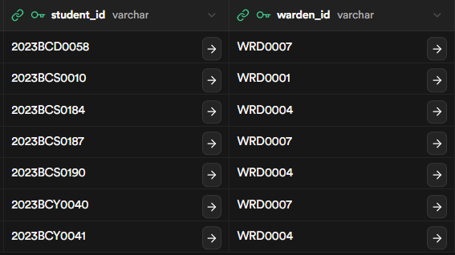

**TRIGGERS USED**

|  |  |
| --- | --- |
| **TRIGGER 1** | Trigger to Reset Application Number to last tuple's app_no – 1 or set it to 0 if application table is empty  CREATE OR REPLACE FUNCTION reset_app_no()  RETURNS TRIGGER AS $$  DECLARE  max_app_no INT;  BEGIN  -- Check if the table is empty  SELECT COUNT(*) INTO max_app_no FROM application;  IF max_app_no = 0 THEN  -- If empty, set app_no to 1 for the new row  NEW.app_no := 1;  ELSE  -- Otherwise, find the next available app_no  SELECT COALESCE(MAX(app_no), 0) + 1 INTO NEW.app_no FROM application;  END IF;  RETURN NEW; -- Return the modified new row with updated app_no  END;  $$ LANGUAGE plpgsql;  CREATE TRIGGER reset_app_no_trigger  BEFORE INSERT ON application  FOR EACH ROW  EXECUTE FUNCTION reset_app_no(); |
| **TRIGGER 2** | Trigger to add entries into application_warden table when a new application is made  CREATE OR REPLACE FUNCTION add_application_warden()  RETURNS TRIGGER AS $$  BEGIN  INSERT INTO application_warden (app_no, warden_id)  SELECT NEW.app_no, warden.warden_id  FROM warden  JOIN student_warden ON student_warden.warden_id = warden.warden_id  WHERE student_warden.student_id = NEW.student_id;  RETURN NEW;  END;  $$ LANGUAGE plpgsql;  CREATE TRIGGER trigger_add_application_warden  AFTER INSERT ON application  FOR EACH ROW  EXECUTE FUNCTION add_application_warden(); |
| **TRIGGER 3** | :Increment On_leave attribute in hostel table when an application is checked out of gate  CREATE OR REPLACE FUNCTION increment_on_leave()  RETURNS TRIGGER AS $$  BEGIN  -- Check if the application status has changed to "On Leave"  IF NEW.app_status = 'On Leave' AND OLD.app_status IS DISTINCT FROM 'On Leave' THEN  UPDATE Hostel  SET on_leave = on_leave + 1  WHERE hostel_name = (  SELECT hostel_name FROM Student WHERE student_id = NEW.student_id  );  END IF;  RETURN NEW;  END;  $$ LANGUAGE plpgsql;  CREATE TRIGGER trigger_increment_on_leave  AFTER UPDATE OF app_status ON Application  FOR EACH ROW  WHEN (NEW.app_status = 'On Leave')  EXECUTE FUNCTION increment_on_leave();  DROP TRIGGER trigger_increment_on_leave ON application; |
| **TRIGGER 4** | Decrement On_leave attribute when an application is checked in at the gate  CREATE OR REPLACE FUNCTION decrement_on_leave()  RETURNS TRIGGER AS $$  BEGIN  -- Check if the application status has changed to "Late" or "Expired"  IF (NEW.app_status = 'Late' OR NEW.app_status = 'Expired')  AND OLD.app_status IS DISTINCT FROM NEW.app_status THEN  UPDATE Hostel  SET on_leave = on_leave - 1  WHERE hostel_name = (  SELECT hostel_name FROM Student WHERE student_id = NEW.student_id  );  END IF;  RETURN NEW;  END;  $$ LANGUAGE plpgsql;  CREATE TRIGGER trigger_decrement_on_leave  AFTER UPDATE OF app_status ON Application  FOR EACH ROW  WHEN (NEW.app_status = 'Late' OR NEW.app_status = 'Expired')  EXECUTE FUNCTION decrement_on_leave(); |
| **TRIGGER 5** | :Add entry into student_warden table when a new student is registered (according to their hostel_name )  CREATE OR REPLACE FUNCTION add_student_warden_entry()  RETURNS TRIGGER AS $$  DECLARE  wardenID varchar(50);  BEGIN  -- Retrieve the warden_id associated with the new student's hostel  SELECT warden_id INTO wardenID  FROM Warden  WHERE hostel_name = NEW.hostel_name;  -- Insert into student_warden if a matching warden_id is found  IF wardenID IS NOT NULL THEN  INSERT INTO student_warden (student_id, warden_id)  VALUES (NEW.student_id, wardenID);  END IF;  RETURN NEW;  END;  $$ LANGUAGE plpgsql;  CREATE TRIGGER after_student_insert  AFTER INSERT ON Student  FOR EACH ROW  EXECUTE FUNCTION add_student_warden_entry(); |

**QUESTIONS**

***-- 1. Find all applications that were approved for medical reasons***

SELECT a.app_no, a.student_id, a.reason, a.start_date, a.end_date

FROM APPLICATION a

WHERE a.reason LIKE '%Medical%'

AND a.app_status = 'Approved';

***-- 2. Count the number of applications handled by each warden***

SELECT w.warden_id, w.wd_name, COUNT(aw.app_no) as applications_handled

FROM WARDEN w

LEFT JOIN Application_Warden aw ON w.warden_id = aw.warden_id

GROUP BY w.warden_id, w.wd_name;

***-- 3. List students who have more than 2 rejected applications***

SELECT s.student_id, s.email_id, COUNT(*) as rejected_count

FROM STUDENT s

JOIN APPLICATION a ON s.student_id = a.student_id

WHERE a.app_status = 'Rejected'

GROUP BY s.student_id, s.email_id

HAVING COUNT(*) > 2;

***-- 4. Find the warden who has approved the most leave applications***

SELECT w.warden_id, w.wd_name, COUNT(*) as approved_count

FROM WARDEN w

JOIN Application_Warden aw ON w.warden_id = aw.warden_id

JOIN APPLICATION a ON aw.app_no = a.app_no

WHERE a.app_status = 'Approved'

GROUP BY w.warden_id, w.wd_name

ORDER BY approved_count DESC

LIMIT 1;

***-- 5. Calculate the average duration of approved leaves for each hostel***

SELECT h.hostel_name,

AVG(DATEDIFF(a.end_date, a.start_date)) as avg_leave_duration

FROM Hostel h

JOIN STUDENT s ON h.hostel_name = s.hostel_name

JOIN APPLICATION a ON s.student_id = a.student_id

WHERE a.app_status = 'Approved'

GROUP BY h.hostel_name;

***-- 6. List all hostels that have strength greater than 100***

SELECT hostel_name, strength

FROM Hostel

WHERE strength > 100;

***-- 7. List wardens and their students who have pending applications***

SELECT w.warden_id, w.wd_name, s.student_id, a.app_no, a.reason

FROM WARDEN w

JOIN Student_Warden sw ON w.warden_id = sw.warden_id

JOIN STUDENT s ON sw.student_id = s.student_id

JOIN APPLICATION a ON s.student_id = a.student_id

WHERE a.app_status = 'Pending';

***-- 8. Display the name and email of warden who manages Nila hostel***

SELECT wd_name, email_id

FROM WARDEN

WHERE hostel_name = 'Nila';

***-- 9. Insert a new warden record***

*INSERT INTO WARDEN (warden_id, wd_name, email_id, hostel_name)*

*VALUES ('WRD0008', 'Mr. James Wilson', 'jameswilson@gmail.com', 'Nila');*

***-- 10. Update the email address of a student***

UPDATE STUDENT

SET email_id = 'newemail@gmail.com'

WHERE student_id = '2023BCS0010';

***-- 11. Update application status to 'Expired' for all past leaves***

UPDATE APPLICATION

SET app_status = 'Expired'

WHERE end_date < CURDATE()

AND app_status = 'Approved';

***-- 12. Find hostels with no students on leave***

*SELECT hostel_name*

*FROM Hostel*

*WHERE on_leave = 0;*

***-- 13. Find students who have never applied for leave but are assigned to a warden***

SELECT s.student_id, s.email_id, w.warden_id, w.wd_name

FROM STUDENT s

JOIN Student_Warden sw ON s.student_id = sw.student_id

JOIN WARDEN w ON sw.warden_id = w.warden_id

LEFT JOIN APPLICATION a ON s.student_id = a.student_id

WHERE a.app_no IS NULL;

***-- 14. List applications that were approved on the same day they were submitted***

SELECT app_no, student_id, start_date, reason

FROM APPLICATION

WHERE DATE(start_date) = DATE(end_date)

AND app_status = 'Approved';

***-- 15. Transfer all students from one warden to another***

BEGIN TRANSACTION;

UPDATE Student_Warden

SET warden_id = 'WRD0002'

WHERE warden_id = 'WRD0001';

UPDATE Application_Warden

SET warden_id = 'WRD0002'

WHERE warden_id = 'WRD0001'

AND app_no IN (

SELECT app_no

FROM APPLICATION

WHERE app_status = 'Pending'

);

COMMIT;