Ex. No.: 4 | PERSONALIZED RECOMMENDATION SYSTEM | URK23CS1074
13-10-2026 | PERSONALIZED RECOMMENDATION SYSTEM | URK23CS1074
Aim:
To develop a personalized recommendation system using GPT-4 that analyzes user preferences and generates, ranks and explains suitable recommendations based on the user's profile, interests, skill level and goals.
Problem Statement:
Design and develop an intelligent personalized recommendation system using GPT-4. The application should collect user information and preferences, analyze the user's requirements, generate personalized recommendations, rank them according to suitability, provide explanations for the recommendations and refine the results based on user feedback.
Software Requirements:
Software | Version
Python | 3.14.3
Ollama | 0.34.0 (model: llama3.2, 3B)
VS Code | 1.141.0
Pandas | 3.0.2
Sentence Transformers | 6.1.0 (model: all-MiniLM-L6-v2)
ollama (Python client) | 0.6.3
PyTorch | 2.14.1
Note: as specified for the lab, the GPT-4 role is served locally through Ollama using the llama3.2 model.
Input Parameters
Parameters | Description
Name | Name of the user; used to personalise output and name the saved files.
Age | Age of the user (validated, 10 to 100).
Background | Academic or professional background, e.g. Computer Science student.
Interests | Comma-separated topics of interest, e.g. Python, AI, Data Science.
Skill Level | Beginner / Intermediate / Advanced; used for level-fit scoring and filtering.
Preferred Category | Course / Project / Book / Certification / Any; filters the catalog.
Goal | What the user wants to achieve, e.g. Learn AI and build real projects.
Preferences | Free-text learning preferences, e.g. practical, hands-on courses (detects preferred format).
Number of items | How many recommendations to generate (1 to 10).
System Architecture
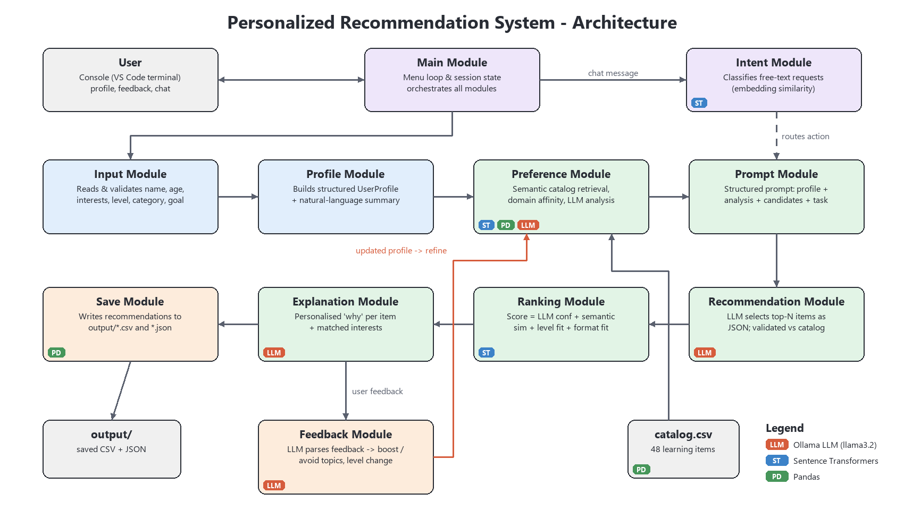
Fig. 1: System architecture of the Personalized Recommendation System
The user interacts through a menu-driven console. The Input and Profile modules build a structured profile. The Preference module retrieves matching items from a 48-item catalog using Sentence-Transformer embeddings and asks the LLM to analyse the learner. The Prompt module turns this into a structured prompt; the Recommendation module gets the LLM's selection as JSON; the Ranking module scores the items and the Explanation module justifies them. Feedback updates the profile and loops back to the Preference module for refinement. The Intent module routes free-text requests to the right action, and the Save module stores the results as CSV and JSON.
Module Design
Module | Responsibility
Input Module | Reads the user's details from the console and validates them (required fields, numeric ranges, allowed choices).
Profile Module | Converts the raw input into a structured UserProfile and builds a natural-language summary of it for prompts and embeddings.
Preference Module | Loads the catalog with Pandas, embeds the profile with Sentence Transformers, retrieves the top candidates, computes domain affinity and asks the LLM for key interests, learning style and focus areas.
Prompt Module | Assembles the system prompt and a structured user prompt (profile, analysis, candidates, feedback, task) that asks for JSON output.
Recommendation Module | Sends the prompt to the LLM through Ollama, parses the JSON and checks every item ID against the catalog, topping up from semantic candidates if needed.
Ranking Module | Scores each item as 0.40 x LLM confidence + 0.35 x semantic similarity + 0.15 x level fit + 0.10 x format fit, then sorts and ranks the items.
Explanation Module | Generates a personalised two-sentence explanation for each item with the LLM and lists the user interests it matches.
Feedback Module | Collects feedback, extracts topics to boost or avoid with the LLM (plus a rule-based fallback), updates the profile and compares the old and refined lists.
Intent Module | Classifies free-text chat messages into intents (get, refine, explain, change level, save, view profile, exit) using embedding similarity to example phrases.
Save Module | Writes the final ranked and explained recommendations to CSV, and the profile, feedback history and results to JSON, in the output folder.
Main Module | Displays the home screen and menu, keeps the session state and orchestrates the modules, running earlier steps automatically when needed.
Implementation
GitHub Link: https://github.com/AdwaithSaji/Exp4-Personalized-Recommendation-System
LinkedIn Post Link: <LinkedIn Post Link>
Output Screenshots:
1. Home Screen
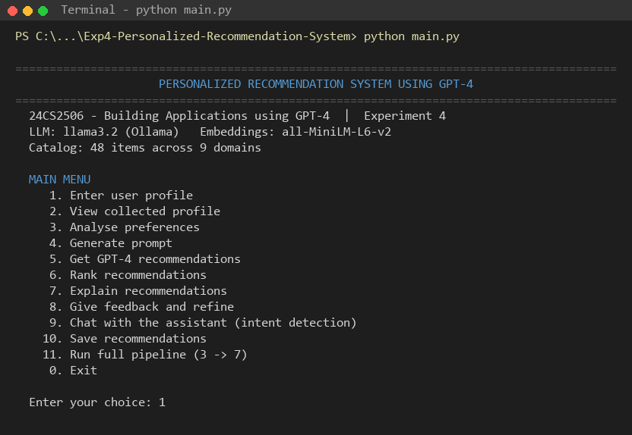
Fig. 2: Home Screen
2. User Profile Input
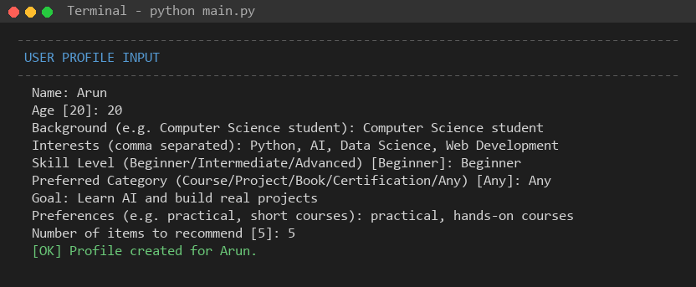
Fig. 3: User Profile Input
3. Collected User Profile
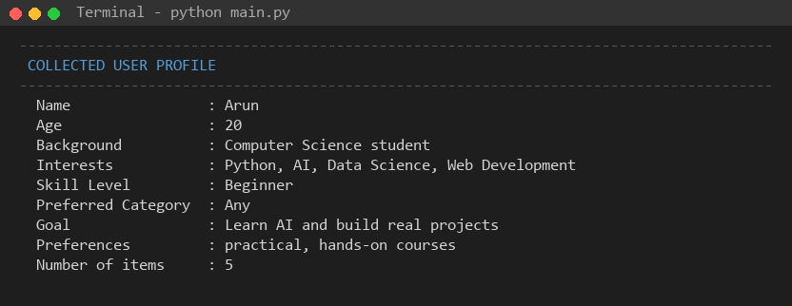
Fig. 4: Collected User Profile
4. Preference Analysis
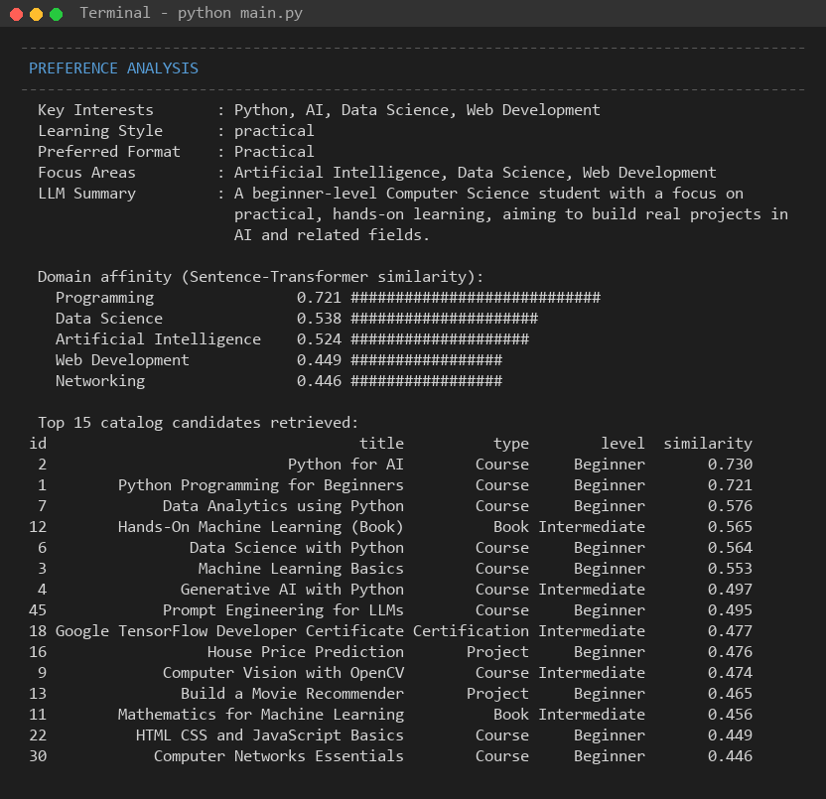
Fig. 5: Preference Analysis
5. Prompt Generation
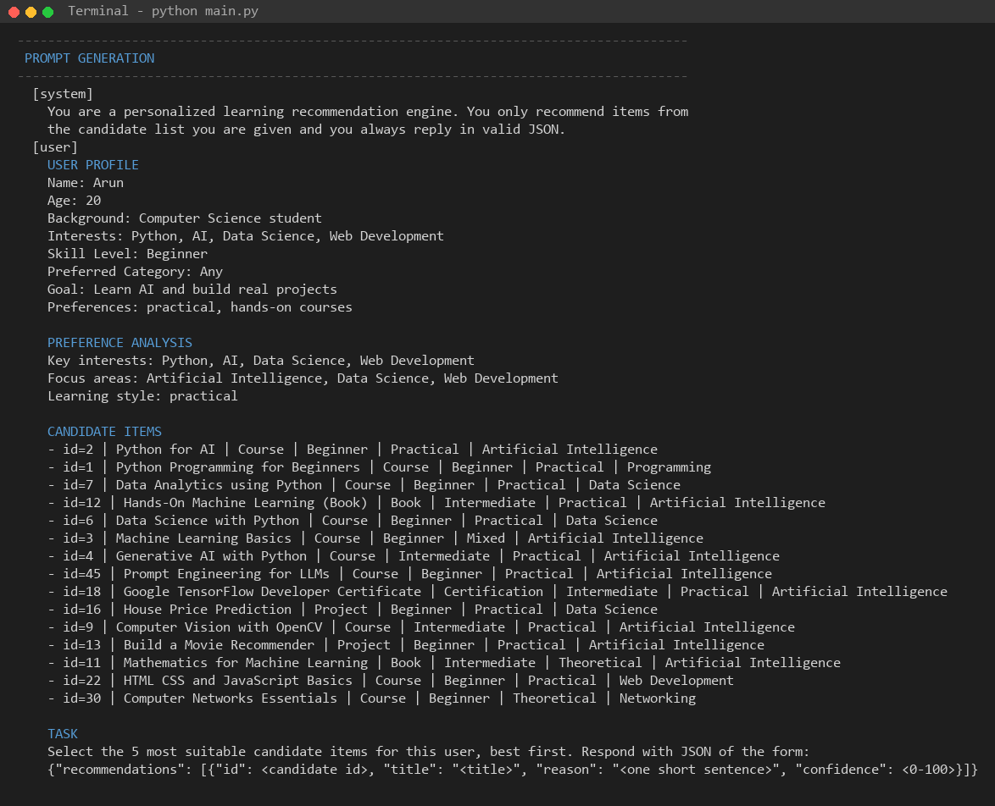
Fig. 6: Prompt Generation
6. GPT-4 Recommendation
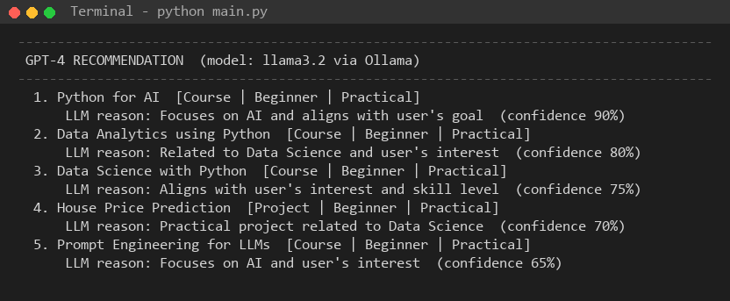
Fig. 7: GPT-4 Recommendation
7. Recommendation Ranking
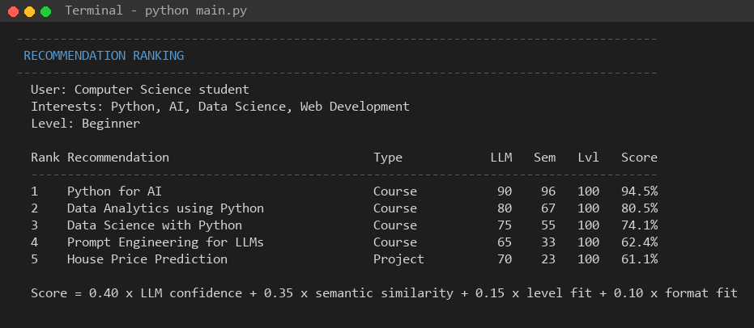
Fig. 8: Recommendation Ranking
8. Recommendation Explanation
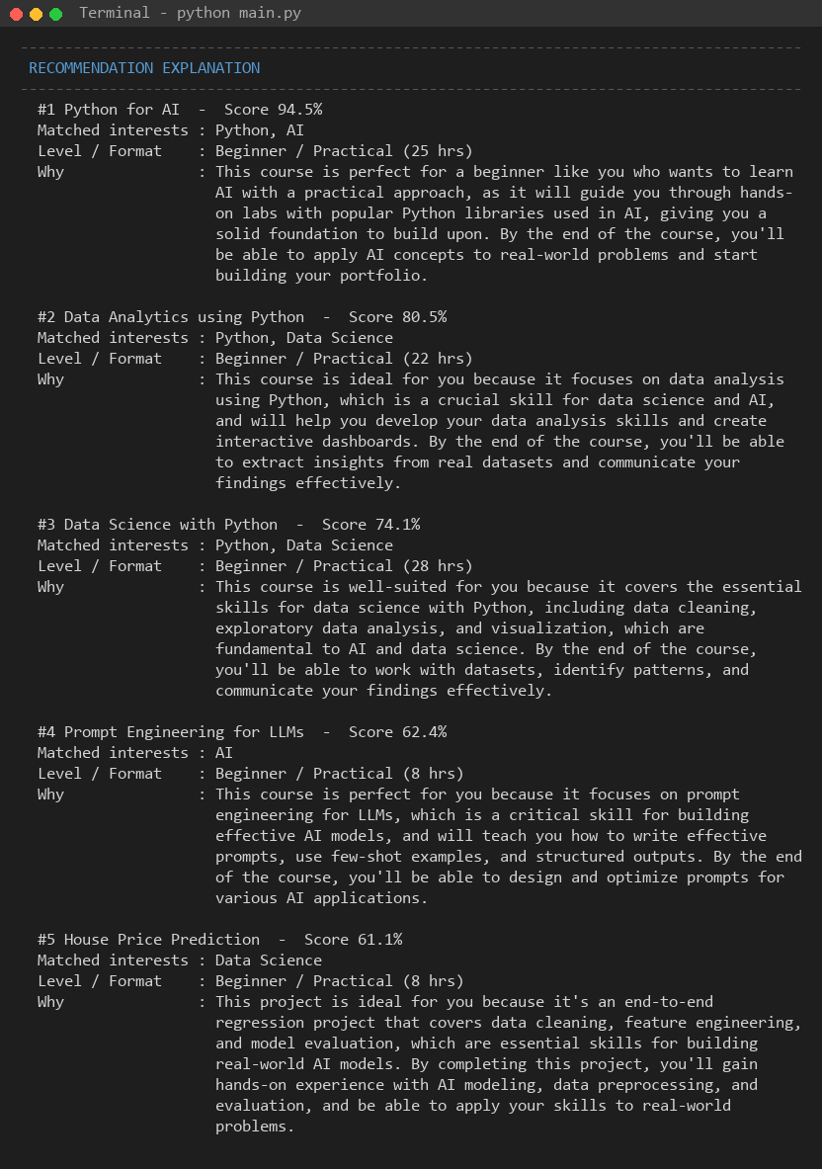
Fig. 9: Recommendation Explanation
9. User Feedback
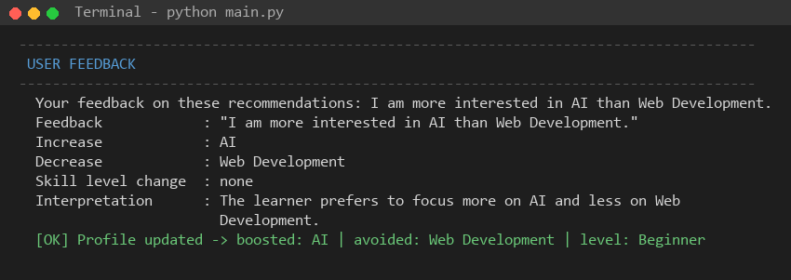
Fig. 10: User Feedback
10. Refined Recommendations
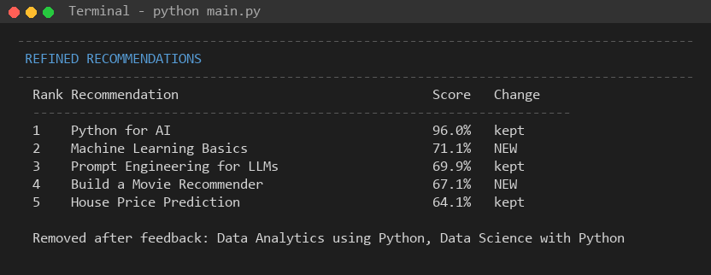
Fig. 11: Refined Recommendations
11. Intent Detection
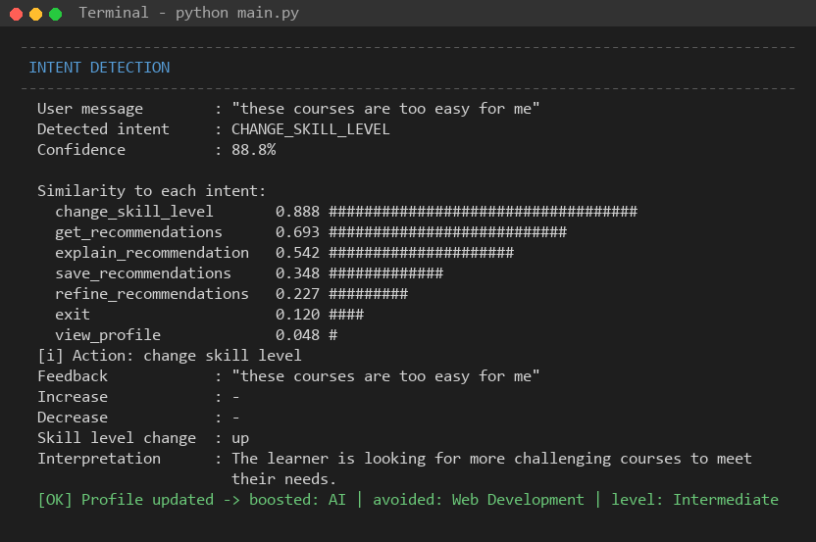
Fig. 12: Intent Detection
12. Recommendation Saved Successfully
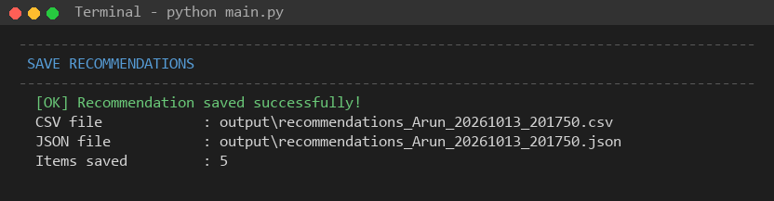
Fig. 13: Recommendation Saved Successfully
Result:
Thus, a personalized recommendation system using GPT-4 was successfully developed. The system collects user information, analyzes preferences, generates personalized recommendations, ranks and explains the recommendations, accepts user feedback and produces refined recommendations.

