EEE 120

Capstone Design Project

Name: Adwait Sharad More

Instructor: Steve Millman

Class Time: Tue Thu 4:30-5:45

Date: 12/5/2024

**Task C-1: Planning the Synchronous Sequential Machines**

(5 pts) Interview at least 3 stakeholders, but 3 is preferred. Ask questions regarding the form, function, and features needed by potential customers for this design. Make sure to capture what the customer prefers from this type of solution, as well as what environment the customer plans to use this design. Summarize your findings here and document the names of who you interviewed.

**Aditya Bohra:** It shouldn’t be a complicated design. It should be easy to understand.

**Anay Shirolkar:** The circuit should be error-less.

**Siddharth Bhatter:** The circuit should be reliable and it should be cost effective.

**Summary of findings:** The interviews revealed three key considerations for the design. Aditya Bohra emphasized the importance of simplicity, advocating for a design that is easy to understand. Anay Shirolkar highlighted the need for an error-free circuit to ensure precise and accurate functionality. Siddharth Bhatter stressed the importance of reliability and cost-effectiveness, focusing on a design that is dependable and affordable.

(5 pts) Please include a comment on why your automation adds value from multiple perspectives (technological, societal, financial, environmental, etc.). (*What value does this add? What is the type of customer for whom this is designed? Where is this most needed? What couldn’t you do before?*)

- The water filler adds value by convenience, user-friendly and secure, it offers to a wide range of customers which includes residents having pool at their place and businesses meeting their need for usage and less work. This type of innovation improves efficiency, and streamlines daily everyday work. It addresses societal concern and minimizing the risk of electric shock of manual handling of the pool water level.

(5 pts) It is allowable to continue to ask questions of stakeholders throughout the design process (and is preferred of a conscientious engineer). This can be done as you are designing, before you are designing if you need input and clarifications, or after you are done designing if you want feedback on improvements. Summarize any changes to your understanding or design based on the feedback you received during your initial interviews or continual interviews?

- I interviewed three stakeholders as required for the project and I received a feedback for the system design simplicity and convenience. Automatic water filler in the pool is based on user-friendly experience.

**Task C-2: Document the Synchronous Sequential Machines**

**Design #1:** (2 pts) What assumptions did you make in the design of this machine?

1. There are four possible inputs L’V’ which means reset, LV’ which means slow fill, L’V which means fast fill and LV which means error.

2. After two consecutive clocks of fast filling it will go to error state and will stay there till V turns 0.

(3 pts) Create a state definition table here that describes in plain English what each state in your machine means and what binary values you have assigned to represent each state, inputs, and outputs.

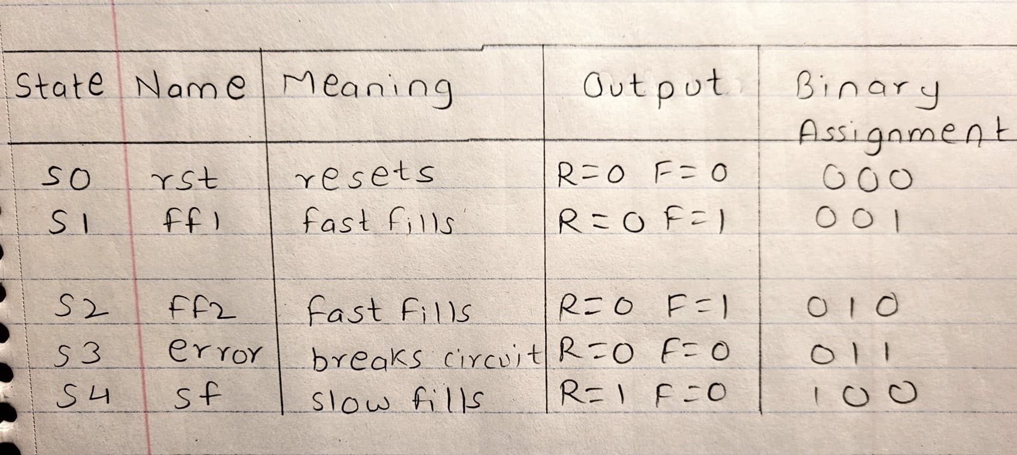

(12 pts) Show your state diagrams, state transition tables and your circuit planning work (Karnaugh maps/equations/MUX/DEC/etc.) used in your design process. (You can do this by hand if you wish, do **not** show the full circuit schematic here.)

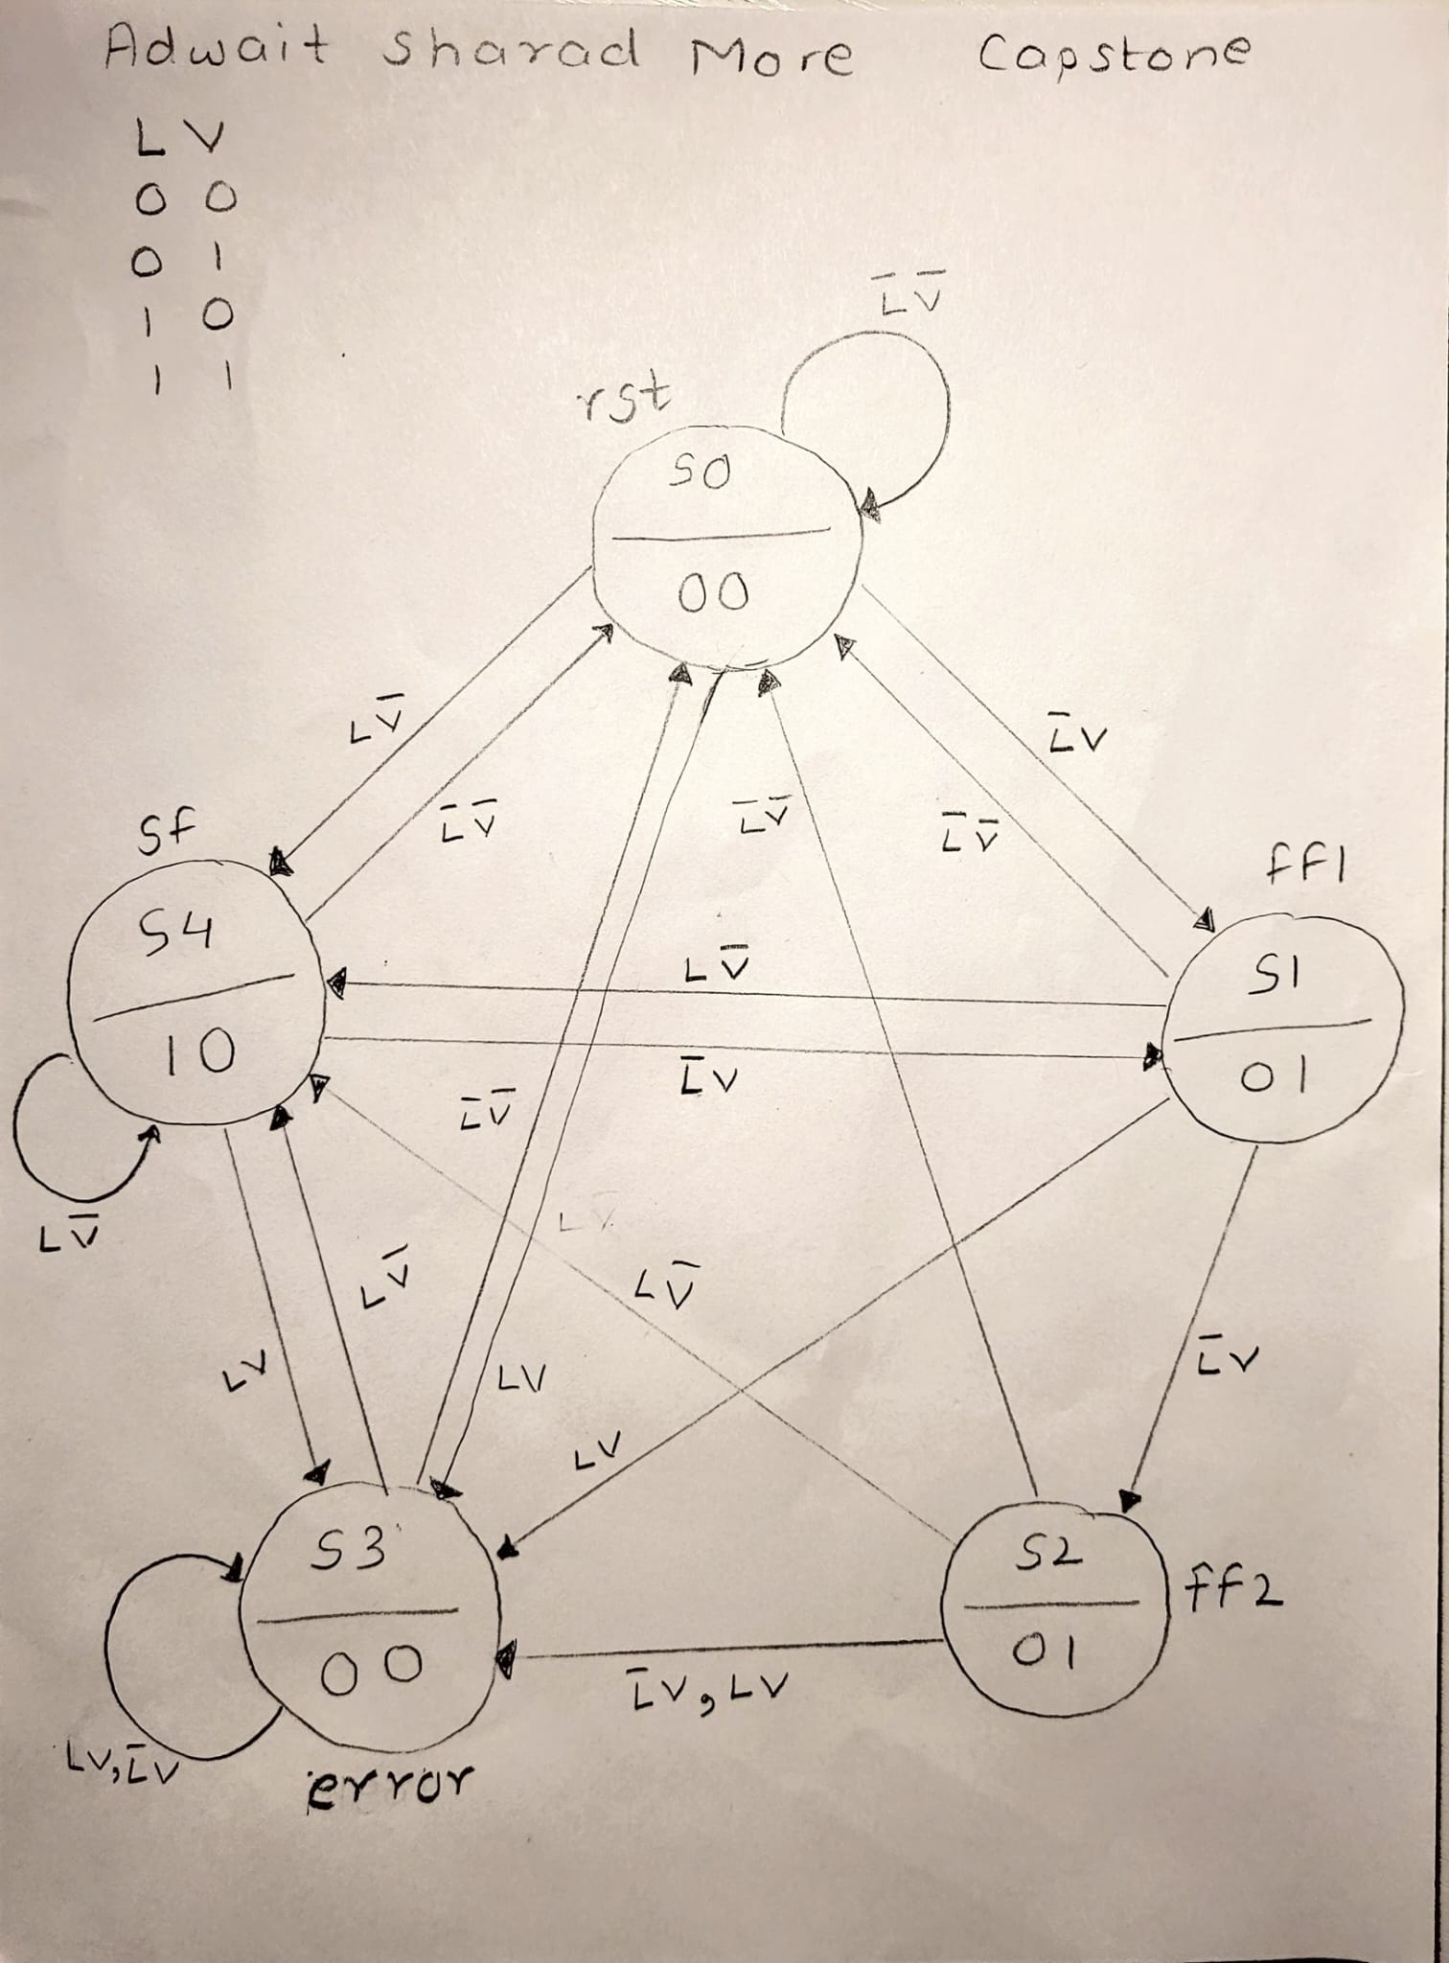

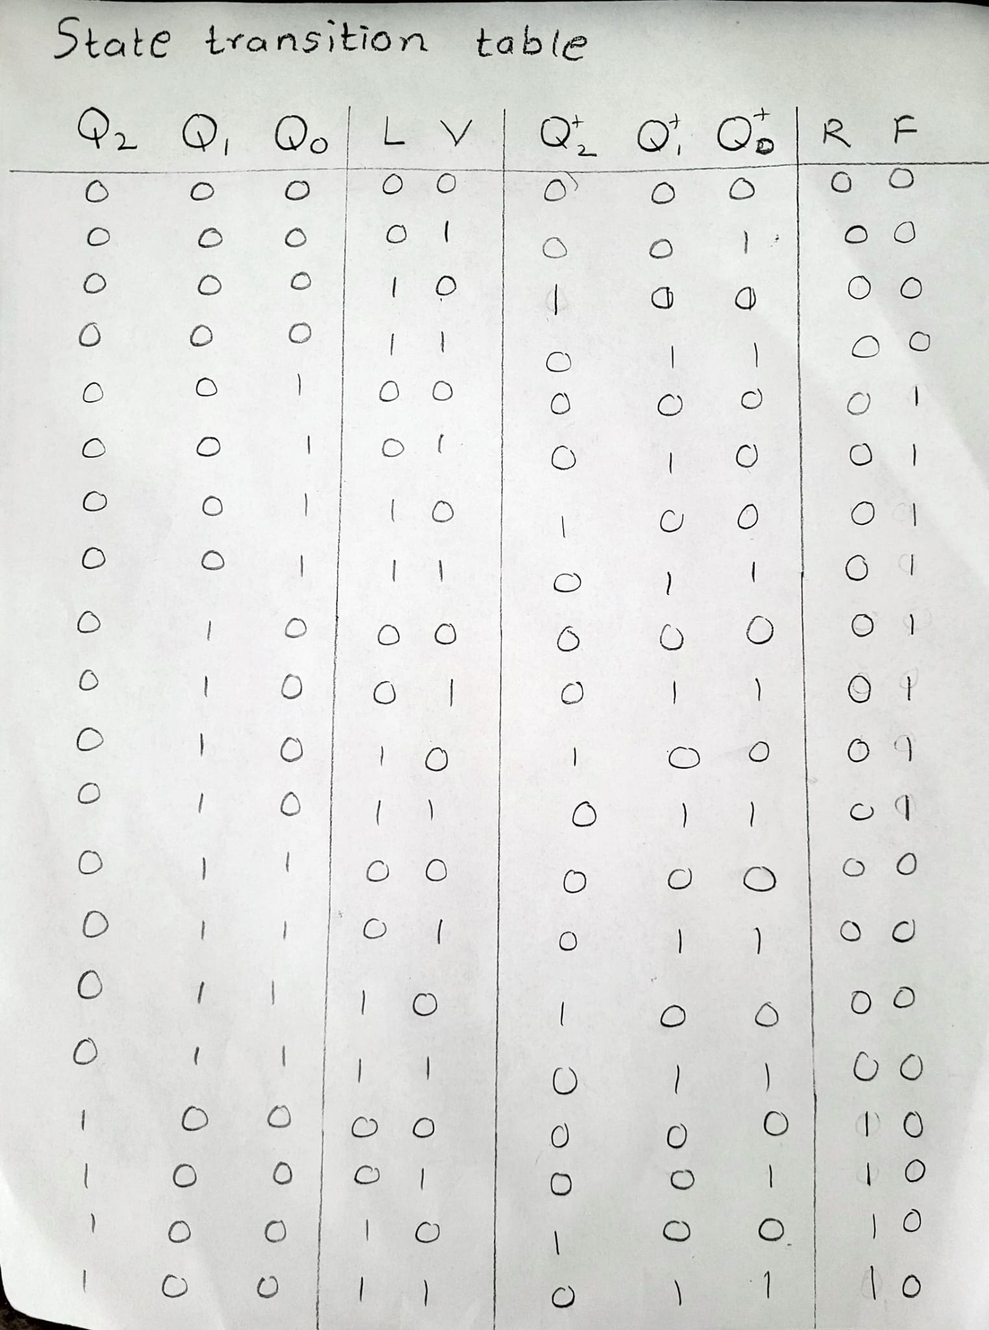

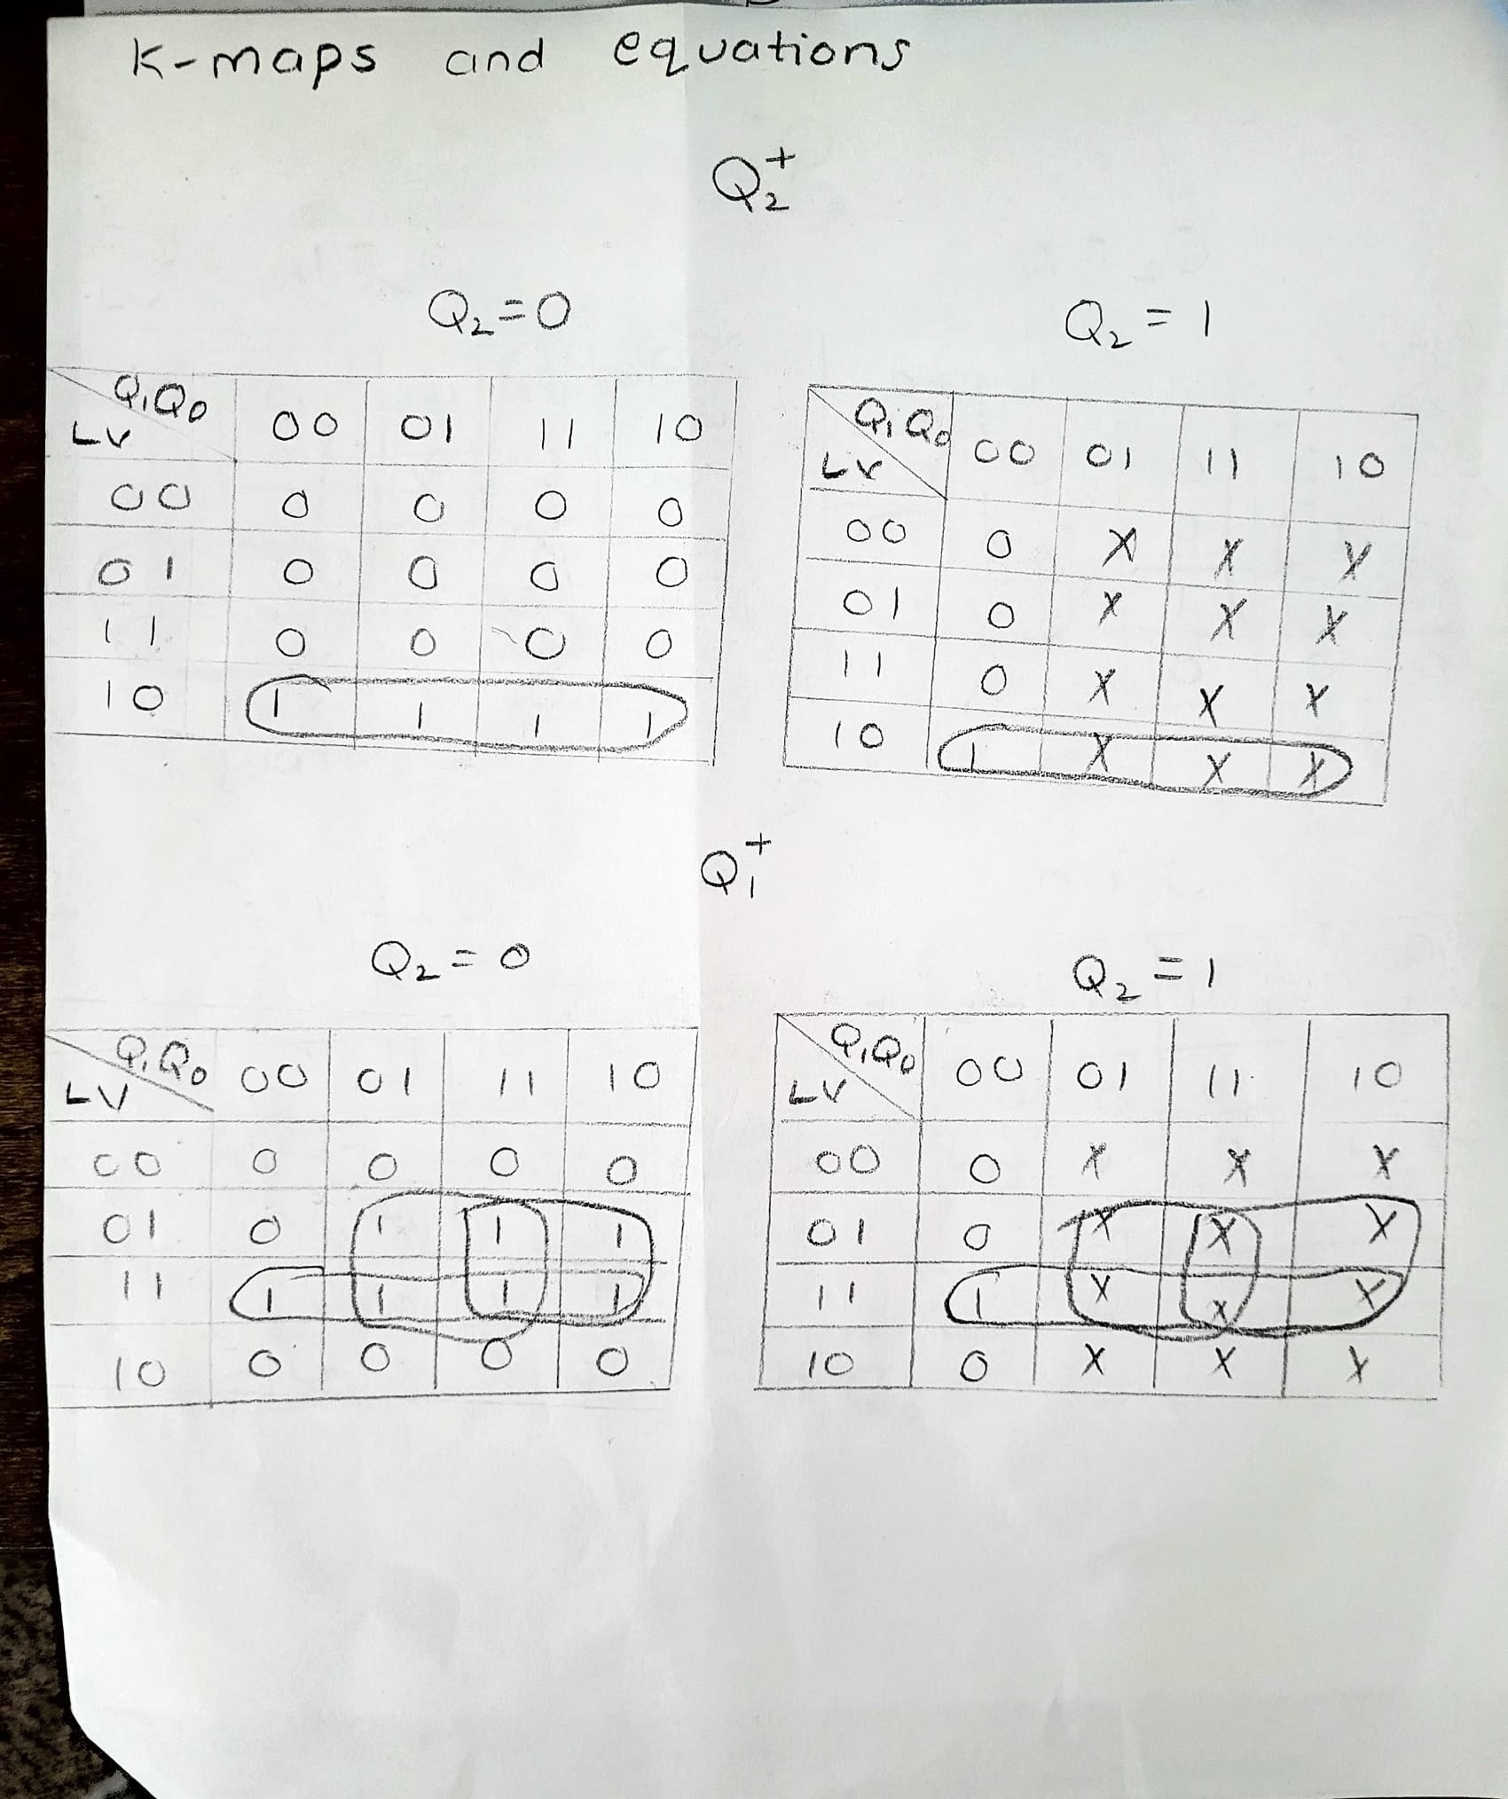

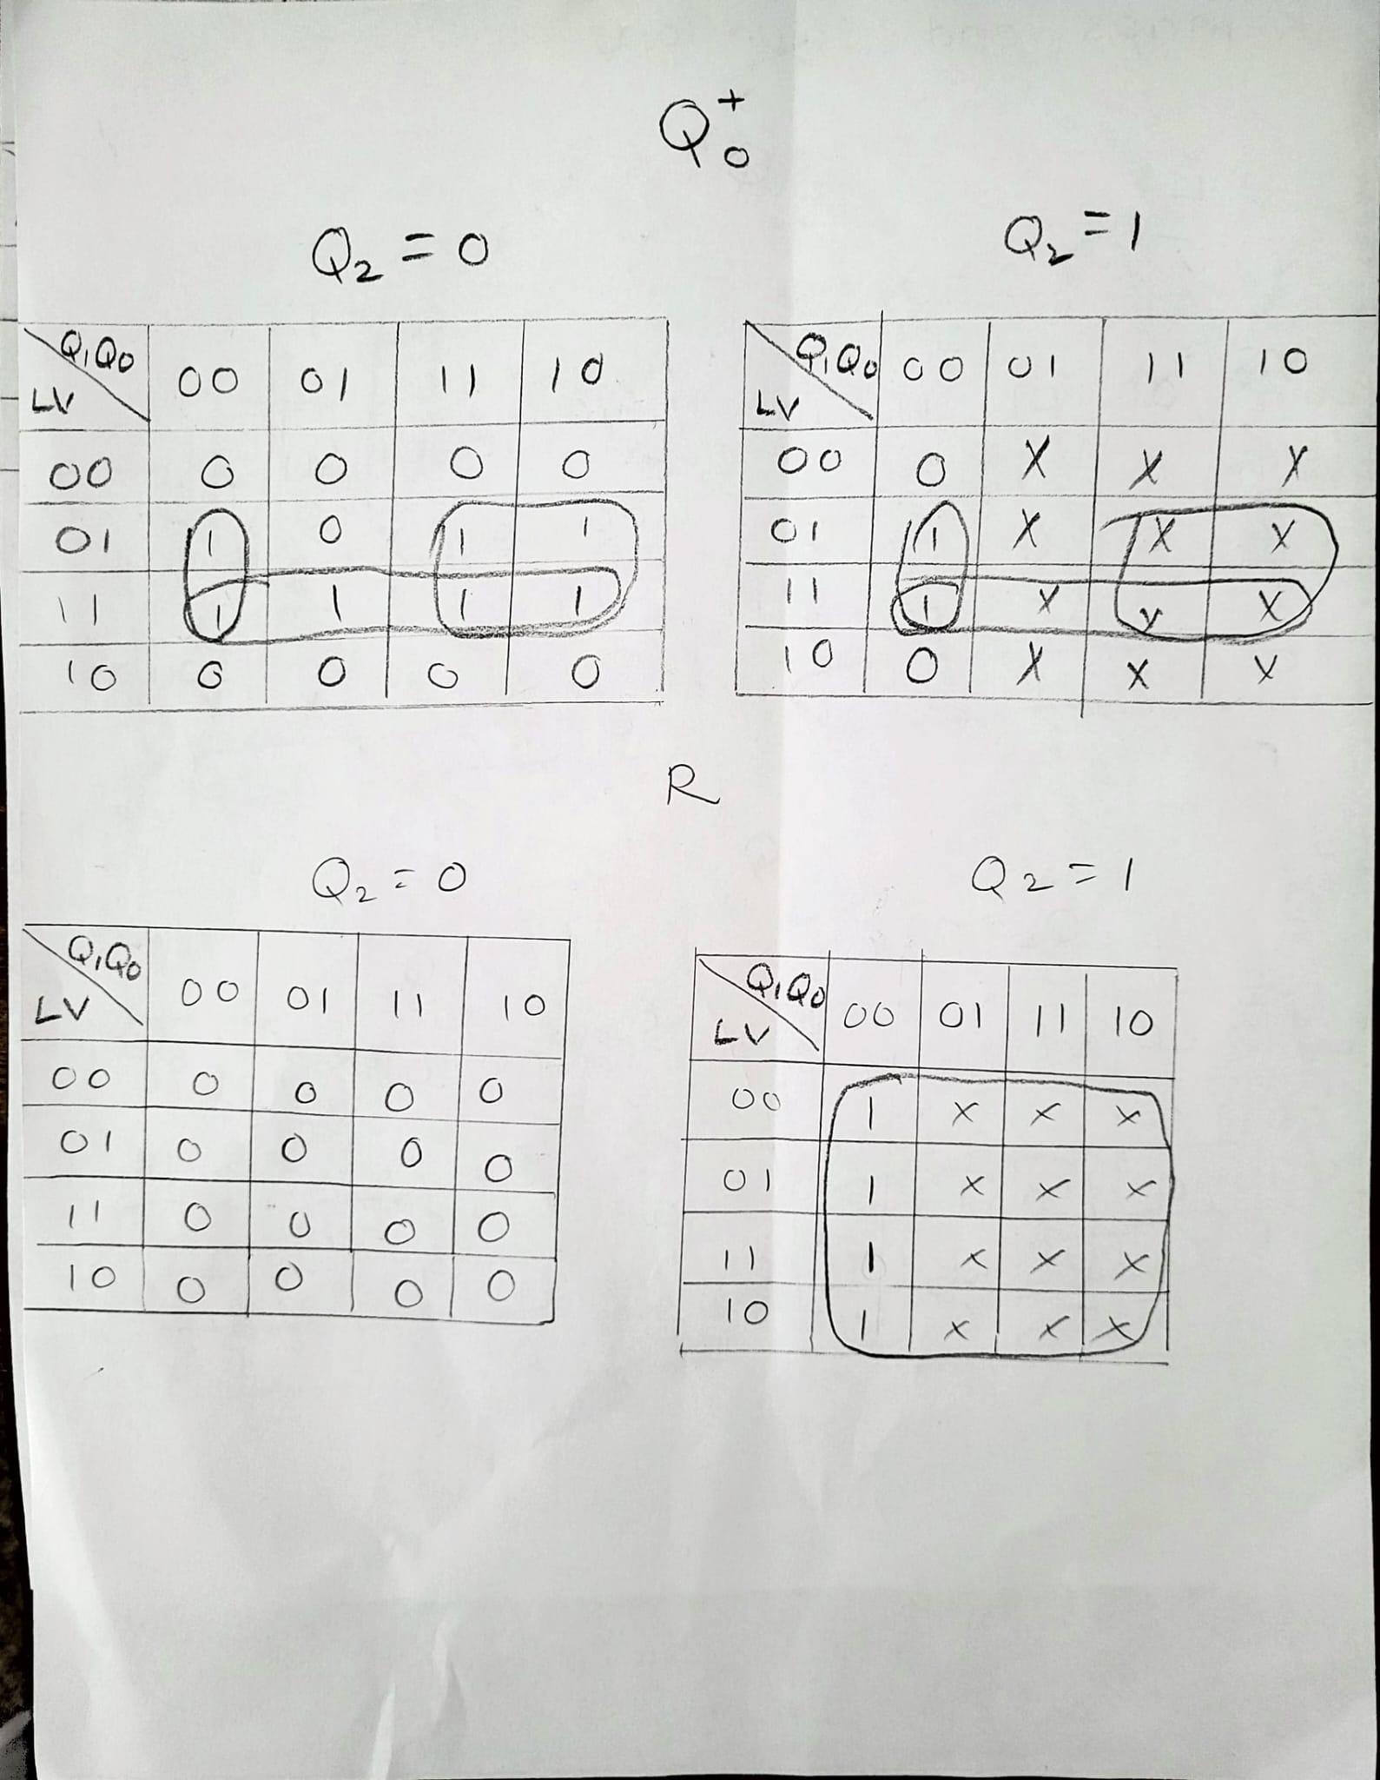

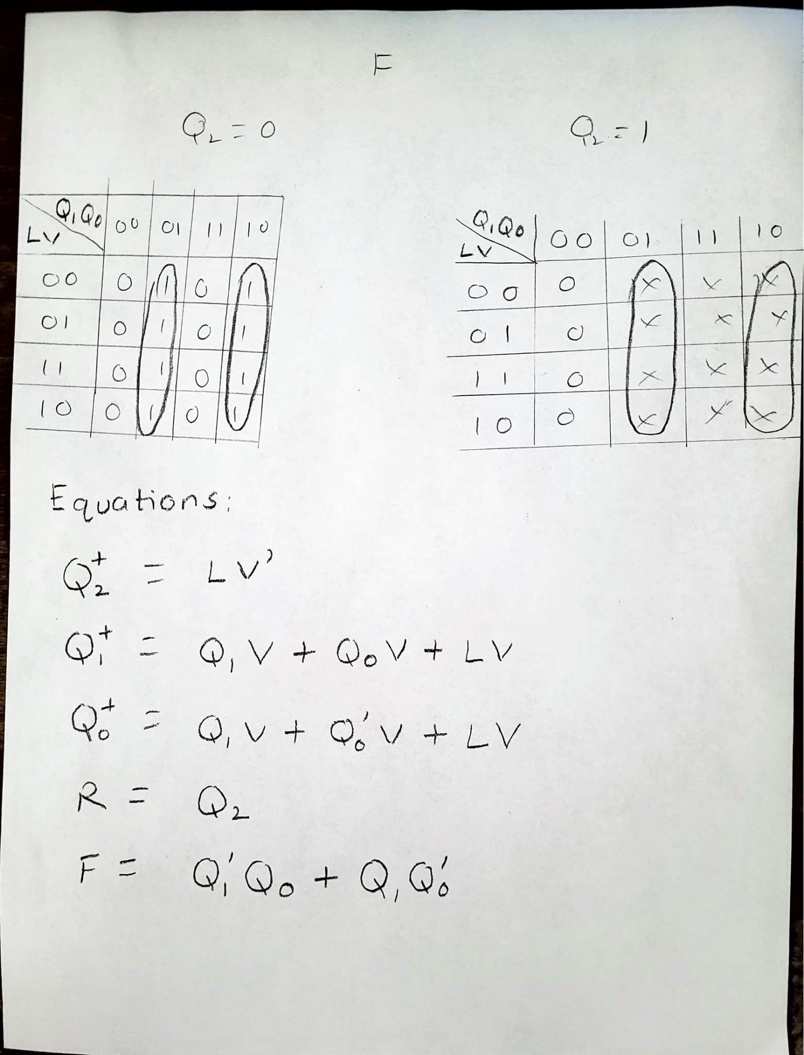

(3 pts) List your final design equations and required logic gates (including types of Flip Flops) needed to complete this circuit.

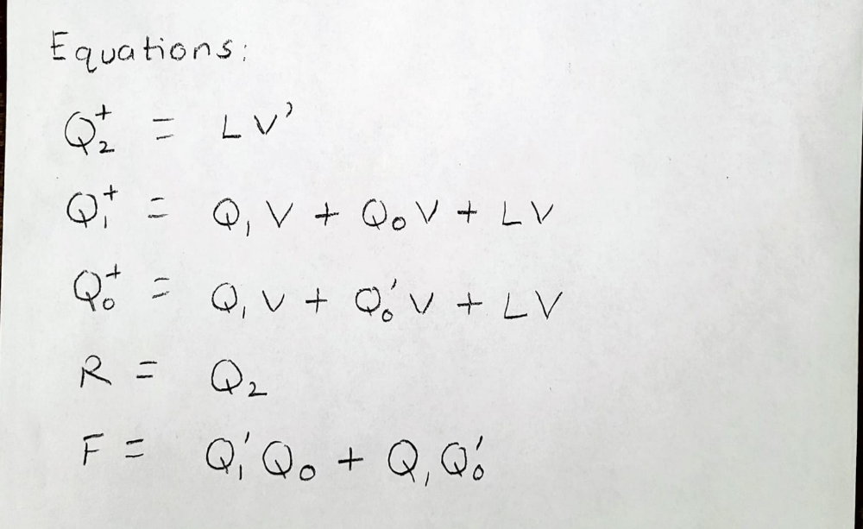

Logic gates required:

1. OR

2. NOT

3. AND

4. D flip-flop asynchronous

**Design #2:** (2 pts) What assumptions did you make in the design of this machine?

1. There are four types of inputs from each state L’V’, L’V, LV’ and LV. When the input is LV it prioritizes to fast fill.

2. After two clocks of fast fill it will transition to the slow fill wait state where it will slowly fill till V turns back to 0.

(3 pts) Create a state definition table here that describes in plain English what each state in your machine means and what binary values you have assigned to represent each state.

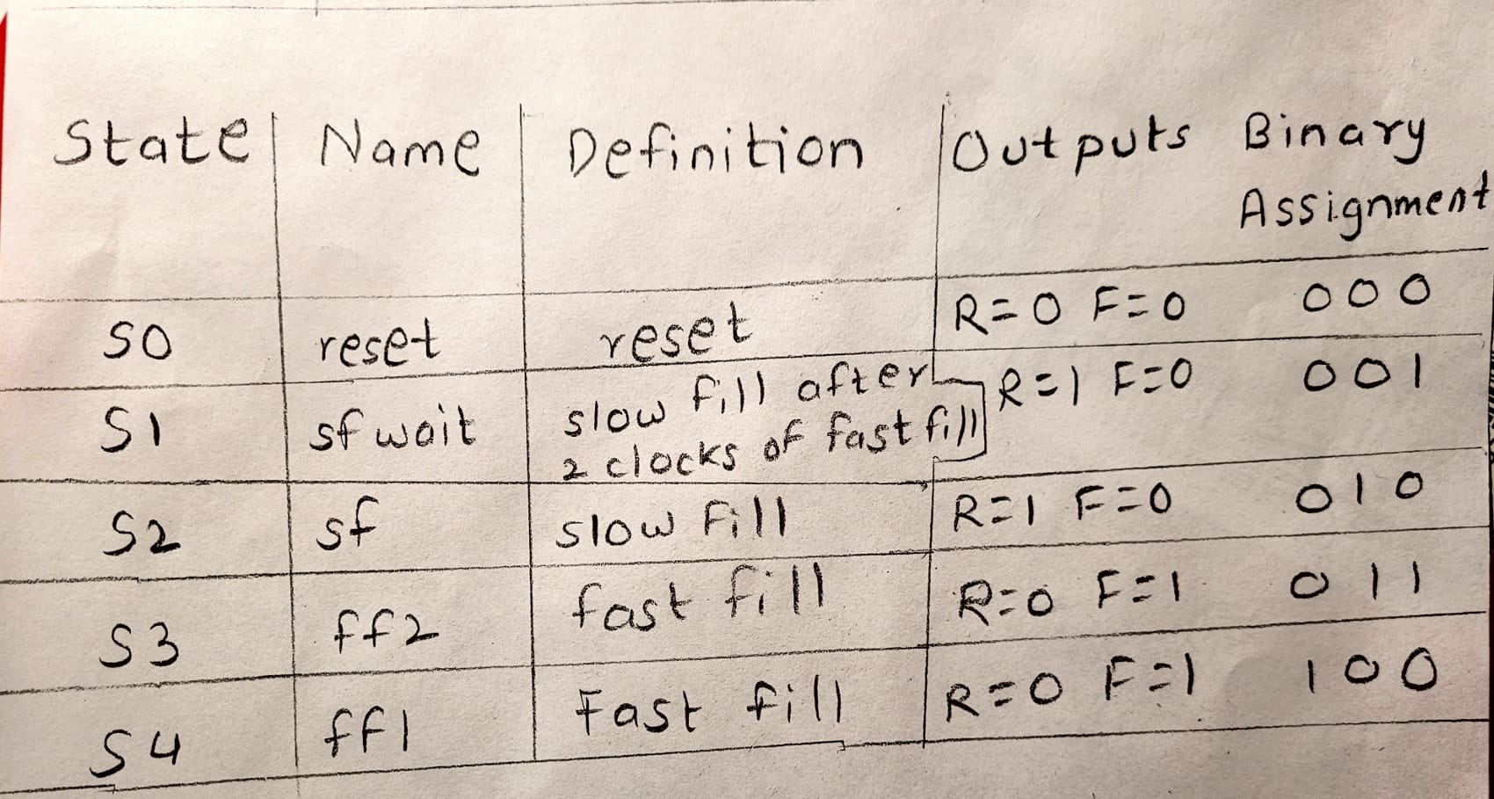

(12 pts) Show your state diagrams, state transition tables and your circuit planning work (Karnaugh maps/equations/MUX/DEC/etc.) used in your design process. (You can do this by hand if you wish, do **not** show the full circuit schematic here.)

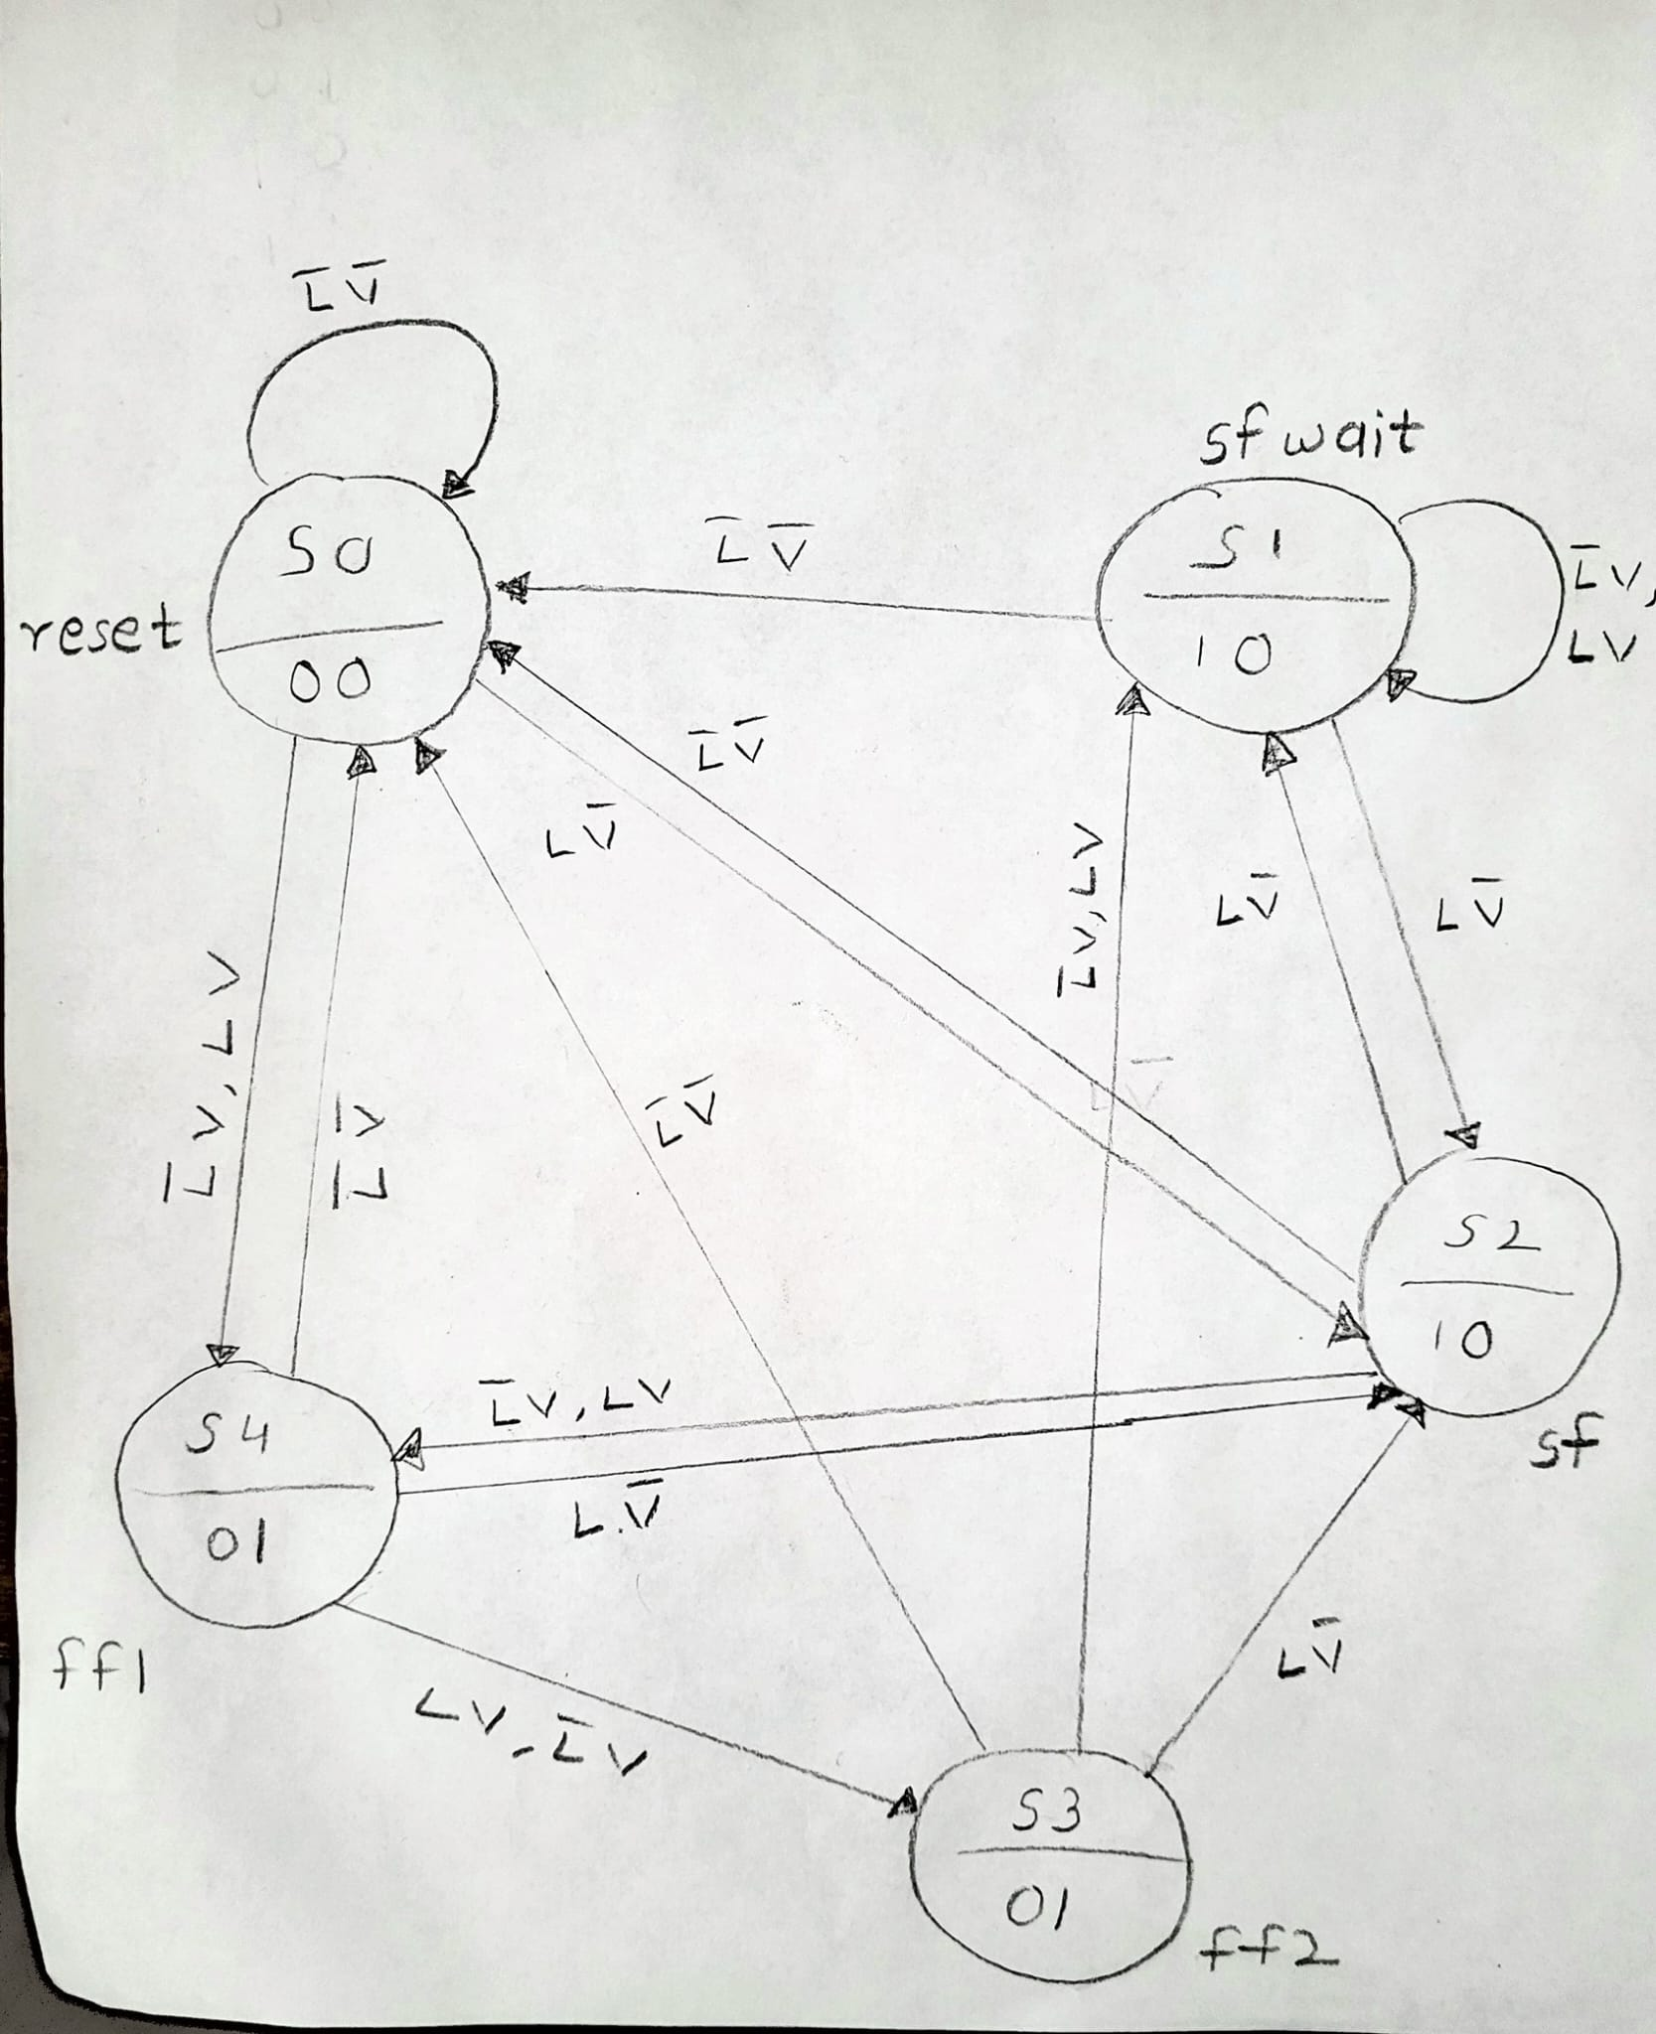

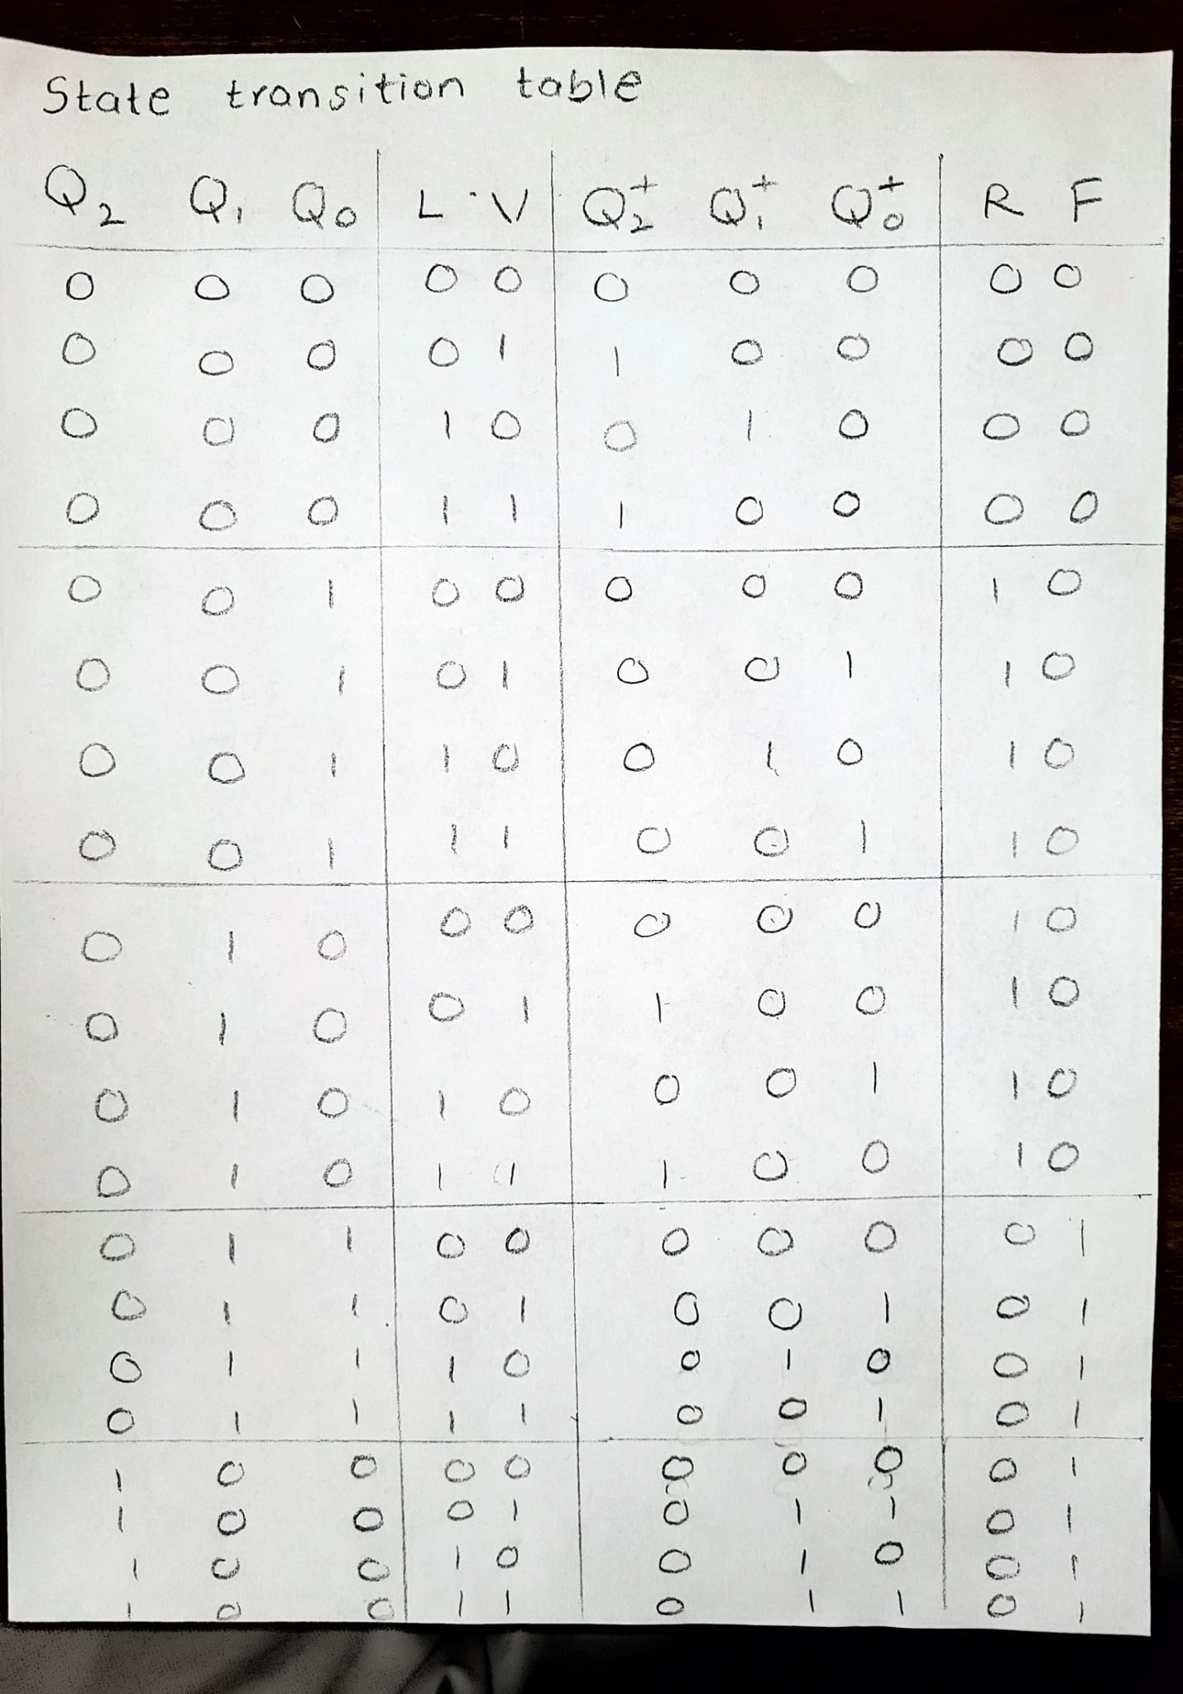

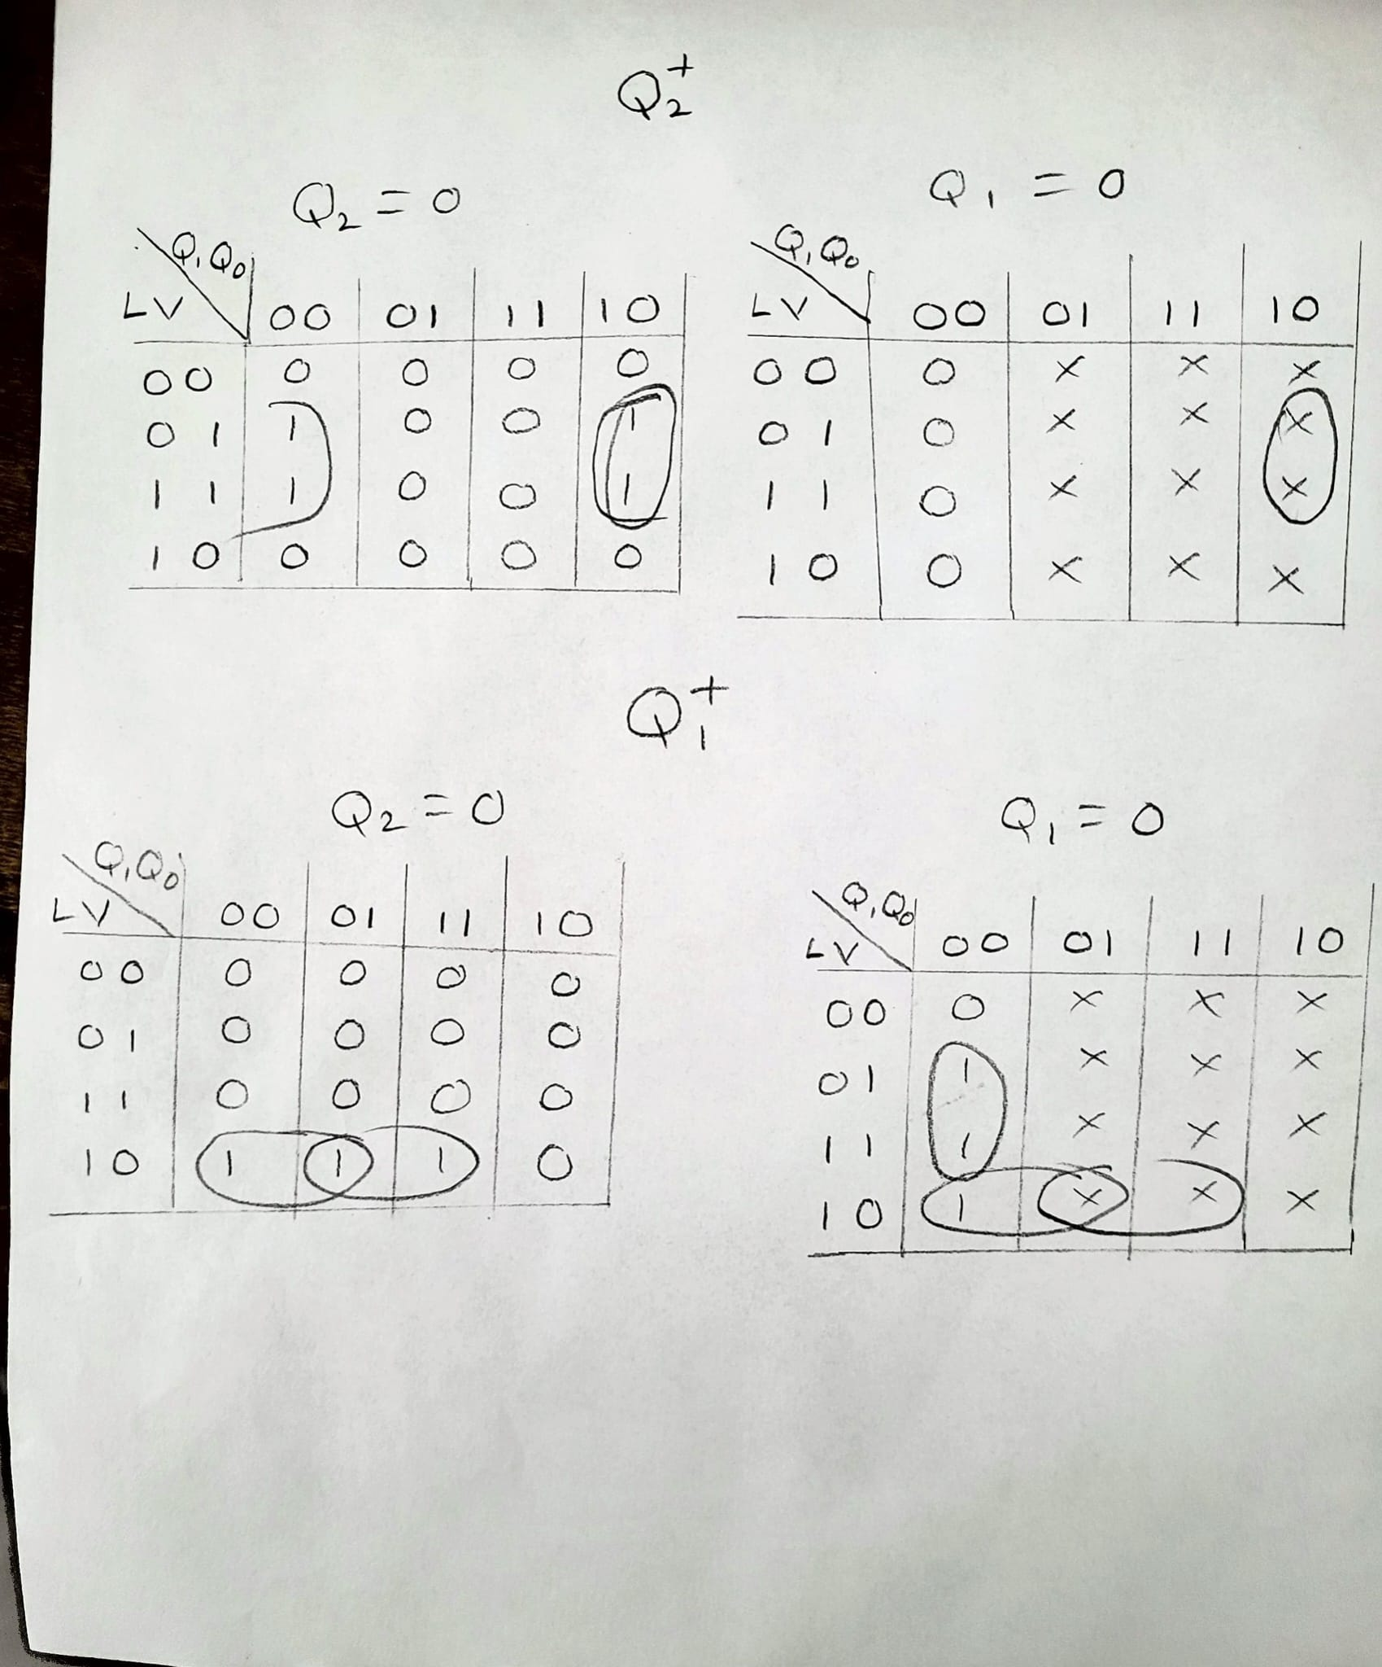

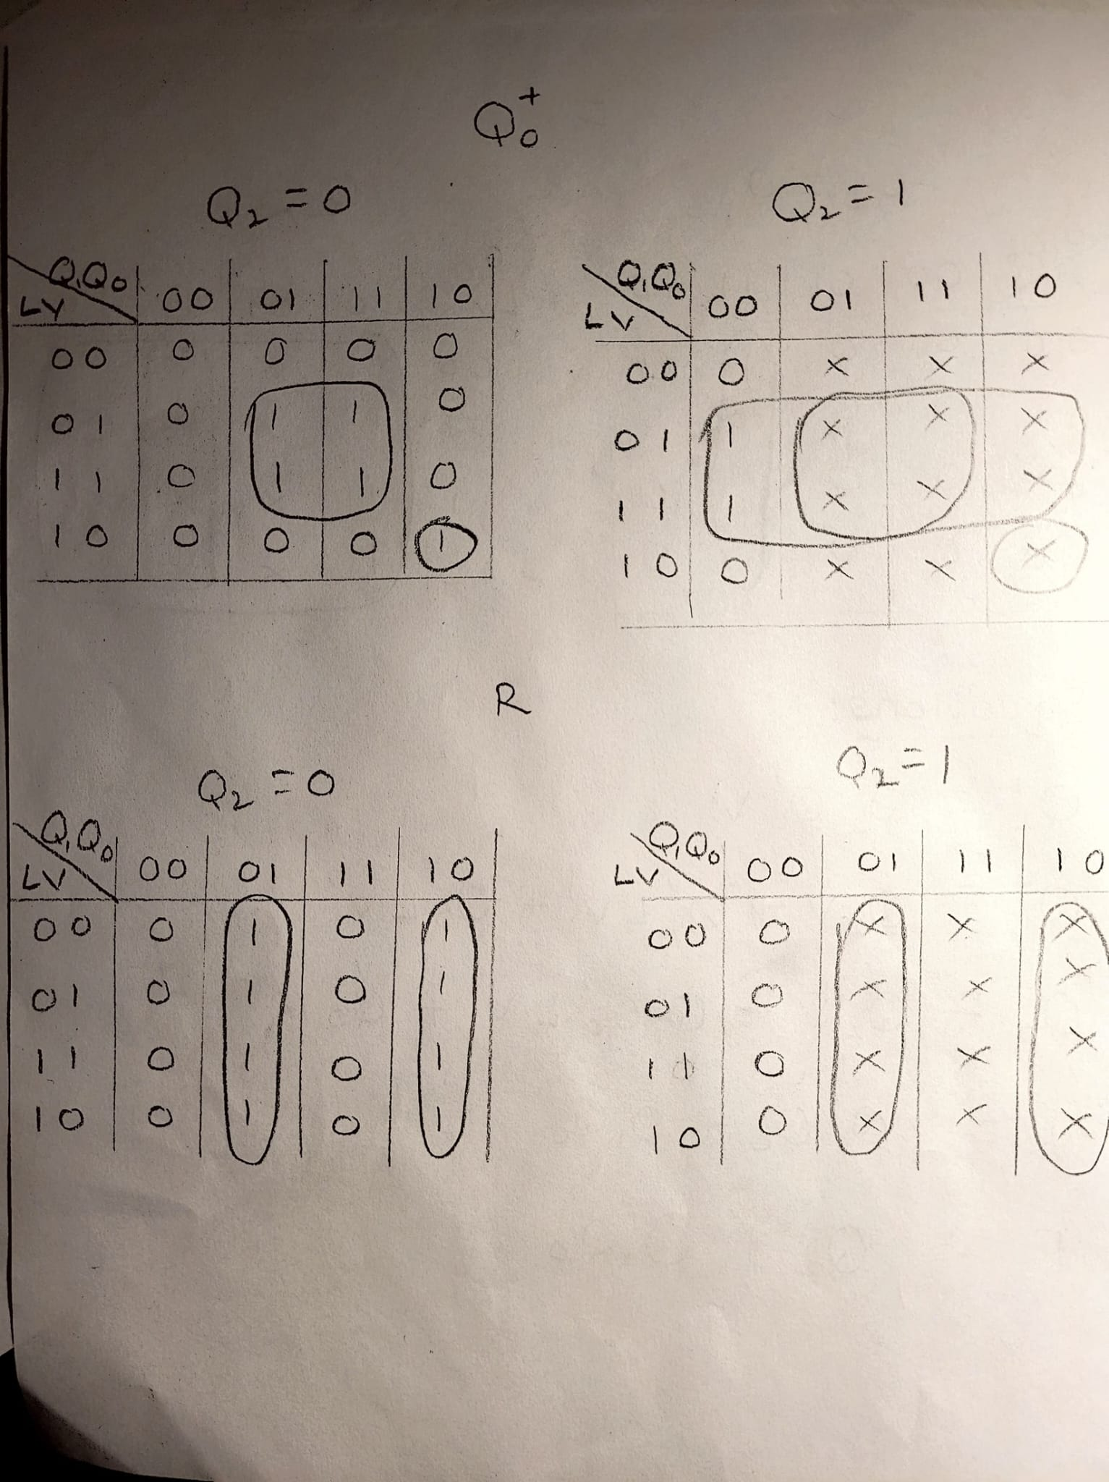

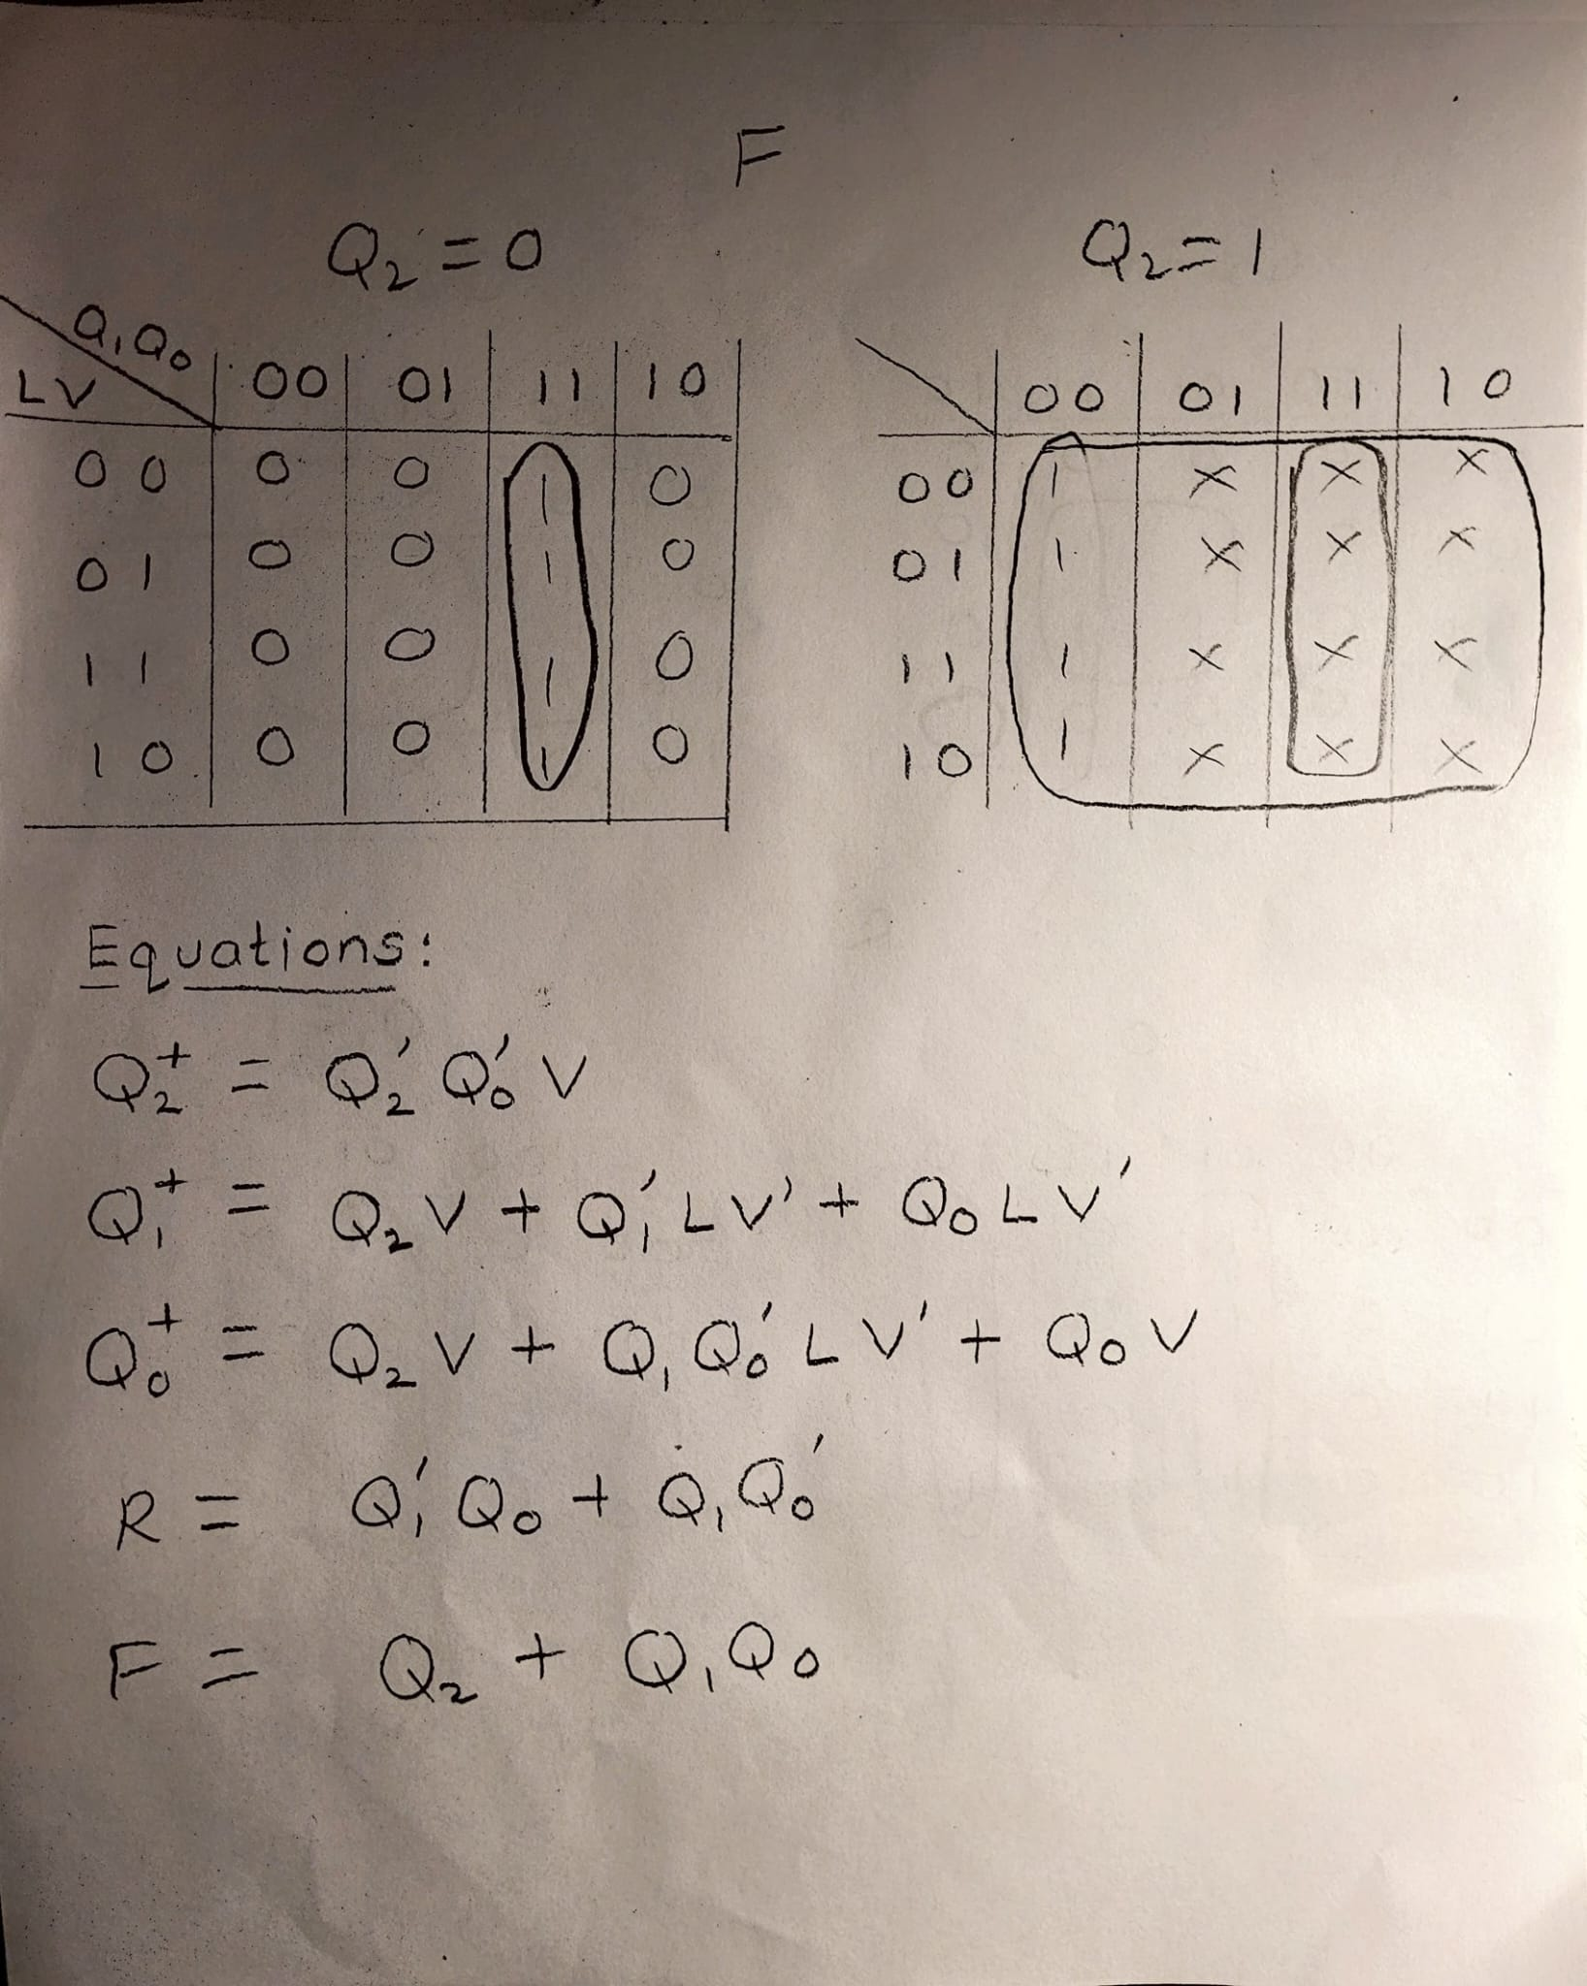

(3 pts) List your final design equations and required logic gates (including types of Flip Flops) needed to complete this circuit.

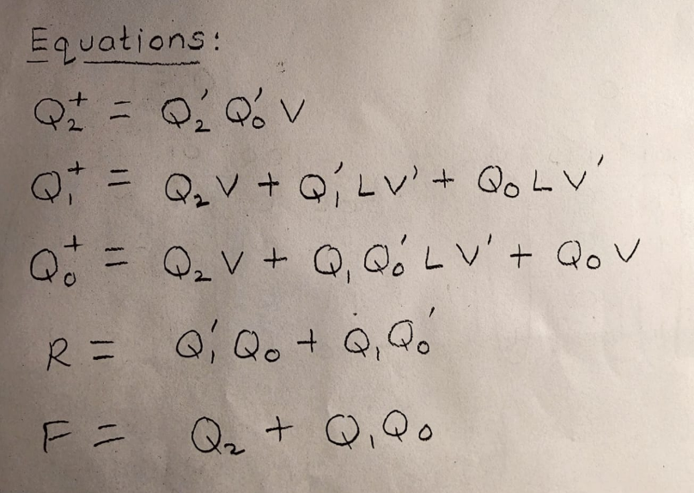

Logic gates required:

1. OR

2. NOT

3. AND

4. D flip-flop asynchronous

**Task C-3: Determine Criteria and Weighting for Judging Your Designs**

(5 pts) Using the guidelines in the laboratory FAQ’s, list your 5 criteria and associated weights here used to help decide between the two design models (weights should add to 100%):

Criteria Weight

Reliability of the circuit 30%

Potency of the application 30%

Simple to operate 25%

Changebility 8%

Number of gates 7%

**Task C-4: Apply the Criteria to Pick the Best Design**

(2 pts) Describe how you applied each of the criteria and weighting system in the above task to pick the best design. How did you choose these criteria (customer interviews, engineering preference)?

-Design 1 is better than design 2 as per criteria mentioned above in C-3. I have considered all the criteria and design 1 had most percentage than design 2. Also According to the stakeholders requirement I got Design 1 more useful for more of their choice.

(3 pts) Which design is better based on your criteria and weighting system and why? Please explain how the winning design scored in each category and why (the winning design does not need to score the highest in every category, but it does need to score higher overall when applying the criteria weights).

|  |  |  |  |
| --- | --- | --- | --- |
| Criteria | Design 1 | Design 2 | Weightage |
| Reliability of the circuit | 25% | 5% | 30% |
| Potency of the application | 25% | 5% | 30% |
| Simple to operate | 5% | 20% | 25% |
| Changeability | 6% | 2% | 8% |
| Number of gates | 4% | 3% | 7% |
| Total | 65% | 35% | 100% |

Based on the criteria and weighting system provided, **Design 1** emerges as the better option. This conclusion is drawn from an evaluation of how each design performs in the weighted categories:

1. **Reliability of the Circuit (30%)**:  
   Design 1 outperforms Design 2 in reliability, which is critical given its significant weight in the overall evaluation. The feedback from the three stakeholders also supports this conclusion.
2. **Potency of the Application (30%)**:  
   Design 1 is stronger in potency, aligning with its purpose and ensuring it meets the required performance standards.
3. **Simple to Operate (25%)**:  
   Design 2 scores better in this category, but the weight of this criterion is less than that of reliability and potency. This makes Design 2's advantage less impactful overall.
4. **Changeability (8%)**:  
   Design 1 is better in terms of changeability, making it more adaptable for future improvements or modifications.
5. **Number of Gates (7%)**:  
   Design 1 uses fewer gates, which enhances its efficiency and supports the simplicity of its architecture.

**Task C-5: Build and Simulate Winning Design in Digital**

(15 pts) Insert a copy of your chosen Digital Schematic here. Please make sure that you have outputs or tunnels connected to each flip flop so that you can easily monitor your states. Make sure that the logic and equations match the final equations presented in either Design 1 or Design 2.

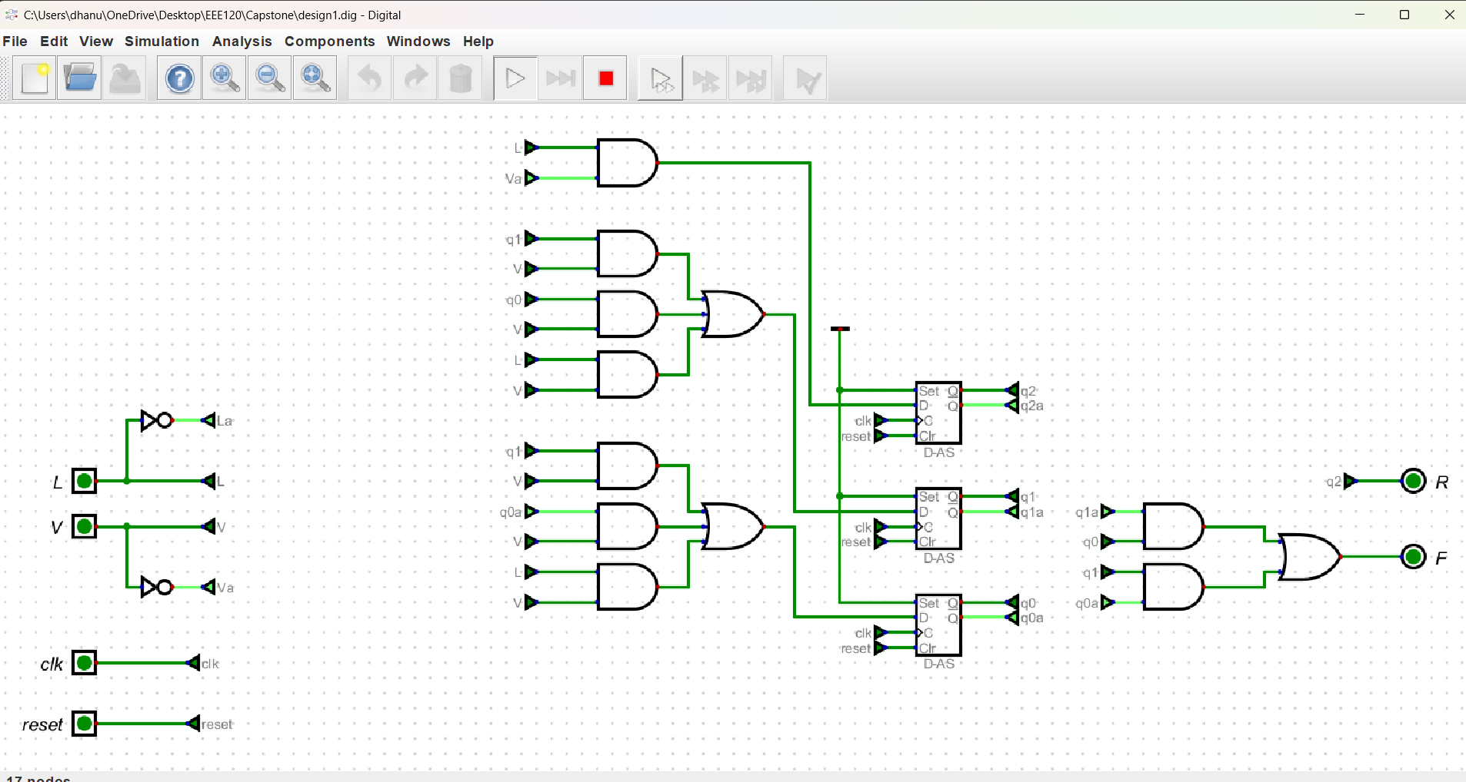

**Task C-6: Record a Video Demonstration of the Winning Design**

(15 pts) Record a video demonstration showing all positions being visited and various combinations of the inputs in Digital. For every clock cycle, explain the inputs, what current state you are in, and point out any outputs that should be noted. Be sure to show what happens for different input combinations at each position. That is, your demonstration should be able to showcase all possible states and transitions required to get there. If you include any asynchronous inputs, make sure to show those features as well. Add a link to your video below. Be sure to include any required password.

**Video link:** [**https://drive.google.com/file/d/1Gp3jPrOJ7cGmX3xz2GQwP_uwCJPCjvFp/view?usp=sharing**](https://drive.google.com/file/d/1Gp3jPrOJ7cGmX3xz2GQwP_uwCJPCjvFp/view?usp=sharing)

**Task C-7: Fill Out the Self-Assessment and Turn in Your Design**

**There are two items to submit.** Turn in the zip file of your capstone project folder. Also turn in this template once it is filled out. There will be a deduction of 5 points if your template is only found inside the zip folder. The self-assessment is on the next page.

# Self-Assessment Worksheet

Put an ‘X’ in the table below indicating how strongly you agree or disagree that the outcomes of the assigned tasks were achieved. Use ‘5’ to indicate that you ‘strongly agree’ and ‘1’ to indicate that you ‘strongly disagree’. Use ‘NA’, Not Applicable, when the tasks you performed did not elicit this outcome. Credit will be given for including this worksheet with your lab report. However, your **responses will not be graded**, they are for your instructor’s information only.

**Table 1: Self-Assessment of Outcomes for the Capstone Design Project Lab.**

| **After completing the assigned tasks and report I am able to:** | **5** | **4** | **3** | **2** | **1** | **NA** |
| --- | --- | --- | --- | --- | --- | --- |
| Initiate a design process based on a value proposition and feedback from various stakeholders. | X |  |  |  |  |  |
| Make assumptions to complete an incomplete functional specification. |  | X |  |  |  |  |
| Use classical design techniques (i.e., state diagrams, state transition tables, and Karnaugh Maps), to design a synchronous sequential machine starting with a functional specification. |  |  | X |  |  |  |
| Build, and debug a synchronous sequential machine. |  |  |  |  |  | X |
| Develop reasonable engineering criteria for comparing different designs. |  | X |  |  |  |  |
| Apply engineering criteria to select a ‘best’ design. | X |  |  |  |  |  |

Write below any suggestions you have for improving this laboratory exercise so that the stated learning outcomes are achieved.

# Capstone Design Project: Lab Report Grade Sheet

**Name:**

| **Grading Criteria** | **Max Points** | **Points lost** |
| --- | --- | --- |
| **Template** |  |  |
| Neatness, Clarity, and Concision | 5 |  |
| **Description of Assigned Tasks, Work Performed & Outcomes Met** |  |  |
| Task C-1: Planning the Synchronous Sequential Machines | 15 |  |
| Task C-2: Document the Synchronous Sequential Machines | 40 |  |
| Task C-3: Determine Criteria and Weighting for Judging Your Designs | 5 |  |
| Task C-4: Apply the Criteria to Pick the Best Design | 5 |  |
| Task C-5: Build and Simulate Winning Design in Digital | 15 |  |
| Task C-6: Record a Video Demonstration of the Winning Design | 15 |  |
| **Self-Assessment Worksheet** (The content of the self-assessment worksheet will not be graded. Full credit is given for including the completed worksheet.) | (2 extra points) |  |
|  | **Points Lost** |  |
| **Lab Score** | **Late Lab** |  |
|  | **Lab Score** |  |