HealthFirst Care Stakeholder Analysis and Engagement Plan
Capstone Project M02L01
Adwoa Boama Acheampong | IBM Business Analyst learning project

Purpose and method
The analysis uses the ten supplied simulated stakeholder profiles and the case data. Hospital leadership is added as an inferred governance stakeholder because scope, risk and pilot decisions require an accountable sponsor. Influence and interest ratings are planning judgments for review, not interview findings.

Stakeholder register
Stakeholder | Role | Interests and concerns | Influence | Interest | Strategy
Sarah Ayvazyan | Patient | Simple online booking, timely cancellation and delay notices, clear next steps | Low | High | Keep informed
Lak Ayer | Patient | Assisted/in-person booking and reachable prescription support | Low | High | Keep informed
Dr. Aftab Khan | Cardiologist | Balanced schedules, diagnostic access, timely lab results and transfers | High | High | Manage closely
Dr. Robert Lee | Orthopedist | Operating-room and equipment access, referral clarity, physiotherapy updates | High | High | Manage closely
Santa Murmu | Pediatric nurse | Shift capacity, supplies and transfer notification | High | High | Manage closely
Jessica Gomes | Emergency nurse | Weekend staffing, bed/monitor access, diagnostic results and ICU handoffs | High | High | Manage closely
Maria Carter | Appointment scheduler | Conflict prevention, live availability and easier record retrieval | High | High | Manage closely
Ivan Walker | Billing administrator | Complete scheduling and treatment data for reconciliation | High | High | Manage closely
Rajesh Singh | IT manager | Integrated systems, network resilience and scalable architecture | High | Low | Keep satisfied
Laura Simkow | Software developer | Usable interface, security remediation, notifications and analytics | High | Low | Keep satisfied
Hospital leadership | Inferred governance stakeholder | Service performance, risk, scope and benefit decisions | High | High | Manage closely

Influence and interest matrix
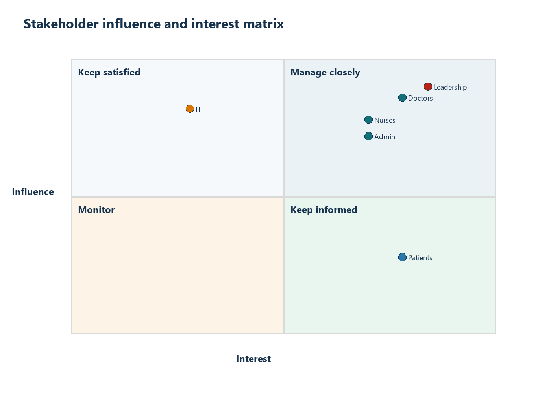
Planning matrix based on supplied profiles. Individual patient influence is low while interest is high; clinical, administrative and leadership stakeholders require close management.
Open the standalone stakeholder matrix

Engagement and communication plan
Group | Purpose | Method | Frequency | Owner | Escalation
Patients | Validate access, notices and next-step clarity | Assisted interviews, usability sessions, accessible SMS/email survey | At discovery, prototype and pilot review | Patient experience lead | Escalate accessibility or consent concern to sponsor and privacy lead
Doctors and nurses | Validate capacity rules, handoffs and patient-safety exceptions | Workflow workshop, clinical huddle and scenario review | Weekly during design and pilot | Clinical lead | Escalate patient-safety or unresolved ownership conflict
Administrative staff | Validate booking, check-in, billing data and exception handling | Walkthrough, working session and UAT | Twice weekly during configuration and UAT | Operations manager | Escalate repeated conflicts, missing data or reconciliation failure
IT team | Validate integration, resilience, security and support model | Architecture review, technical backlog and incident rehearsal | Weekly; immediate for release gates | IT manager | Escalate security, outage or interface control failure
Hospital leadership | Decide scope, targets, risk acceptance and scale | Decision brief, dashboard and risk review | Biweekly and at stage gates | Project sponsor | Record approve, reject, defer or request evidence

Conflicting needs and engagement risks
- Patients need simple access while security teams require identity and privacy controls. Design must retain assisted channels and proportional authentication.
- Clinical staff need schedule flexibility while operations need predictable capacity. Exceptions require named approval and auditability.
- IT may prefer phased integration while users want immediate end-to-end visibility. The RTM should distinguish pilot capability from later integration.
- Leadership needs concise measures while data owners need visible quality caveats. Dashboard summaries must preserve denominator and freshness definitions.

Feedback and decision control
Every engagement records decisions, actions, owner, due point and unresolved question. Changes affecting requirements are added to the RTM. Changes affecting baseline scope follow the scope-control process. Patient-safety, security and privacy concerns bypass routine cadence and move directly to the accountable lead.

Conclusion
The engagement plan gives the strongest participation to the groups who operate or govern the workflows while maintaining accessible patient feedback. It supports the BRD objectives by connecting each stakeholder concern to a requirement, workflow decision or control.

Appendix A: supplied profile digest
The ten named profiles below are condensed from the supplied course document; hospital leadership is an inferred governance stakeholder and is not in that source. The unmodified three-page source is appended to the PDF export as Appendix C.
Named profile | Role | Need captured for the plan
Sarah Ayvazyan | Patient | Simple online booking, timely cancellation and delay notices, clear next steps
Lak Ayer | Patient | Assisted/in-person booking and reachable prescription support
Dr. Aftab Khan | Cardiologist | Balanced schedules, diagnostic access, timely lab results and transfers
Dr. Robert Lee | Orthopedist | Operating-room and equipment access, referral clarity, physiotherapy updates
Santa Murmu | Pediatric nurse | Shift capacity, supplies and transfer notification
Jessica Gomes | Emergency nurse | Weekend staffing, bed/monitor access, diagnostic results and ICU handoffs
Maria Carter | Appointment scheduler | Conflict prevention, live availability and easier record retrieval
Ivan Walker | Billing administrator | Complete scheduling and treatment data for reconciliation
Rajesh Singh | IT manager | Integrated systems, network resilience and scalable architecture
Laura Simkow | Software developer | Usable interface, security remediation, notifications and analytics

Appendix B: matrix record
Matrix reproduced for review; editable positions and strategies are recorded in the linked workbook.

Appendix C: original profile source
The complete source PDF follows this report in the PDF edition. It is kept intact, allowing the reader to compare the stakeholder plan against the course profiles.

