HealthFirst Care Excel Dashboard Evidence and Operating Guide
Dashboard lab portfolio evidence
Adwoa Boama Acheampong | IBM Business Analyst learning project

Decision purpose and reader
The dashboard supports hospital operations and leadership review of appointment volume and outcome, patient wait and feedback, resource use and availability. It is implemented locally in Excel. It is not a Cognos or Looker Studio artifact.

KPI definitions
KPI | Definition | Population and unit | Missing-data treatment
Appointments | Count of appointment rows | Rows; all or selected department | Missing AppointmentID retained but disclosed
Completion rate | Completed divided by all appointment rows in the selected department or full population | Percent | Missing status remains in denominator for headline; PivotTable supports known-status review
No-show rate | No Show divided by all appointment rows in the selected department or full population | Percent | Same denominator rule as completion
Average wait | Mean of nonmissing feedback wait-time values in the selected department or full population | Minutes | Three blanks excluded from 198 substantive feedback rows
Average feedback | Mean after lab-directed score imputation | 1–10 score | Six blank scores use valid-score mean
Average resource usage | Mean UsageHours | Hours per resource observation | No missing UsageHours
Availability rate | Available observations divided by resource observations | Percent | Missing department is unavailable, never zero

Dashboard views
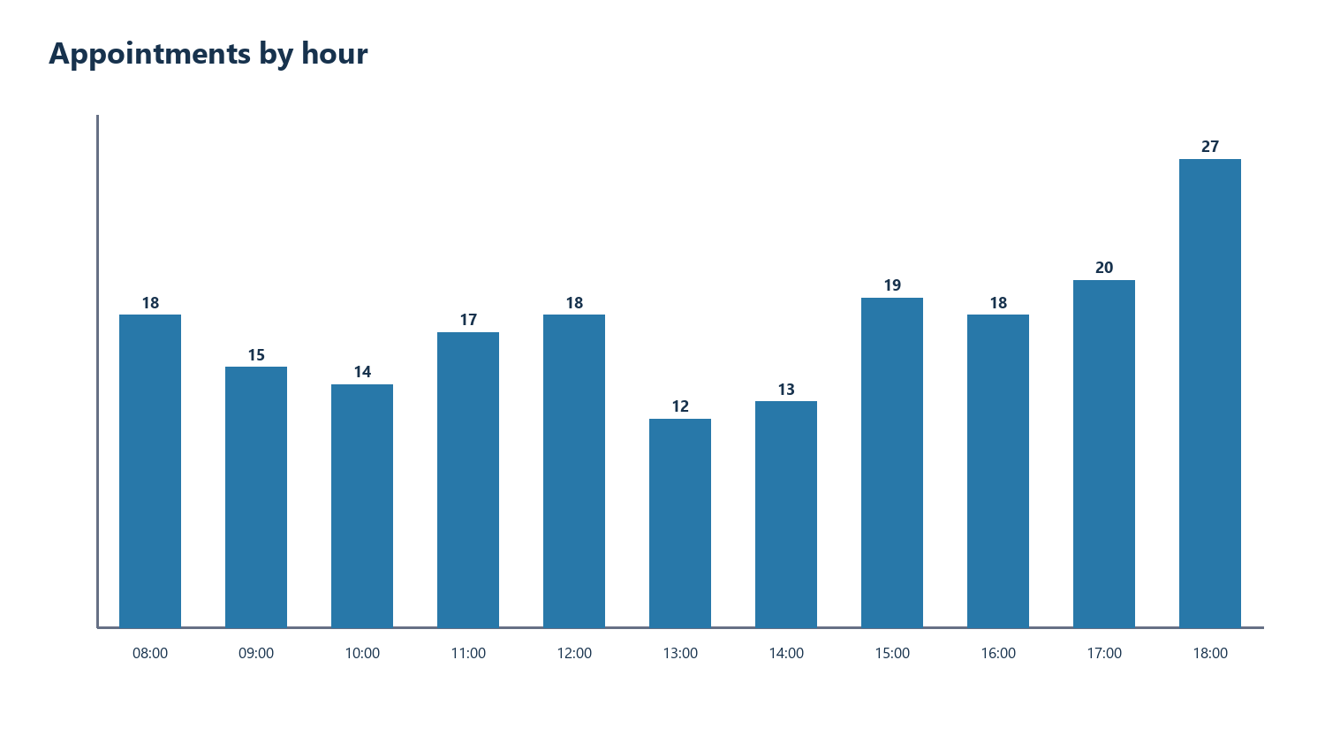
Volume view
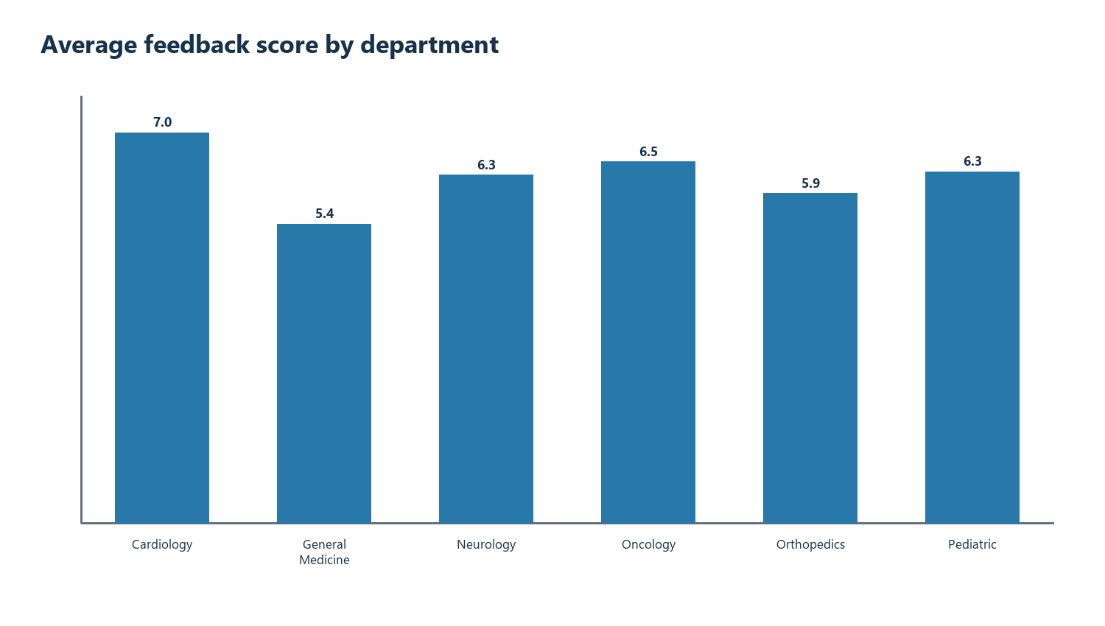
Patient feedback view
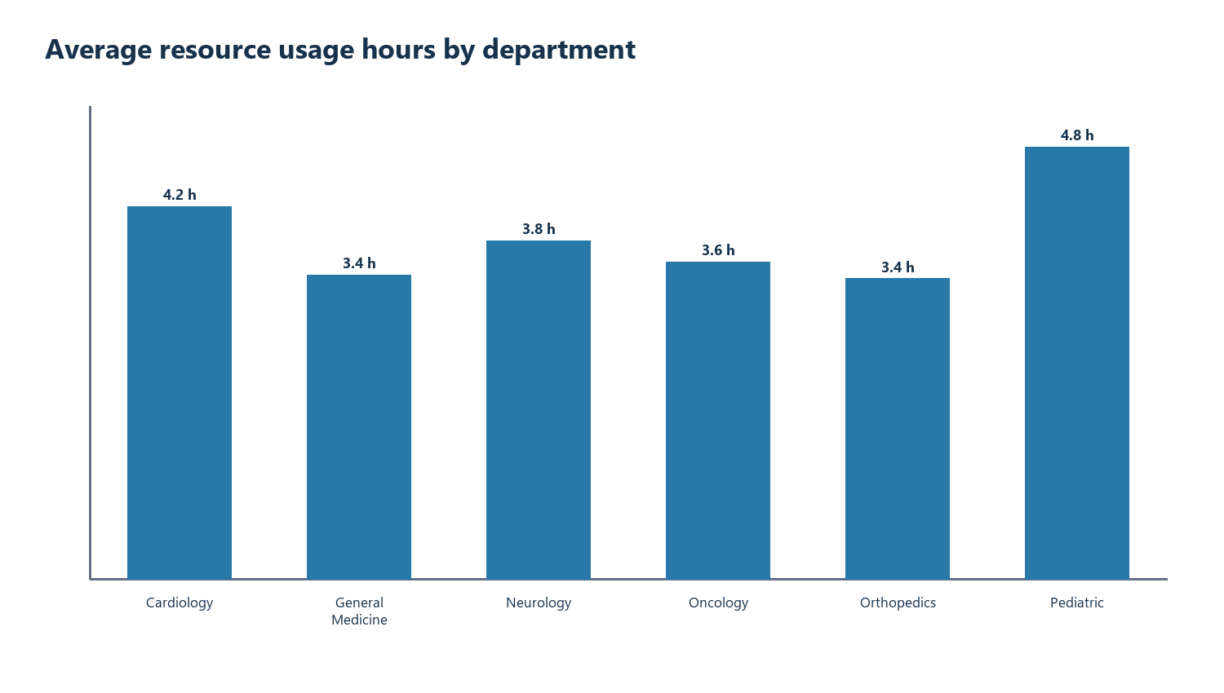
Resource view

Filters refresh and use
- Use Dashboard!B2 (All or one department) to update the front-page cards, comparison table and both chart series together. The headline card denominator is all appointment rows in that selection.
- Use native slicers on Pivot Appointments for Department and Status, Pivot Satisfaction for Department and Satisfaction Level, and Pivot Resources for Department and Availability. These are separate exploratory views: their slicers do not change the front-page cards.
- Replace or append source rows only through the governed source process, rerun the documented cleaning build, then refresh all PivotTables.
- Review the Data Quality Log and unmatched records before using dashboard values in a decision.

Functional checks
Check | Expected result | Status
Refresh PivotTables | Pivot tables remain linked to Excel tables | Passed locally
Front-page department control | All shows 200 appointments; Cardiology shows 38; table and chart series change; reset restores all | Passed locally
Slicer interaction | Six native slicers are wired to pivots; their selection changes the corresponding pivot views | Passed locally
Blank versus zero | Three missing wait values remain blank; unmatched KPI shows Unavailable | Passed locally
Repeated feedback | Patient summary aggregates by ID, retaining record count; ten patients have repeated substantive feedback | Passed locally
Source reconciliation | Clean counts are 200 appointments, 198 feedback and 200 resources; mean feedback is 6.270833 | Passed locally

Platform limitation
The original Coursera dashboard page could not be retrieved without an authenticated course session. The local Excel implementation satisfies the analytical and portfolio evidence requirement but does not establish platform-specific Cognos or Looker completion.
Open the standalone Excel dashboard workbook

