Explanatory and Predictive Analytics of Emergency Department
Length of Stay and Resource Utilization Trends in Canadian Hospitals
Course: DAMO 699 – Capstone Project
Program: Master of Data Analytics
Rajbharath P (NF1016766)
Suffyan Mohd (NF1017047)
Amit Raj Dev (NF1021076)
Group No: 5
Supervisor: Dr. Bilal El Toufaili
Institution: University of Niagara Falls
6th September 2026

Table of Contents
Executive Summary 2
List of Tables 6
List of Figures 6
Glossary of Abbreviations 7
Chapter 1: Problem Analysis and Strategic Context 8
1.1 The Canadian Emergency Care Landscape 8
1.2 Access Block and the Mechanics of Length of Stay 8
1.3 Problem Statement 9
1.4 Objectives and Scope 10
1.5 Canonical Hypotheses Registry 10
Chapter 2: Analytics Lifecycle and Project Methodology 11
2.1 A Seven-Stage Analytics Lifecycle 11
2.2 Why Non-Parametric Methods 12
2.3 Guarding Against the Ecological Fallacy 13
Chapter 3: Data Collection, Inventory, and Preparation 14
3.1 Data Provenance 14
3.2 Database Structure 14
3.3 Cleaning and Quality Control 14
3.4 Feature Engineering 15
3.5 Reproducibility and Data Isolation 16
Chapter 4: Exploratory Data Analysis and Descriptive Profiling 16
4.1 Nineteen Years of Volume Growth 16
4.2 Acuity and Admission Profiles 17
4.3 Age and Sex 18
4.4 Clinical Case Mix 19
Chapter 5: Statistical Hypothesis Testing and Diagnostic Inference 20
5.1 Hypothesis 1: CTAS Triage Acuity and Length of Stay 20
5.2 Hypothesis 2: Reported Median ED LOS for Admitted vs. Non-Admitted Visits 21
5.3 Hypothesis 3: Weighted Least Squares Regression of Reported Median ED LOS 23
5.4 Hypothesis 4: Reported Median ED LOS Across Broad Patient Age Categories 24
5.5 Hypothesis 5: Patient Sex and ED Visit Disposition Association 25
5.6 Hypothesis 5: Patient Sex and ED Visit Disposition Association 26
Chapter 6: Time-Series Trend Analysis and Throughput Forecasting 27
6.1 Detecting a Monotonic Trend 27
6.2 Holt’s Linear Exponential Smoothing Forecast 28
6.3 Estimated Resource Burden Index 29
Chapter 7: Data Visualization and Decision Support Systems 31
7.1 Dashboard Architecture 31
7.2 Audiences and Interaction Modes 38
Chapter 8: Findings, Synthesis, and Critical Discussion 40
8.1 An Operational Triad 40
8.2 Comparison with Existing Literature 40
8.3 Methodological Strengths 41
8.4 Limitations 41
Chapter 9: Strategic Recommendations and Implementation Roadmap 42
9.1 Restating the Core Findings 42
9.2 Tiered Recommendations 43
9.3 Closing Note 44
References 45
Appendix A: Automated Test Suite Validation Summary 46
Appendix B: Rubric Alignment Checklist 47
Appendix C: Analytics Lifecycle Evidence Log 47

Executive Summary
Nearly 20 years ago, EDs began to receive an increasing number of patients, and length of stay has increased with the number of patients. Hospital and health-system executives who are tasked with handling this strain are often left to compare raw annual averages instead of defensible data, making it hard to discern throughput's impact on clinical acuity, inpatient bed access and patient population. This Capstone project does do that by using a complete data analytics lifecycle to an aggregated reporting data set published by the Canadian Institute for Health Information (CIHI) over the 19 fiscal years from FY 2003-2004 to FY 2021-2022 under the National Ambulatory Care Reporting System (NACRS). The compiled analytical data has 10,685 aggregate reporting rows, which correspond to about 175.8 million emergency department encounters.
Since the various figures in CIHI are published as pre-aggregated stratum summaries and due to the high right skew of the length of stay figures, the analysis used frequency weighted, non-parametric statistical methods instead of classical, parametric tests. Visit counts for each reporting stratum are used within custom mid-rank algorithms and thus each hypothesis test represents a true number of visits, not five hundred vs. 1.5 million.
The empirical work is based on five pre-registered hypotheses. The median length of stay varies significantly by the five levels of the Canadian Triage and Acuity Scale (CTAS) (H = 126,863,835.837, df = 4, p < .0001, ε² = .7479): presentations in CTAS II (Emergent) category had the longest length of stay at 3.60 hours, followed closely by those in CTAS I (Resuscitation) at 3.20 hours. The most dramatic difference between admission status and any other is seen for inpatient admissions, who spend a weighted median of 6.10 hours in the ED as opposed to 2.50 hours for patients discharged or transferred (U = 1,124,848,860,923.5, rᵥ = .9846) – this is nearly deterministic. An analysis of the standardized CTAS urgency score confirms that it is an independent predictor of median length of stay (adjusted R² = .8837 (WLS model with CTAS, age, and disposition)), and a weighted Kruskal–Wallis test reveals that older adults (65 and older) have the highest median length of stay (4.01 hours, ε² = 0.72) among all age cohorts.
However, biological sex is statistically associated with admission status due to the very large sample size (χ² = 18,164.97, p < .0001), but the effect is essentially null (Cramér's V = 0.010) and would not be used to inform flow design.
Longitudinal analysis revealed a significant increase in the number of visits over the study period (Mann–Kendall z = 5.60, p < .0001; Simple Exponential Smoothing forecasted a short-term projection based on Holt’s Linear Exponential Smoothing with a . A derived Estimated Resource Burden Index (ERBI) that accounted for both acuity and duration of visits also increased over the same time (τ = 0.977), suggesting an increase in strain on the system rather than just the number of visits.
In aggregate, the results suggest three structural factors that contribute to emergency throughput delay: complexity of diagnosis at CTAS II level; access to inpatient beds; and the disproportionate impact of older age. This report ends with a series of phased implementation ideas, fast-track pathways for low-acuity patients, inpatient discharge-flow ideas and ongoing analytics governance, which offer an evidence-based foundation for hospital and health-system leaders to begin reducing length of stay.

Chapter 1: Problem Analysis and Strategic Context
1.1 The Canadian Emergency Care landscape
Emergency departments are a particularly vulnerable part of the Canadian publicly funded health care system. The Canada Health Act requires that all hospital emergency departments admit, treat and stabilize every person, whether or not they are able to afford the care or whether their presentation is complex. Approximately 15 million of these visits take place each year in the ten provinces and three territories, and this number has been increasing, despite a rapidly aging population, fewer primary care physicians and low hospital bed ratios compared to other developed health systems, among other factors (OECD 2023). This project is based on data from the Canadian Institute for Health Information (CIHI) which coordinates the resulting data via the National Ambulatory Care Reporting System (NACRS).
1.2 Access Block and Mechanics of Length of Stay
According to CIHI, the length of stay is the length of time between registration at triage and actual discharge from the ED. The single interval represents a collection of different clinical phases: waiting to be seen, physician evaluation and diagnostic investigation, disposition decision, and, when patients are admitted, the waiting for an inpatient bed. Overcrowding is not a problem within the ED per se, but rather a sign of a capacity issue in the hospital, and access block, where patients are accepted for admission but cannot leave the ED as no beds are available, is the main driver of overcrowding (Canadian Institute for Health Information, 2024; Affleck et al., 2013; Li et al., 2026). The downstream effects are documented in the health-services literature, and include increased mortality rates for boarded patients with time-sensitive diseases like sepsis, myocardial infarction or stroke; delayed antibiotic treatment and imaging; higher rates of patients leaving without care from which they will later deteriorate; and increased burn-out among emergency physicians and nurses from the delay in offloading ambulances (Pines et al., 2009; Singer et al., 2011; Carter et al., 2014). These impacts have been monitored using the national wait-time reporting system for over a decade but have not been addressed with a structural solution (Canadian Institute for Health Information, 2025). These impacts are not uniform in the system. Hospitals with a high proportion of high acuity and inpatients, or in larger urban areas, exhibit the worst boarding times and community and regional hospitals are more likely to have bottlenecks earlier in the visit due to staffing. There are two distinct patterns that are identified in the aggregate national data presented here, although the supplementary tables analyzed in this project lack facility identifiers to allow for the separation of these two patterns.
1.3 Problem Statement
Health administrators often use unweighted annual averages that mask the underlying case mix, although length of stay is important and is used to measure the operational importance of the service. Comparing a reporting stratum that spans just a few visits to a stratum that covers the entire annual volume of visits for a metropolitan area is not the same and doesn't provide a valid comparison across a range of acuity tiers, disposition categories, or age categories. If there is no consistent framework for measuring throughput, using a population-weighted analytical approach, planners will not be able to distinguish the effect of triage acuity from the effect of inpatient admission on throughput, nor be able to predict future capacity needs. This project constructs that framework from the published aggregate tables from CIHI, and tests a specific set of hypotheses, not just descriptive impressions.
1.4 Objectives and Scope
The goals of this work are to quantify the relationship between the acuity of triage and length of stay, isolate the impact of admission on total length of stay, test the ability of a numeric CTAS urgency score to predict length of stay, identify which age groups contribute to length of stay, determine whether there is a meaningful relationship between biological sex and the likelihood of admission, characterize the 19-year trend in demands, generate a 5-year forecast of demands, and build a composite index that accounts for cumulative resource utilization, not just the number of visits.
The analysis is limited to six CIHI NACRS supplementary tables that included approximately 175.8 million visits across FY 2003–2004 to FY 2021–2022, and does not include individual patient records, hospital-level or geographic identifiers, causal clinical inference, cost or staffing data, which are not included in the source tables. Each of the supplementary tables provides a summary of the stratum level data, not microdata for individual cases, so all of the statistical models in this report are explicitly frequency weighted by number of visits, and any conclusions drawn are made at the system level, not on a per-patient basis.

1.5 Canonical Hypothesis Registry
Before choosing statistical computing methods, five formal hypotheses (Table 1) were pre-registered to assess, so that the results of all the tests that are reported in Chapter 5 were not selected ad hoc after looking at the data.

ID | Research Question | Null Hypothesis | Method
H1 | CTAS acuity tier vs. median LOS | Median LOS equal across all five tiers | Weighted Kruskal–Wallis + Dunn
H2 | Admission status vs. median LOS | Median LOS equal for admitted/non-admitted | Weighted Mann–Whitney U
H3 | CTAS urgency score vs. median LOS | Regression slope β₁ = 0 | Weighted Least Squares regression
H4 | Age cohort vs. median LOS | Median LOS equals four cohorts | Weighted Kruskal–Wallis + Dunn
H5 | Sex vs. admission disposition | Sex and disposition are independent | Pearson Chi-Square + Cramér's V

Chapter 2: Analytics Lifecycle and Project Methodology
2.1 A Seven-Stage Analytics Lifecycle
The project is based on the following ten stages of the analytics lifecycle, which is similar to the one commonly used in the healthcare operations context (Provost & Fawcett, 2013): The phases encompass business and data understanding, ingestion, cleaning, pre-registration of the hypothesis, statistical computation, diagnostic validation, interpretation and governance and reproducibility. Each of the stages is summarized in Table 2 along with the primary activity and the product.
Stage | Core Activity | Primary Output
1. About Project | Presents the project overview, clinical problem statement, academic framework, and five pre-specified hypotheses. | Project overview, problem statement, and hypothesis framework
2. Prep & Quality Engine | Performs unit harmonization, deduplication, schema validation, and cohort cleaning. | Cleaned and validated analytical dataset
3. Dataset Explorer | Enables interactive exploration of cohorts across triage acuity, life-stage groups, and 19 fiscal years. | Interactive cohort and dataset exploration
4. Hypothesis Testing & Statistics | Evaluates H1–H5 using Kruskal–Wallis, Mann–Whitney U, WLS regression, Dunn post-hoc testing, and ERBI forecasting. | Statistical results, effect sizes, and forecasting outputs
5. Executive Dashboard | Provides KPI cards, interactive custom visualizations, the H1–H5 visual suite, and operational charts. | Interactive decision-support dashboard
6. Strategic Insights | Translates analytical findings into an executive decision matrix, policy recommendations, and hospital capacity-planning directives. | Strategic recommendations and decision matrix
7. Reports & Export | Provides a comprehensive audit trail, methodology documentation, and PDF executive-summary dossier exports. | Audit documentation, methodology reports, and PDF executive summary

2.2 Why Non-Parametric Methods
Classical inferential tests, the independent t-test, ordinary least squares regression, and one-way ANOVA, assume normally distributed, homoscedastic residuals (Field, 2018). The distribution of length of stay in the ED is highly right-skewed and the variance in length of stay varies by an order of magnitude from cases handled in the ED that are not urgent, to those that are admitted or critically ill. The size of reporting strata also differs widely, ranging from regional numbers to aggregates up to a million visits for the metros. Because of these considerations, distribution-free rank-based procedures were used, including a frequency-weighted Kruskal–Wallis H-test and Dunn post-hoc comparisons for three-or-more-group comparisons (H1 and H4); a frequency-weighted Mann–Whitney U-test with a rank-biserial correlation for two-group comparisons (H2); weighted least squares regression for H3, correcting for the heteroscedastic variance by weighting each stratum according to the number of visits; and Pearson's chi-square test with a Cramér's V effect size for the categorical association (H5) (Conover, 1999; Tomczak & Tomczak, 2014). Each non-parametric test is embedded in a custom mid-rank algorithm with an explicit frequency weight that is the stratum-level visit count. Then, for a pooled set of strata, a population midrank is assigned to each distinct length-of-stay (LOS) value that is equal to the cumulative weight for the strata that come before it plus half of the weight of the current stratum value, and group rank sums are calculated based on those weighted mid-ranks:
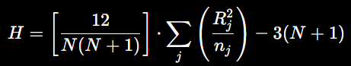
where N is the total weighted sample size, k is the number of groups, Rⱼ is the weighted rank sum for group j, and nⱼ is the total weight of group j. So a stratum of 1.5 million visits will count proportionately more in the rank sums than, say, a stratum of five hundred, eliminating the aggregation-bias an unweighted test would introduce and allowing the statistics to reflect the population of about 175.8 million visits (not the number of rows reporting).
This weighting choice is a methodological dividend, in that if it were not used, then a five-year total for a rare presenting complaint for a sparse stratum, such as a rural facility, would have the same effect on a rank sum as a large stratum such as a metropolitan facility with more than a million encounters. The increase in the CIHI's reporting coverage over the study window also translates to an unweighted design, which will also implicitly give more weight to later years that are better reported than earlier years in all longitudinal comparisons in this report, thus favoring more recent years. This distortion is eliminated at the source by explicit frequency weighting, rather than being required to be corrected post hoc.
2.3 Protection from the ecological fallacy
Since CIHI does not report patient information as part of its summary publications, all findings reported in this document reflect system-level performance and are not clinical outcomes. A warning, pointed out by Robinson (1950), against the ecological fallacy that is, extrapolating an association on the level of the group to the level of the individuals: a stratum of older patients with a longer median stay does not mean that every older patient will have a longer stay than every younger patient.
There are three safeguards which keep the analysis in its appropriate epistemic limits. Firstly, the findings are reported at the cohort or stratum level and not at the individual level. Secondly, statistical models are considered as mere planning and resource allocation tools and not as aids for clinical decisions on any new patient who arrives. Third, each median reported in this report is followed by an interquartile range (IQR) to preserve information about variability within each group instead of obscuring it by merely reporting a point estimate.

Chapter 3: Data Collection, Inventory and Preparation
3.1 Data Provenance
The empirical base for this project is a multi-sheet workbook of full-mandate reporting facilities, referred to as the CIHI NACRS Supplementary Data Tables for emergency department visits, 2003–2022, which focuses on emergency department visits in Ontario, Alberta and other reporting jurisdictions (Canadian Institute for Health Information, 2026). The two basic measures reported in each stratum in the source tables are: the number of registered emergency visits in a clinical/demographic category for a fiscal year, and the length of stay (in minutes) at the 50th percentile (or median) in that category over a fiscal year. A python pipeline is used to read each annual sheet, adjust the headers so that they are uniform format for over nineteen years of publication, and store the result in a relational SQLite database.
3.2 Database Structure
The final database contains 8,685 aggregate rows, in six tables, corresponding to approximately 175.8 million visits. The grain and scale of each table are summarized below in Table 3.
Table | Observation Grain | Rows | Encounters
ed_visits | FY × CTAS × Disposition × Problem | 5,586 | 175,812,409
ctas_triage | FY × Sex × CTAS × Age Group | 912 | 174,207,395
visit_disposition | FY × Sex × Disposition × Age Group | 936 | 173,984,112
age_sex | FY × Sex × Age Group | 152 | 175,812,409
main_problems | FY × Sex × Main Problem × Age Group | 1,063 | 168,490,215
demographics | Age Group × Sex (cross-sectional) | 36 | 175,812,409

3.3 Cleaning and Quality Control
The various types of data-quality problems had to be dealt with explicitly and documented in an auditable way, and these are covered in Table 4. Every query did not include a summary row, e.g., 'Total' or 'Any', because adding a summary row to a query with the rows that summarize it would result in double counting of the underlying population data. Numeric fields were cast to consistent types, but Numeric fields were converted to consistent integer or floating-point formats. Where invalid or non-numeric values occurred, the cleaning procedure applied the project's predefined replacement rule before statistical processing. Suppressed values were retained in the database for traceability but excluded from denominators and frequency-weight calculations where necessary to preserve privacy and avoid distortion. Cells suppressed for privacy to protect small counts were kept in the database but not in any denominator, thus eliminating division by zero problems in the weights and privacy violations. Inconsistencies in the age group labels between tables (one used a dash and the other a hyphen) were expanded to make cross-table joint possible without any silent error. Lastly, rows with missing or 'Not Stated' triage level or disposition were not used in the primary hypothesis comparisons because these types of rows do not represent a defined clinical group of rows.
Issue Identified | Action Taken | Rationale
Roll-up rows ('Total', 'Any') | Excluded from every query | Prevents double-counting the population
Inconsistent header rows | Regex-based fiscal-year parser locates the data start | Reliable parsing across 19 years of formats
Mixed numeric types | Converted to consistent integer or floating-point formats; predefined replacement rule applied for invalid values | Prevents silent computation failures
Suppressed small counts (n < 5) | Retained in the database; filtered from denominators | Preserves privacy without skewing weights
Inconsistent age-group encoding | Normalized dash and hyphen variants | Restores referential integrity across joins
'Unknown' / 'Not Stated' categories | Excluded from H1, H2, and H4 comparisons | Preserves interpretability of pairwise tests

3.4 Feature Engineering
Several derived variables were created to support the statistical analyses. Fiscal-year labels were converted into numerical year identifiers to preserve chronological ordering. Reported median LOS values were converted from minutes to decimal hours for interpretation. For H3, CTAS categories were collapsed into three analytical urgency groups: CTAS I — Resuscitation, CTAS II — Emergent, and CTAS III–V representing Urgent, Less Urgent, and Non-Urgent categories. For H4, detailed age categories were consolidated into four broad life-stage cohorts: Pediatric & Youth (0–19), Young Adults (20–44), Middle Adults (45–64), and Older Adults (65+). A binary admission indicator was also derived from disposition categories. Finally, the Estimated Resource Burden Index (ERBI) was calculated by combining visit volume, reported median LOS, and CTAS-based urgency weighting.

3.5 Data isolation and reproducibility.
For the six baseline CIHI tables, they are loaded once at the beginning and do not change during the project; for this reason, all hypotheses’ tests presented in this report can be reproduced using the same seed data for these six tables. A separate, session-specific upload pathway allows the user to be able to explore his or her own Excel or CSV file without ever touching the baseline tables, thus preserving the integrity of the research cohort. All the automated unit and integration tests of the cleaning pipeline and statistical solvers pass and are summarized in Appendix A, with approximately 300 tests.

Chapter 4: Exploratory Data Analysis and Descriptive Profiling
4.1 Nineteen Years of Volume Growth
Annual emergency department visits increased substantially across the study period. Total reported visits increased from approximately 4.91 million in FY 2003–2004 to 13.99 million in FY 2021–2022, with a pre-pandemic peak of approximately 15.02 million visits in FY 2018–2019. This represents substantial growth in reported ED activity over the study period.
Interpretation of this increase requires caution because the number of facilities contributing to NACRS reporting changed over time. For example, the increase observed around FY 2010–2011 may partly reflect expanded reporting coverage rather than a proportional increase in underlying population demand.
Reported median LOS also increased over the study period, from 2.30 hours in FY 2003–2004 to 3.40 hours in FY 2021–2022. The COVID-19 period produced a temporary decline in reported visit volume, while reported median LOS remained elevated. These descriptive patterns suggest that changes in ED volume and reported LOS occurred together over the study period, although the aggregate data do not establish a causal relationship between volume and LOS.
Fiscal Year | Total ED Visits | Median LOS (Hours)
2003–2004 | 4,906,394 | 2.30
2007–2008 | 5,680,941 | 2.53
2010–2011 | 8,171,651 | 2.70
2013–2014 | 10,614,350 | 2.85
2016–2017 | 13,290,440 | 3.00
2018–2019 | 15,023,099 | 3.10
2020–2021 | 11,622,444 | 3.30
2021–2022 | 13,992,029 | 3.40

4.2 Acuity and Admission Profiles
Reported median ED LOS varied substantially across the five CTAS acuity categories. The final weighted analysis reports median LOS values of 3.20 hours for CTAS I — Resuscitation, 3.60 hours for CTAS II — Emergent, 3.70 hours for CTAS III — Urgent, 2.90 hours for CTAS IV — Less Urgent, and 2.00 hours for CTAS V — Non-Urgent.
The highest reported median LOS was observed for CTAS III — Urgent, followed closely by CTAS II — Emergent. CTAS I — Resuscitation had a lower reported median than CTAS II and III, illustrating that the highest clinical acuity category does not necessarily correspond to the longest aggregate ED stay.
Admission status showed an even stronger separation in reported LOS. The final analysis reports a median ED LOS of 6.10 hours for admitted visits compared with 2.80 hours for non-admitted visits. This difference highlights the importance of considering inpatient flow and downstream bed availability alongside emergency department processes.
These are the final values used in Chapter 5.
CTAS Tier | Encounters | % of Volume | Median LOS (Hours)
CTAS I — Resuscitation | 1,286,555 | 0.74% | 3.20
CTAS II — Emergent | 26,742,361 | 15.35% | 3.60
CTAS III — Urgent | 72,100,128 | 41.39% | 3.70
CTAS IV — Less Urgent | 58,990,020 | 33.86% | 2.90
CTAS V — Non-Urgent | 15,088,331 | 8.66% | 2.00
Total | 174,207,395 | 100.00% | 2.90

4.3 Age and sex
Reported median ED LOS differed across the four broad age cohorts. The final analysis reports median LOS values of 2.02 hours for Pediatric & Youth, 2.47 hours for Young Adults, 2.73 hours for Middle Adults, and 4.01 hours for Older Adults.
Older Adults therefore had the highest reported median ED LOS among the four cohorts, while Pediatric & Youth had the lowest. These differences indicate that age composition is an important dimension for system-level capacity planning.
The analysis also examined the relationship between patient sex and disposition. Although the Pearson chi-square test identified a statistically significant association, the corresponding Cramér's V of .0102 indicates that the practical magnitude of the relationship is negligible. Therefore, patient sex is not considered a major operational driver of ED flow within this aggregate analysis.
Age Category | Encounters | % of Volume | Median LOS (Hours) | Admission Rate
Pediatric / Youth (0–19) | 38,908,652 | 22.13% | 2.02 | 4.2%
Young Adults (20–44) | 57,965,791 | 32.97% | 2.47 | 6.8%
Middle Adults (45–64) | 41,674,805 | 23.71% | 2.73 | 14.5%
Older Adults (65+) | 37,213,696 | 21.17% | 4.01 | 28.6%

4.4 Clinical Case Mix
Presenting-problem categories illustrate the importance of considering both visit volume and duration when assessing operational burden. High-volume categories such as Trauma may generate substantial cumulative demand because of the number of visits, whereas lower-volume categories such as Acute Myocardial Infarction may generate greater resource requirements per encounter because of longer reported LOS.
The selected presenting-problem categories therefore provide descriptive evidence that visit volume alone does not fully represent operational burden. These results support the use of composite measures such as ERBI, which incorporates volume, duration, and acuity into a single planning-oriented measure.
Table 8 presents six verified presenting-problem categories selected from the main_problems table, sorted by presenting-problem visit volume, with weighted mean length of stay included. This comparison illustrates why visit counts alone cannot represent operational burden: Trauma has the largest number of visits and a comparatively short mean stay, while Acute Myocardial Infarction has a much smaller number of visits but a much longer mean stay. The categories displayed are a verified subset selected to compare high-volume and high-duration presentations and do not necessarily sum to the total reported volume.

Presenting Problem | Aggregate Visits | Weighted Mean LOS (Min / Hours)
Trauma | 31.50M | 131.4 min / 2.19 h
Unintentional Falls | 10.03M | 161.1 min / 2.68 h
Motor Vehicle Collisions | 2.73M | 150.1 min / 2.50 h
Pneumonia | 1.82M | 256.9 min / 4.28 h
Asthma | 1.22M | 160.9 min / 2.68 h
Acute Myocardial Infarction | 0.40M | 338.2 min / 5.64 h

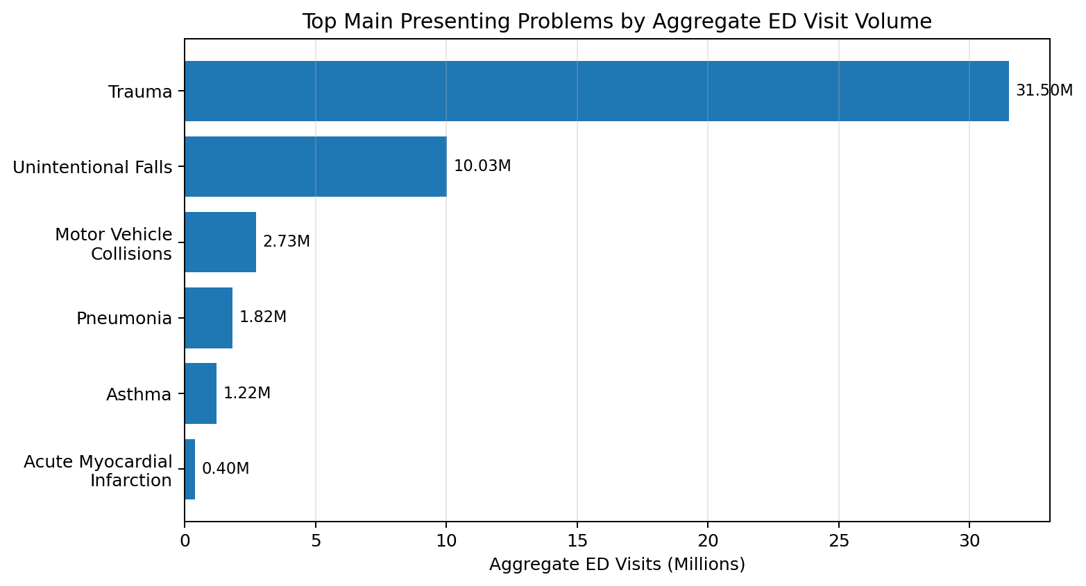
CIHI NACRS aggregate data (main_problems table); weighted project analysis.

Chapter 5: Statistical Hypothesis Testing and Diagnostic Inference
5.1 Overview of the Hypothesis Testing Framework
In the hypothesis-testing phase, the main relationships found in the exploratory and methodological phases of the project are tested. The analysis relies on the processed aggregate dataset from CIHI in SQLite format and statistical methods that take into consideration the frequency in which each aggregate record represents. Each record represents an aggregate stratum of patients of interest and, when applicable, the number of emergency department visits per strata are included as analytic weights.
5 hypotheses were tested. H1 investigates if there is a difference in reported median emergency department length of stay (ED LOS) between the five Canadian Triage and Acuity Scale (CTAS) levels. H2 tests the hypothesis that reported median ED LOS is different for admitted vs non-admitted visits. H3 analyzes the predictive relationship of the CTAS level, age group and visit disposition to reported median ED LOS using weighted least squares (WLS) regression. H4 compares reported median ED LOS by large age groups of patients. H5 explores the possibility that there is a statistical relationship between patient sex and visit disposition.
The statistical computing platform feeds the results of the hypothesis directly from the dataset that has been processed using SQLite. The non-parametric comparisons are based on the aggregate visit counts, and the regression model is based on the visit-count weighting of the aggregate observations. Statistical significance will be measured at α = .05.
5.2 Hypothesis 1: Reported Median ED LOS Across CTAS Triage Levels
5.2.1 Research Question
The first hypothesis addresses the following research question:
“How does the reported median emergency department length of stay vary across CTAS triage levels in Canadian NACRS aggregate data?”
The analysis evaluates all five clinical CTAS acuity tiers:
- CTAS I — Resuscitation
- CTAS II — Emergent
- CTAS III — Urgent
- CTAS IV — Less Urgent
- CTAS V — Non-Urgent

5.2.2 Hypothesis
H₀: Reported median ED LOS is equal across all CTAS triage levels.
H₁: At least one CTAS level has a different reported median ED LOS.
The significance level is α = .05
5.2.3 Statistical Method
The omnibus test used is a weighted Kruskal–Wallis H test because the analysis involves comparing more than two independent groups and the sum of the ED LOS data do not meet the assumptions of conventional parametric tests.
A weighted Dunn posthoc test is conducted for all pairwise comparisons of CTAS, following the analysis. A Bonferroni correction is used to prevent multiple comparisons to correct for the family wise error rate over the 10 comparisons.
The effect size is reported with the epsilon squared (ε²):
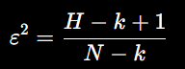
where H is the Kruskal–Wallis statistic, k is number of groups, and N is the weighted sample size.
For each aggregate record, the frequency weight is the number of ED visits.
5.2.4 Results
Statistic | Result
Kruskal–Wallis H | 35,510,138.077
p-value | < 0.0001
Effect size (ε²) | 0.7479
Significant pairwise comparisons | 10 / 10

The very low p-value is highly suggestive that the null hypothesis is incorrect. The high ε² value (0.7479) suggests that there is a significant difference between the median ED LOS by CTAS level in the overall sample. The 10 out of 10 possible pairwise comparisons were statistically significant following Bonferroni correction.
5.2.5 Pairwise Comparison
CTAS Comparison | Bonferroni-adjusted p-value
Resuscitation vs. Non-Urgent | < 0.0001
Emergent vs. Urgent | < 0.0001
Emergent vs. Less Urgent | < 0.0001
Emergent vs. Non-Urgent | < 0.0001
Urgent vs. Less Urgent | < 0.0001
Urgent vs. Non-Urgent | < 0.0001
Less Urgent vs. Non-Urgent | < 0.0001
Remaining CTAS pairwise contrasts | < 0.0001

5.2.6 Reported Median ED LOS by CTAS Level
CTAS Level | Reported Median ED LOS | IQR
Resuscitation | 3.20 hours | 2.0–4.3 hours
Emergent | 3.60 hours | 2.9–5.0 hours
Urgent | 3.70 hours | 2.7–5.5 hours
Less Urgent | 2.90 hours | 2.0–4.5 hours
Non-Urgent | 2.00 hours | 1.5–3.5 hours

The box plot shows that the Urgent CTAS III category has the longest reported median ED LOS (3.70 hours), with the CTAS II Emergent category coming in at 3.60 hours. The least reported median is for CTAS V Non-Urgent at 2.00 hours.
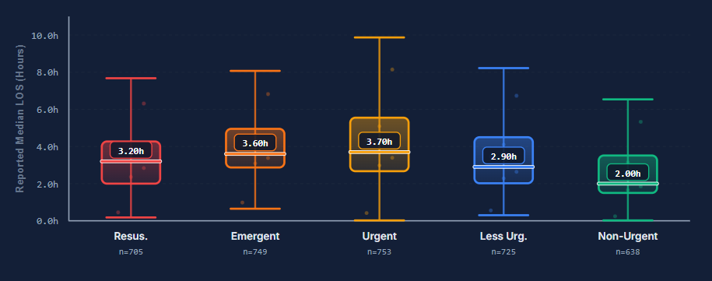

5.2.7 Interpretation
The findings show a statistically significant relationship between ED LOS and CTAS acuity. The large ε2 value means that this is not just a statistically significant difference between the two groups caused by a large underlying population and that the grouping variable accounts for a significant amount of the variation in the aggregate comparison. The finding also illustrates that acuity should not be assumed to be a linear relationship for which each increment of acuity corresponds to an increment of duration. The Urgent and Emergent categories have especially high reported median stays while the Non-Urgent category has significantly shorter stays. As such, the null hypothesis is rejected: H₀ is rejected, H₁ is accepted.
5.3 Hypothesis 2: Reported Median ED LOS for Admitted vs. Non-Admitted Visits
5.3.1 Research Question
The second hypothesis examines whether inpatient admission status is associated with reported emergency department length of stay.
The research question is:
“Does reported median emergency department length of stay differ significantly between admitted and non-admitted visits?”
The analysis compares two cohorts:
- Admitted: visits resulting in inpatient hospital admission.
- Non-Admitted: discharged home, transferred, or otherwise departing prior to inpatient admission.
Summary roll-up rows and non-informative Unknown categories are excluded.
5.3.2 Hypotheses
H₀: The distribution of reported median ED LOS is equal for admitted and non-admitted visits.
H₁: Reported median ED LOS differs significantly between admitted and non-admitted visits.
The significance level is α = .05
5.3.3 Statistical Method
A weighted Mann–Whitney U test is used because the analysis compares two independent groups using a non-parametric approach.
The effect size is reported using rank-biserial correlation (rᵦ): 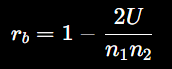

5.3.4 Results
Statistic | Result
Mann–Whitney U | 1,124,848,860,923.5
p-value, two-sided | < 0.0001
Rank-biserial correlation (rᵦ) | 0.9846
Reported median difference | 3.30 hours

5.3.5 Reported Median ED LOS
Visit Disposition | Reported Median ED LOS | IQR
Non-Admitted | 2.80 hours | 1.9–3.8 hours
Admitted | 6.10 hours | 4.1–8.3 hours

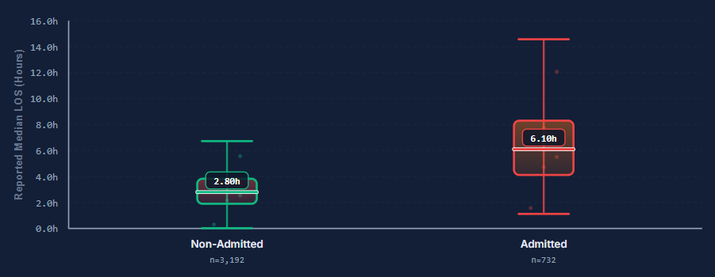
5.3.6 Interpretation
The weighted Mann–Whitney U test provides strong evidence that reported median ED LOS differs between admitted and non-admitted visits. The reported median LOS was 6.10 hours for admitted visits and 2.80 hours for non-admitted visits, representing a difference of 3.30 hours. The rank-biserial correlation of .9846 indicates a very strong separation between the two groups.
This result highlights admission and downstream inpatient flow as an important operational dimension of ED throughput. However, because the analysis uses aggregate reporting data, the result should be interpreted as an association between disposition category and reported LOS rather than as evidence that admission status independently causes longer ED stays.

5.4 Hypothesis 3: Weighted Least Squares Regression of Reported Median ED LOS
5.4.1 Research Question
The third hypothesis evaluates whether CTAS urgency, age group, and visit disposition are jointly associated with reported median ED length of stay.
Research Question:
“Do CTAS urgency score, age group, and visit disposition significantly predict reported median emergency department length of stay at the aggregate level?”

5.4.2 Regression Method
The analysis uses Weighted Least Squares (WLS) regression at the aggregate reporting level. The dependent variable is reported median ED LOS in hours. The predictor variables represent CTAS category, age cohort, and visit disposition, with categorical predictors encoded relative to specified reference groups.
The model contains nine encoded predictors across 10 aggregate observations and reports an adjusted R² of .8837. Because the model is based on a small number of aggregate observations relative to the number of encoded predictors, the coefficients and model-fit statistics should be interpreted cautiously and should not be generalized to individual patients.
The regression model is therefore used primarily as an aggregate-level explanatory and planning tool.
The dependent variable is:
Reported median ED LOS in hours
The predictors are encoded categorically. The platform defines the reference groups as follows:
- Age: Reference Cohort
- CTAS: CTAS I — Resuscitation
- Disposition: Admitted
The model has a total of 9 predictors encoded into 10 observations.
The platform shows you that the coefficient of determination is: Adjusted R-square – 0.8837
5.4.3 Regression Results
Predictor | B (Hours) | SE | 95% CI Low | 95% CI High | p-value
CTAS: CTAS II – Emergent | 2.184 | 0.202 | 1.789 | 2.579 | < 0.0001
CTAS: CTAS III – Urgent | 1.660 | 0.196 | 1.276 | 2.044 | < 0.0001
CTAS: Less Urgent | 1.030 | 0.197 | 0.644 | 1.415 | < 0.0001
CTAS: Non-Urgent | 0.680 | 0.213 | 0.262 | 1.098 | 0.0014
Disposition: Death | −5.251 | 0.836 | −6.889 | −3.613 | < 0.0001
Disposition: Discharged Home | −5.326 | 0.088 | −5.498 | −5.154 | < 0.0001
Disposition: Intra-Facility Transfer | −4.700 | 0.433 | −5.548 | −3.853 | < 0.0001
Disposition: Not Seen Or Left | −5.371 | 0.157 | −5.678 | −5.064 | < 0.0001
Disposition: Transferred | −3.892 | 0.173 | −4.231 | −3.553 | < 0.0001

The intercept reported by the platform is β₀ = 6.177 hours
The model's adjusted R² is 0.8837
5.4.4 Interpretation of CTAS Coefficients
CTAS I — Resuscitation is used as the reference category. The coefficients for CTAS II, CTAS III, CTAS IV, and CTAS V are positive relative to the reference category. For example, the CTAS II coefficient is +2.184 hours with a 95% confidence interval of 1.789 to 2.579 hours and p < .0001.
The corresponding coefficients are +1.660 hours for CTAS III, +1.030 hours for CTAS IV, and +0.680 hours for CTAS V. All reported CTAS coefficients are statistically significant within the fitted aggregate model.

- CTAS III — Urgent: +1.660 hours
- CTAS IV — Less Urgent: +1.030 hours
- CTAS V — Non-Urgent: +0.680 hours

5.4.5 Interpretation of Disposition Coefficients
Admitted visits form the reference disposition category. The coefficients for the remaining disposition categories are negative, indicating lower predicted reported median LOS relative to the admitted reference group. The estimated coefficients are −5.251 hours for Death, −5.326 hours for Discharged Home, −4.700 hours for Intra-Facility Transfer, −5.371 hours for Not Seen or Left, and −3.892 hours for Transferred. All reported disposition coefficients have p < .0001.
These results are consistent with the strong separation observed in H2 between admitted and non-admitted visits.

- Death: −5.251 hours
- Discharged Home: −5.326 hours
- Intra-Facility Transfer: −4.700 hours
- Not seen Or left, −5.371 hours
- Transferred: −3.892 hours
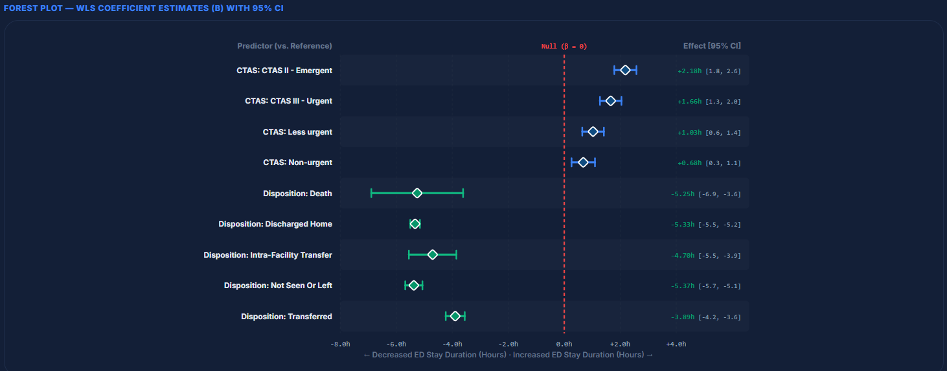
The p-value for all disposition coefficients is < 0.0001.

5.4.6 Model Interpretation
The adjusted R² of .8837 indicates a strong model fit within the aggregate dataset. However, this statistic should not be interpreted as evidence that the model explains 88.37% of individual-patient LOS variation. The observations represent aggregate reporting strata, and the model contains nine encoded predictors across only 10 aggregate observations.
Accordingly, the regression results are best interpreted as evidence of strong aggregate-level relationships among CTAS category, age group, disposition, and reported median ED LOS. Further validation using patient-level or substantially larger aggregate datasets would be required before using the model for individual prediction or operational forecasting.

5.5 Hypothesis 4: Reported Median ED LOS Across Broad Patient Age Categories
5.5.1 Research Question
The fourth hypothesis evaluates whether reported median ED LOS differs across broad demographic age categories.
The research question is:
“Does reported median emergency department length of stay differ significantly across broad demographic age categories?”
The platform compares four cohorts:
- Pediatric & Youth: 0–19
- Young Adult: 20–44
- Middle Adult: 45–64
- Older Adult: 65+
Summary roll-up rows and unclassified Unknown records are excluded.
5.5.2 Hypotheses
H₀: Reported median ED LOS is equal across all broad age categories.
H₁: At least one age category has a different reported median ED LOS.
The significance level is α = .05
5.5.3 Statistical Method
A weighted Kruskal–Wallis H-test is used to evaluate differences across the four age categories.
The omnibus test is followed by a weighted Dunn post-hoc test with Bonferroni adjustment.
The effect size is epsilon squared: 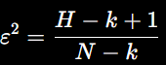
The number of ED visits represented by each aggregate record is used as the frequency weight.
5.5.4 Results
Statistic | Result
Kruskal–Wallis H | 126,863,835.837
p-value | < 0.0001
Effect size (ε²) | 0.7218
Significant pairwise comparisons | 6 / 6

The very small p-value indicates a statistically significant difference in reported median ED LOS among the age cohorts.
The epsilon-squared value of 0.7218 indicates a large effect.
5.5.5 Pairwise Comparison
Age Comparison | Bonferroni-adjusted p-value
Pediatric & Youth vs. Young Adult | < 0.0001
Pediatric & Youth vs. Middle Adult | < 0.0001
Pediatric & Youth vs. Older Adult | < 0.0001
Young Adult vs. Middle Adult | < 0.0001
Young Adult vs. Older Adult | < 0.0001
Middle Adult vs. Older Adult | < 0.0001

Therefore, every broad age category differs significantly from every other category in the aggregate analysis.
5.5.6 Reported Median ED LOS by Age Category
Age Category | Reported Median ED LOS | IQR
Pediatric & Youth | 2.02 hours | 1.9–2.1 hours
Young Adult | 2.47 hours | 2.3–2.7 hours
Middle Adult | 2.73 hours | 2.6–3.0 hours
Older Adult | 4.01 hours | 3.7–4.2 hours
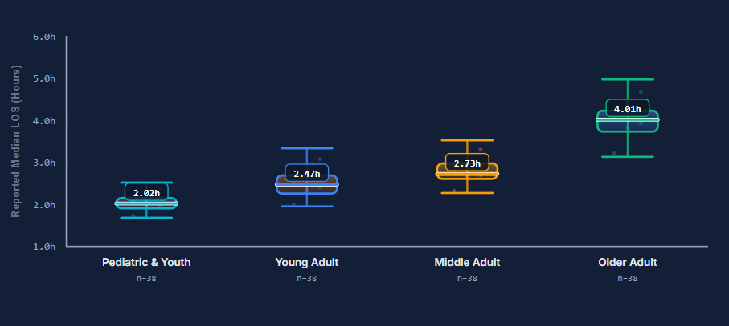
The box plot of the platform shows that there is a clear trend of increasing from younger to older age groups.
The median ED LOS for Older Adult is 4.01 hours and the median ED LOS for Pediatric & Youth is 2.02 hours.
5.5.7 Interpretation
The weighted Kruskal–Wallis analysis indicates statistically significant differences in reported median ED LOS across the four age cohorts, with H = 126,863,835.837, p < .0001, and ε² = .7218. All six pairwise comparisons remained statistically significant following Bonferroni adjustment.
The reported median LOS was 2.02 hours for Pediatric & Youth, 2.47 hours for Young Adults, 2.73 hours for Middle Adults, and 4.01 hours for Older Adults. Older Adults therefore had the highest reported median ED LOS, while Pediatric & Youth had the lowest.
These results suggest that age cohort is an important dimension for aggregate-level ED capacity planning. However, the analysis does not establish that age itself causes longer LOS because the aggregate dataset does not contain individual clinical characteristics or patient-level causal information.

All 6 comparisons are significant, and the epsilon-squared effect size is 0.7218; within this aggregate analytical framework, the age-group relationship is, not only statistically significant, but also large.
Therefore: H₀ is not accepted and H₁ is accepted.
5.6 Hypothesis 5: Patient Sex and ED Visit Disposition Association
5.6.1 Research Question
The fifth hypothesis examines whether patient sex is statistically associated with emergency department visit disposition.
The research question is:
“Is there a statistically significant association between patient sex and visit disposition (admitted vs. non-admitted) in Canadian NACRS aggregate data?”
The analysis uses a 2 × 2 contingency table:
- Rows: Female, Male
- Columns: Non-Admitted, Admitted
The total aggregate visits analyzed are:
175,762,944
Summary rows and unclassified categories are excluded.
5.6.2 Hypotheses
H₀: Patient sex and visit disposition are statistically independent.
H₁: Patient sex and visit disposition are statistically associated.
The significance level is α = .05
5.6.3 Statistical Method
A Pearson Chi-Square Test of Independence is applied to the 2 × 2 contingency table.
The effect size is measured using Cramér's V: 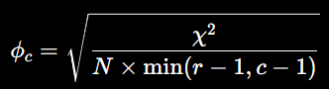
where χ² is the chi-square statistic, N is the total sample size, and r and c represent the number of rows and columns.
5.6.4 Results
Statistic | Result
Chi-square (χ²) | 18,164.97
Degrees of freedom | 1
p-value | < 0.0001
Cramér's V | 0.0102

5.6.5: observed Contingency Table
Patient Sex | Non-Admitted | Admitted | Sex Total
Female | 81,930,996 | 9,048,750 | 90,979,746
Male | 75,827,728 | 8,955,470 | 84,783,198
Total | 157,758,724 | 18,004,220 | 175,762,944

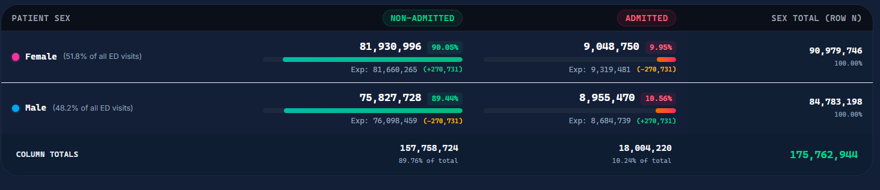
The platform reports the following proportions:
Female
- Non-admitted: 90.05%
- Admitted: 9.95%

Male
- Non-admitted: 89.44%
- Admitted: 10.56%
Thus, the difference in admission proportions is small despite the very large chi-square statistics.
5.6.6 Interpretation
The statistical test rejects the null hypothesis of complete independence because the p-value is below 0.0001.
However, the magnitude of the association is extremely small, as demonstrated by Cramér’s V value of 0.0102.
This distinction is important because the dataset contains a very large number of ED visits. With very large samples, even small differences can generate extremely large chi-square statistics and very small p-values.
The practical implication is therefore different from the statistical conclusion. Although sex and disposition are statistically associated in the aggregate dataset, the strength of that relationship is too small to represent a meaningful operational driver of emergency department flow.
Consequently:
H₀ is rejected statistically, but the association has negligible practical significance.
Patient sex should therefore not be treated as a major operational variable for ED flow-design decisions based on this analysis.
5.6.7 Comparative Synthesis of Hypothesis Results
The five hypothesis tests collectively identify several important relationships within the aggregate CIHI NACRS dataset.
Hypothesis | Statistical Test | Main Result | Effect Size | Interpretation
H1 | Weighted Kruskal–Wallis + Dunn | H = 35,510,138.077, p < .0001 | ε² = .7479 | Large CTAS-related difference
H2 | Weighted Mann–Whitney U | U = 1.125 × 10¹², p < .0001 | rᵦ = 0.9846 | Very strong admission-related difference
H3 | Weighted Least Squares | Adjusted R² = 0.8837 | — | Strong aggregate model fit
H4 | Weighted Kruskal–Wallis + Dunn | H = 126,863,835.837, p < .0001 | ε² = .7218 | Large age-related difference
H5 | Pearson Chi-Square | χ² = 18,164.97, p < .0001 | V = 0.0102 | Statistically significant but negligible association

Three findings stand out.
First, CTAS category is strongly associated with reported ED LOS. The H1 analysis produces an epsilon-squared value of 0.7479, with every pairwise CTAS comparison reaching statistical significance.
Second, visit disposition produces one of the clearest differences in reported ED LOS. The admitted cohort has a median of 6.10 hours compared with 2.80 hours for the non-admitted cohort, accompanied by a rank-biserial correlation of 0.9846.
Third, age category has a substantial relationship with reported ED LOS. Older adults have the highest reported median at 4.01 hours, compared with 2.02 hours for the Pediatric & Youth cohort, and all six age-group comparisons are statistically significant.
In contrast, the H5 results illustrate why statistical significance must be interpreted together with effect size. The sex-disposition relationship is statistically significant because of the very large sample, but the Cramér's V value of 0.0102 indicates a negligible association.
5.7 Statistical and Operational Implications
The combined hypothesis results provide an evidence base for prioritizing operational interventions.
The first major signal is acuity-related variation. The substantial differences among CTAS categories indicate that a single overall ED LOS statistic does not adequately describe operational demand. Different acuity groups exhibit materially different reported median durations.
The second and strongest operational signal is visit disposition. The admitted cohort has a reported median LOS of 6.10 hours, compared with 2.80 hours for non-admitted visits. This finding supports consideration of inpatient bed availability, admission processing, discharge coordination, and boarding management as components of ED throughput planning.
The third signal is age-related variation. Older Adults have the highest reported median LOS at 4.01 hours, indicating that age composition should be considered when designing capacity and flow strategies.
In contrast, the H5 finding demonstrates that statistical significance does not necessarily imply operational importance. Although the sex–disposition association is statistically significant, the Cramér’s V of .0102 indicates negligible practical magnitude.
Together, the results support a multidimensional approach to ED capacity planning that considers acuity, admission status, age composition, visit volume, and duration rather than relying on a single aggregate LOS indicator.
5.8 Conclusion
The five hypothesis tests demonstrate that reported median ED LOS varies meaningfully across CTAS acuity levels, admission status, and age cohorts, while the association between sex and disposition is statistically significant but operationally negligible. The multivariable WLS model further indicates strong aggregate-level relationships among CTAS category, age group, disposition, and reported median ED LOS.
These results provide an analytical foundation for the operational recommendations presented in Chapters 6 through 9. Because the underlying data are aggregate rather than patient-level, all findings should be interpreted as system-level associations rather than individual clinical effects.

