Business Template

Subject areas
Logo / Image

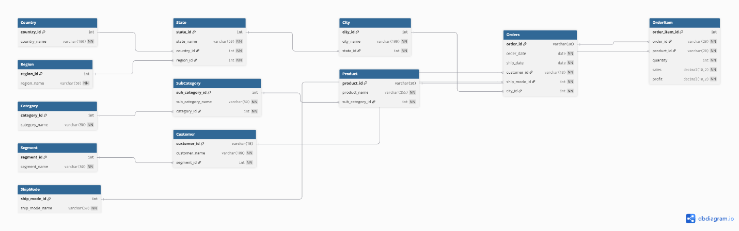

Contents
1 Business Description 3
1.1 Business background 3
1.2 Problems. Current Situation 3
1.3 The benefits of implementing a database. Project Vision 3
2 Model description 3
2.1 Definitions & Acronyms 3
2.2 Logical Scheme 3
2.3 Objects 3

Business Description

Business background
Superstore is a US retailer. It sells things for offices and homes in three categories: furniture, office supplies, and tech. The customers come in three groups: regular people buying for themselves, businesses buying for their offices, and people working from home. Orders go out across the country in four sales regions: South, East, West, and Central. Customers pick from four shipping options, ranging from Same Day delivery down to Standard Class. Each order can have several products on it, and the company tracks how many were sold, the sales amount, and the profit on each one.

Problems. Current Situation
Some customer's name and address is in every order they put. The word "Furniture" is shown thousands of times. "United States" is in every single row. So if a customer changes their name, we have to find every row with that customer and edit them all by hand. Miss one and the data is no longer correct.
There's also no way to stop typos. If someone types "Standerd Class" instead of "Standard Class" once, the file just treats it as a brand new shipping option. Same problem with category names, segment names, and any other text value.
Adding new things is not easy too. If we want to add new shipping option, someone has to edit rows by hand.

the Benefits of implementing a database. Project Vision
Moving everything into a real database fixes all those problems.
Each information is stored only once, in the right place. If a customer changes their name, we update one row in the Customer table and every order they placed shows the new name. Foreign keys make sure every order is connected to real customer, every product is connected to real sub-category, and every line item belongs to real order.
The goal is something easy to query, easy to update, and doesn't break when something changes.

Model description

Definitions & Acronyms

Logical Scheme


2.3 Objects
Country
The countries Superstore operates in. Right now there is only "United States," but keeping it as its own table means we can add more later without changing anything.
Table Name | Field name | Field Description | Data Type
Country | country_id | Unique ID for each country, PK | INT
 | country_name | Country name | VARCHAR(100), NOT NULL, UNIQUE
Comments on table relationships
One country has many states.
Example with data
country_id | country_name
1 | United States

Region
The four sales regions Superstore uses to group its territories.
Table Name | Field name | Field Description | Data Type
Region | region_id | Unique ID for each region, PK | INT
 | region_name | Region name | VARCHAR(50), NOT NULL, UNIQUE
Comments on table relationships
One region groups many states.
Example with data
region_id | region_name
1 | South
2 | West
3 | East
4 | Central

State
US states. Each state is in one country and one sales region.
Table Name | Field name | Field Description | Data Type
State | state_id | Unique ID for each state, PK | INT
 | state_name | State name | VARCHAR(50), NOT NULL
 | country_id | Country this state is in, FK -> Country(country_id) | INT, NOT NULL
 | region_id | Sales region this state is in, FK -> Region(region_id) | INT, NOT NULL
Plus UNIQUE (state_name, country_id). Two different countries could each have a state with the same name, so the state name alone is not unique.
Comments on table relationships
Belongs to one country and one region. Has many cities.
Example with data
state_id | state_name | country_id | region_id
1 | Kentucky | 1 | 1
2 | California | 1 | 2

City
Cities that orders ship to. Each city is in one state.
Table Name | Field name | Field Description | Data Type
City | city_id | Unique ID for each city, PK | INT
 | city_name | City name | VARCHAR(100), NOT NULL
 | state_id | State this city is in, FK -> State(state_id) | INT, NOT NULL
Plus UNIQUE (city_name, state_id). There are several "Springfields" across different states, so the city name alone is not unique.
Comments on table relationships
Belongs to one state. Receives many orders.
Example with data
city_id | city_name | state_id
1 | Henderson | 1
2 | Los Angeles | 2

Category
The top-level product categories. The dataset has three: Furniture, Office Supplies, and Technology.
Table Name | Field name | Field Description | Data Type
Category | category_id | Unique ID for each category, PK | INT
 | category_name | Category name | VARCHAR(50), NOT NULL, UNIQUE
Comments on table relationships
One category has many sub-categories.
Example with data
category_id | category_name
1 | Furniture
2 | Office Supplies
3 | Technology

SubCategory
Sub-groups inside each category. For example, Bookcases, Chairs, and Tables all sit under Furniture.
Table Name | Field name | Field Description | Data Type
SubCategory | sub_category_id | Unique ID for each sub-category, PK | INT
 | sub_category_name | Sub-category name | VARCHAR(50), NOT NULL
 | category_id | Parent category, FK -> Category(category_id) | INT, NOT NULL
Plus UNIQUE (sub_category_name, category_id).
Comments on table relationships
Belongs to one category. Has many products.
Example with data
sub_category_id | sub_category_name | category_id
1 | Bookcases | 1
2 | Chairs | 1
3 | Labels | 2

Product
Individual products. The original product code from the source data (like FUR-BO-10001798) is kept as the primary key, since it is already unique and lines up with the source.
Table Name | Field name | Field Description | Data Type
Product | product_id | Product code from the source data, PK | VARCHAR(20)
 | product_name | Full product name | VARCHAR(255), NOT NULL
 | sub_category_id | Sub-category this product is in, FK -> SubCategory(sub_category_id) | INT, NOT NULL
Comments on table relationships
Belongs to one sub-category. Appears on many order lines, which together with Orders is the many-to-many handled through OrderItem.
Example with data
product_id | product_name | sub_category_id
FUR-BO-10001798 | Bush Somerset Collection Bookcase | 1
FUR-CH-10000454 | Hon Deluxe Fabric Upholstered Stacking Chairs, Rounded Back | 2

Segment
The customer segment: Consumer, Corporate, or Home Office.
Table Name | Field name | Field Description | Data Type
Segment | segment_id | Unique ID for each segment, PK | INT
 | segment_name | Segment name | VARCHAR(50), NOT NULL, UNIQUE
Comments on table relationships
One segment groups many customers.
Example with data
segment_id | segment_name
1 | Consumer
2 | Corporate
3 | Home Office

Customer
The people who place orders. Same idea as Product: the original customer code from the source data (like CG-12520) is kept as the primary key.
Table Name | Field name | Field Description | Data Type
Customer | customer_id | Customer code from the source data, PK | VARCHAR(10)
 | customer_name | Customer full name | VARCHAR(100), NOT NULL
 | segment_id | Segment this customer belongs to, FK -> Segment(segment_id) | INT, NOT NULL
Comments on table relationships
Belongs to one segment. Places many orders.
Example with data
customer_id | customer_name | segment_id
CG-12520 | Claire Gute | 1
DV-13045 | Darrin Van Huff | 2

ShipMode
The four shipping options Superstore offers.
Table Name | Field name | Field Description | Data Type
ShipMode | ship_mode_id | Unique ID for each shipping option, PK | INT
 | ship_mode_name | Name of the shipping option | VARCHAR(50), NOT NULL, UNIQUE
Comments on table relationships
One shipping option is used on many orders.
Example with data
ship_mode_id | ship_mode_name
1 | Standard Class
2 | Second Class
3 | First Class
4 | Same Day

Orders
One row per order. Records who placed it, when it was placed and shipped, where it shipped to, and which shipping option was used. The actual products on the order are stored in OrderItem.
Table Name | Field name | Field Description | Data Type
Orders | order_id | Order code from the source data, PK | VARCHAR(20)
 | order_date | Date the order was placed | DATE, NOT NULL
 | ship_date | Date the order shipped | DATE, NOT NULL
 | customer_id | Customer who placed the order, FK -> Customer(customer_id) | VARCHAR(10), NOT NULL
 | ship_mode_id | Shipping option used, FK -> ShipMode(ship_mode_id) | INT, NOT NULL
 | city_id | Where the order shipped to, FK -> City(city_id) | INT, NOT NULL
Plus CHECK (ship_date >= order_date). You cannot ship an order before it is placed, so this rule blocks that.
Comments on table relationships
Belongs to one customer, one shipping option, one city. Has many lines in OrderItem.
Example with data
order_id | order_date | ship_date | customer_id | ship_mode_id | city_id
CA-2019-152156 | 2019-11-08 | 2019-11-11 | CG-12520 | 1 | 1
CA-2019-138688 | 2019-06-12 | 2019-06-16 | DV-13045 | 2 | 2

OrderItem
The bridge table that handles the many-to-many between Orders and Product. Each row is one product on a specific order, with the quantity, the sales amount, and the profit on that line. Those three fields live here because they describe the sale itself, not the order alone or the product alone. The same product on two different orders can have different quantities and prices, so they have to sit with the link.
Table Name | Field name | Field Description | Data Type
OrderItem | order_item_id | Unique ID for each line, PK | INT
 | order_id | Order this line belongs to, FK -> Orders(order_id) | VARCHAR(20), NOT NULL
 | product_id | Product on this line, FK -> Product(product_id) | VARCHAR(20), NOT NULL
 | quantity | How many units were sold | INT, NOT NULL, CHECK (quantity > 0)
 | sales | Sales amount for this line | DECIMAL(10, 2), NOT NULL
 | profit | Profit on this line (can be negative for losses) | DECIMAL(10, 2), NOT NULL
Comments on table relationships
Belongs to one order. Points to one product. Many lines per order plus many lines per product is what makes the many-to-many work.
Example with data
order_item_id | order_id | product_id | quantity | sales | profit
1 | CA-2019-152156 | FUR-BO-10001798 | 2 | 261.96 | 41.91
2 | CA-2019-152156 | FUR-CH-10000454 | 3 | 731.94 | 219.58

