If you want to manage Azure blob with python3 in Azure runbook, we need to import package azure.storage.blob with its dependencies.

**Step 1:** ***a) Download this package:***

pip3 download -d <output dir name> azure-storage-blob==12.8.0

***b) Import these packages*** 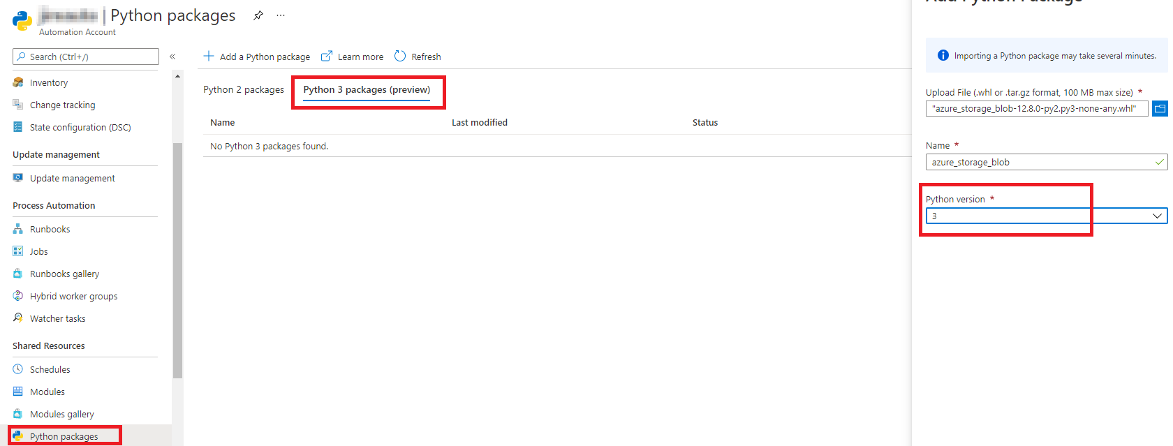

**Step 2:**

***Runbook - connect code***

from azure.storage.blob import BlobServiceClient

connect_str = ''

blob_service_client = BlobServiceClient.from_connection_string(connect_str)

container_client=blob_service_client.get_container_client('test')

blobs = container_client.list_blobs( )

for blob in blobs:

print(blob.name)

***Test and Output:***

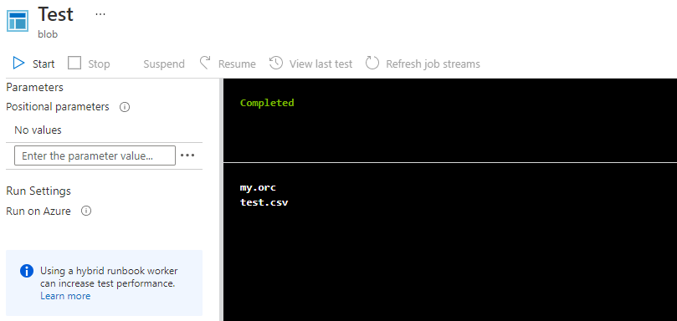

[Share](https://stackoverflow.com/a/69565267)

[Improve this answer](https://stackoverflow.com/posts/69565267/edit)

Follow