Script path

s3://aws-glue-assets-986206516095-us-west-2/scripts/

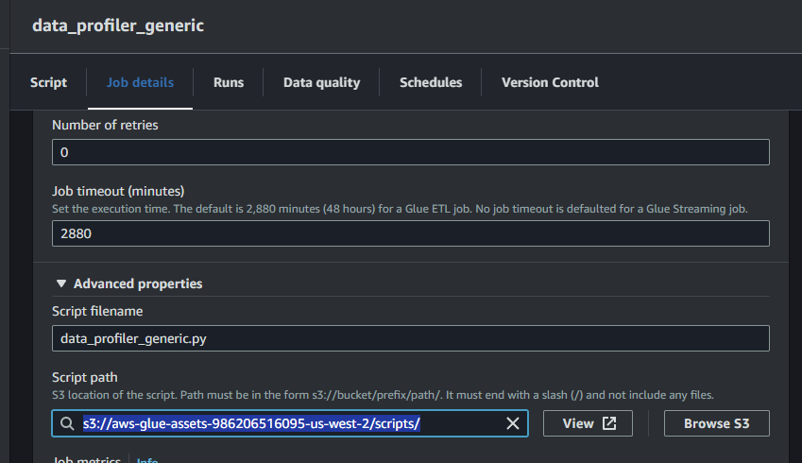

Configuration file

Referenced files path

s3://iris-etl-framework/config/FileIngestion_Config.ini

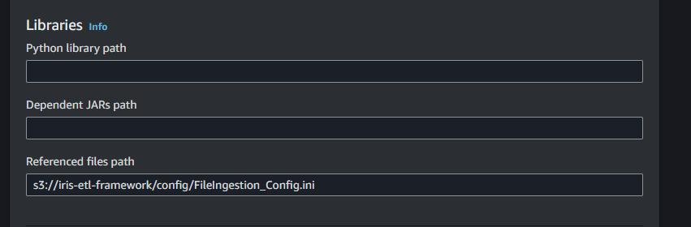

Job parameters

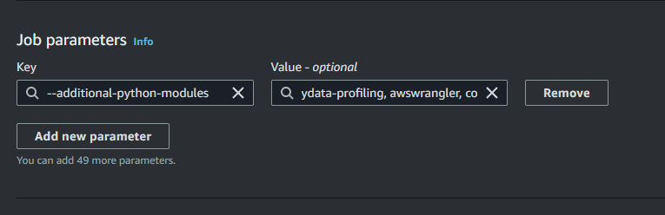

--additional-python-modules

ydata-profiling, awswrangler, configparser, xlrd , openpyxl, pyarrow, fastparquet ,glob2

Python library path

s3://iris-etl-framework/code_save/maths_ady.zip,s3://iris-etl-framework/code_save/maths2_ady.zip

