`
School: ............................................................................................................. Campus: ....................................................... Academic Year: ...................... Subject Name: ........................................................... Subject Code: ..........................
Semester: ............... Program: ........................................ Branch: ......................... Specialization: .......................... Date: .....................................
(Learning by Doing and Discovery)
* Coding Phase: Pseudo Code / Flow Chart / Algorithm
SHA-256 (Secure Hash Algorithm, FIPS 182-2)

- Definition: SHA-256 is a cryptographic, keyless hash function — specifically a Manipulation Detection Code (MDC) — that produces a 256-bit (32-byte) fixed-length digest.
- History: Released in 2001 through a collaboration between NSA and NIST as a stronger alternative to the SHA-1 family, which was becoming vulnerable to brute-force and collision attacks.
- Processing: It processes data in 512-bit blocks (16 × 32-bit words) with 64 computational rounds per block.
- Core Function: Converts any input into a unique, fixed-length 256-bit output, ensuring integrity, authenticity, and tamper resistance.
- Deterministic Output: The same input always produces the same hash output.
- One-Way Function: It’s computationally infeasible to reverse the hash to find the original data.
- Avalanche Effect: Even a single-bit change in input drastically changes the entire hash output.
- Collision Resistance: The probability of two different inputs producing the same hash is extremely low.
- Preimage Resistance: Given a hash output, it’s practically impossible to find any input that generates it.
- Second Preimage Resistance: It’s infeasible to find another input with the same hash as a given message.

Coding Phase: Pseudo Code / Flow Chart / Algorithm
Features of SHA-256
- Fixed Output Size – Always produces a 256-bit (32-byte) hash regardless of input size.
- Deterministic – Same input always gives the same output hash.
- One-Way Function – Impossible to reconstruct the original input from its hash.
- Avalanche Effect – Small input changes cause a completely different hash.
- Collision Resistance – Extremely rare for two different inputs to generate the same hash.
- Preimage Resistance – Hard to find an input that hashes to a specific value.
- Second Preimage Resistance – Difficult to find a different input with the same hash as another input.
- High Security – Resistant to current known cryptographic attacks.
- Efficient Processing – Works well on both hardware and software platforms.
10.Standardized Algorithm – Defined by NIST and widely used globally.

* Softwares used
Brave Browser
SHA-256 Online tool

- Testing Phase: Compilation of Code (error detection)
Initial Phase

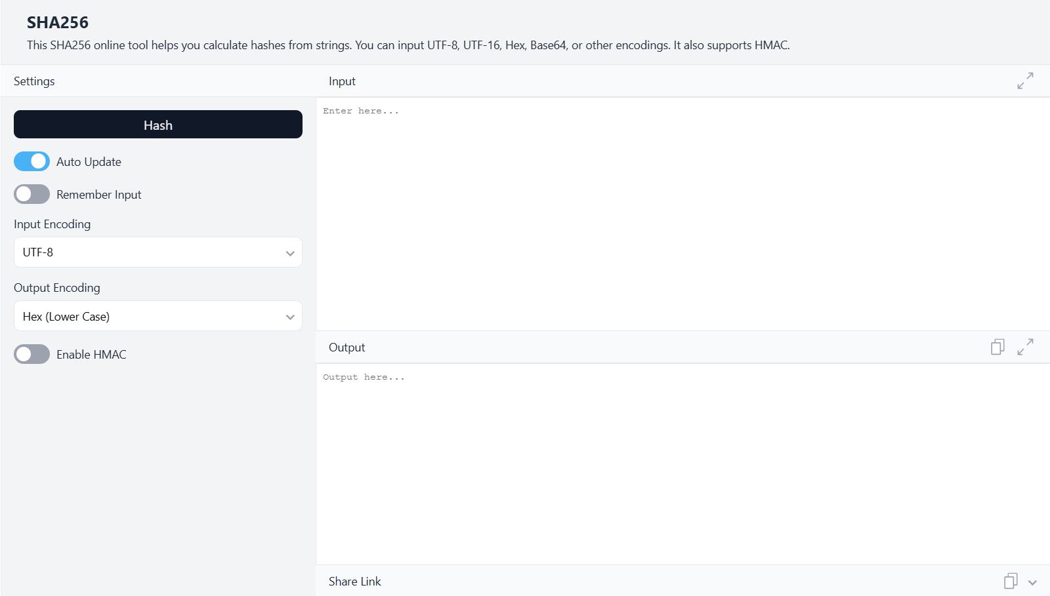

Inserted the data
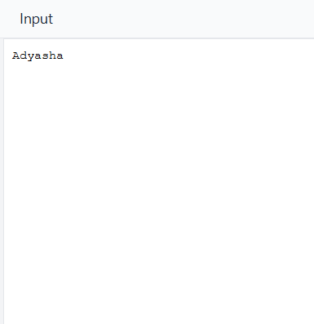
Hash generated automatically
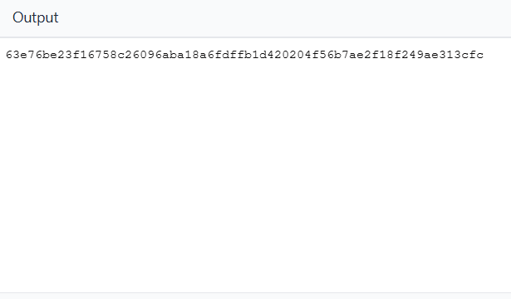

- Implementation Phase: Final Output (no error)

Implementation Phase: Final Output (no error)

- Implementation Phase: Final Output (no error)
Applied and Action Learning

Final Output

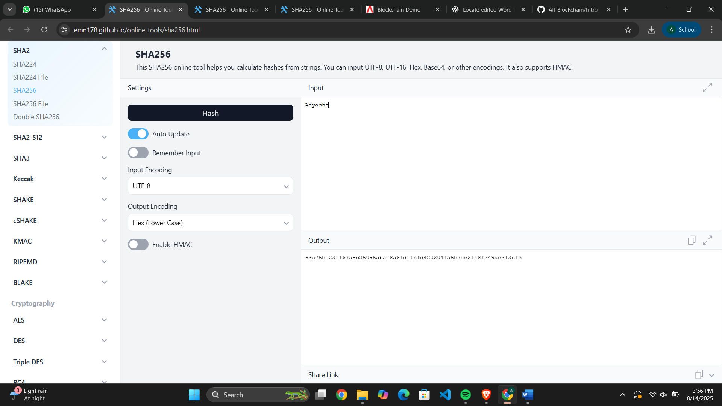

* Observations
SHA-256 is a secure cryptographic hash function that produces a fixed 256-bit output. It is deterministic, one-way, and highly resistant to collisions, with a strong avalanche effect. These features make it ideal for ensuring data integrity and security in applications like blockchain, digital signatures, and password protection.

ASSESMENT

Rubrics
Concept | 10
Planning and Execution/  Practical Simulation/ Programming | 10
Result and Interpretation | 10
Record of Applied and Action Learning | 10
Viva | 10
Total | 50


Signature of the Student:
Signature of the Faculty:

