**CHAPTER III**

**Conceptual Framework**

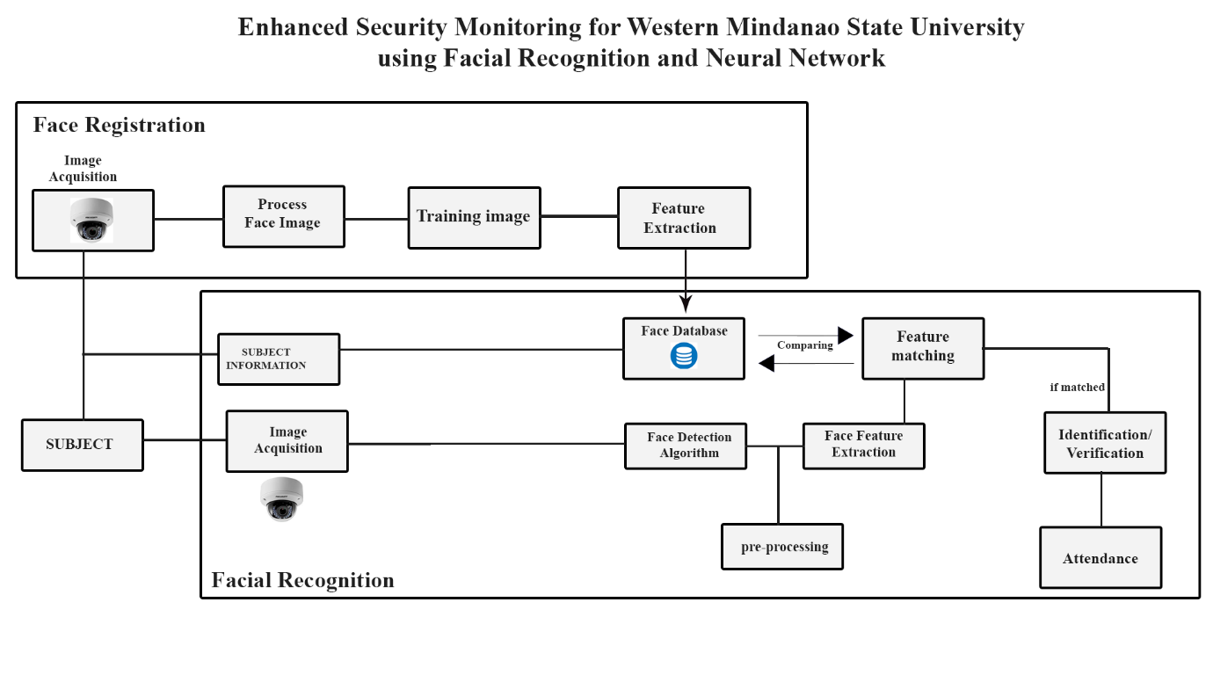

**Operational Definition**

|  |  |
| --- | --- |
| **Facial Recognition** | **A bio-metric software application capable of distinctively verifying or identifying a person by analysing and comparing patterns based on the person’s facial shapes is referred to as face recognition.** |
| **Face Detection** | **The face detection lets you find the location (pixel coordinates) of any faces in an image.** |
| **Face Extraction** | **A neural network takes an image of the person’s face as input and outputs a vector which represents the most important features of a face.** |
| **Image Acquisition** | **Image Acquisition is the first stage of any vision systems that refers to the collection of data required to form an image.** |
| **Training image** | **The training process involves finding a set of weights in the network that proves to be good, or good enough, at solving the specific problem.** |
| **Face Database** | **Database containing student and employee face** |
| **Face embedding** | **is a vector that represents the features extracted from the face.** |
| **Applied Research Design** | **Refers to a type of research design that seeks to solve a specific problem or provide innovative solutions to issues affecting an individual, group or society.** |
| **Descriptive-survey** | Refers to a research design that uses surveys to gather data about varying subjects. |
| **Stratified Random Sampling Method** | Refers to a method of sampling that involves the division of a population into smaller sub-groups known as strata. |
| **Frequency Table** | Refers to a table that lists items and shows the number of times the item occurs. |

**3.1 Research Design**

The study will be using the Applied research design method. The method is chosen to determine the respondents' perception in implementing the facial recognition system around the school campus of Western Mindanao State University. Specifically, the researchers will use a descriptive-survey where a survey questionnaire is used as a tool to gather perception data from the respondents.

**3.2 Research Locale**

           The research study is conducted at Western Mindanao State University's main campus, where students and employees will be the respondents. The Western Mindanao State University main campus is located at Normal Rd, Zamboanga City, Zamboanga Del Sur.

**3.3 Population and Sampling**

           The researchers will use the Stratified Random Sampling Method to stratify the WMSU population by the college. The researchers will only gather samples sizes from 5 colleges of WMSU. In each college, the researchers will obtain equal sizes of respondents.

           The participation of WMSU employees is essential in collecting data for the study; therefore, the researchers will also obtain respondents from WMSU's faculty and staff.

**3.4 Research Instrument**

The researchers will be using a survey questionnaire to gather data from the respondents. The survey questionnaires will be consisting two parts. Part 1 of the research instrument collects personal information from the respondents, such as name, age, gender, and college. Part 2 of the research instrument contains a questionnaire where the research gathers the necessary data to complete the study.

(PROVIDE SAMPLE SURVEY QUESTIONNAIRE)

**3.5 Validity of the Instrument**

**The researchers produce a self-made survey questionnaire in which the ideas are based from the previously cited related studies. The researchers made sure that each item from the questionnaire is not biased and or fabricated. Therefore, a validation from the research instructor is asked for approval of the survey questionnaire.**

**3.6 Data Gathering Procedure**

**Image Acquisition**

**The Face Recognition system will obtain the images by interfacing a CCTV or a webcam with automation light sensor; the camera will be connected to the Computer.**

**Face Detection**

**After capturing the image, the system will detect the person’s face and proceed to the pre-processing phase by removing noise, enhance its contrast, cropping the image and resizing to standardize the data set.**

**Face Extraction**

**Now that the image is has pass the processing phase, the system will now extract features from it; using face embedding to extract the facial land points out of the face, the neural network takes the person’s face as input and output a vector which will represents as the most important feature of a face;**

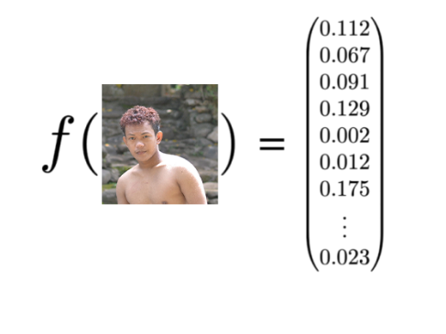

**After extracting, the system will use a pre-trained network trained by Davis King with dataset of ~3 million images, the network will output a vector containing 128 number**

**Which will be use as ID to represent the feature of person face.**

**With this the network can also learn to output similar vectors for faces that look similar, example, if the subject or person have multiple images of faces within the database with minor changes of faces features like beard the model can still recognize if they are very close in the vector space.**

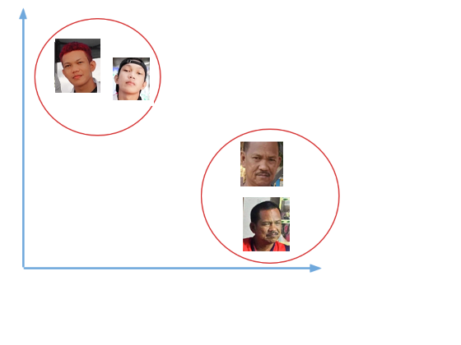

**Comparing faces**

**After generating a vector, the represent the person’s face and saving it to the database; the next phase is to compare the faces in the camera video feed from the faces in the database. The first step in this process is to also compute and generate the face embedding for face obtain in the camera using the same network that the system uses to train the image and compare this embedding with the rest of the face embedding we have in the database; the system will recognise the face if the generated embedding is equal or closer to other face embedding in the database.**

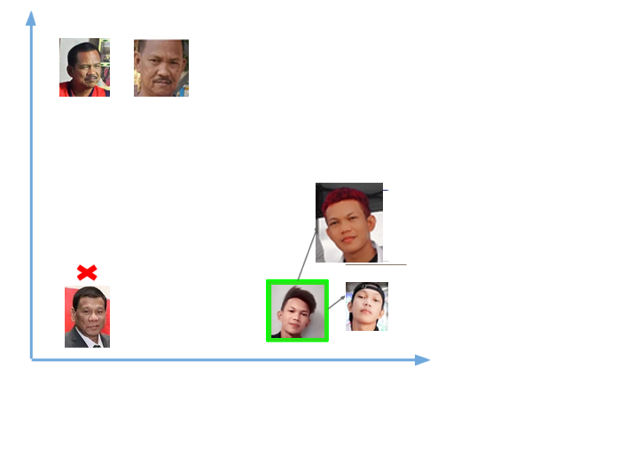

**3.7 Statistical Tool**

The following statistical tools were utilized in the analysis of gathered data: the researchers used the frequency table, which is a statistical tool under the qualitative research method. The frequency table consists of bar charts and pie charts representing the data gathered from the respondents. Stratified random sampling is used for acquiring the sample size of the study.