Assignment No. IV

Kainotomo Tech.

For our automated testing, the tools that we have used are Selenium IDE and Codeception. Integrating tools depended on what type of approach a programmer wants when testing the built application.

For Selenium IDE, we have installed it as a browser extension and through its own window, we inputted our webapp’s site and began the testing through recording of manual input of data, then testing through the IDE’s function. The scripts are as shown below.

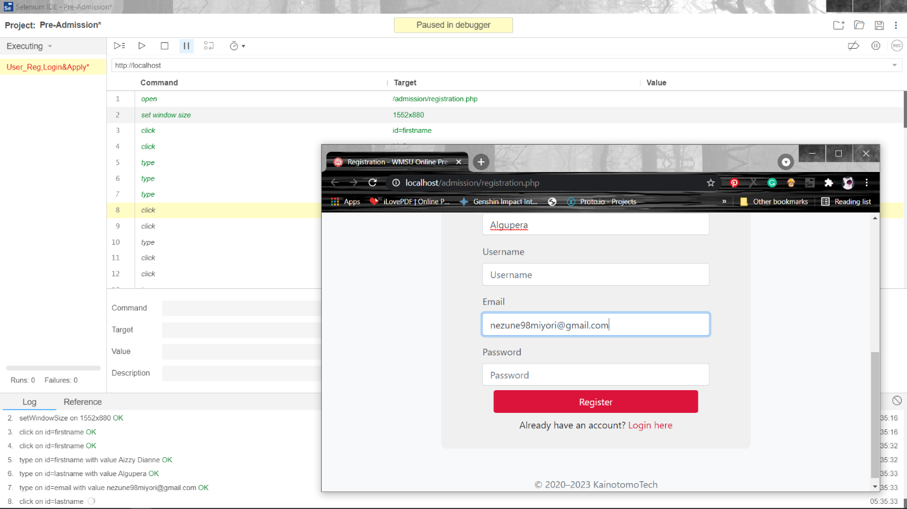

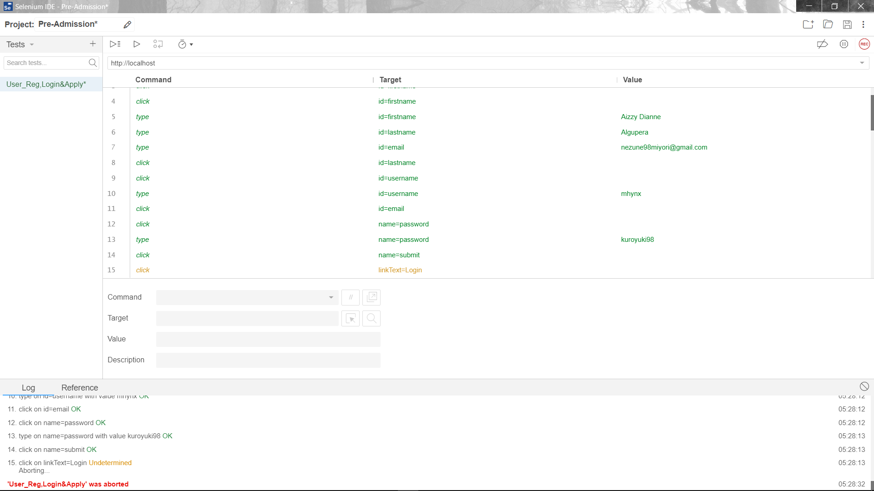

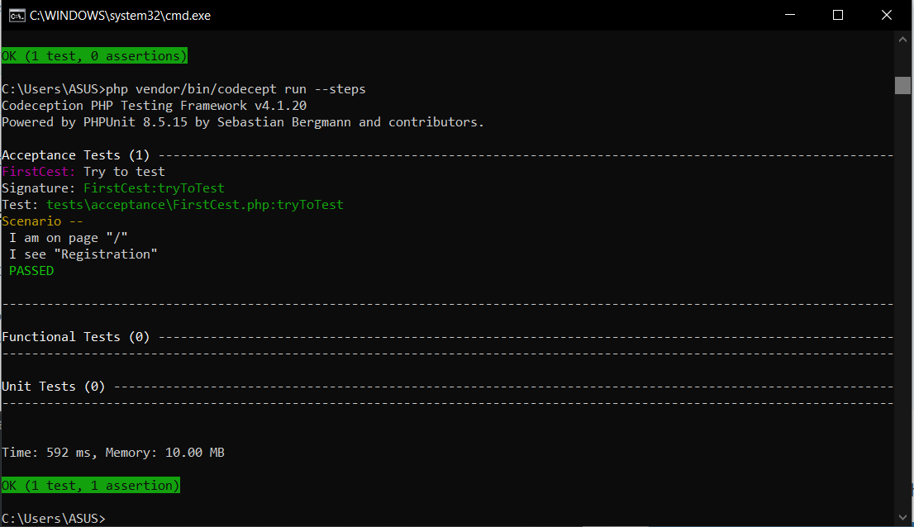For the Codeception tool, we have installed it in the computer itself and used another php file and an yml to run the tests.

