**Project**

**Of Introduction to Game Development**

**on the topic: “Tower Defense game”**

**made by:**

**Adilet Zhaksylyk**

**To:**

**Bayburin Aidos**

**OUTLINE**

INTRODUCTION………………………………………………………………….3

DEVELOPMENT PROCESS……………………………………………………...3

GAME DESCRIPTION……………………………………………………………3

TECHNICAL DETAILS…………………………………………………………...3

TESTING AND QUALITY ASSURANCE………………………………………..4

SCREENSHOTS….………………………………………………………………..4

**Topic:** Tower Defense Game

**INTRODUCTION:**

My project is a Tower Defense Game developed using Unity and C#. In this report, we will provide a brief overview of the project, discuss the objectives, and highlight the importance and relevance of developing a 2D Roguelike game.

**Goal:** To create an engaging and challenging game experience for players in Tower defense genre.

**GAME`s Goal:** Defend base from enemies, by placing defending towers, considering their characteristics

**DEVELOPMENT PROCESS:**

The development process included several stages, including planning, design, implementation and testing. I used various tools and technologies, such as Unity for game development and C# for scripting.

**GAME DESCRIPTION:**

Game includes 2 levels, that includes special route, by which enemies attack base, special places for tower placement, that used to enter towers in game and to defend base.

**TECHNICAL DETAILS:**

The architecture of the game is designed in such a way as to ensure modularity and scalability. Key systems, including tower placement, enemy behavior and route generation, have been implemented to ensure smooth gameplay. During development, I encountered a number of problems, such as optimizing performance and balancing game mechanics. Through careful problem solving and iteration, I was able to overcome these difficulties and create a high-quality game.

Here you can get acquainted with the sprites and prefabs that were used.

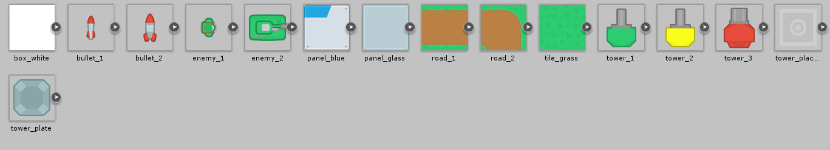



Here you can get acquainted with the scripts.

**TESTING AND QUALITY ASSURANCE:**

From SIS1 it was detected some balance issues, for example, enemies speed and the problem of tower placement. Enemies “Variant 2” characteristic were changed, by slowing it, because of their fast speed, it was impossible to win. In addition, the problem of placement of towers was described: It was able to place multiple towers in one place, that’s why game became too easy. By fixing this bug, the problem of game balance was fixed.

**SCREENSOTS:**



