**Testing**

**Sticky header**

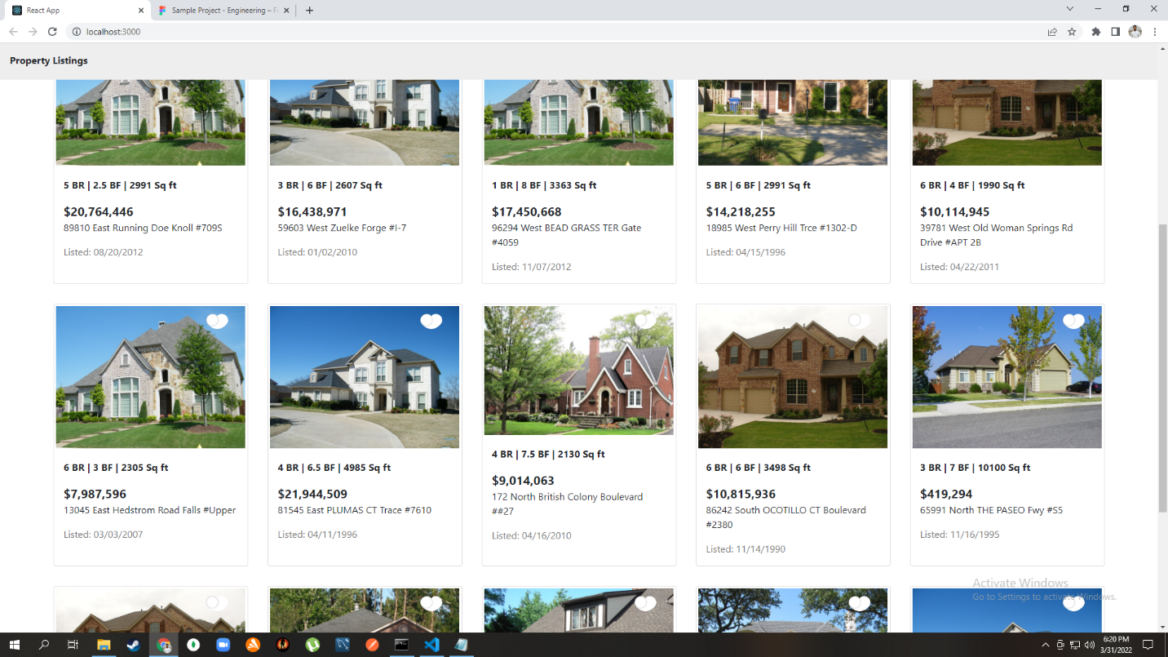

**ListingProperty page**

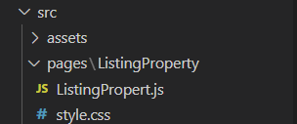

**Data in Card format**

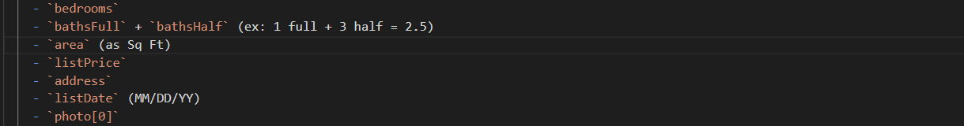

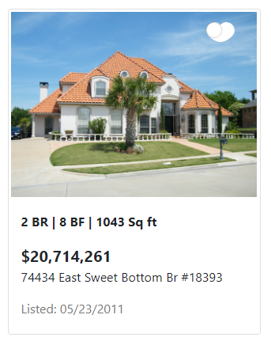

**For heart feature**

Instead of using svg I have used heartSwitch component



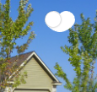

**Screen Size**

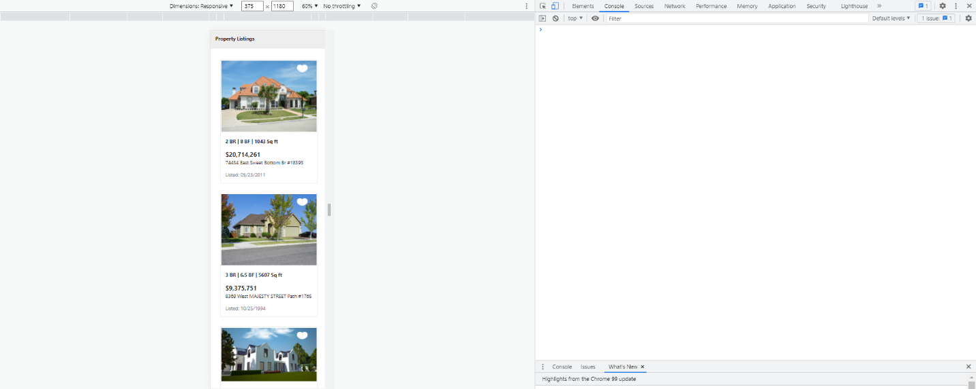

**LocalStorage**

Screenshots of local storage data ( and you can see that our username and password is encoded )

So the below image shows that at the time when page is rendered all the data we fetched is stored in localStorage with key=”items”

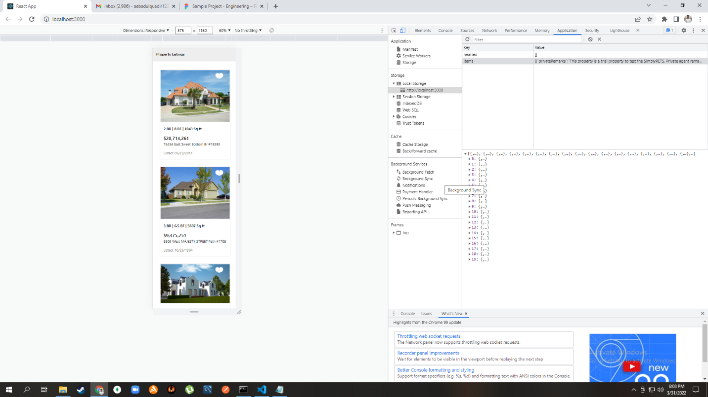

Below screenshot is the expanded form of data

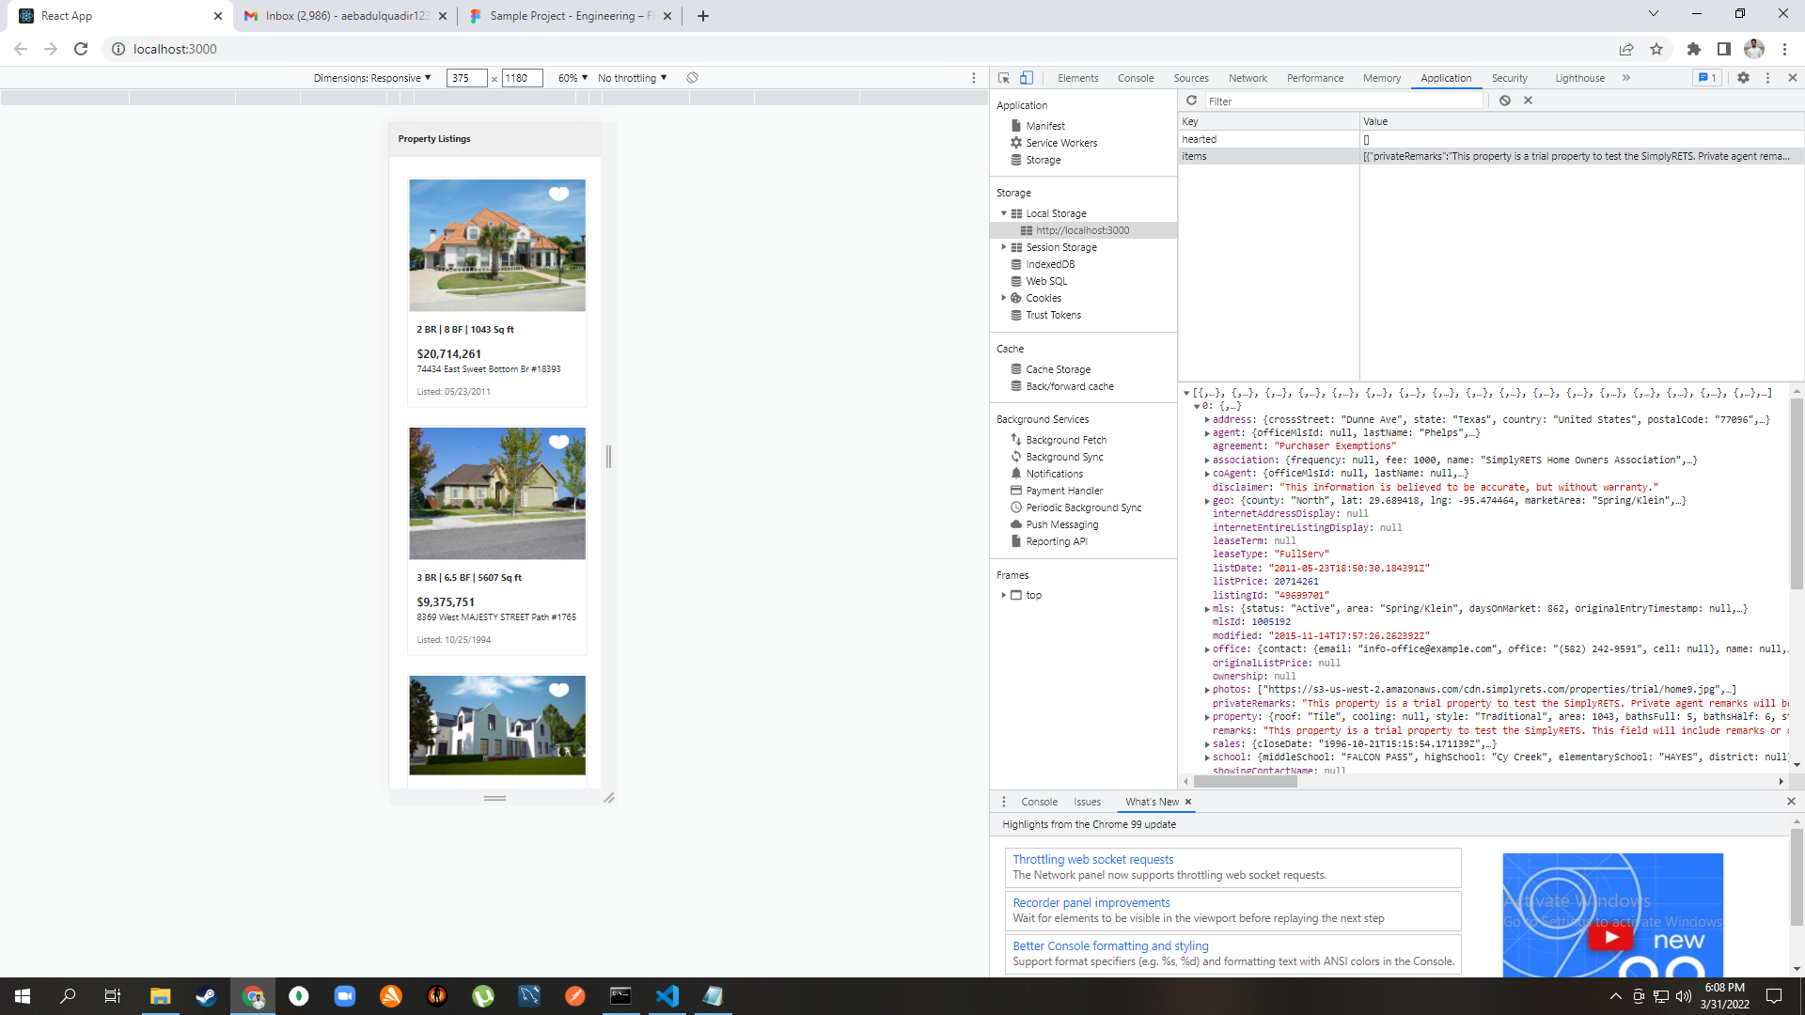

Now for the hearted data with key=”hearted”

In the beginning local storage contains only empty array

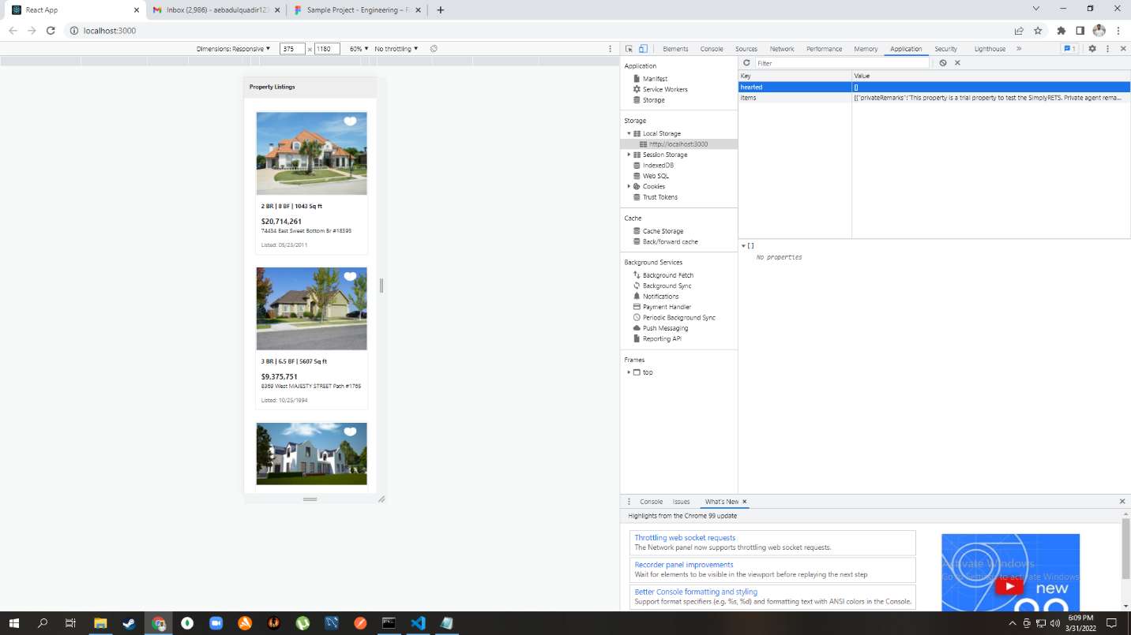

So when the time I started hearting the property my data in localStorage starts to change

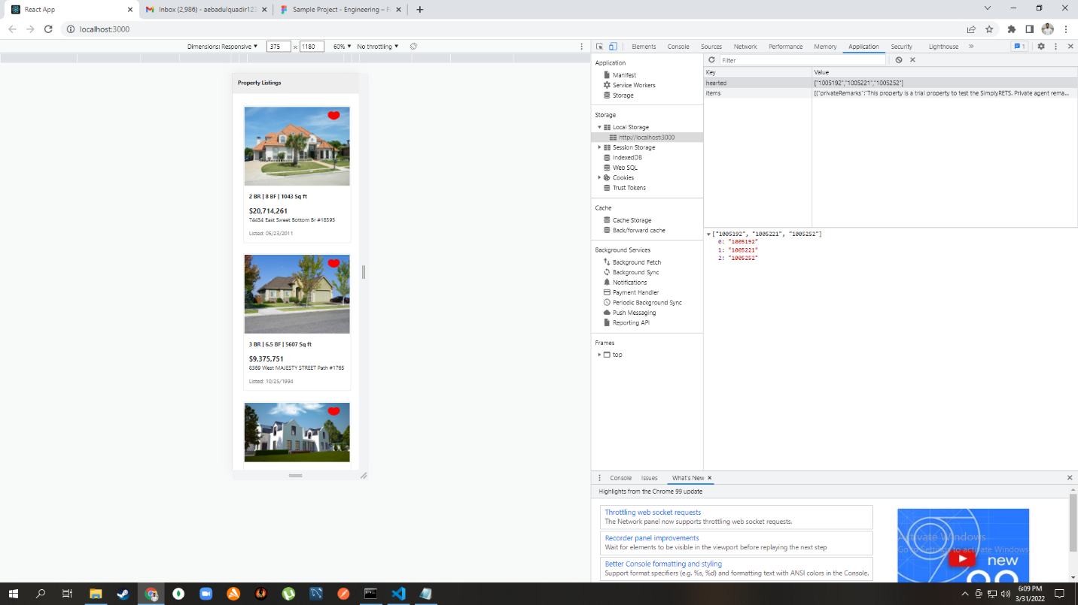

And if I want to unheart any property so I can unheard in by again clicking on the heart icon and from the below ss we can see that out localStorage is also updated

