VITALSCOPE
Nextion Control Station
Technical Documentation v2

Hardware · Protocol · Code Architecture · AI Analysis Engine · Threat Simulator

1. System Overview
VitalScope is a PC-to-display telemetry bridge that surfaces live system metrics, network diagnostics, and security data on a Nextion touchscreen. Three hardware components form the signal chain:
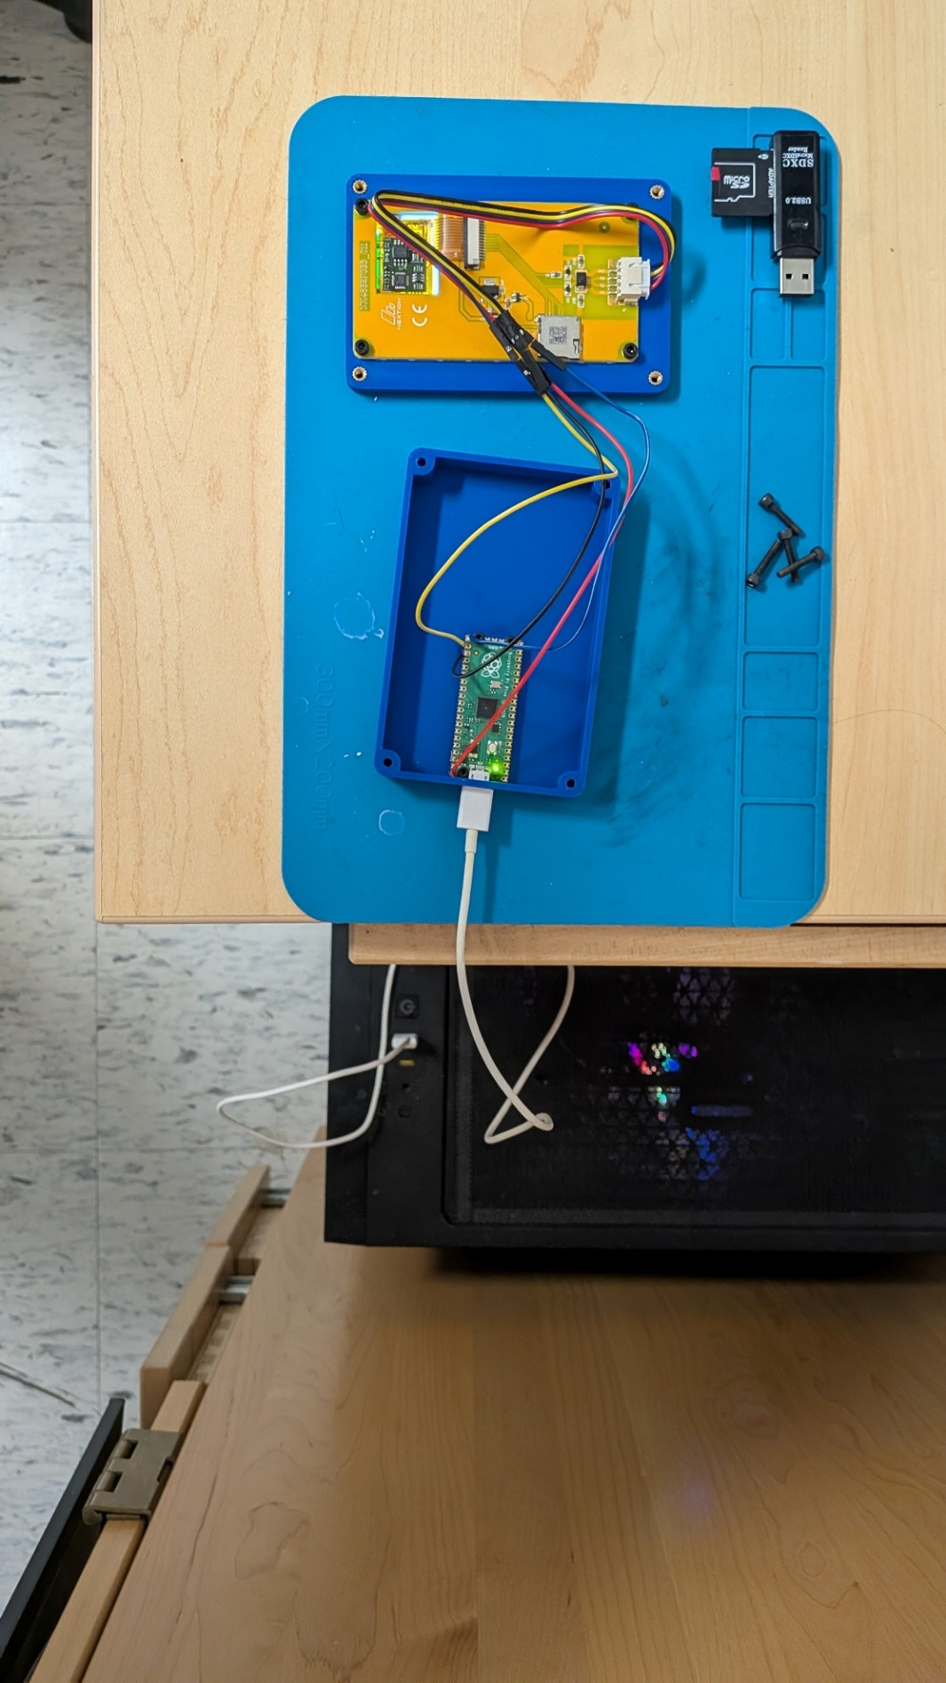
Component | Role
Windows PC | Runs the Nextion Control Station Python application; performs all data collection (CPU, RAM, disk, network, security scans, AI analysis).
Raspberry Pi Pico | Acts as a USB CDC serial bridge, translating plain-text commands from the PC into the Nextion UART protocol and forwarding Nextion print events back to the PC.
Nextion Enhanced Display | Renders pages, handles touch input, and emits page-change events back through the chain via its print() function.

NOTE: The PC application never speaks directly to the Nextion. All communication flows through the Pico, which handles protocol translation in both directions.

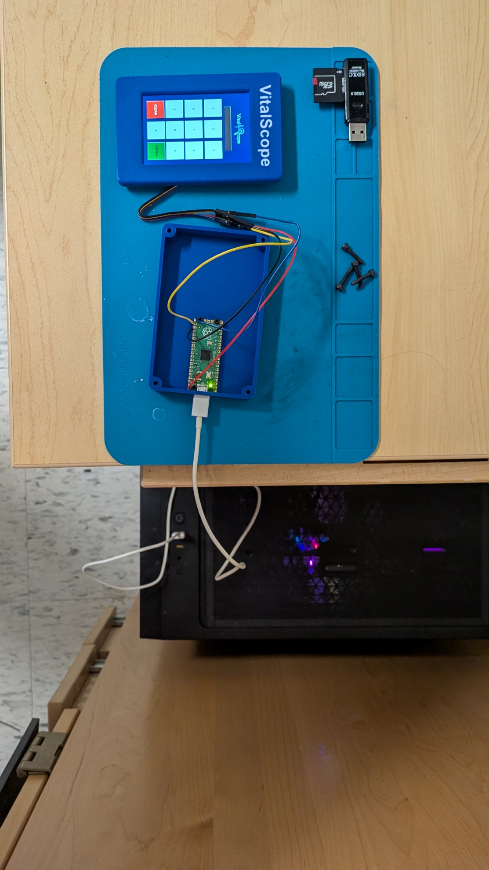

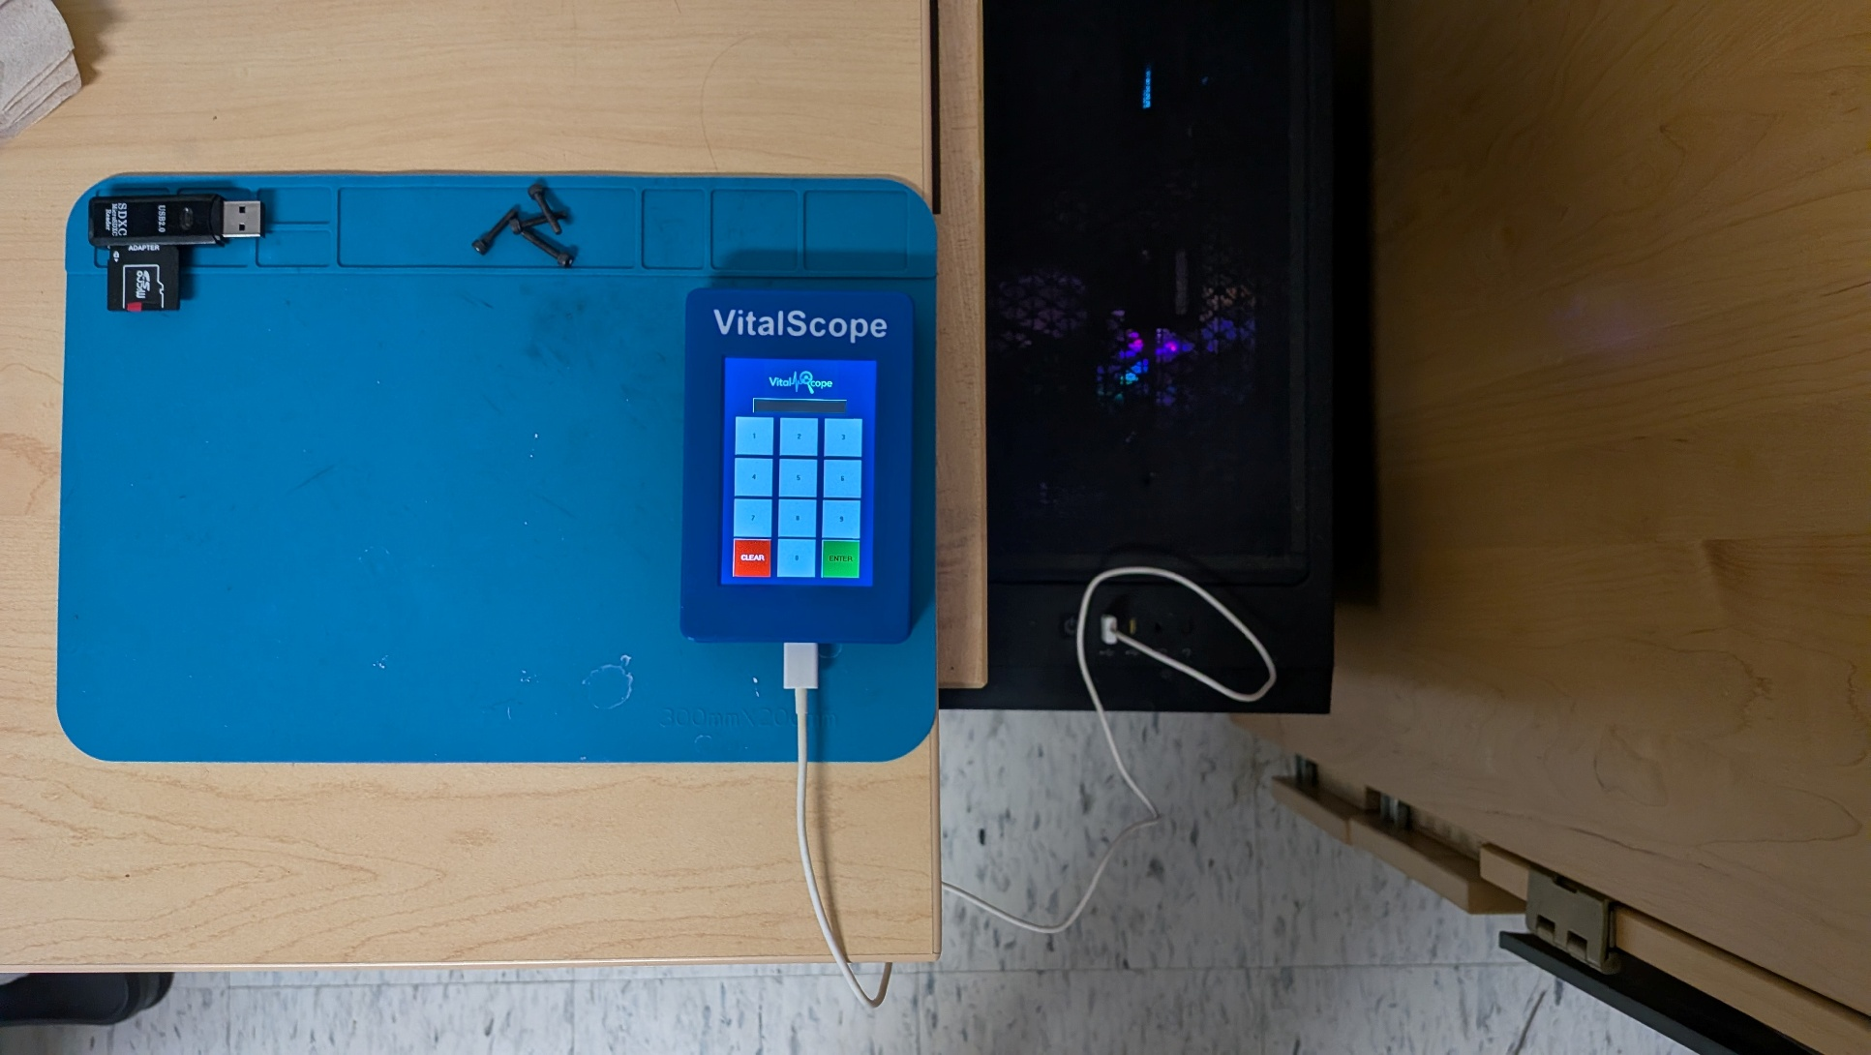

1.1 File Structure
File | Responsibility
main.py | Entry point — creates the Tk root window and launches NextionControlStation.
app.py | Main application class — UI layout, serial connection management, listener thread, page routing, and the Threat Simulator panel.
pages.py | PageHandlersMixin — per-page data refresh methods: dashboard, network, portscan, procs (NEW), lock. Also network quality loop and dashboard live loop.
ai_analysis.py | NEW — Pure-Python deterministic security analysis engine. No external dependencies or API keys. Scores processes, ports, users, and firewall state; yields a streaming report.
network_utils.py | Pure network helpers — quality scoring, speed test, DNS lookup, ARP device count, port check. No GUI or serial dependencies.
security_scan.py | Windows security scanner — process enumeration, user accounts, firewall state, listening ports. SecurityScanWindow GUI now includes an AI Analysis tab.
ui_widgets.py | Reusable Tkinter factories — styled_btn, styled_entry, section_frame, ElementCard.
config.py | All constants — baud rate, delays, RGB565 colours, GUI palette, fonts, PAGE_REFRESH_MAP (now includes 'procs').
pico_bridge.py | MicroPython firmware running on the Pico — UART bridge, page name detection, boot sequence. Now recognises b'page_procs'.

2. Hardware Layout

2.1 Signal Chain
PC ──(USB CDC / virtual COM port)──► Pico ──(UART0 @ 9600 baud)──► Nextion

Nextion ──(UART0 TX)──► Pico ──(USB CDC stdout)──► PC Listener Thread

2.2 GPIO Pin Assignment
GPIO Pin | Direction | Connected To | Purpose
GPIO 16 | TX (out) | Nextion RX | Sends commands to the display
GPIO 17 | RX (in) | Nextion TX | Receives print() output from display
USB (built-in) | Bidirectional | PC USB port | CDC serial — commands in, events out
Onboard LED | Output | N/A | Lit solid while bridge is running
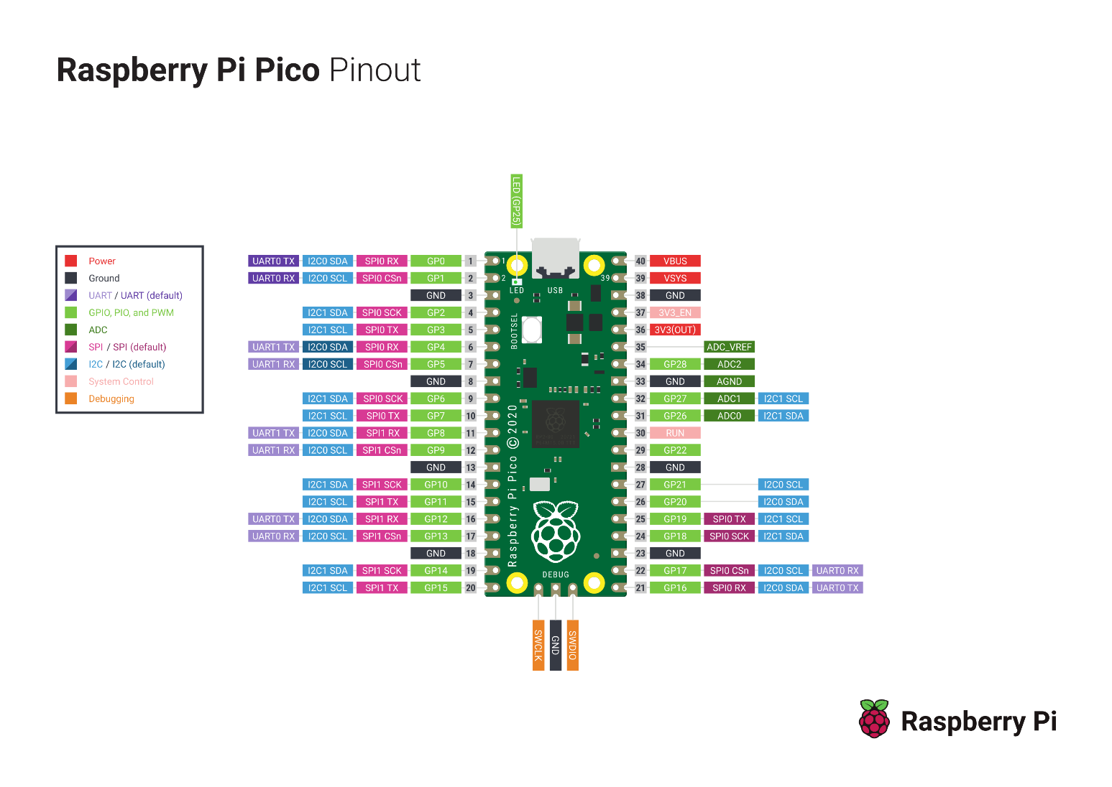

2.3 UART Configuration
Parameter | Value
UART bus | UART0
Baud rate | 9600
TX pin | GPIO 16
RX pin | GPIO 17
Command terminator | 0xFF 0xFF 0xFF (3-byte Nextion requirement)
Boot delay | 5 seconds (BOOT_DELAY_S — allows Nextion startup to complete)

3. Communication Protocol

3.1 Three-Layer Stack
Layer | Medium | Format
PC → Pico | USB CDC (virtual COM port) | Newline-delimited ASCII, one command per line
Pico → Nextion | Hardware UART0 @ 9600 baud | ASCII command + 0xFF 0xFF 0xFF terminator
Nextion → Pico → PC | UART RX → USB CDC stdout | ASCII print() strings, forwarded by Pico

3.2 PC → Pico (USB CDC)
Commands are sent one per line, terminated with \n. The Pico reads from sys.stdin using select() for non-blocking I/O. Example commands:
t_ip.txt="192.168.1.10" # update text element
g_cpu.val=72 # set gauge/numeric value
pc_status.pco=11648 # set foreground colour (NX_GREEN)

3.3 Pico → Nextion (UART)
The Nextion requires every command terminated with exactly three 0xFF bytes. send_to_nextion() appends this automatically. Common Nextion command forms:

Command Form | Example | Effect
name.txt="value" | t_ip.txt="10.0.0.1" | Set a text element's string content
name.val=N | g_cpu.val=72 | Set a numeric or gauge value (0–100)
name.pco=N | g_cpu.pco=11648 | Set foreground colour (RGB565 integer)
name.bco=N | t0.bco=63488 | Set background colour (RGB565 integer)
page NAME | page main | Navigate to a named Nextion page

3.4 Nextion → Pico → PC (Events)
When the user changes pages, the Nextion page-load event calls print() to emit the page name over its UART TX pin. The Pico's persistent RX buffer accumulates bytes and dispatches complete 0xFF 0xFF 0xFF-terminated packets to handle_nextion_message(). Recognised page names:
PAGE_NAMES = [
b'page_dashboard',
b'page_network',
b'page_portscan',
b'page_main',
b'page_lock',
b'page_procs', # NEW
]

The portscan page additionally emits a port number after the page name in the same UART chunk. The Pico detects both tokens and prints portscan_init <N> to the PC, which stores the value for use ~0.5 s later when the page refresh fires.

3.5 Nextion RGB565 Colour Constants
Constant | RGB565 Value | Colour | Usage
NX_GREEN | 11648 | Bright green | Connected / OK status
NX_RED | 63488 | Bright red | Error / disconnected status
NX_YELLOW | 65504 | Bright yellow | Warning / fair quality
NX_GREY | 33840 | Mid grey | Inactive / placeholder text
NX_WHITE | 65535 | White | Default text colour
NX_BLACK | 0 | Black | Background / off state

4. Code Architecture

4.1 Page Refresh Flow
Step | Where | Action
1 | Nextion HMI | Page-load event executes print("page_<n>")
2 | Pico — handle_nextion_message() | Detects page name in raw UART bytes, prints to USB stdout
3 | PC — listener thread | Reads line; if page_* prefix, immediately stops loops for the old page synchronously (not via Tkinter queue)
4 | PC — root.after(0, _handle_incoming) | Schedules dispatch on main thread; calls _on_page_change()
5 | PC — _on_page_change() | Updates active_page_var, looks up PAGE_REFRESH_MAP, checks enabled checkbox
6 | PC — _run_page_refresh() | Daemon thread: waits 0.5 s settle delay, then calls mapped method(s)
7 | PC — page handler method | Collects data, calls self.send() for each Nextion command
8 | PC — self.send() / _send_raw_cmd() | Acquires _serial_lock, writes command + \n to COM port

4.2 Page → Refresh Method Map
Defined in config.py as PAGE_REFRESH_MAP. All methods implemented in pages.py (PageHandlersMixin):

Page Name | Method | What It Sends / Does
main | page_dashboard_refresh() | Identical to dashboard — Pico boots to main page.
dashboard | page_dashboard_refresh() | CPU %, RAM %, disk %, IP, hostname, pc_status / pi_status. Starts 3-second live loop.
network | page_network_refresh() | Internet status, DNS, device count, download/upload speed. Starts network quality monitor loop.
portscan | page_portscan_refresh() | Runs scan_firewall(), scores ports by PORT_RISK_SCORES, writes top 7 to label + score element pairs.
procs | page_procs_refresh() | NEW — Runs scan_processes(), scores each unknown proc via ai_analysis._score_process(), writes top 4 to name/score/flag element triplets.
lock | page_lock_refresh() | Flashes t0 background red/black three times.

4.3 Background Loop Management
Loop | Page(s) | Interval | Stop mechanism
Dashboard live loop (_dash_loop) | dashboard, main | 3 seconds | _dash_stop_event — set by _stop_dash_loop() called from listener thread on page change
Network quality loop (_net_quality_loop) | network | PING_INTERVAL (3 s default) | _net_stop_event — set by _stop_net_loop() called from listener thread on page change

THREAD SAFETY: Loop stop calls happen synchronously on the listener thread, not via root.after(). This prevents stale writes from a previous page's loop arriving after the new page has loaded.

4.4 Serial Thread Safety
Mechanism | What it protects | Detail
threading.Lock (_serial_lock) | All serial.write() calls | _send_raw_cmd() acquires the lock before writing and releases after flush(). Concurrent threads queue rather than interleave bytes.
root.after(0, fn) | All Tkinter widget mutations | Background threads never touch widgets directly. Updates are scheduled via root.after(0, ...) or _queue_log().

5. AI Analysis Engine — ai_analysis.py
Ai: ai_analysis.py provides deterministic, rule-based security analysis with no external dependencies and no API keys.

The engine receives the dict returned by security_scan.run_full_scan() and yields the analysis report line-by-line as a Python generator. The caller (SecurityScanWindow._run_ai_analysis) consumes each line and appends it to the GUI text widget with a short sleep, producing a streaming effect.

5.1 Entry Point
from ai_analysis import analyse

# scan_results is the dict from run_full_scan()
for line in analyse(scan_results):
append_to_widget(line)
time.sleep(0.02) # streaming effect

5.2 Scoring — Processes
_score_process(proc) evaluates a single flagged process and returns (score: int, findings: list[str]). Score range is 0–100. The function is also imported directly by pages.py for use in the procs page refresh.

Signal | Max Points | Detail
Name entropy (very high ≥ 4.2) | 30 | Shannon entropy of the filename stem — measures character randomness
Name entropy (elevated ≥ 3.5) | 15 | Elevated but below 'very random' threshold
Suspicious path location | 20 per finding | Running from \temp\, \AppData\Local\Temp\, \Downloads\, \Desktop\, etc.
Path unresolvable | 20 | Process path cannot be read — may be hidden or SYSTEM-level
Non-standard path root | 20 | Not under C:\Windows\, C:\Program Files\, or C:\Program Files (x86)\
Extreme memory (≥ 1.4 GB) | 25 | Flagged as extreme — possible data staging or crypto-mining
High memory (≥ 488 MB) | 15 | Above normal for an unknown process
Elevated memory (≥ 97 MB) | 5 | Moderately elevated
Long name (> 25 chars) | 10 | Unusually long process name
Very short name (≤ 2 chars) | 15 | Suspiciously short stem
Consonant run ≥ 5 chars | +points | Long run of consonants with no vowels (e.g. 'xvzqtbmf')
Digit ratio > 40% | +points | Name is primarily digits — unusual for a real program
Hex string match | +points | Full filename stem matches [0-9a-f]{6,}

5.3 Scoring — Ports
_port_analysis(listeners) evaluates individual high-risk ports and dangerous port combinations:

Check | Detail
Individual high-risk ports | Each port in HIGH_RISK_PORTS (excluding BENIGN_PORTS like 135) generates a finding naming the port, service, and bound process.
Risky port combinations | Specific port pairs are flagged as more dangerous together than individually (e.g., SMB+NetBIOS, RDP+SSH, MSSQL+MySQL, FTP+Telnet, RDP+SMB).
Simultaneous risk count | If ≥ 5 high-risk ports are open at once, an attack-surface warning is generated.

5.4 Scoring — Users & Firewall
Category | Check | Finding Condition
Users | Admin count | More than 2 administrator accounts active
Users | Never-logged-in accounts | Account has 'Never' as last login but is still active
Users | Stale admin accounts | Inactive account that holds admin privileges
Firewall | Profile disabled | Any firewall profile (Domain / Private / Public) has state OFF
Firewall | Inbound rule count | Fewer than 5 inbound rules — firewall may not be meaningfully configured
Firewall | Outbound rule count | Fewer than 5 outbound rules — no egress filtering

5.5 Overall Risk Score
_overall_risk_score() produces a composite 0–100 score from four weighted components:

Component | Max Points | Calculation
Processes | 50 | Mean of the top-3 individual process scores, scaled by 0.5
Ports | 25 | 5 points per port finding, capped at 25
Users | 15 | 5 points per user finding, capped at 15
Firewall | 10 | 5 points per firewall finding, capped at 10

Score Range | Label
0–24 | CLEAN
25–49 | LOW RISK
50–74 | MODERATE RISK
75–100 | HIGH RISK

5.6 Memory Outlier Detection
_outlier_memory_processes() identifies processes whose memory usage is a statistical outlier across the flagged set. The threshold is mean + 2 standard deviations. At least 3 flagged processes are required for outlier detection to activate. Outliers are reported in their own report section and flagged in the recommendations.

5.7 Report Structure
The analyse() generator yields a structured plain-text report with the following sections, in order:
- Header block — timestamp, overall rating, score
- Executive Summary — high-level counts and key findings
- Process Analysis — deep-dive on processes scoring ≥ 50, with PID, memory, path, and individual findings
- Memory Outliers — statistical outlier processes (if any)
- Port & Network Analysis — individual port risks and dangerous combinations
- User Account Analysis — admin count, unused accounts, stale admin accounts
- Firewall Analysis — per-profile state and rule count concerns
- Recommendations — prioritised, actionable steps with specific commands where applicable

Processes scoring below 50 are suppressed from the detailed section to reduce noise. Processes scoring below 20 are noted in the summary as 'no specific concerns beyond whitelist absence.'

5.8 Constants Reference
Constant | Value | Purpose
ENTROPY_SUSPICIOUS | 3.5 | Shannon entropy threshold — elevated character randomness
ENTROPY_VERY_RANDOM | 4.2 | Shannon entropy threshold — almost certainly machine-generated name
MEM_HIGH_KB | 500 000 | ~488 MB — flagged as high memory for an unknown process
MEM_EXTREME_KB | 1 500 000 | ~1.4 GB — flagged as extreme
RISK_LOW | 25 | Overall score threshold — LOW RISK rating
RISK_MODERATE | 50 | Overall score threshold — MODERATE RISK rating
RISK_HIGH | 75 | Overall score threshold — HIGH RISK rating

6. Page Handlers — pages.py

6.1 Page: Dashboard

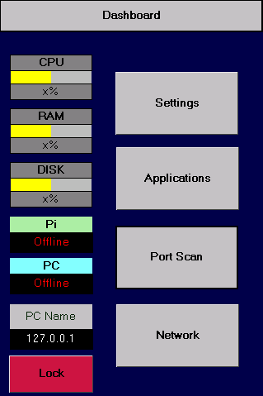
page_dashboard_refresh() pushes all static data then starts the 3-second live CPU/RAM/Disk loop:
- CPU %, gauge value, gauge colour (g_cpu.val / g_cpu.pco)
- RAM %, gauge value, gauge colour (g_ram.val / g_ram.pco)
- Disk %, gauge value, gauge colour (g_disk.val / g_disk.pco)
- PC hostname (t_pcname.txt), IP address (t_ip.txt)
- pc_status.txt / pc_status.pco, pi_status.txt / pi_status.pco
- Starts _dash_loop — refreshes CPU, RAM, disk every 3 seconds

6.2 Page: Network

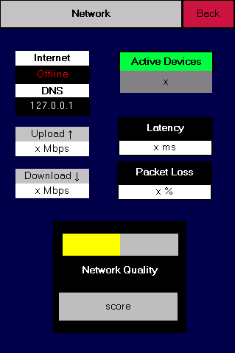
page_network_refresh() spawns a background thread (_network_full_refresh) that runs five sequential steps:

Step | Element(s) Updated | Detail
1. Internet check | int_status.txt, int_status.pco | TCP probe to 8.8.8.8:53; green = online, red = offline
2. DNS lookup | t_DNS.txt | First DNS server from ipconfig /all, or 'N/A'
3. LAN device count | t_dev.txt | Dynamic ARP entries (arp -a)
4. Speed test | dwnld_status.txt, upld_status.txt | Downloads up to 4 MB from a test URL; upload estimated as 30% of download. Aborts if user leaves page.
5. Quality loop | j0.val, j0.pco, t5.txt, t3.txt, t7.txt | Starts _net_quality_loop — 4 TCP probes every PING_INTERVAL seconds, updates score, latency, and loss %

6.3 Page: Portscan

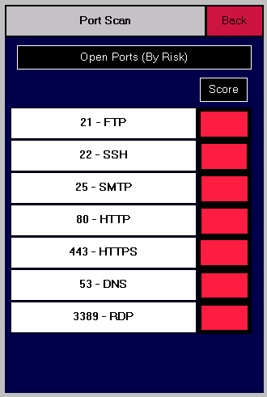
_run_portscan() runs scan_firewall(), scores every listening port, sorts highest risk first, and writes the top 7 to two parallel element lists:

Element list | Nextion elements | Content
PORTSCAN_ELEMENTS | t2, t5, t6, t7, t8, t14, t16 | "PORT process_name" (process truncated to 14 chars + ~ if longer)
PORTSCAN_SCORE_ELEMENTS | t21, t22, t25, t80, t443, t53, t3389 | Bare risk score integer (0–100)

Port Risk Score Table
Port | Service | Risk Score
23 | Telnet | 95
445 | SMB | 92
3389 | RDP | 90
21 | FTP | 85
1433 | MSSQL | 82
25 | SMTP | 80
3306 | MySQL | 80
135 | RPC | 75
5985 | WinRM HTTP | 72
22 | SSH | 70
5986 | WinRM HTTPS | 68
53 | DNS | 60
8080 | HTTP alt | 50
80 | HTTP | 45
8443 | HTTPS alt | 35
443 | HTTPS | 20
(any other) | — | 30 (default)

6.4 Page: Procs

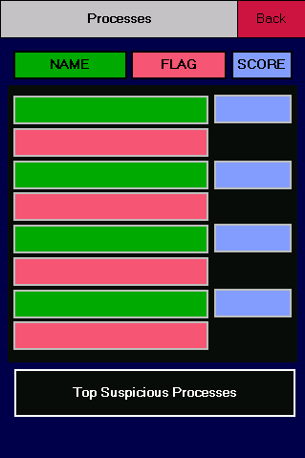
page_procs_refresh() spawns _run_procs() in a background thread:
- Calls scan_processes() to enumerate non-whitelisted running processes.
- Calls _score_process() from ai_analysis.py for each flagged process.
- Sorts by score descending and writes top 4 to three parallel element lists.

Element list | Nextion elements | Content
PROCS_NAME_ELEMENTS | t2, t9, t15, t13 | Full process name (no truncation)
PROCS_SCORE_ELEMENTS | t6, t10, t16, t12 | Score as "N/100"
PROCS_FLAG_ELEMENTS | t7, t8, t14, t11 | First finding reason (category prefix stripped)

Unused rows in all three lists are cleared. If no unknown processes are found, t2 is set to "All clear" and all other elements are cleared.

6.5 Page: Lock

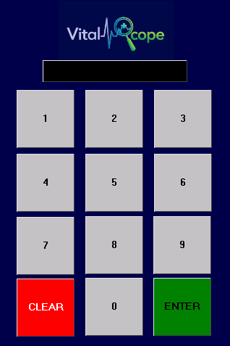
page_lock_refresh() flashes t0 background red/black three times (0.3 s per state). Aborts early if the user navigates away from the lock page mid-animation.

7. Security Scan GUI — security_scan.py

7.1 Tabs
Tab | Content
PROCESSES | Treeview of non-whitelisted processes. Columns: name, PID, memory, flag, path. Sortable by memory and flag. Right-click to open file location or copy path.
USERS | Treeview of all local accounts with last-login timestamp, admin status, and active state. Admin accounts highlighted yellow; inactive accounts dimmed.
FIREWALL & NETWORK | Grouped treeview: firewall profile states, inbound/outbound rule counts, network adapters, and all LISTENING ports with bound process and risk indicator.
AI ANALYSIS | NEW — Streaming text widget that shows the ai_analysis report line-by-line. Auto-runs after every scan. Can also be triggered independently via [ RUN ANALYSIS ].

7.2 AI Analysis Tab
Workflow:
- _start_ai_analysis() is called automatically from _display_results() after each scan.
- It switches to the AI Analysis tab and kicks off _run_ai_analysis() in a daemon thread.
- _run_ai_analysis() consumes the analyse() generator, sleeping 20 ms between lines to create a streaming effect.
- As lines arrive, _append_ai_line() colour-tags them on the main thread (red for HIGH, yellow for MODERATE / warnings, green for CLEAN, dim for separators).
- On completion, _ai_analysis_done() resets UI state and optionally pushes the summary to the Nextion via _push_ai_to_nextion().

7.3 Scan Functions

scan_processes()
Uses tasklist /FO CSV /NH and cross-references psutil for full executable paths. Any process not in KNOWN_SAFE_PROCESSES is flagged.
{
"flagged": [{"name": str, "pid": int, "mem_kb": int, "path": str|None}],
"total": int,
"error": str|None
}

scan_users()
Uses net user, net user <n>, and net localgroup Administrators.
{
"accounts": [{"name": str, "last_login": str, "is_admin": bool, "active": bool}],
"error": str|None
}

scan_firewall()
Uses netsh advfirewall, ipconfig /all, netstat -ano, and tasklist.
{
"profiles": {"Domain": {"state": "ON"|"OFF"}, ...},
"rules": {"inbound": int, "outbound": int},
"adapters": [{"name": str, "ip": str, "mac": str}, ...],
"listeners": [{"port": int, "proto": str, "pid": int, "process": str}, ...],
"error": str|None
}

7.4 Known-Safe Process Whitelist
KNOWN_SAFE_PROCESSES is a frozenset of ~70 lowercase process names. Any process name not in this set is returned in the 'flagged' list. The whitelist includes core Windows system processes, common browsers, productivity applications, and dev/serial tools used with this project (thonny.exe, putty.exe, wireshark.exe, etc.). Add additional entries to reduce false positives for your specific environment.

8. Threat Simulator — app.py
The panel contains two buttons:

Button | Scenario | Pages affected | What it injects
MALWARE SIM | Simulates a malware infection | page_procs | Navigates to page_procs, then writes 4 fake high-risk process entries to the name, score, and flag element triplets. Uses realistic-looking malicious names: svch0st.exe (92/100), xvzqtbmf.exe (85/100), winlogon32.exe (71/100), a3f9b2c1.exe (63/100).
DDoS SIM | Simulates a DDoS attack in progress | page_network | Navigates to page_network, then collapses quality score to 4, sets latency to 850 ms, packet loss to 75%, internet status to 'Degraded' (red), download to 0.1 Mbps, upload to 0.0 Mbps.

9. Networking Tools — network_utils.py
All functions are pure (no GUI or serial dependencies) and safe to call from background threads.

Function | Returns | Description
get_network_quality() | (score, avg_ms, loss_pct) | 4 TCP probes to PING_HOST:53; score 0–100, avg latency ms, packet loss %
check_internet() | bool | TCP probe to 8.8.8.8:53 with 3 s timeout — fast online/offline check
get_dns_servers() | str | First DNS server IP from ipconfig /all; Windows-only; returns 'N/A' on failure
get_speed_mbps(stop_flag) | (dl_mbps, ul_mbps) | Streams up to 4 MB from test URLs. stop_flag aborts mid-download. Upload = 30% of download.
count_local_devices() | int | Dynamic ARP entries from arp -a — counts recently-seen LAN devices
check_port(host, port, timeout) | bool | TCP connection attempt; True = port open

Network Quality Scoring
Round-trip time | Points per probe (max 4 probes)
< 20 ms | 25
< 50 ms | 20
< 100 ms | 15
< 200 ms | 10
≥ 200 ms | 5
Timeout / failure | 0

10. Pico Bridge Reference — pico_bridge.py

10.1 Boot Sequence
Step | Action
1 | Wait BOOT_DELAY_S (5 s) for the Nextion to finish its own startup.
2 | Send 'page main' to navigate to the main dashboard page.
3 | Set pi_status.txt = "Connected" and pi_status.pco = 11648 (NX_GREEN).
4 | Set pi_con.val = 1 to signal Pico connectivity to the display.
5 | Print 'page_main' to stdout so the PC listener knows which page is active.

10.2 Main Loop

PC → Nextion
Reads newline-terminated commands from sys.stdin using select() for non-blocking I/O. Commands starting with DASHBOARD_PREFIXES (pi_, cpu_, ram_, disk_) trigger a 'page main' switch first. The command is then forwarded with the 3-byte terminator and echoed back as [PC_CMD] <cmd>.

Nextion → PC
Content found in raw bytes | Action
Recognised PAGE_NAMES entry | Prints page name to stdout (e.g. page_procs); calls on_page_load() for Pico-side actions.
Anything else | Printed as [NEX_MSG] <text> for debug visibility.

10.3 nextion_get(component)
Queries a Nextion element's value. Sends 'get <component>', waits up to 500 ms for a 0x70 response packet (format: 0x70 <ASCII> 0xFF 0xFF 0xFF). Returns the decoded string, or None on timeout.

10.4 on_page_load(page_name)
Pico-side actions fired immediately on page detection — no PC round-trip required. Currently sets pi_status on the dashboard page only.

11. Configuration Reference — config.py

11.1 Serial / Timing
Constant | Default | Description
DEFAULT_BAUD | 9600 | Baud rate for USB CDC (PC↔Pico) and UART0 (Pico↔Nextion)
DEFAULT_DELAY | 0.12 s | Wait between consecutive serial.write() calls
BOOT_DELAY_S | 5 s | Pico waits this long after power-on before sending to Nextion

11.2 Network Quality
Constant | Default | Description
PING_HOST | "8.8.8.8" | Target host for TCP latency probes (Google DNS port 53)
PING_INTERVAL | 3.0 s | Seconds between network quality updates on the network page
QUALITY_GAUGE | "j0" | Nextion progress-bar element for quality score

11.3 PAGE_REFRESH_MAP
PAGE_REFRESH_MAP = {
"main": ["page_dashboard_refresh"],
"dashboard": ["page_dashboard_refresh"],
"network": ["page_network_refresh"],
"portscan": ["page_portscan_refresh"],
"procs": ["page_procs_refresh"], # NEW
"lock": ["page_lock_refresh"],
}

To add a new page: (1) add its entry here, (2) implement page_<n>_refresh() in pages.py, (3) add b'page_<n>' to PAGE_NAMES in pico_bridge.py.

11.4 GUI Colour Palette
Variable | Hex | Role
BG / BG2 / BG3 | #0d0f12 / #13161b / #1a1e26 | Window, panel, widget backgrounds (darkest to lightest)
BORDER | #252a35 | Subtle border lines between sections
ACCENT | #00e5ff | Primary highlight (cyan) — headings, focus rings, send buttons
ACCENT2 | #ff6b35 | Secondary highlight (orange) — page names, badges
GREEN / RED / YELLOW | #39ff14 / #ff3131 / #ffd600 | Status colours — connected, error, warning
TEXT / TEXT_DIM | #c8d0e0 / #4a5568 | Normal and de-emphasised text

12. Adding a New Page — Checklist
Step | File | Action
1 | pico_bridge.py | Add b"page_<n>" to PAGE_NAMES list.
2 | config.py | Add "<n>": ["page_<n>_refresh"] to PAGE_REFRESH_MAP.
3 | pages.py | Implement def page_<n>_refresh(self): in PageHandlersMixin.
4 (if needed) | app.py | If the page needs a persistent background loop, add _stop_xxx_loop / _start_xxx_loop helpers and a threading.Event, following the dashboard or network pattern.
5 | Nextion HMI | Add a page-load event that calls print("page_<n>"). No other Nextion-editor changes are required — all logic lives in Python.

13. Known Constraints & Notes
Area | Constraint / Note
Platform | network_utils.get_dns_servers() and all security_scan functions require Windows (ipconfig, tasklist, netstat, net user, netsh).
AI engine | ai_analysis.py is fully deterministic — no ML model, no API, no randomness. Results are reproducible for the same input. The 'AI' in the name refers to analyst-style heuristic reasoning, not a neural network.
Speed test upload | Upload speed is estimated as 30% of measured download. No real uplink test is performed.
ARP device count | count_local_devices() only counts devices appearing in the ARP cache (recent communication). May undercount on quiet networks.
Process whitelist | KNOWN_SAFE_PROCESSES is static. Newly installed applications appear as 'unknown' until added manually.
Procs page — 4-row limit | The current Nextion procs page layout has 4 display rows. Only the top 4 highest-scored unknown processes are shown.
Portscan page — 7-row limit | The current portscan layout has 7 rows. Only the top 7 highest-risk listening ports are shown.
Nextion buffer | The Pico accumulates bytes in a persistent bytearray across loop iterations, dispatching only on complete 0xFF 0xFF 0xFF-terminated packets. This prevents split-packet issues for multi-token output like page_portscan + port_137.
Tkinter thread safety | All widget updates from background threads must use root.after(0, ...). Direct widget mutation from non-main threads causes silent failures on Windows.
Serial write delay | DEFAULT_DELAY (120 ms) is conservative. Reduce cautiously — the Nextion can drop rapid writes on slower displays.
Threat Simulator | Simulation data is not cleared automatically on page navigation. Press [ CLEAR SIM ] or navigate to any page to restore live values via the normal refresh flow.

