**I. Summary of the Project**

This feasibility study aimed at establishing a paper waste recycling company. Re-Paper Company is a manufacturer of eco-friendly notebooks that made from paper wastes, etc. The company is located near in Nagpayong Elementary and High School and this strategic location is crucial in the making of the company’s eco-friendly notebooks, as it is easy to collect paper wastes because schools are primary source of paper wastes.

The process of making eco-friendly notebooks begins with collecting paper wastes, etc. as much as possible. The company also collects paper wastes from houses near the schools as it is also one of the possible sources of paper wastes. Once the paper wastes are collected, the paper waste is transported in the production area of the company. The paper waste is first cleaned to remove any non-paper contaminants such as dirt, bacteria, etc. It is then processed into tiny bits through eco-friendly methods such as using blender to grind the paper wastes and preparing them to mold. Once the grinded papers are turned into a mushy like texture, it is then processed in molding session. After the paper is molded, the paper can now process in drying session. After it dries, the company can now process it into new sustainable notebooks.

By the operations of the company, Re-paper can significantly help the environment to reduce deforestation and to eliminate paper wastes. Because the notebooks are made from recycled materials, the price of these notebooks are student friendly.

**A. Name of Firm**

Re-Paper

**Location: Head office/factory**

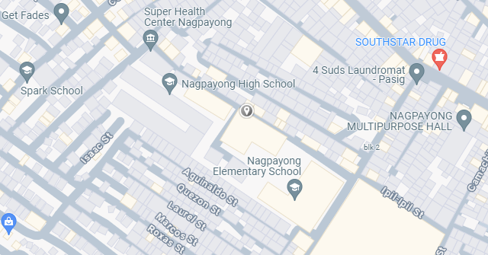The Re-paper head office and factory of Re-Paper is located near Nagpayong Elementary and Highschool, we decided to locate our recyclable paper manufacturing operation in a school. Schools are the best places to recycle since they produce a lot of paper waste, which is regularly recycled and provides a stable supply of raw materials. This enables business proponents to effectively gather and make use of waste paper at the source, including abandoned notebooks, workbooks, and envelopes.

*Molave St. Nagpayong Pinagbuhatan, Pasig City*

**Brief discussion of the project**

The Re-Paper is a high-quality, eco-conscious notebook made entirely from paper wastes. It offers a smooth and resilient surface ideal for writing and sketching, while promoting sustainability. - The eco-friendly notebooks are crafted using newly sustainable papers derived entirely from recycled paper waste. This approach significantly reduces the environmental impact associated with traditional paper production, such as deforestation and water consumption.

**History of business**

Nowadays, there is an inflation going in the country. This results the consumer's purchasing power and spending pattern to decrease. Almost all the paper crafts that are made out of woods costs high enough, which is the main reason why students do not always have a notebook to use in school activities.

Re-Paper would be a big help for students during this economic condition since it is cheaper but with the same quality as the paper crafts made out of woods. Papers that are made out from woods are usually used in making notebooks because it is stronger and more durable, but nowadays people finding some alternative to woods to make papers because of the scarcity of the trees, and also it reduces environment impact. Using newspapers, paper envelopes, and paper wastes as an alternative material for making sustainable notebooks can also help the paper manufacturer at the same time the environment to reduce massive paper wastes and to prevent disasters and tree cutting.

There is a policy that the government implemented about illegal logging, it is harvest, transporting, purchase or sale of timber in violation of laws. The raw materials for making paper crafts is commonly known as woods, wherein other people making paper crafts wants to be on top, this pushed them to harvest and sell trees without permission. Re-Paper use paper wastes as a material for making notebooks in order to avoid deforestation, natural disasters like flood and landslides.

**Nature and kind of industry**

Re-Paper operates within the recycling and manufacturing industry, specifically focusing on paper products. The business model involves collecting waste paper, processing it, and producing recycled paper products. This industry plays a crucial role in waste management and environmental conservation by converting waste into valuable resources.

Re-Paper operates within the recycling and manufacturing industry, with a specific emphasis on paper products. The Re-Paper industry is characterized by the following:

* **Waste Collection and Recycling** - Business proponents collect paper waste, diverting it from landfills and repurposing it into new products.
* **Manufacturing** - The business produces a range of recycled paper products, catering to various needs within the community and beyond.
* **Sustainability** - The business operations are designed to minimize environmental impact, promoting the principles of reduce, reuse, and recycle.

**Type of organization**

Re-Paper is a sole proprietorship organization which provides the company with the help needed to manage complicated operations and meet the company’s long-term goals. Sole proprietorship allows the company to effectively handle investments, strategic planning, and stakeholder relations, ensuring the scalability and sustainability of the business model.

**Officers of the business and their qualifications**

**II. Economic Aspect**

* **General Marketing Description**
* **Market Description**
* **Demand**
* **Supply**
* **Competitive Position**
* **Marketing Program**
* **Projected Sales**
* **Contributions to the Philippine Economy**
* **Net Amount of Pesos earned or saved**
* **Labor Employed**
* **Taxes Paid**