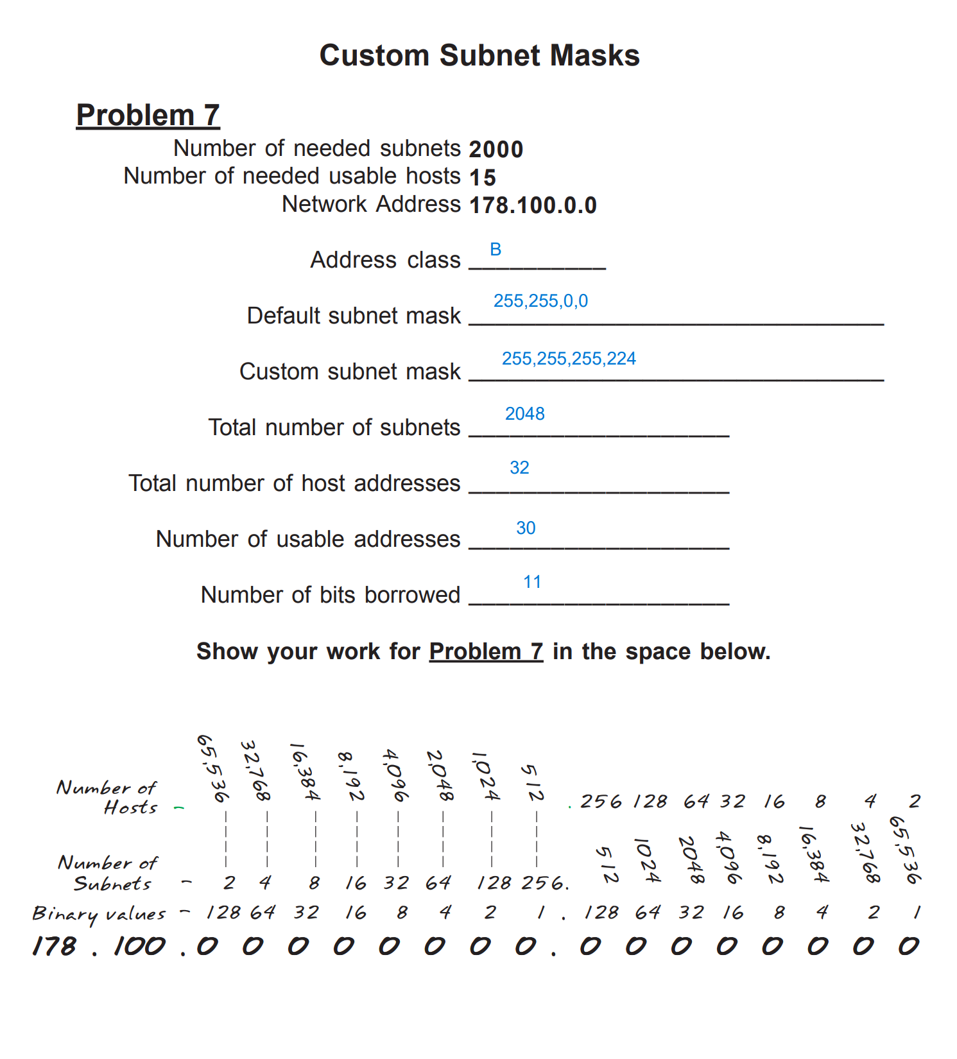

0-127 = class A, 127-191 = B default subnet mask = 255,255,0,0

Custom: 255,255,255, 128 + 64 + 32 = 255,255,255,224

Num of subnets = 2048

Num of host addresses = 32

Usable addresses = 32 – 2 = 30

Bits borrowed = 8 + 3 = 11

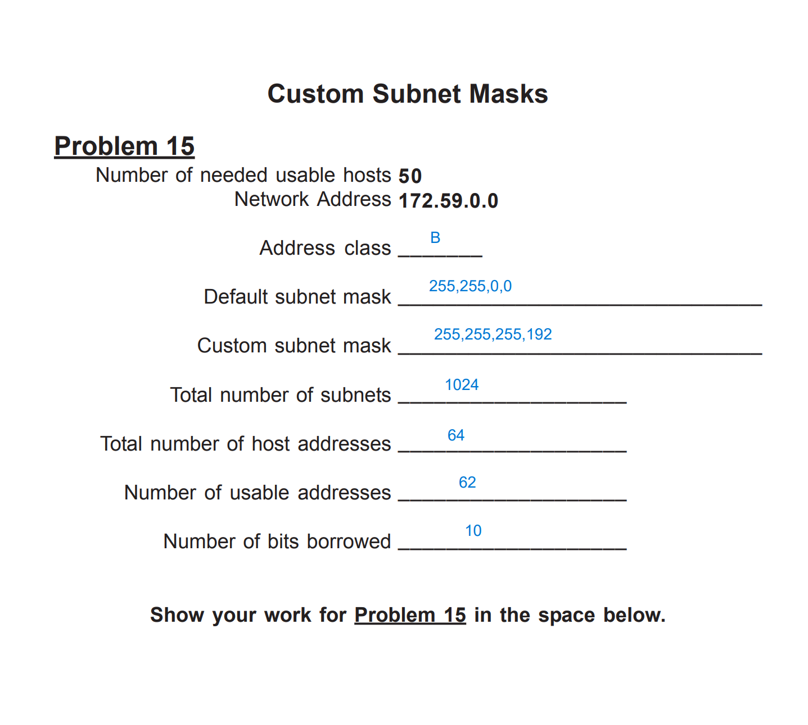

0-127 = class A, 127-191 = B default subnet mask = 255,255,0,0

Custom: 255,255,255, 128 + 64 = 255,255,255,192

Num of subnets = 1024

Num of host addresses = 64

Usable addresses = 64 – 2 = 62

Bits borrowed = 8 + 2 = 10

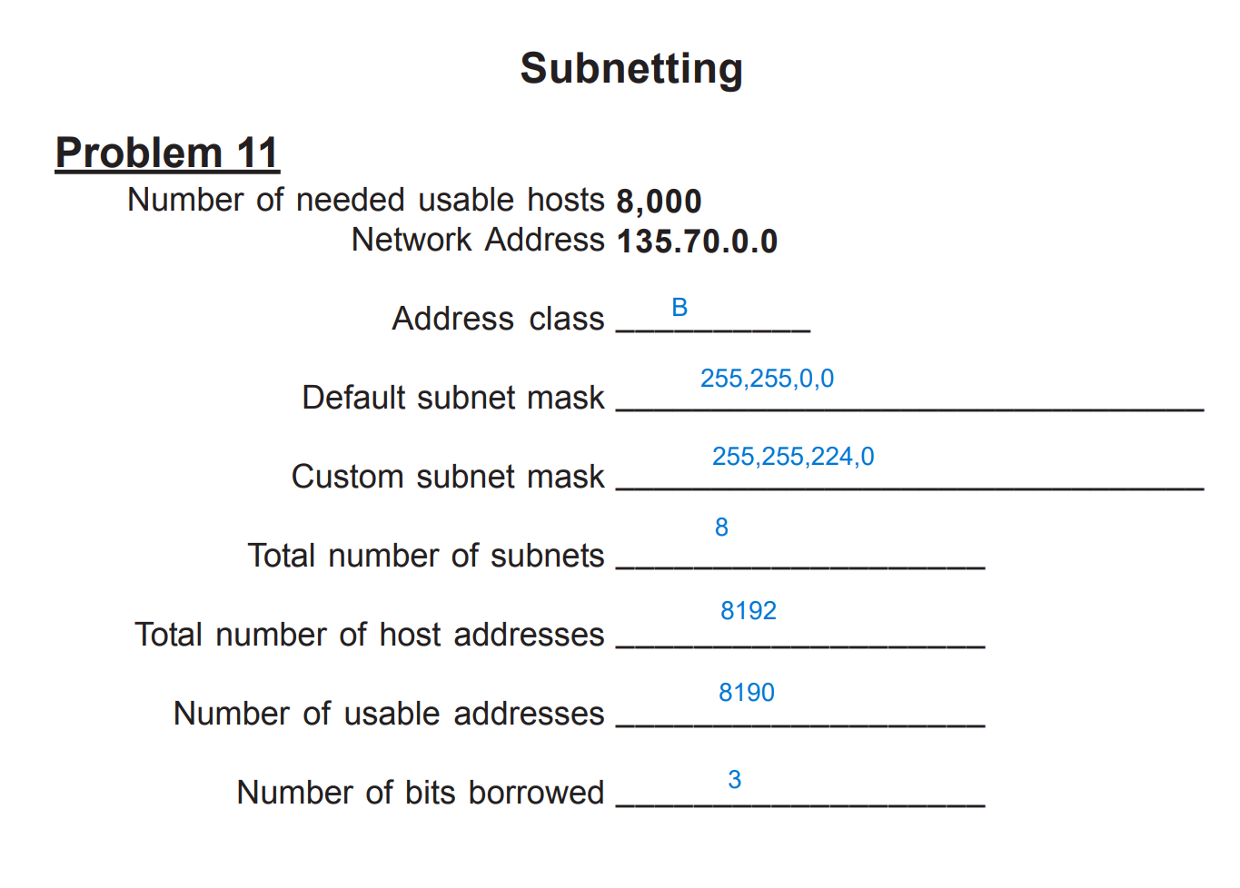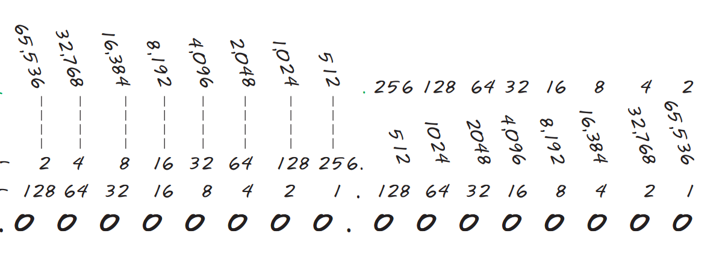

0-127 = class A, 127-191 = B default subnet mask = 255,255,0,0

Custom: 255,255,128 + 64 + 32, 0= 255,255,224,0

Num of subnets = 8

Num of host addresses = 8192

Usable addresses = 8192 – 2 = 8190

Bits borrowed = 3

What is the 6th subnet range?

Based on nun of bits borrowed. This one will increment in 32

135.70.0.0 -> 135.70.31

135.70.32.0 -> 135.70.63

135.70.64.0 -> 135.70.95

135.70.96.0 -> 135.70.127

135.70.128.0 -> 135.70.159

135.70.160.0 -> 135.70.191

135.70.192.0 -> 135.70.223

135.70.224.0 -> 135.70.255

Answer = 135.70.160.0 -> 135.70.191.255