Andrew Riggs

Data Quality Report (Preliminary)

Summaries can be found by running the packaged R script “DataQuality.R”. Here I will attempt to make sense of the images I have produced thus far, and make notes as to potential trends and where to go next.

Issues
(Largely marked with TODO tags in R)

From preliminary examination of my summaries and plots, it's become clear that a great deal of my data has zero values. This makes sense, as many of the games that are published to steam never have a great deal of success, but I'm not sure whether or not these entries are something to leave in or not. At the moment I'm leaning towards yes because it seems like poor practice to simply throw them out because they don't fit what I want, but they do make observing any potential trends somewhat more difficult.
-For now, I've created two new data frames named modgamedata100 and modgamedata1000. Each of these contains only entries where the average playtime is above 100 and 1000 minutes, respectively.

Another problem I'm currently running into is the representation of the “prices” and “score_rank” columns. Both of these are variables that I would like to make use of a great deal, but many of the functions that I'd like to apply seem to break on them. Sometimes, this is due to the presence of N/A values, and sometimes it is because they are not the correct type (even after my attempts at conversion). I hesitate to fill these N/A values, because they do have meaning, especially in the case of the scoring system. If no scores were given, that is not necessarily the same as a score of 0. It can be said with perhaps a bit more confidence that if no price is listed, it is free, but that's still uncertain.
-Managed to fix this. Prices are now able to be compared. This was done by removing all entries where the price was marked as NA, because those pieces of software marked as such were usually pieces of software that were either partially removed from the store or packaged with another product (such as betas, server tools, mod development kits, etc).

The question of how to best represent the tags is something I must work out. As of right now, I've essentially turned them into a boolean value consisting of either “0” for false or “1” for true, with the query being whether or not the game was tagged as being within that category. This seems to serve decently, though any data regarding the quantity of votes for each category (categories are defined based on user classification, leading to no hard “yes” or “no” categorization, instead producing a quantity of votes for that classification) is lost.
-I've decided to stick with my system of 1s and 0s, as it allows for much easier classification of each entry.

I have a great deal of variables (347) to contend with, most of which are classification tags. I'm not sure whether I should try to trim this down or not. Removing some of the lesser used tags could make handing the data easier and potentially lead to better conclusions. The choice to remove them would inherently change the way the data would be interpreted, however, and choosing which tags to remove would surely expose the data to a great deal of personal bias.
-Working on this, I've added a bit of code to my R script that will allow me to see the number of entries tagged with each tag. At the moment, I'm thinking of removing any tag that occurs fewer than 10 times. I have no basis for that number, however, so some averaging is required to actually get a proper number.

Still looking into a way of keeping track of average playtime per tag, though I'm not sure how to add it to my existing data set. I can create an entirely new one, but that would largely defeat the purpose of the original data. I could create a data frame with an average of each relevant stat for each tag, but this seems like it might be focusing in too much, potentially making me miss some other relationship in the data.

I'd also like to explore comparisons to other metrics, aside from average playtime. Total owners will be my next target, though I moved away from this initially due to its cumulative nature. A total ownership target may simply have more to do with how long the product has been released than anything else.

Plots
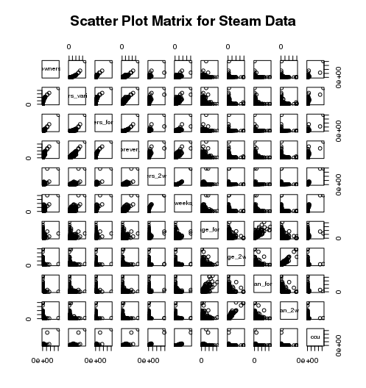
ScatterPlot.png in Images

Basic matrix for all the variables I can currently plot. As mentioned above, the abundance of zero values makes reading this a bit difficult.

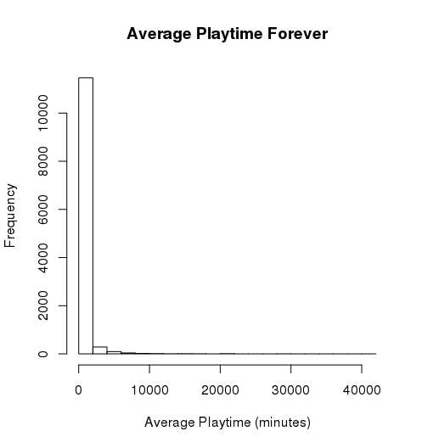
Average_Playtime.png in Images

Further proof of the abundance of zero values. This would imply that the vast majority of products on steam get very little (or no) playtime. This would make sense, as not every product can be popular, but produces an obstacle in interpretation. Potentially a sign that this data is not very good for finding trends(?)

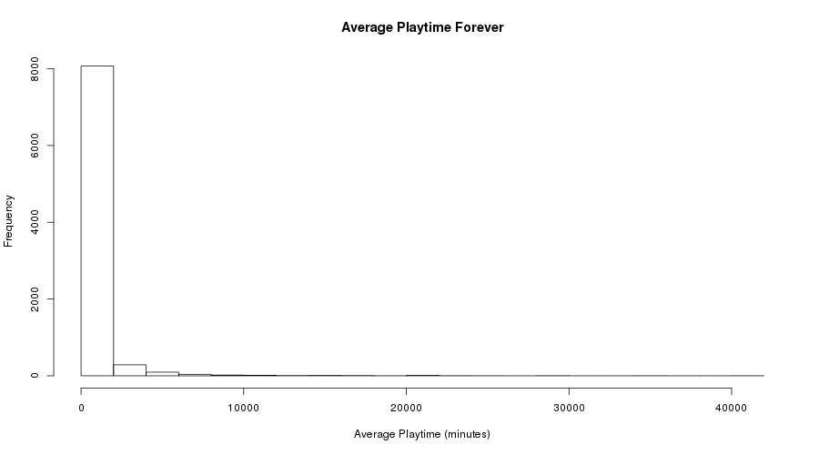
avgHist100.png in Images

Reduced the number of entries to those whose average playtime was above 100 minutes. This seems to have removed a great deal of entries, but the trend still remains.

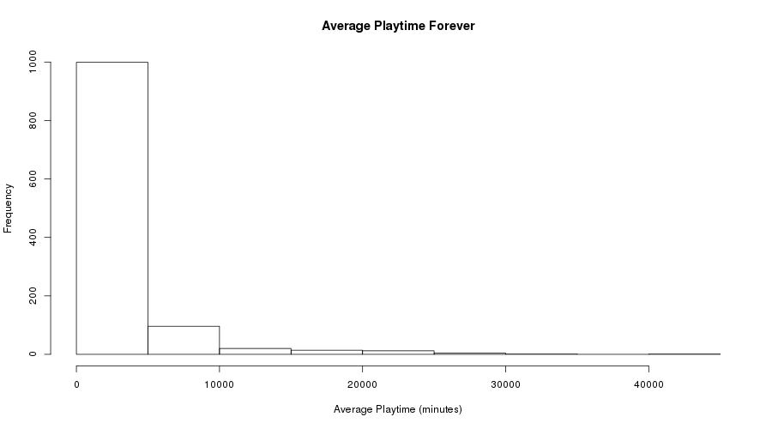
AvgHist1000.png in Images

Further reduced the entries to those above 1000 minutes of playtime. Seems to make things more readable, but removes a ridiculous amount of the data. Likely not reasonable to use.

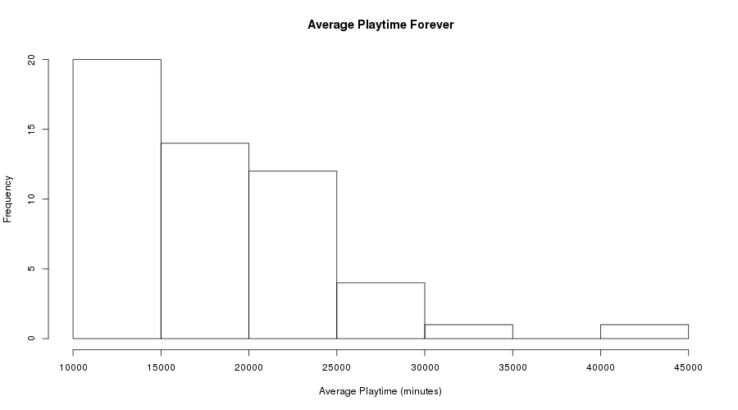
AvgHist10000.png in Images

Reduced the number of entries to those above 10000 minutes played. Completely impractical, as it removes basically all of the data.

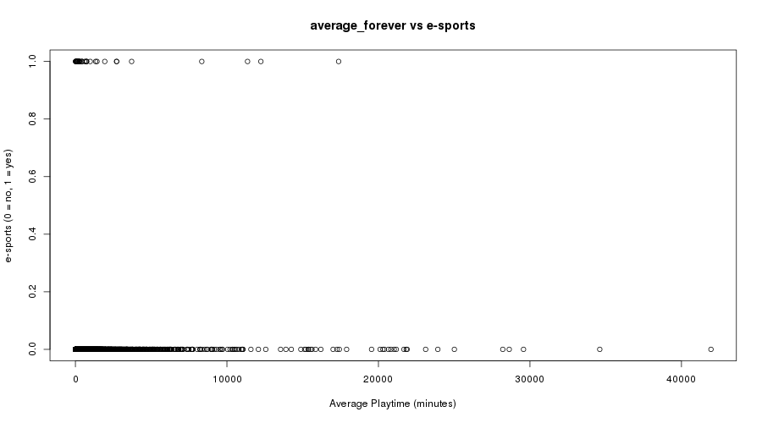
average_forever vs e-sports.png in Images/average_forever

First plotting of a tag and average playtime. Those dots at the 1 mark represent a game that is tagged as “e-sports”, and those at 0 as games that are not tagged in such a manner. This would seem to suggest that games tagged with “e-sports” have a lower average playtime than the mean, but there is no way to know this for sure without calculation (which I believe might be the next step).

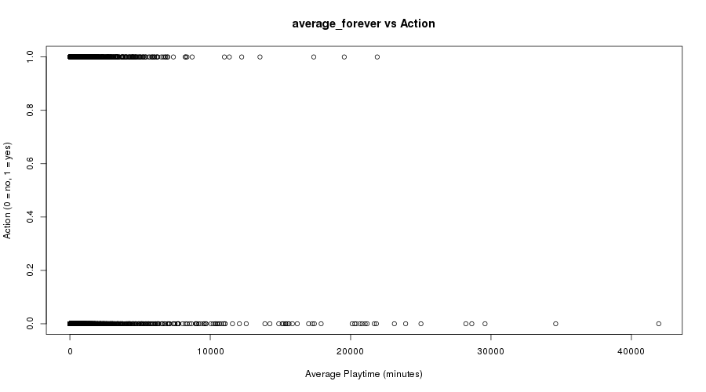
average_forever vs Action.png in Images/average_forever

Plotting of the Action tag vs the average playtime. Same scale and method as the last plot. This would seem to imply that action games receive more playtime, but it could also simply point towards a greater quantity of games tagged as “action.” This tag is much broader, after all, and more likely to be applied to games. Again, this will require averaging.

I've created a few more plots of this type, the images of which have been saved in the “Images” folder of the submitted archive. Many of them are largely the sort of business, but I've included a few that I found to be interesting below, with accompanying remarks.

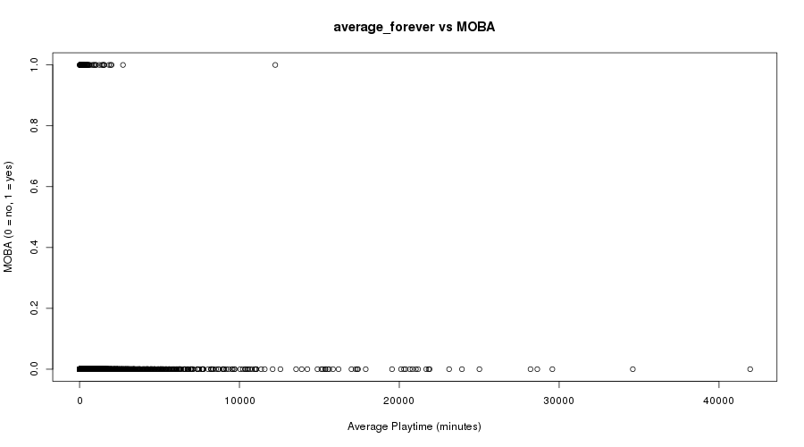
average_forever vs MOBA.png in Images/average_forever

After looking at the previous two plots and reading my comments (if they're not entirely off base), one may assume that the MOBA category has a shorter overall playtime than other genres. The problem with this is the single point much farther to the right than all the others, indicating what is (probably) a single game with comparatively high playtime. MOBAs as a genre are particularly susceptible to having one or two games at the top, while the rest see little action. This is due to the nature of the game itself, as a MOBA requires the player to learn the mechanics of the game to a level that is not often seen in other genres. This may cause players to develop a preference for that one specific game, attracting other to it while leaving other with nobody playing. While I'm not sure if that's what's happening here, cases like this could prove problematic when attempting to average together the entirety of a genre's playtime. Simply averaging the genre together may ignore cases such as this, and lead to results that aren't necessarily accurate. Something to consider.

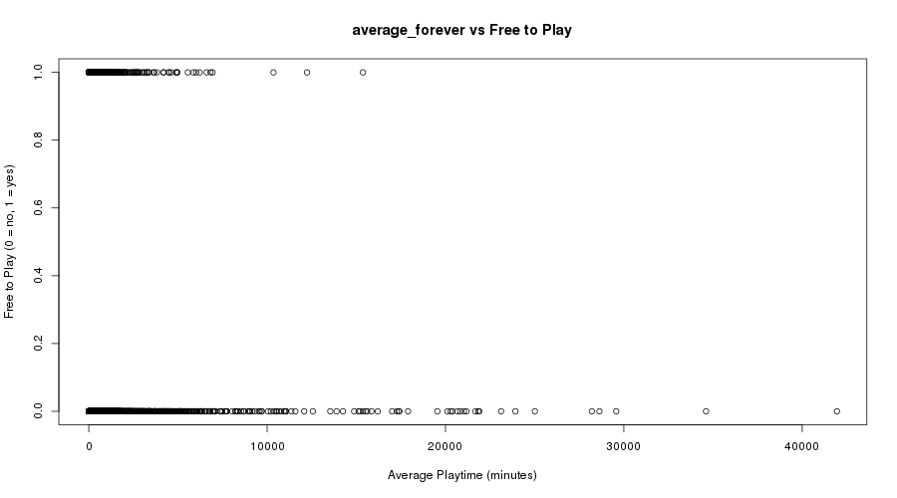
average_forever vs Free to Play.png in Images/average_forever

Free to play is another interesting consideration, as the cost to entry is so low. Technically, everyone who wants the game owns it, and all they have to do to be considered an owner is to download it once. This was one of my primary hesitations when considering using ownership data, and I think average play time may prove more useful in this regard. Still, not making use of the ownership variable seems like a poor decision simply because one subset of game. Maybe introducing the concept of player retention would be an interesting solution, doing so by comparing the ownership stats and the average time played stats. I'm not entirely sure what other trends could be found from that data, though. Something else to consider.

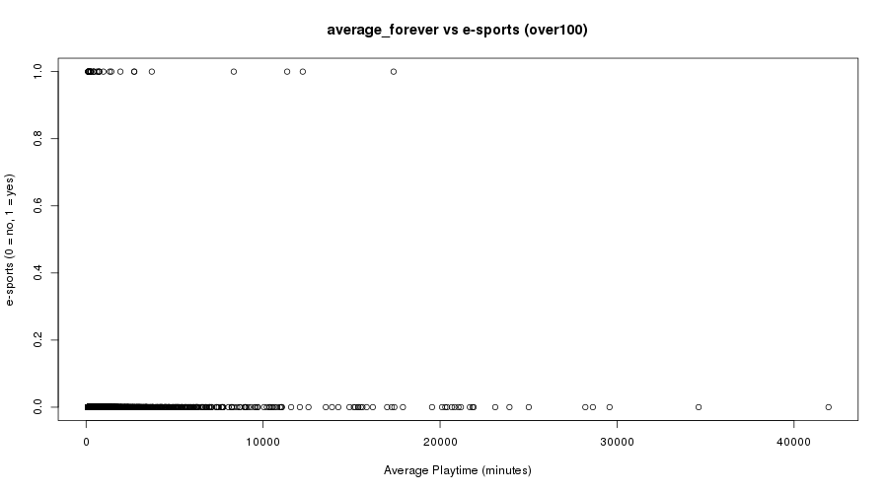
average_forever vs e-sports 100.png in Images/average_forever100

Reducing the number of entries has helped somewhat with identifying the outliers and any trends, but I'd still like to create some form of reliable computation that could help determine whether or not a tag is actually related to the playtime of a game.

